Supplementary Material
Exposure to ambient air pollution over developmental stages induced neurodevelopmental impairment in mice offspring via microbiome-gut-brain axis

Zijun Yang ¹, Yi Zhang ², Shanshan Ran ¹, Jingyi Zhang ¹, Yonggui Gao ¹, Yali Zhang ², Xinyue Li ¹, Baozhuo Ai ¹, Shengtao Wei ¹, Fei Tian ¹, Guang Jia ², Hualiang Lin ¹, Zhangjian Chen ², * and Zilong Zhang ¹, *

1. Department of Epidemiology, School of Public Health, Sun Yat-sen University, Guangzhou 510080, China;
2. Department of Occupational and Environmental Health Sciences, School of Public Health, Peking University, Beijing 100191, China;

* Correspondence to: Dr. Zhangjian Chen, Department of Occupational and Environmental Health Sciences, School of Public Health, Peking University, Beijing 100191, China; or Dr. Zilong Zhang, Department of Epidemiology, School of Public Health, Sun Yat-sen University, Guangzhou 510080, China.

Fig. S1.
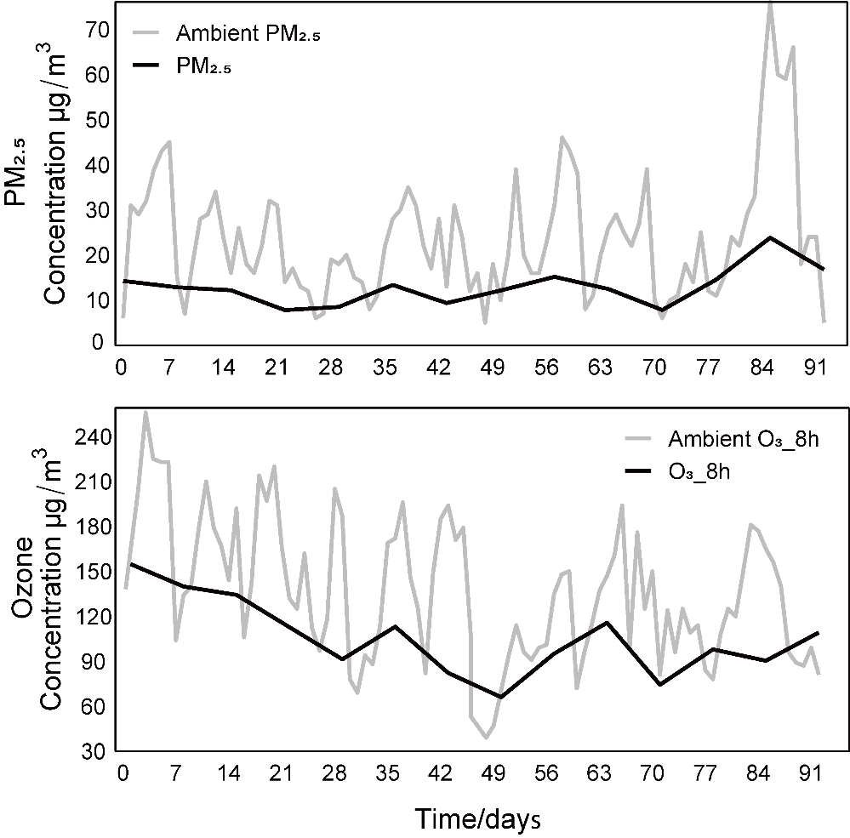
Fig. S1. Concentration of PM_{2.5} and ozone in ambient air and exposure chambers.

Fig. S2.
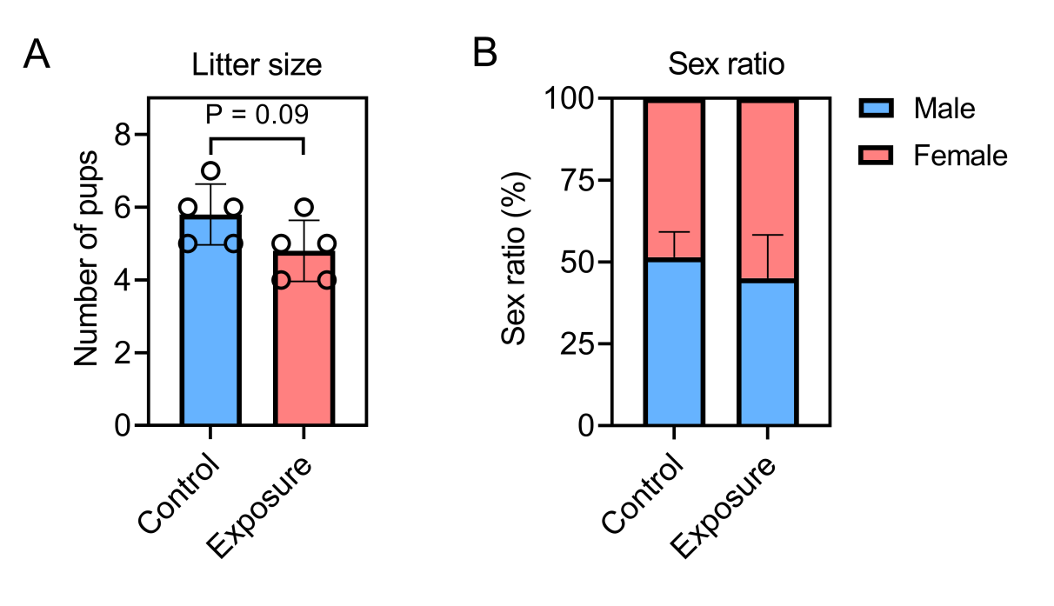
Fig. S2. The litter size and sex ratio of offspring from dams that successfully maintained pregnancy. (A) Litter size of offspring from dams. (B) Sex ratio of offspring at weaning. Control n=29 from 5 litters; Exposure n=24 from 5 litters.

Fig. S3.
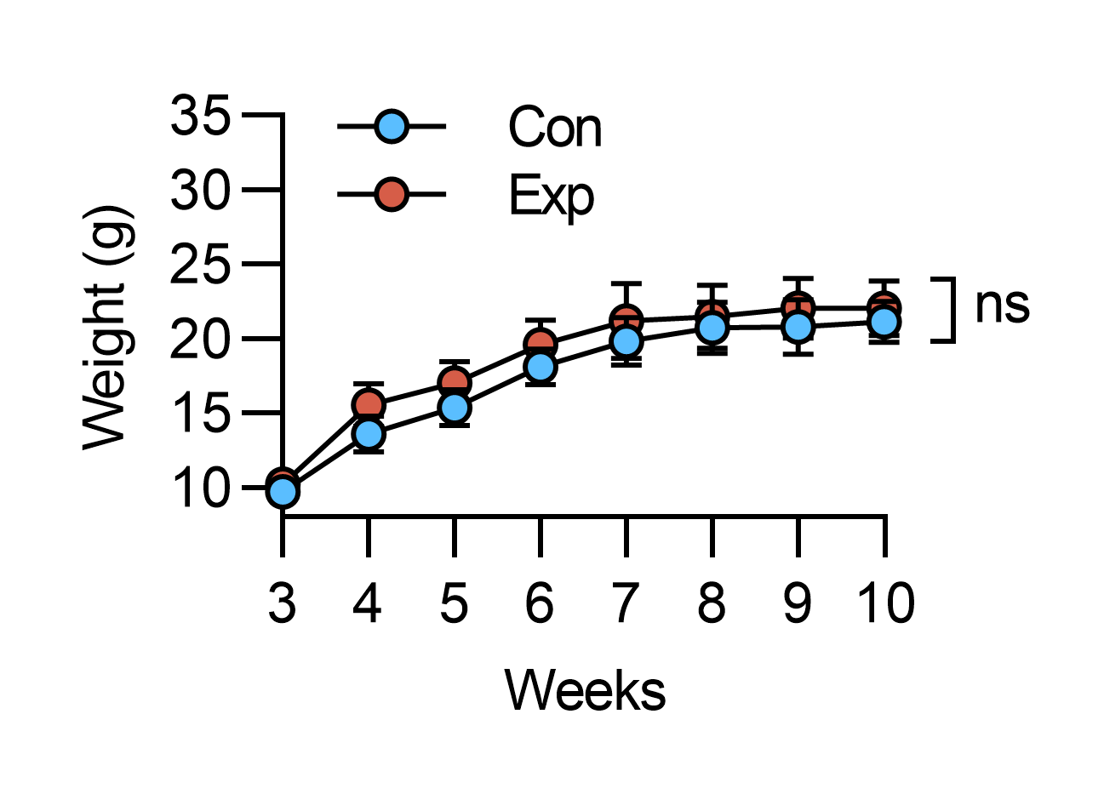
Fig. S3. Body weight changes of offspring mice after weaning. n = 10 per group (male: 5, female: 5), from 5 different litters. Data are presented as mean±SD (n = 10).

Fig. S4.
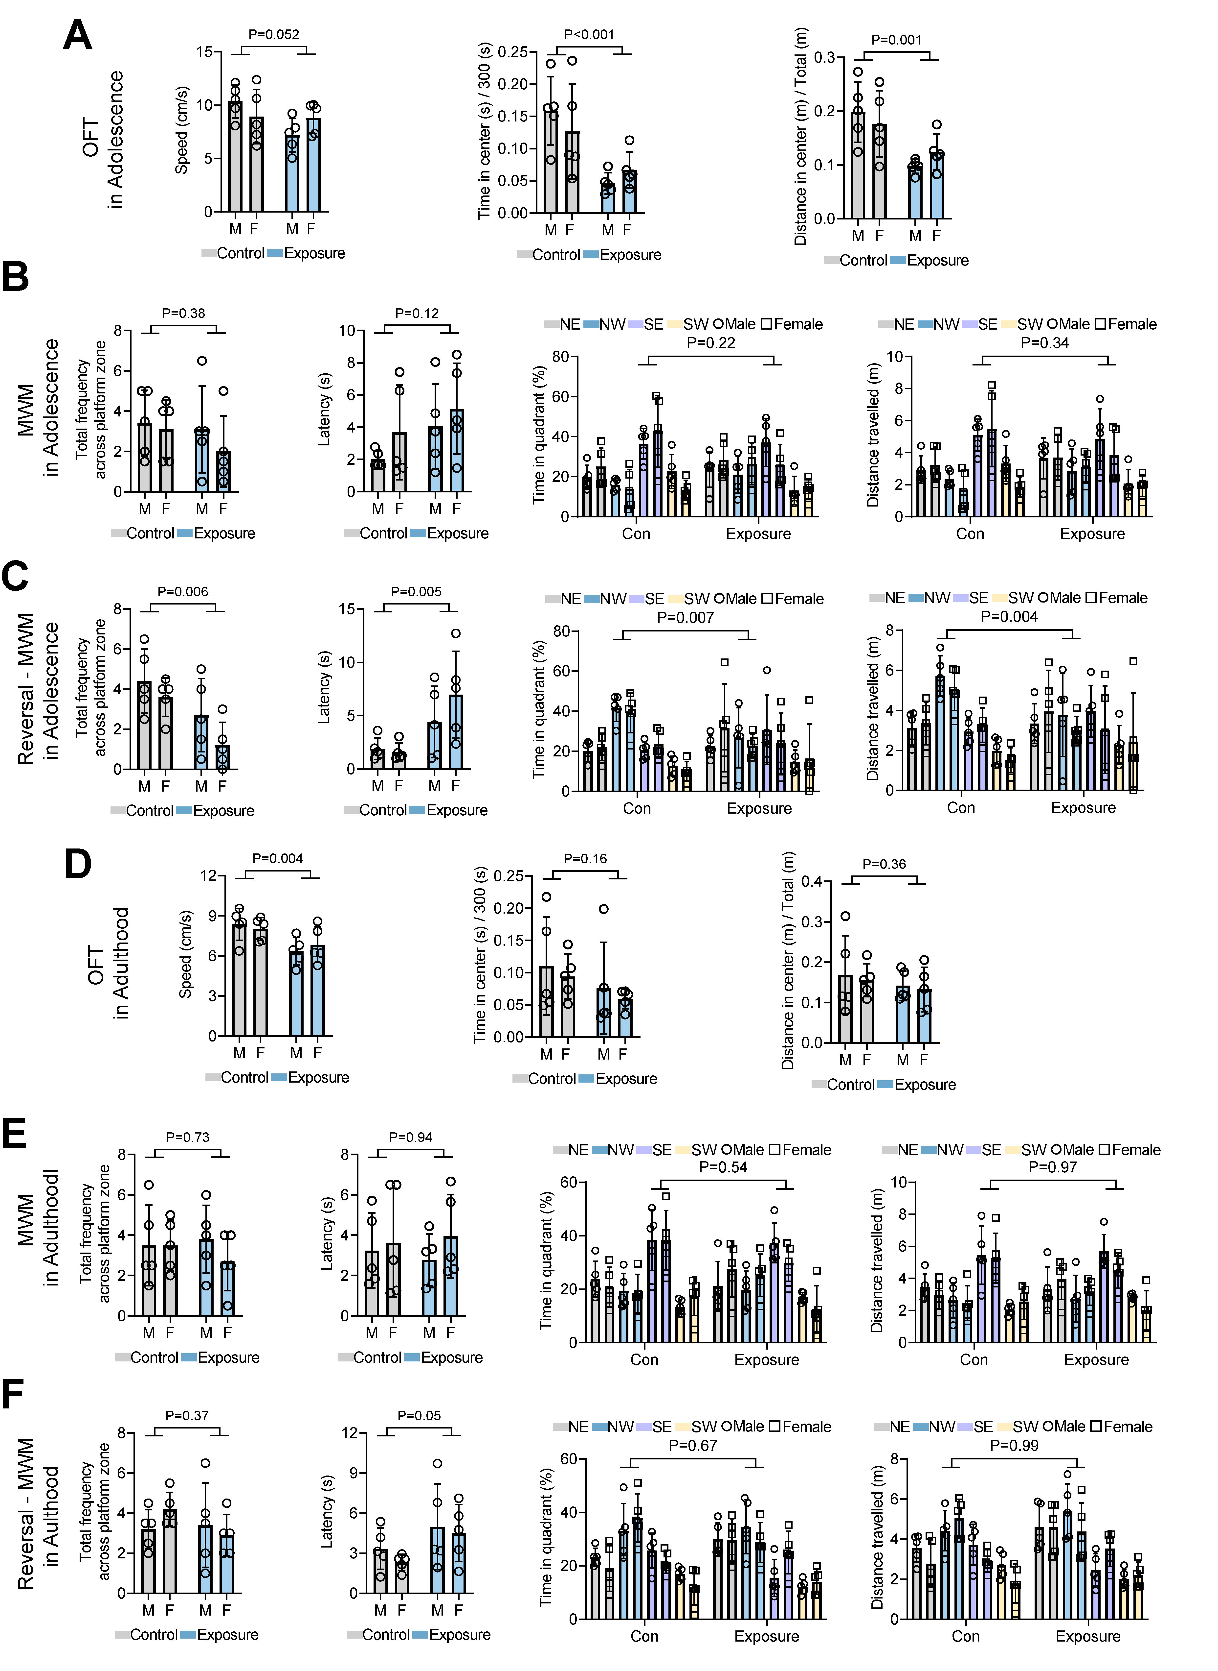
Fig. S4. Effects of exposure on anxiety-like behaviors assessed using OFT and on learning, memory and cognitive abilities assessed using MWM and the reversal platform MWM during both adolescence and young adulthood.
During Adolescence: (A) The speed, time in the center, distance in the center in the OFT. MWM and the reversal MWM tests using the following metrics: total frequency across the platform zone, latency, time spent in the quadrant, distance traveled. Results for MWM are shown in (B), and reversal MWM in (C). During young Adulthood: The same parameters measured in the OFT (D), with results for MWM shown in (E), and reversal MWM in (F). n = 10 per group (male: 5, female: 5), from 5 different litters. The data are expressed as the mean ± SD (n = 5). Compared with the control group using t-test or ANOVA. M: Male; F: Female.

Fig. S5
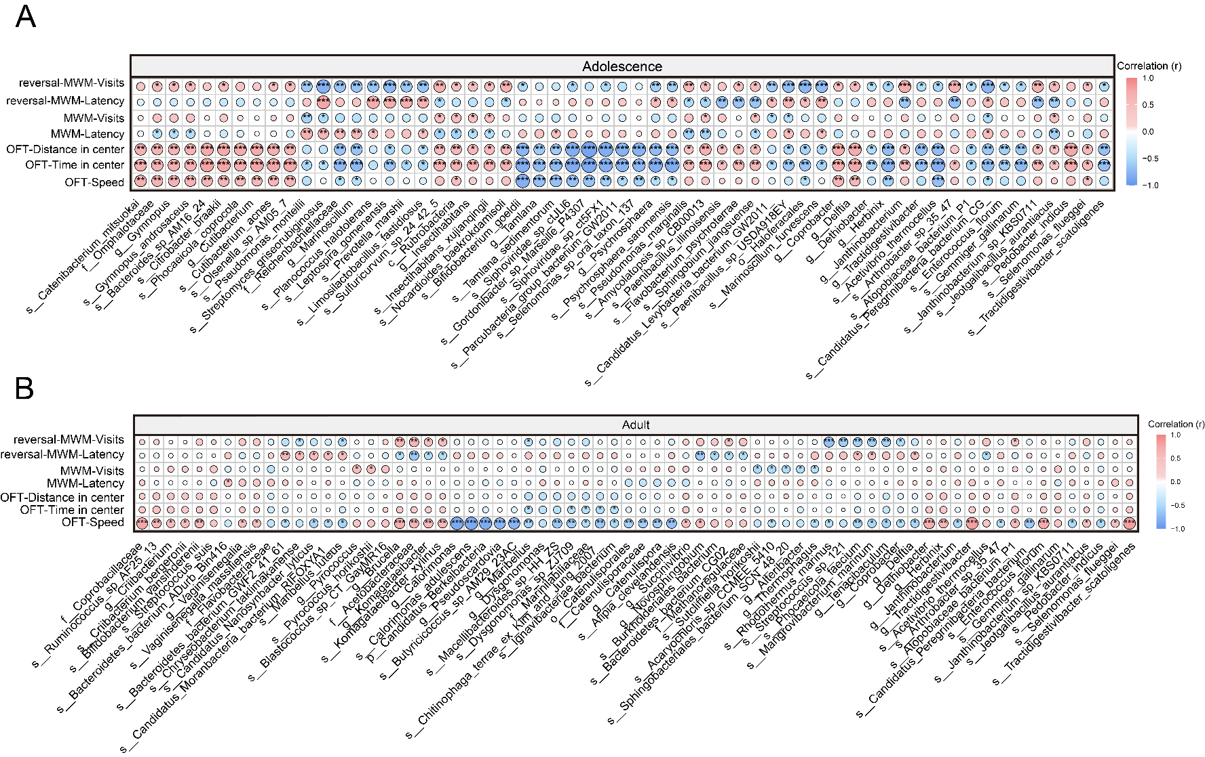
Fig. S5. Spearman correlation analysis including species level. (A) Results of Spearman correlation analysis between differential bacteria identified by LEfSe analysis during adolescence and behavioral performance, and (B) results for young adulthood (red indicates positive correlation, blue indicates negative correlation; circle size represents P-value). n = 10 per group (male: 5, female: 5), from 5 different litters. *P<0.05, **P<0.01, ***P<0.001.

Fig. S6.
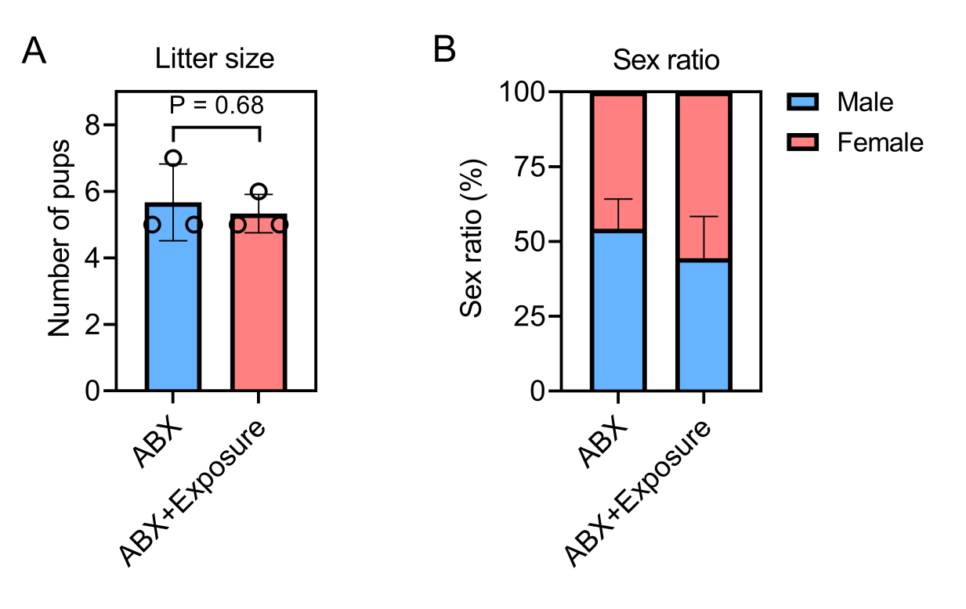
Fig. S6. The litter size and sex ratio of offspring from dams that successfully maintained pregnancy. (A) Litter size of offspring from dams. (B) Sex ratio of offspring at weaning. ABX n=17 from 3 litters; ABX + Exposure n=16 from 3 litters.

Fig. S7.
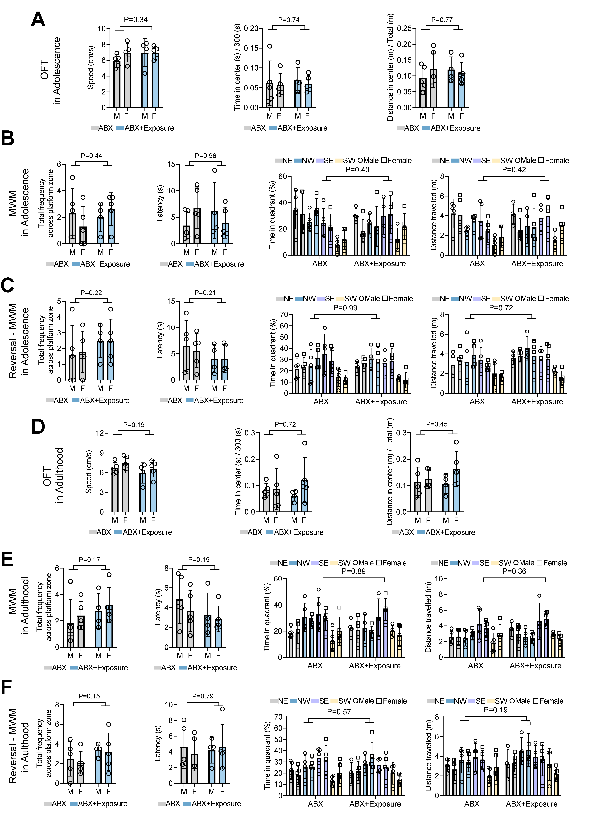
Fig. S7. Effects of exposure on anxiety-like behaviors (OFT), and on learning, memory, and cognitive abilities (MWM and reversal MWM) during adolescence and young adulthood after ABX treatment.
During Adolescence: (A) The speed, time in the center, distance in the center in the OFT. MWM and the reversal MWM tests using the following metrics: total frequency across the platform zone, latency, time spent in the quadrant, distance traveled. Results for MWM are shown in (B), and reversal MWM in (C). During young Adulthood: The same parameters measured in the OFT (D), with results for MWM shown in (E), and reversal MWM in (F). n = 9-10 per group (male: 4-5, female: 5), from 3 different litters. The data are expressed as the mean ± SD (n = 10). Compared with the control group using t-test or ANOVA. M: Male; F: Female.

Table S1
Comparison of the percentage of time spent in the target quadrant and the 25% chance level. (μ₀ = 25%)
Group | N | Mean± SE (%) | Mean Difference (M - μ₀) (95% CI) | t | P-value
Adolescence MWM
Control | 10 | 39.52±4.22 | 14.52 (4.98, 24.05) | 3.44 | 0.007
Exposure | 10 | 31.50±3.80 | 6.50 (-2.09, 15.09) | 1.71 | 0.121
Adolescence reversal-MWM
Control | 10 | 40.45±2.56 | 15.45 (9.66, 21.25) | 6.03 | <0.0001
Exposure | 10 | 24.85±3.43 | -0.15 (-7.91, 7.62) | 0.04 | 0.966
Young adulthood MWM
Control | 10 | 38.36±3.36 | 13.36 (5.75, 20.97) | 3.36 | 0.003
Exposure | 10 | 33.55±2.47 | 8.55 (2.97, 14.13) | 2.47 | 0.007
Young adulthood reversal-MWM
Control | 10 | 35.51±3.00 | 10.51 (3.72, 17.30) | 3.50 | 0.007
Exposure | 10 | 31.75±2.83 | 6.75 (0.33, 13.17) | 2.38 | 0.041

Table S2
Mediation analysis of early-life ambient air pollutions on behavioral performance, accounting for α-diversity.
Outcome indicator | Potential mediators | Total effect (95% CI) | Direct effect (95% CI) | Indirect effect (95% CI) | Proportion mediated (%)
Ado-OFT-speed | Observed-species | -1.639 (-3.231, -0.113) | -1.163 (-2.893, 0.197) | -0.476 (-1.326, 0.466) | 29.0
 | ACE | -1.639 (-3.297, 0.040) | -0.741 (-2.621, 0.740) | -0.898 (-1.947, 0.095) | 54.8
Ado-OFT-Duration | ACE | -0.086 (-0.13, -0.045) | -0.072 (-0.125, -0.037) | -0.015 (-0.032, 0.014) | 16.9
Ado-OFT-Distance | ACE | -0.077 (-0.117, -0.038) | -0.065 (-0.120, -0.031) | -0.012 (-0.029, 0.024) | 15.5
Adult-OFT-speed | Shannon | -1.595 (-2.479, -0.655) | -1.427 (-2.311, -0.577) | -0.168 (-0.650, 0.354) | 10.5
 | Observed-species | -1.595 (-2.520, -0.612) | -1.282 (-2.274, -0.402) | -0.313 (-0.950, 0.092) | 19.6
 | ACE | -1.595 (-2.486, -0.667) | -1.272 (-2.189, -0.347) | -0.323 (-0.968, 0.107) | 20.3

Table S3
The mediation analysis for microbiome and behavioral indicators during adolescence.
Outcome indicator | Rank | Mediators | Total effect (95% CI) | Direct effect (95% CI) | Indirect effect (95% CI) | Proportion mediated (%)
Ado-OFT-speed | species | s__Prevotella_sp_kh1p2 | -1.639 (-3.301, -0.031) | -0.088 (-2.586, 3.415) | -1.551 (-4.981, -0.028) | 94.6
Ado-OFT-speed | species | s__Gemella_sp_ | -1.639 (-3.245, -0.004) | -0.830 (-2.764, 1.172) | -0.809 (-1.860, -0.221) | 49.4
Ado-OFT-speed | species | s__Gymnopus_androsaceus | -1.639 (-3.227, -0.035) | -0.811 (-3.024, 1.538) | -0.828 (-2.621, -0.060) | 50.5
Ado-OFT-duration | species | s__Bifidobacterium_goeldii | -0.086 (-0.129, -0.046) | -0.057 (-0.104, -0.012) | -0.029 (-0.072, -0.009) | 34.0
Ado-OFT-duration | species | s__Mycobacterium_avium | -0.086 (-0.126, -0.045) | -0.037 (-0.093, 0.043) | -0.049 (-0.120, -0.007) | 57.0
Ado-OFT-duration | species | s__Nocardia_concava | -0.086 (-0.127, -0.045) | -0.043 (-0.093, 0.007) | -0.044 (-0.093, -0.01) | 50.6
 | species | s__Cutibacterium_acnes | -0.086 (-0.129, -0.048) | -0.034 (-0.092, 0.026) | -0.053 (-0.108, -0.009) | 60.9
 | species | s__Gordonibacter_sp_Marseille_P4307 | -0.086 (-0.129, -0.047) | -0.041 (-0.097, 0.004) | -0.045 (-0.089, -0.020) | 52.4
 | species | s__Paenibacillus_sp_7523_1 | -0.086 (-0.127, -0.044) | -0.051 (-0.110, 0.013) | -0.036 (-0.086, -0.007) | 41.3
 | species | s__Lactobacillus_gigeriorum | -0.086 (-0.129, -0.045) | -0.058 (-0.101, -0.002) | -0.029 (-0.078, -0.004) | 33.3
 | species | s__Sphingobium_jiangsuense | -0.086 (-0.125, -0.048) | -0.063 (-0.114, 0.019) | -0.024 (-0.096, -0.002) | 27.3
 | species | s__Citrobacter_braakii | -0.086 (-0.128, -0.047) | -0.017 (-0.058, 0.024) | -0.069 (-0.123, -0.019) | 79.9
 | species | s__Pseudomonas_otitidis | -0.086 (-0.125, -0.048) | -0.064 (-0.109, -0.018) | -0.022 (-0.054, -0.003) | 25.6
 | species | s__Siphoviridae_sp_ctJLl6 | -0.086 (-0.127, -0.047) | -0.038 (-0.104, 0.009) | -0.048 (-0.098, -0.010) | 56.1
Ado-OFT-distance | species | s__Haloplanus_aerogenes | -0.077 (-0.113, -0.038) | -0.042 (-0.088, 0.019) | -0.035 (-0.088, -0.004) | 45.9
Ado-OFT-distance | species | s__Bifidobacterium_goeldii | -0.077 (-0.114, -0.038) | -0.052 (-0.099, -0.005) | -0.025 (-0.066, -0.002) | 32.5
Ado-OFT-distance | species | s__Mycobacterium_avium | -0.077 (-0.113, -0.039) | -0.033 (-0.094, 0.035) | -0.044 (-0.105, -0.005) | 57.0
 | species | s__Nocardia_concava | -0.077 (-0.113, -0.037) | -0.044 (-0.095, 0.000) | -0.033 (-0.056, -0.004) | 42.7
 | species | s__Cutibacterium_acnes | -0.077 (-0.114, -0.035) | -0.044 (-0.098, 0.009) | -0.033 (-0.071, -0.002) | 43.3
 | species | s__Streptomyces_sp_Ag109_G2_15 | -0.077 (-0.115, -0.038) | -0.056 (-0.096, -0.009) | -0.021 (-0.052, -0.006) | 27.7
 | species | s__Olsenella_sp_AF21_51 | -0.077 (-0.114, -0.038) | -0.012 (-0.083, 0.088) | -0.065 (-0.164, -0.014) | 84.5
 | species | s__Gordonibacter_sp_Marseille_P4307 | -0.077 (-0.114, -0.04) | -0.029 (-0.082, 0.010) | -0.048 (-0.084, -0.021) | 62.2
 | species | s__Candidatus_Nomurabacteria_bacterium_ | -0.077 (-0.115, -0.038) | -0.049 (-0.085, 0.002) | -0.027 (-0.068, -0.005) | 35.8
 | species | s__Scytonema_tolypothrichoides | -0.077 (-0.115, -0.041) | -0.034 (-0.088, 0.036) | -0.042 (-0.104, -0.011) | 55.3
 | species | s__Paenibacillus_sabinae | -0.077 (-0.114, -0.037) | -0.065 (-0.103, -0.018) | -0.012 (-0.032, -0.001) | 15.5
 | species | s__Paenibacillus_sp_7523_1 | -0.077 (-0.115, -0.035) | -0.043 (-0.095, 0.014) | -0.034 (-0.081, -0.004) | 44.3
 | species | s__Selenomonas_sp_oral_taxon_137 | -0.077 (-0.114, -0.039) | -0.065 (-0.103, -0.026) | -0.012 (-0.027, -0.003) | 15.0
 | species | s__Paraburkholderia_aromaticivorans | -0.077 (-0.115, -0.039) | -0.032 (-0.086, 0.041) | -0.045 (-0.111, -0.005) | 58.8
 | species | s__Deltaproteobacteria_bacterium_RBG | -0.077 (-0.114, -0.037) | -0.039 (-0.087, 0.038) | -0.038 (-0.104, -0.012) | 49.4
 | species | s__Citrobacter_braakii | -0.077 (-0.113, -0.037) | -0.021 (-0.063, 0.021) | -0.056 (-0.095, -0.016) | 73.0
 | species | s__Myoviridae_sp_ct8Eu10 | -0.077 (-0.117, -0.038) | -0.066 (-0.106, -0.023) | -0.011 (-0.026, -0.002) | 13.8
 | species | s__Siphoviridae_sp_ctJLl6 | -0.077 (-0.115, -0.041) | -0.025 (-0.092, 0.013) | -0.052 (-0.088, -0.009) | 67.4
Ado-reversal-MWM-Latency | species | s__Tenacibaculum_sp_Bg11_29 | 17.885 (7.387, 28.891) | 5.892 (-13.03, 20.280) | 11.993 (0.558, 31.485) | 67.1
Ado-reversal-MWM-Latency | species | s__Paenibacillus_illinoisensis | 17.885 (6.740, 28.975) | 10.710 (-2.212, 25.310) | 7.175 (1.472, 15.922) | 40.1
Ado-reversal-MWM-Latency | species | s__Leptospira_gomenensis | 17.885 (6.783, 29.556) | 7.889 (-23.552, 22.131) | 9.996 (3.896, 41.184) | 55.9
Ado-reversal-MWM-Visits | species | s__Arthrobacter_sp_35_47 | -2.050 (-3.267, -0.717) | -0.828 (-2.352, 1.422) | -1.222 (-3.167, -0.147) | 59.6
Ado-reversal-MWM-Visits | species | s__Streptomyces_griseorubiginosus | -2.050 (-3.396, -0.774) | -1.037 (-2.970, 0.453) | -1.013 (-2.183, -0.019) | 49.4
Ado-reversal-MWM-Visits | species | s__Tenacibaculum_sp_Bg11_29 | -2.050 (-3.333, -0.800) | -0.759 (-2.465, 1.095) | -1.291 (-2.775, -0.234) | 63.0
 | species | s__Candidatus_Saccharibacteria_bacterium_ | -2.050 (-3.300, -0.733) | -0.687 (-2.522, 0.786) | -1.363 (-2.602, -0.009) | 66.5
 | species | s__Lactobacillus_amylovorus | -2.050 (-3.273, -0.793) | -0.878 (-2.564, 1.257) | -1.172 (-3.128, -0.288) | 57.2
 | species | s__Lactobacillus_gigeriorum | -2.050 (-3.250, -0.783) | -1.134 (-2.733, 0.799) | -0.916 (-2.403, -0.104) | 44.7
 | species | s__Janthinobacterium_sp_KBS0711 | -2.050 (-3.229, -0.800) | -0.900 (-2.498, 1.088) | -1.150 (-3.132, -0.025) | 56.1
 | species | s__Leptospira_gomenensis | -2.050 (-3.298, -0.771) | -0.988 (-2.493, 2.323) | -1.062 (-3.604, -0.549) | 51.8

Table S4
The mediation analysis for microbiome and behavioral indicators during young adulthood.
Outcome indicator | Rank | Mediators | Total effect (95% CI) | Direct effect (95% CI) | Indirect effect (95% CI) | Proportion mediated (%)
Adult-OFT-speed | Species | s__Candidatus_Nitrosotenuis_sp_ | -1.595 (-2.532, -0.630) | -0.118 (-1.668, 1.544) | -1.477 (-3.017, -0.367) | 92.6
Adult-OFT-speed | Species | s__Mycobacterium_timonense | -1.595 (-2.496, -0.595) | -0.045 (-1.725, 1.557) | -1.550 (-3.073, -0.157) | 97.1
 | Species | s__Collinsella_sp_AM20_15AC | -1.595 (-2.494, -0.559) | -0.405 (-2.120, 1.196) | -1.190 (-2.517, -0.005) | 74.6
 | Species | s__Collinsella_sp_AM28_11LB | -1.595 (-2.478, -0.627) | -0.596 (-1.973, 0.762) | -0.999 (-2.250, -0.023) | 62.6
 | Species | s__Bacteroides_sp_D1 | -1.595 (-2.484, -0.661) | -0.316 (-1.832, 1.757) | -1.279 (-3.045, -0.142) | 80.2
 | Species | s__Flavobacterium_sp_BFFFF1 | -1.595 (-2.496, -0.633) | -0.235 (-1.388, 1.054) | -1.360 (-2.343, -0.559) | 85.3
 | Species | s__Aggregatilinea_lenta | -1.595 (-2.469, -0.708) | -0.751 (-1.735, 0.325) | -0.844 (-1.726, -0.139) | 52.9
 | Species | s__Fibrobacter_sp_UWB2 | -1.595 (-2.463, -0.553) | -0.394 (-1.492, 0.604) | -1.201 (-1.879, -0.537) | 75.3
 | Species | s__Firmicutes_bacterium_AM55_24TS | -1.595 (-2.502, -0.650) | -0.308 (-1.684, 0.896) | -1.287 (-2.267, -0.305) | 80.7
 | Species | s__Firmicutes_bacterium_M10_2 | -1.595 (-2.541, -0.609) | -0.015 (-1.507, 1.424) | -1.580 (-2.822, -0.360) | 99.1
 | Species | s__Anoxybacillus_sp_BCO1 | -1.595 (-2.477, -0.597) | -0.211 (-1.727, 1.480) | -1.384 (-2.824, -0.301) | 86.8
 | Species | s__Bacillus_anthracis | -1.595 (-2.515, -0.630) | -0.667 (-2.075, 0.505) | -0.928 (-1.828, -0.132) | 58.2
 | Species | s__Bacillus_sp_TSO22 | -1.595 (-2.480, -0.614) | -0.536 (-1.688, 0.640) | -1.059 (-1.870, -0.291) | 66.4
 | Species | s__Vulcanibacillus_modesticaldus | -1.595 (-2.509, -0.647) | -0.724 (-1.950, 0.371) | -0.871 (-1.638, -0.205) | 54.6
 | Species | s__Paenibacillus_sabinae | -1.595 (-2.512, -0.716) | -0.651 (-1.721, 0.598) | -0.944 (-2.017, -0.191) | 59.2
 | Species | s__Paenibacillus_sp_DA_C8 | -1.595 (-2.517, -0.701) | -0.132 (-1.339, 1.018) | -1.463 (-2.549, -0.598) | 91.8
 | Species | s__Enterococcus_florum | -1.595 (-2.413, -0.614) | -0.021 (-1.572, 1.410) | -1.574 (-2.890, -0.357) | 98.7
 | Species | s__Lactobacillus_delbrueckii | -1.595 (-2.493, -0.628) | -0.687 (-1.848, 0.681) | -0.908 (-2.159, -0.136) | 56.9
 | Species | s__Lactobacillus_nasalidis | -1.595 (-2.476, -0.669) | -0.313 (-1.612, 1.527) | -1.282 (-2.972, -0.263) | 80.4
 | Species | s__Streptococcus_rubneri | -1.595 (-2.519, -0.599) | -1.147 (-2.095, 0.277) | -0.448 (-1.532, -0.051) | 28.1
 | Species | s__Sulfobacillus_thermosulfidooxidans | -1.595 (-2.533, -0.639) | -0.862 (-2.131, 0.182) | -0.733 (-1.402, -0.116) | 46.0
 | Species | s__Butyricicoccus_sp_AM29_23AC | -1.595 (-2.526, -0.638) | -0.290 (-1.384, 0.995) | -1.305 (-2.421, -0.568) | 81.8
 | Species | s__Caloramator_proteoclasticus | -1.595 (-2.502, -0.565) | -0.725 (-2.087, 0.178) | -0.870 (-1.705, -0.054) | 54.6
 | Species | s__Clostridium_carboxidivorans | -1.595 (-2.435, -0.677) | -0.008 (-1.880, 2.276) | -1.587 (-3.731, -0.048) | 99.5
 | Species | s__Clostridium_fallax | -1.595 (-2.501, -0.619) | -0.640 (-1.660, 0.482) | -0.955 (-1.566, -0.426) | 59.8
 | Species | s__Clostridium_sporogenes | -1.595 (-2.453, -0.65) | -0.245 (-1.693, 1.198) | -1.350 (-2.690, -0.267) | 84.6
 | Species | s__Herbinix_hemicellulosilytica | -1.595 (-2.477, -0.688) | -0.110 (-1.784, 1.767) | -1.485 (-3.200, -0.178) | 93.1
 | Species | s__Paeniclostridium_sordellii | -1.595 (-2.45, -0.706) | -0.450 (-1.611, 1.300) | -1.145 (-2.697, -0.285) | 71.8
 | Species | s__Calorimonas_adulescens | -1.595 (-2.488, -0.679) | -0.436 (-1.530, 0.599) | -1.159 (-1.979, -0.558) | 72.7
 | Species | s__Sharpea_porci | -1.595 (-2.498, -0.662) | -0.042 (-1.378, 1.513) | -1.553 (-3.200, -0.460) | 97.4
 | Species | s__Absiella_sp_AM27_20 | -1.595 (-2.536, -0.677) | -0.224 (-1.919, 1.473) | -1.371 (-2.759, -0.170) | 85.9
 | Species | s__Achromobacter_xylosoxidans | -1.595 (-2.501, -0.706) | -0.003 (-1.502, 1.669) | -1.592 (-3.341, -0.274) | 99.8
 | Species | s__Burkholderia_mallei | -1.595 (-2.559, -0.68) | -0.307 (-1.816, 1.645) | -1.288 (-3.139, -0.165) | 80.7
 | Species | s__Neisseria_sp_HMSC065D04 | -1.595 (-2.495, -0.595) | -0.579 (-1.859, 0.842) | -1.016 (-2.317, -0.208) | 63.7
 | Species | s__Syntrophorhabdus_sp_PtaB_Bin006 | -1.595 (-2.520, -0.682) | -0.808 (-1.722, 0.124) | -0.787 (-1.543, -0.149) | 49.3
 | Species | s__Cronobacter_sakazakii | -1.595 (-2.491, -0.591) | -0.466 (-1.943, 1.153) | -1.129 (-2.421, -0.046) | 70.8
 | Species | s__Pseudomonas_yangmingensis | -1.595 (-2.528, -0.649) | -0.976 (-1.982, 0.238) | -0.619 (-1.397, -0.090) | 38.8

Table S5
Comparison of the percentage of time spent in the target quadrant and the 25% chance level after ABX treatment. (μ₀ = 25%)
Group | N | Mean± SE (%) | Mean Difference (M - μ₀) (95% CI) | t | P-value
Adolescence MWM
ABX | 10 | 22.70±3.29 | -2.30 (-9.75, 5.15) | 0.70 | 0.502
ABX + Exposure | 9 | 30.54±4.41 | 1.26 (-4.64, 15.71) | 1.26 | 0.249
Adolescence reversal-MWM
ABX | 10 | 27.55±3.87 | 2.55 (-6.19, 11.29) | 0.66 | 0.526
ABX + Exposure | 9 | 29.05±3.75 | 4.05 (-4.59, 12.68) | 1.08 | 0.311
Young adulthood MWM
ABX | 10 | 30.78±3.28 | 5.78 (-1.63, 13.20) | 1.76 | 0.112
ABX + Exposure | 9 | 33.90±3.64 | 8.90 (0.51, 17.29) | 2.45 | 0.040
Young adulthood reversal-MWM
ABX | 10 | 25.57±2.67 | 0.57 (-5.47, 6.60) | 0.21 | 0.837
ABX + Exposure | 9 | 30.99±3.72 | 6.00 (-2.58, 14.56) | 1.61 | 0.146

