Supporting Information for
Inhalation toxicity, pulmonary clearance, and biotransformation of ferric oxide nanoparticles in rats
Songyeon Kim^{†,1}, Jiyoung Jeong^{†,1}, Seunghan Lee‡, Jaehyuck Sung‡, Kyung Seuk Song‡, Wan-Seob Cho†, *
†Lab of Toxicology, Department of Health Sciences, The Graduate School of Dong-A University, 37, Nakdong-daero 550 beon-gil, Saha-gu, Busan, 49315, Republic of Korea
‡Bio Division, Korea Conformity Laboratories, Incheon, 21999, Republic of Korea

¹These authors contributed equally.

*Corresponding authors:
Professor Wan-Seob Cho
Lab of Toxicology, Department of Health Sciences, Dong-A University
37, Nakdong-dero 550 beon-gil, Saha-gu, Busan 49315, Republic of Korea
Tel: +82-51-200-7563, E-mail: wcho@dau.ac.kr

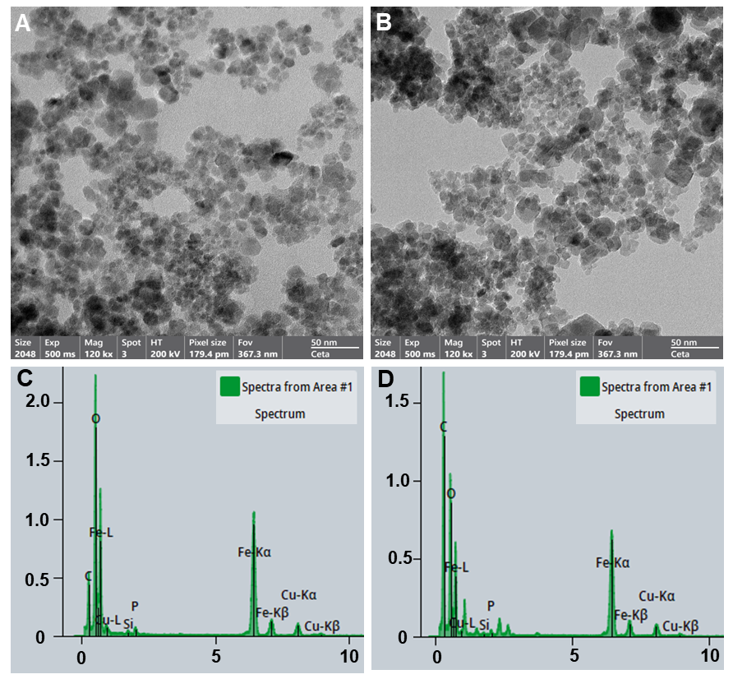
Figure S1. Transmission electron microscopy (TEM) observations and energy-dispersive X-ray spectroscopy (EDS) analyses of collected Fe₂O₃ nanoparticles from the lung tissue homogenates using the proteinase K. Both the (A) pristine particles and (B) particles collected from lung tissue by spiking Fe₂O₃ nanoparticles at 5 μg/20 mg dried lung tissue showed similar morphology. Likewise, the chemical composition of (C) pristine particles was similar to that of (D) collected particles from the lung tissue. Note that the proteinase K tissue digestion process did not influence the physicochemical properties of test particles.

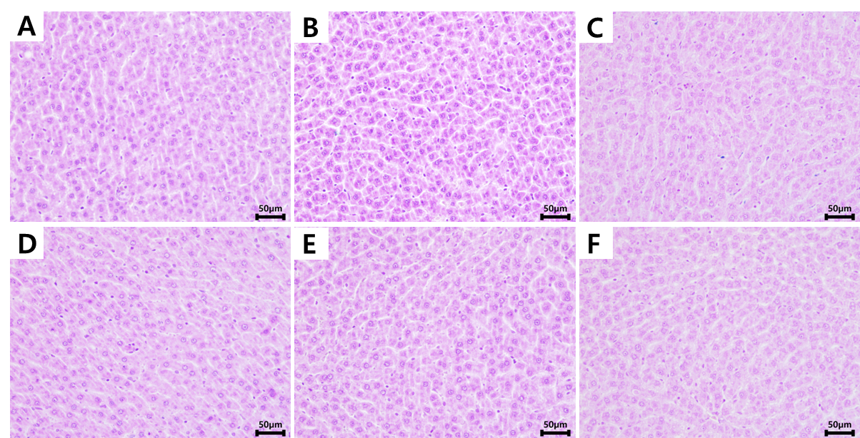
Figure S2. Representative liver sections stained for iron at days 1, 7, and 28 following inhalation exposure to Fe₂O₃ nanoparticles in rats. Only the high-concentration group (4.92 mg/m³) was displayed to show the time-course distribution. Representative liver sections from vehicle control rats at (A) day 1, (B) day 7, and (C) day 28 of the recovery period. (D–F) Liver sections from rats exposed to a high concentration of Fe₂O₃ (4.92 mg/m³) at (D) day 1, (E) day 7, and (F) day 28 of the recovery period. No positive signals were detected in any of the samples, as indicated by the absence of blue staining. Scale bars: 50 μm.

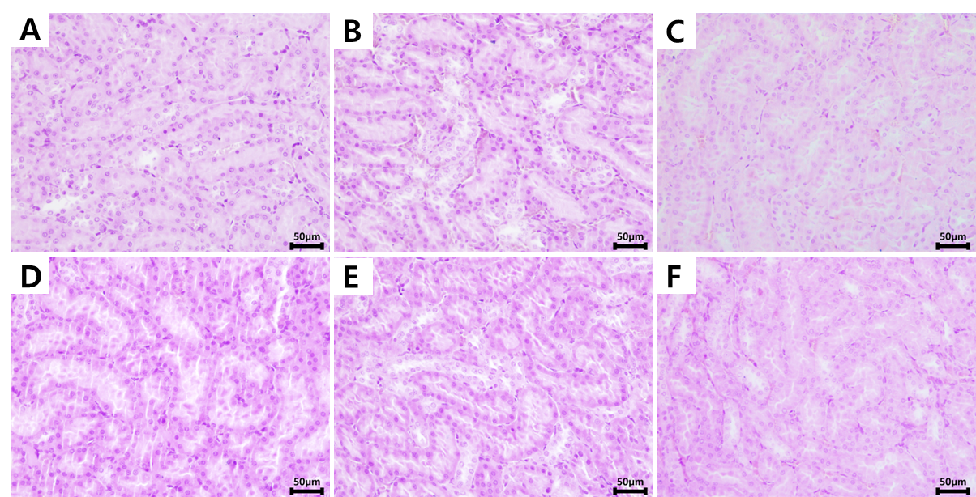
Figure S3. Representative kidney sections stained for iron at days 1, 7, and 28 following inhalation exposure to Fe₂O₃ nanoparticles in rats. Only the high-concentration group (4.92 mg/m³) was displayed to show the time-course distribution. Representative kidney sections from vehicle control rats at (A) day 1, (B) day 7, and (C) day 28 of the recovery period. (D–F) Kidney sections from rats exposed to a high concentration of Fe₂O₃ (4.92 mg/m³) at (D) day 1, (E) day 7, and (F) day 28 of the recovery period. No positive signals were detected in any of the samples, as indicated by the absence of blue staining. Scale bars: 50 μm.

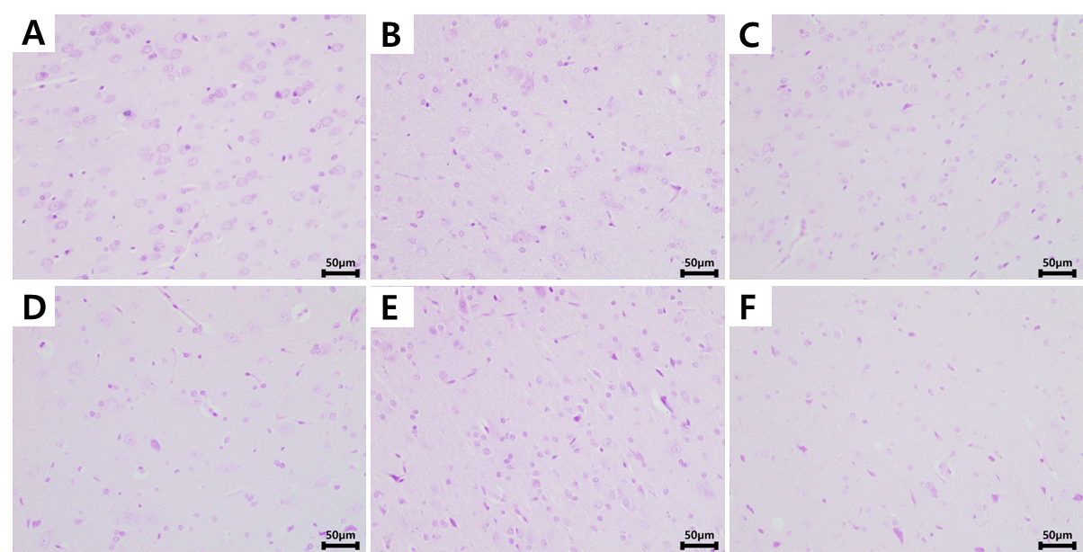
Figure S4. Representative brain sections stained for iron at days 1, 7, and 28 following inhalation exposure to Fe₂O₃ nanoparticles in rats. Only the high-concentration group (4.92 mg/m³) was displayed to show the time-course distribution. Representative brain sections from vehicle control rats at (A) day 1, (B) day 7, and (C) day 28 of the recovery period. (D–F) Brain sections from rats exposed to a high concentration of Fe₂O₃ (4.92 mg/m³) at (D) day 1, (E) day 7, and (F) day 28 of the recovery period. No positive signals were detected in any of the samples, as indicated by the absence of blue staining. Scale bars: 50 μm.

Figure S5. Lung iron burden normalized to dried right lung lobes during the recovery period following 28-day repeated inhalation exposure to Fe₂O₃ nanoparticles. (A) Total Fe levels (particulates + ions) per dried right lung lobes (μg/g). (B) Particulate Fe levels per dried right lung lobes (μg/g). (C) Ionized Fe levels per dried right lung lobes (μg/g). (D) Ionized Fe fraction (%) relative to particulate Fe in the right lung lobes. Data are presented as mean ± SEM (n = 4 per group).

Table S1. Physicochemical properties of Fe₂O₃ nanoparticles.
Parameters | Information
Formula | Fe₂O₃
CAS number | 1309-37-1
Product number | NG04SO1404
Lot number | NGPD20220722-3
Appearance | Brown red powder
Purity | 99.01%
Purity by EDS analysis* | 97.04%
Crystal structure | Gamma iron
Metal impurities
- Al | 0.003%
- Si | 0.001%
- Mg | 0.0007%
- Ti | 0.003%
- Cu | 0.0003%
Primary size (nm)* | 16.89 ± 7.68
Hydrodynamic size in DW (nm)* | 733 ± 130
Polydispersity index in DW* | 0.25 ± 0.07
Zeta potential* | -19.5 ± 0.5
*The analyses of purity by EDS, primary size, hydrodynamic size, and zeta potential were performed by the authors, while the manufacturer provided the remaining data.

Table S2. Absolute and relative organ weight of rats in the recovery period of the 28-day repeated inhalation toxicity study.
Organs | Control | Low  (0.56 mg/m³) | Medium  (1.63 mg/m³) | High  (4.92 mg/m³)
On day 7 of the recovery period
Body weight | 358 ± 11.5 | 350 ± 9.80 | 368 ± 14.2 | 365 ± 16.5
Absolute weight (gram)
- Spleen | 0.39 ± 0.02 | 0.37 ± 0.02 | 0.46 ± 0.03 | 0.47 ± 0.05
- Liver | 6.64 ± 0.29 | 6.80 ± 0.25 | 7.21 ± 0.31 | 7.03 ± 0.47
- Kidney (left) | 1.25 ± 0.06 | 1.22 ± 0.05 | 1.28 ± 0.05 | 1.34 ± 0.09
- Lung (right lobes) | 0.86 ± 0.02 | 0.86 ± 0.04 | 0.94 ± 0.03 | 0.97 ± 0.03
- Brain | 1.00 ± 0.03 | 1.02 ± 0.02 | 0.96 ± 0.04 | 1.00 ± 0.06
Relative weight versus body weight (i.e., organ weight×100/body weight)
- Spleen | 0.11 ± 0.01 | 0.11 ± 0.01 | 0.13 ± 0.01 | 0.13 ± 0.01
- Liver | 1.85 ± 0.03 | 1.93 ± 0.08 | 1.96 ± 0.03 | 1.92 ± 0.04
- Kidney (left) | 0.35 ± 0.01 | 0.35 ± 0.02 | 0.35 ± 0.00 | 0.37 ± 0.02
- Lung (right lobes) | 0.24 ± 0.00 | 0.24 ± 0.01 | 0.26 ± 0.01 | 0.27 ± 0.01
- Brain | 0.28 ± 0.01 | 0.29 ± 0.01 | 0.26 ± 0.01 | 0.28 ± 0.03
On day 28 of the recovery period
Body weight | 415 ± 11.2 | 425 ± 11.7 | 420 ± 10.8 | 413 ± 2.65
Absolute weight (gram)
- Spleen | 0.44 ± 0.02 | 0.39 ± 0.03 | 0.40 ± 0.03 | 0.41 ± 0.02
- Liver | 7.62 ± 0.26 | 8.25 ± 0.56 | 7.63 ± 0.24 | 7.24 ± 0.11
- Kidney (left) | 1.33 ± 0.05 | 1.33 ± 0.08 | 1.30 ± 0.04 | 1.27 ± 0.05
- Lung (right lobes) | 0.97 ± 0.03 | 0.98 ± 0.05 | 0.96 ± 0.03 | 0.91 ± 0.03
- Brain | 1.00 ± 0.05 | 1.01 ± 0.03 | 1.00 ± 0.003 | 1.02 ± 0.01
Relative weight versus body weight (i.e., organ weight×100/body weight)
- Spleen | 0.11 ± 0.01 | 0.09 ± 0.00 | 0.10 ± 0.00 | 0.10 ± 0.00
- Liver | 1.84 ± 0.02 | 1.94 ± 0.01 | 1.82 ± 0.01 | 1.75 ± 0.02
- Kidney (left) | 0.32 ± 0.01 | 0.31 ± 0.01 | 0.31 ± 0.01 | 0.31 ± 0.01
- Lung (right lobes) | 0.23 ± 0.01 | 0.23 ± 0.01 | 0.23 ± 0.01 | 0.22 ± 0.01
- Brain | 0.24 ± 0.01 | 0.24 ± 0.01 | 0.24 ± 0.01 | 0.25 ± 0.00
Data are mean ± SEM (n=5 per group).

Table S3. Hematology on day 7 in the recovery period of the 28-day repeated inhalation toxicity study.
Measurements | Control | Low  (0.56 mg/m³) | Medium  (1.63 mg/m³) | High  (4.92 mg/m³)
White blood cells (10³/μL) | 3.81 ± 0.31 | 6.64 ± 0.39* | 7.03 ± 0.90** | 5.05 ± 0.75
Neutrophils (10³/μL) | 0.66 ± 0.09 | 0.98 ± 0.03 | 0.85 ± 0.12 | 0.77 ± 0.14
Lymphocytes (10³/μL) | 3.00 ± 0.28 | 5.44 ± 0.37 | 5.99 ± 0.77 | 4.10 ± 0.65
Monocytes (10³/μL) | 0.05 ± 0.01 | 0.10 ± 0.00 | 0.08 ± 0.01 | 0.08 ± 0.02
Eosinophils (10³/μL) | 0.07 ± 0.01 | 0.06 ± 0.01 | 0.06 ± 0.01 | 0.07 ± 0.01
Large unstained cells (10³/μL) | 0.03 ± 0.01 | 0.04 ± 0.00 | 0.04 ± 0.01 | 0.03 ± 0.01
Basophils (10³/μL) | 0.00 ± 0.00 | 0.01 ± 0.00 | 0.01 ± 0.00 | 0.00 ± 0.00
Platelets (10³/μL) | 919 ± 28.1 | 1004 ± 31.6 | 1011 ± 49.3 | 947 ± 17.6
Red blood cell count (10³/μL) | 8.71 ± 0.08 | 8.66 ± 0.15 | 8.31 ± 0.21 | 8.24 ± 0.20
Neutrophils (%) | 17.6 ± 2.55 | 14.8 ± 1.47 | 12.1 ± 0.59 | 15.4 ± 2.04
Lymphocytes (%) | 78.6 ± 2.84 | 82.0 ± 1.88 | 85.1 ± 0.59 | 81.1 ± 2.31
Monocytes (%) | 1.28 ± 0.25 | 1.54 ± 0.12 | 1.18 ± 0.10 | 1.64 ± 0.20
Eosinophils (%) | 1.74 ± 0.38 | 0.92 ± 0.33* | 0.92 ± 0.08* | 1.28 ± 0.12
Large unstained cells (%) | 0.70 ± 0.11 | 0.66 ± 0.07 | 0.62 ± 0.10 | 0.52 ± 0.15
Basophils (%) | 0.08 ± 0.04 | 0.12 ± 0.05 | 0.10 ± 0.03 | 0.10 ± 0.03
Hematocrit (%) | 46.8 ± 0.59 | 45.8 ± 0.83 | 42.9 ± 0.38 | 44.6 ± 0.60
Red cell distribution width (%) | 11.3 ± 0.13 | 11.4 ± 0.14 | 11.9 ± 0.27 | 11.5 ± 0.19
Reticulocytes (%) | 2.13 ± 0.18 | 2.13 ± 0.12 | 2.53 ± 0.09 | 2.40 ± 0.60
Hemoglobin concentration (g/dL) | 15.7 ± 0.21 | 15.2 ± 0.25 | 15.0 ± 0.10 | 15.0 ± 0.21
MCHC (g/dL) | 33.6 ± 0.17 | 33.2 ± 0.20 | 33.3 ± 0.17 | 33.6 ± 0.18
Mean corpuscular volume (fL) | 53.7 ± 0.42 | 53.0 ± 0.05 | 54.1 ± 1.08 | 54.3 ± 0.81
Mean platelet volume (fL) | 5.58 ± 0.23 | 5.44 ± 0.08 | 5.94 ± 0.27 | 5.76 ± 0.12
Mean corpuscular hemoglobin (pg/cell) | 18.0 ± 0.16 | 17.6 ± 0.24 | 18.1 ± 0.45 | 18.2 ± 0.36
MCHC, mean corpuscular hemoglobin concentration. Data are mean ± SEM (n=5 per group). *p < 0.05, **p < 0.01 compared with the control group.

Table S4. Hematology on day 28 in the recovery period of the 28-day repeated inhalation toxicity study.
Measurements | Control | Low  (0.56 mg/m³) | Medium  (1.63 mg/m³) | High  (4.92 mg/m³)
White blood cells (10³/μL) | 4.74 ± 0.42 | 3.88 ± 0.40 | 4.04 ± 0.38 | 4.04 ± 0.39
Neutrophils (10³/μL) | 0.80 ± 0.11 | 0.62 ± 0.19 | 0.50 ± 0.18 | 0.50 ± 0.18
Lymphocytes (10³/μL) | 3.73 ± 0.46 | 3.16 ± 0.36 | 3.12 ± 0.20 | 3.12 ± 0.20
Monocytes (10³/μL) | 0.07 ± 0.01 | 0.04 ± 0.01 | 0.05 ± 0.01 | 0.05 ± 0.01
Eosinophils (10³/μL) | 0.04 ± 0.01 | 0.04 ± 0.01 | 0.07 ± 0.01 | 0.07 ± 0.01
Large unstained cells (10³/μL) | 0.04 ± 0.01 | 0.02 ± 0.00 | 0.03 ± 0.01 | 0.03 ± 0.01
Basophils (10³/μL) | 0.00 ± 0.00 | 0.00 ± 0.00 | 0.00 ± 0.00 | 0.00 ± 0.00
Platelets (10³/μL) | 1062 ± 33.1 | 917 ± 38.2 | 972 ± 16.1 | 972 ± 16.1*
Red blood cell count (10³/μL) | 8.89 ± 0.19 | 8.78 ± 0.06 | 8.87 ± 0.05 | 8.87 ± 0.05
Neutrophils (%) | 18.5 ± 3.62 | 15.8 ± 2.20 | 17.6 ± 3.88 | 17.6 ± 3.88
Lymphocytes (%) | 78.1 ± 3.63 | 82.0 ± 2.45 | 78.7 ± 3.98 | 78.7 ± 3.98
Monocytes (%) | 1.46 ± 0.12 | 1.54 ± 0.19 | 1.80 ± 0.14 | 1.80 ± 0.14
Eosinophils (%) | 1.06 ± 0.19 | 1.16 ± 0.07 | 1.50 ± 0.11 | 1.50 ± 0.11
Large unstained cells (%) | 0.88 ± 0.16 | 0.54 ± 0.06 | 0.80 ± 0.06 | 0.80 ± 0.06
Basophils (%) | 0.10 ± 0.00 | 0.20 ± 0.03 | 0.16 ± 0.04 | 0.16 ± 0.04
Hematocrit (%) | 47.0 ± 0.82 | 47.3 ± 0.56 | 47.7 ± 0.84 | 47.7 ± 0.84
Red cell distribution width (%) | 12.9 ± 0.27 | 12.9 ± 0.05 | 12.6 ± 0.16 | 12.6 ± 0.16
Reticulocytes (%) | 1.88 ± 0.03 | 1.94 ± 0.06 | 1.82 ± 0.07 | 1.82 ± 0.07
Hemoglobin concentration (g/dL) | 15.9 ± 0.23 | 15.8 ± 0.23 | 15.8 ± 0.27 | 15.8 ± 0.27
MCHC (g/dL) | 33.8 ± 0.18 | 33.6 ± 0.17 | 33.3 ± 0.11* | 33.3 ± 0.11*
Mean corpuscular volume (fL) | 53.0 ± 0.27 | 53.1 ± 0.64 | 52.9 ± 0.59 | 52.9 ± 0.59
Mean platelet volume (fL) | 6.72 ± 0.09 | 6.86 ± 0.16 | 6.78 ± 0.12 | 6.78 ± 0.12
Mean corpuscular hemoglobin (pg/cell) | 17.7 ± 0.19 | 18.1 ± 0.28 | 17.7 ± 0.21 | 17.7 ± 0.21
MCHC, mean corpuscular hemoglobin concentration. Data are mean ± SEM (n=5 per group). *p < 0.05 compared with the control group.

Table S5. Serum biochemistry on day 7 in the recovery period of the 28-day repeated inhalation toxicity study.
Measurements | Control | Low  (0.56 mg/m³) | Medium  (1.63 mg/m³) | High  (4.92 mg/m³)
Albumin (g/dL) | 2.26 ± 0.04 | 2.26 ± 0.02 | 2.18 ± 0.04 | 2.12 ± 0.02
Total protein (g/dL) | 5.44 ± 0.08 | 5.64 ± 0.05 | 5.52 ± 0.09 | 5.38 ± 0.08
Calcium (mg/dL) | 9.40 ± 0.09 | 9.40 ± 0.05 | 9.46 ± 0.02 | 9.32 ± 0.12
Total cholesterol (mg/dL) | 62.2 ± 2.01 | 69.4 ± 3.33 | 66.2 ± 4.74 | 67.6 ± 3.67
Creatinine (mg/dL) | 0.58 ± 0.03 | 0.56 ± 0.02 | 0.60 ± 0.02 | 0.56 ± 0.02
Glucose (mg/dL) | 140 ± 5.77 | 135 ± 6.79 | 141 ± 5.59 | 133 ± 6.61
Aspartate aminotransferase (mg/dL) | 137 ± 8.13 | 140 ± 15.8 | 132 ± 7.39 | 136 ± 9.24
Inorganic phosphorus (mg/dL) | 7.24 ± 0.41 | 7.96 ± 0.14 | 7.76 ± 0.08 | 8.02 ± 0.27
Magnesium (mg/dL) | 1.90 ± 0.05 | 2.00 ± 0.05 | 2.06 ± 0.06 | 1.96 ± 0.02
Uric acid (mg/dL) | 1.14 ± 0.07 | 1.16 ± 0.08 | 1.20 ± 0.08 | 1.18 ± 0.12
Blood urea nitrogen (mg/dL) | 18.0 ± 1.47 | 15.8 ± 0.43 | 18.8 ± 0.97 | 15.0 ± 0.70
Total bilirubin (mg/dL) | 0.00 ± 0.00 | 0.01 ± 0.00 | 0.00 ± 0.00 | 0.00 ± 0.00
Triglyceride (mg/dL) | 47.2 ± 3.23 | 61.6 ± 15.2 | 59.6 ± 7.98 | 56.4 ± 12.5
Alkaline phosphatase (IU/L) | 345 ± 19.0 | 397 ± 28.4 | 343 ± 27.6 | 387 ± 21.4
Gamma-glutamyl transferase (IU/L) | 0.20 ± 0.20 | 0.60 ± 0.24 | 0.40 ± 0.24 | 0.00 ± 0.00
Alanine aminotransferase (IU/L) | 33.2 ± 0.80 | 39.2 ± 1.77 | 35.2 ± 0.66 | 32.6 ± 1.78
Lactate dehydrogenase (IU/L) | 1699 ± 298 | 2143 ± 418 | 1871 ± 162 | 1916 ± 219
Creatine phosphokinase (IU/L) | 1817 ± 331 | 1815 ± 235 | 1748 ± 101 | 1570 ± 174
Sodium (mmol/L) | 142 ± 0.20 | 142 ± 0.20 | 142 ± 0.20 | 142 ± 0.40
Potassium (mmol/L) | 4.72 ± 0.11 | 4.86 ± 0.05 | 4.88 ± 0.07 | 4.84 ± 0.07
Chloride (mmol/L) | 106 ± 0.68 | 105 ± 1.17 | 103 ± 0.37 | 102 ± 0.37
Albumin/Globulin ratio | 0.71 ± 0.01 | 0.68 ± 0.01 | 0.66 ± 0.02 | 0.65 ± 0.02
Data are mean ± SEM (n=5 per group).

Table S6. Serum biochemistry on day 28 in the recovery period of the 28-day repeated inhalation toxicity study.
Measurements | Control | Low  (0.56 mg/m³) | Medium  (1.63 mg/m³) | High  (4.92 mg/m³)
Albumin (g/dL) | 2.20 ± 0.03 | 2.20 ± 0.00 | 2.14 ± 0.02 | 2.20 ± 0.04
Total protein (g/dL) | 5.80 ± 0.09 | 5.70 ± 0.08 | 5.68 ± 0.06 | 5.62 ± 0.09
Calcium (mg/dL) | 9.42 ± 0.11 | 9.10 ± 0.09 | 9.08 ± 0.12 | 9.02 ± 0.11
Total cholesterol (mg/dL) | 83.0 ± 6.07 | 73.4 ± 5.54 | 71.8 ± 2.22 | 69.4 ± 4.37
Creatinine (mg/dL) | 0.60 ± 0.02 | 0.57 ± 0.03 | 0.60 ± 0.01 | 0.60 ± 0.02
Glucose (mg/dL) | 140 ± 8.98 | 144 ± 5.13 | 129 ± 2.36 | 129 ± 7.92
Aspartate aminotransferase (mg/dL) | 133 ± 13.1 | 165 ± 15.3 | 137 ± 11.4 | 139 ± 9.21
Inorganic phosphorus (mg/dL) | 7.40 ± 0.19 | 7.36 ± 0.15 | 7.40 ± 0.09 | 7.30 ± 0.27
Magnesium (mg/dL) | 1.88 ± 0.06 | 2.00 ± 0.04 | 1.90 ± 0.05 | 1.94 ± 0.07
Uric acid (mg/dL) | 1.38 ± 0.09 | 1.30 ± 0.03 | 1.26 ± 0.08 | 1.20 ± 0.09
Blood urea nitrogen (mg/dL) | 16.4 ± 0.41 | 16.5 ± 1.37 | 17.0 ± 0.59 | 17.7 ± 0.51
Total bilirubin (mg/dL) | 0.00 ± 0.00 | 0.01 ± 0.01 | 0.00 ± 0.00 | 0.00 ± 0.00
Triglyceride (mg/dL) | 63.2 ± 11.3 | 50.4 ± 3.16 | 47.8 ± 5.56 | 45.6 ± 4.04
Alkaline phosphatase (IU/L) | 366 ± 18.1 | 367 ± 38.1 | 374 ± 20.3 | 345 ± 44.6
Gamma-glutamyl transferase (IU/L) | 0.80 ± 0.37 | 1.20 ± 0.20 | 1.00 ± 0.32 | 0.40 ± 0.40
Alanine aminotransferase (IU/L) | 38.0 ± 5.09 | 47.6 ± 7.49 | 36.4 ± 1.36 | 33.6 ± 2.94
Lactate dehydrogenase (IU/L) | 2701 ± 177 | 2454 ± 133 | 2254 ± 248 | 2313 ± 259
Creatine phosphokinase (IU/L) | 2302 ± 196 | 1930 ± 240 | 1784 ± 193 | 1866 ± 229
Sodium (mmol/L) | 143 ± 0.24 | 143 ± 0.37 | 143 ± 0.40 | 143 ± 0.40
Potassium (mmol/L) | 5.10 ± 0.06 | 5.04 ± 0.07 | 4.96 ± 0.05 | 4.94 ± 0.17
Chloride (mmol/L) | 102 ± 0.37 | 102 ± 0.32 | 102 ± 0.37 | 102 ± 0.51
Albumin/Globulin ratio | 0.60 ± 0.02 | 0.63 ± 0.02 | 0.61 ± 0.01 | 0.64 ± 0.02
Data are mean ± SEM (n=5 per group).

Table S7. Histological analysis of male rats on day 7 in the recovery period of the 28-day repeated inhalation toxicity study of Fe₂O₃.
Group | Vehicle control | High concentration  (4.92 mg/m³)
Liver
Vacuolation | 2/5 (1.0) | 1/5 (1.0)
Inflammatory cell foci | 2/5 (1.0) | 3/5 (1.3)
Kidney
Basophilia, tubular | 3/5 (1.3) | 1/5 (2.0)
Tubular dilatation | 1/5 (1.0) | 0/5 (0.0)
Hyaline droplet | 2/5 (2.0) | 1/5 (2.0)
Lung
Inflammatory cell foci | 0/5 (0.0) | 1/5 (1.0)
Peribronchial inflammation | 0/5 (0.0) | 0/5 (0.0)
Alveolar histiocytosis | 0/5 (0.0) | 1/5 (1.0)
Numbers in parentheses next to the incidence indicate the mean severity score among affected animals (minimal = 1, mild = 2, moderate = 3, severe = 4).

Table S8. Histological analysis of male rats on day 28 in the recovery period of the 28-day repeated inhalation toxicity study of Fe₂O₃.
Group | Vehicle control | High concentration  (4.92 mg/m³)
Liver
Inflammatory cell foci | 1/5 (1.0) | 2/5 (1.0)
Kidney
Hyaline droplet | 1/5 (2.0) | 0/5 (0.0)
Lung
Alveolar histiocytosis | 3/5 (2.0) | 2/5 (1.5)
Numbers in parentheses next to the incidence indicate the mean severity score among affected animals (minimal = 1, mild = 2, moderate = 3, severe = 4).

