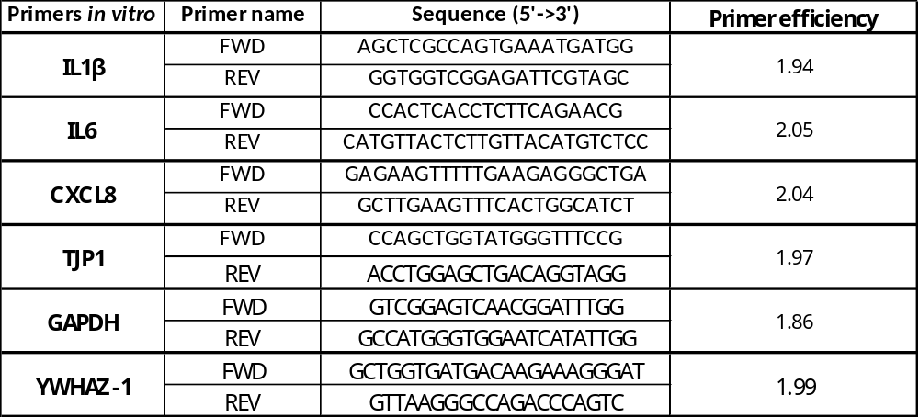
Table S1. Primer sequences for in vitro qRT-PCR
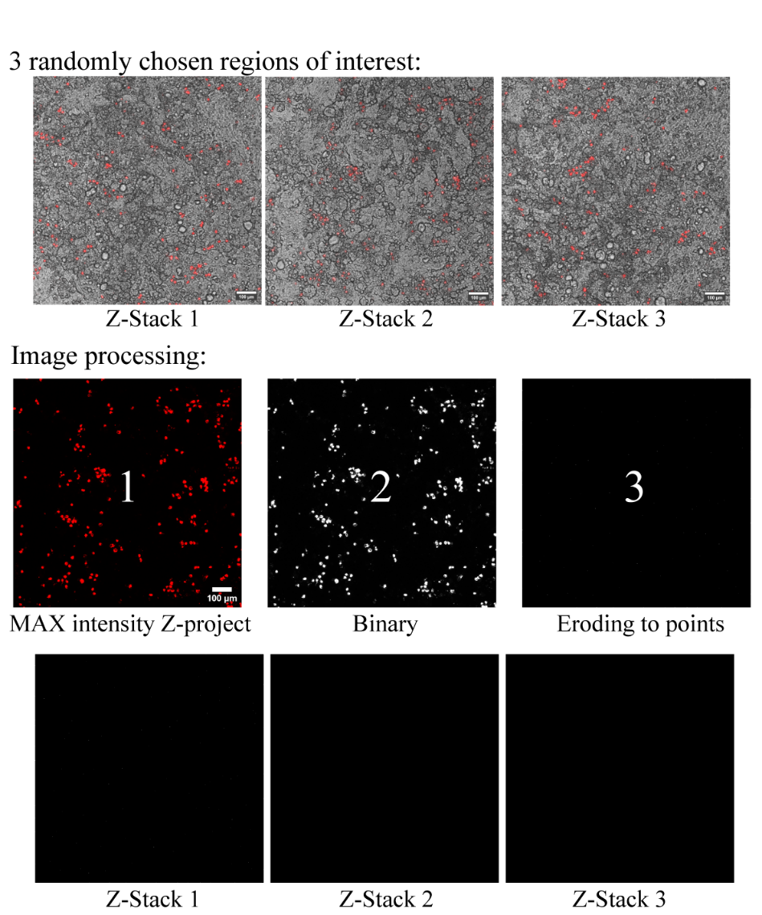
Figure S1. MDMs count and image processing operations
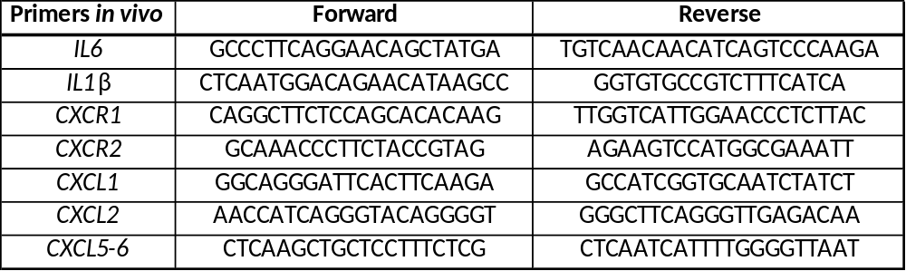
Table S2. Primer sequences for in vivo qRT-PCR
IL-8 | in vivo-in vitro low | in vivo-in vitro high
IL-8 | Mean | Mean
IL-8 | 0.499 | 0.260
IL-1β | in vivo-in vitro low | in vivo-in vitro high
IL-1β | Mean | Mean
IL-1β | 0.495 | 0.121
IL-6 | in vivo-in vitro low | in vivo-in vitro high
IL-6 | Mean | Mean
IL-6 | 0.037 | 0.109
Table S3. The Spearman correlation coefficient between all data points for in vivo and in vitro low or in vitro high dose. Data are represented as mean values.
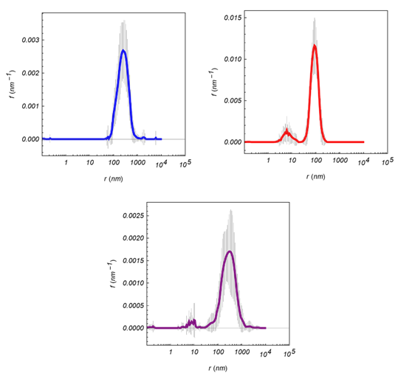
Figure S2. DLS measurements of DQ12 size – Measurements are performed in MiliQ water (blue) and complete cell culture media (purple). Results for just cell culture media without particles are presented in red. No apparent aggregation was present.
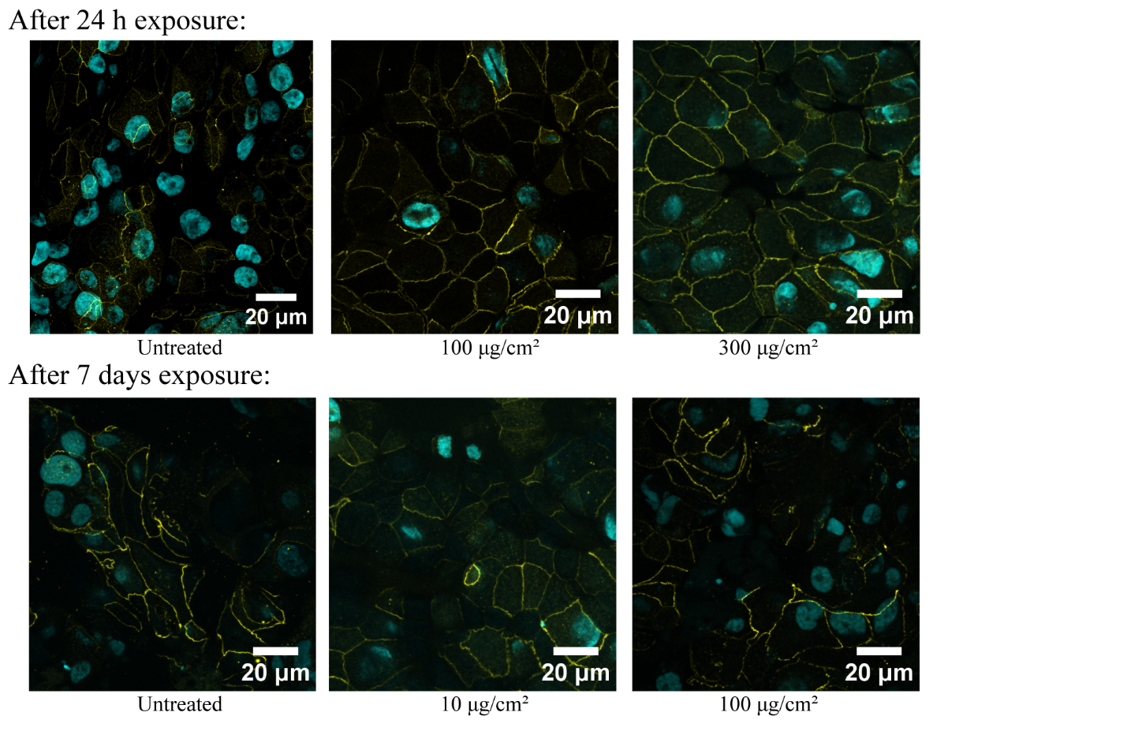
Figure S3. Presence of tight junctions – ZO-1 staining (yellow), cell nuclei (cyan). Image processing was done with the ImageJ software (version 1.54). Channels for ZO-1 and DAPI were merged. Z-projection of 5 to 15 upper images in the stacks (ZO-1 only visible at the surface) with standard deviation projection type was performed. Afterward, noise reduction with a despeckle option and the addition of the scale bar were performed.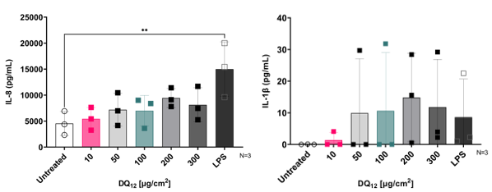
Figure S4. Inflammatory cytokine secretion was measured by ELISA assay from the supernatant of the apical side of the insert after 24h of exposure.
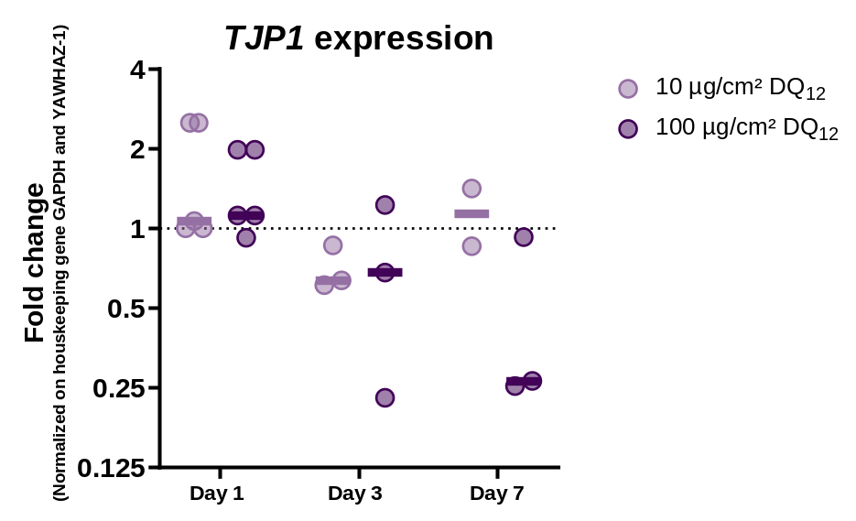
Figure S5. Tight junction protein 1 gene expression was measured over one week for the doses of 10 µg/cm² and 100 µg/cm² of DQ₁₂. The dotted line represents the untreated condition, and the results are represented as a fold change.
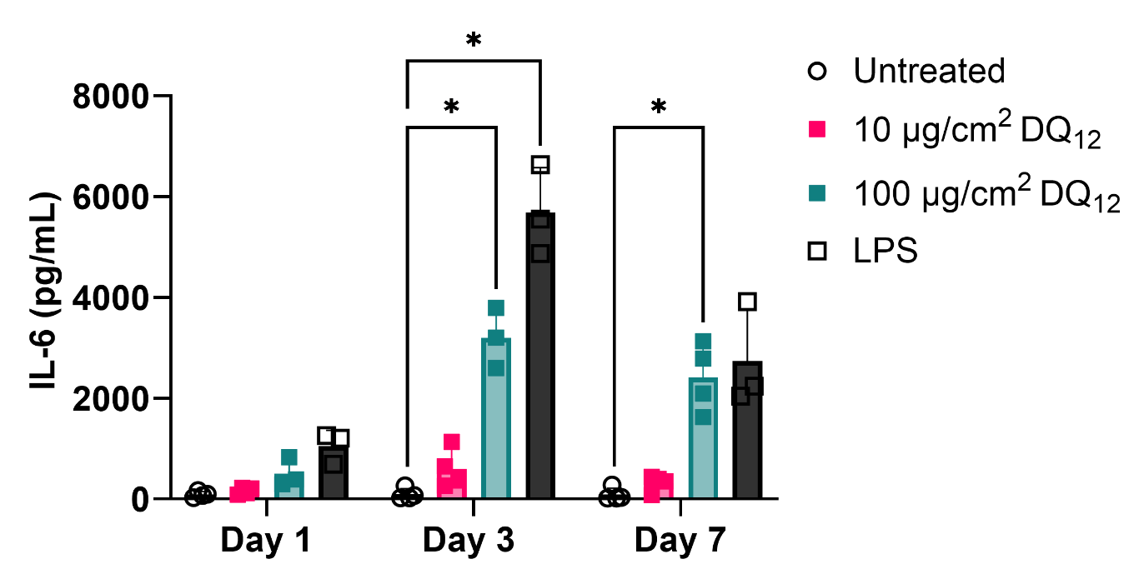
Figure S6. Inflammatory cytokine IL-6 secretion was measured by ELISA assay from the supernatant of the apical side of the insert after 7 days of exposure.

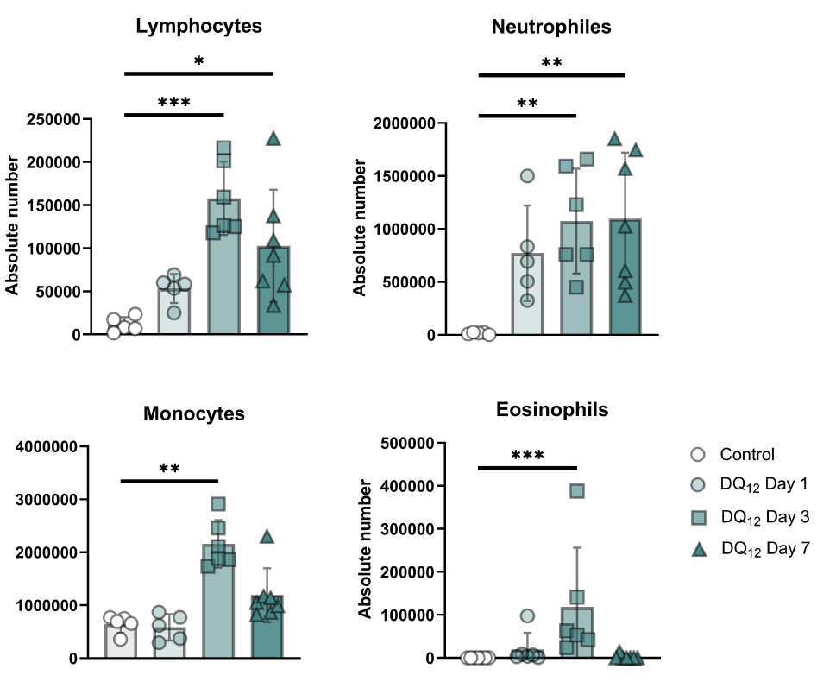
Figure S7. Differential counts of each cell type were counted in BALF at different time points post-DQ₁₂ administration in rats. Rats were administered 8 mg/kg of DQ₁₂ via oropharyngeal aspiration in two doses of 200 µl of dH₂O, and BALF was collected 24 hours, 3 days, and 7 days post-administration. Control rats received 400 µl of dH₂O via oropharyngeal aspiration.
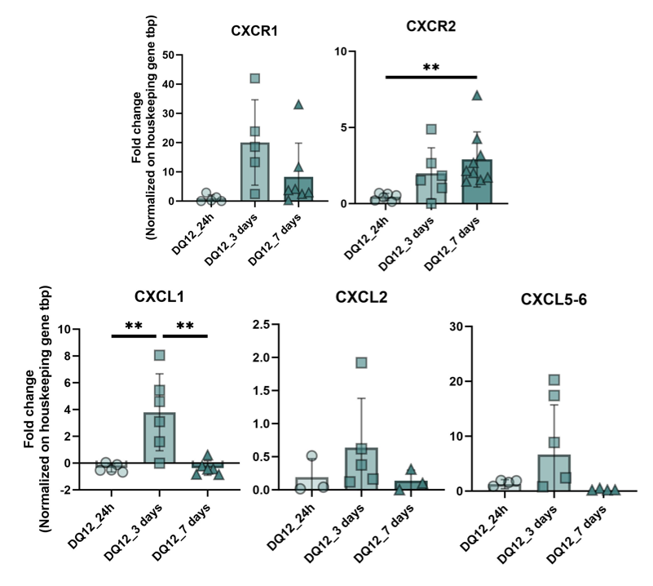
Figure S8. Gene expression of other IL-8 homologs (CXCL1,2 and 5-6) and IL-8 receptors (CXCR1-2) at 1, 3 and 7 days post-DQ₁₂ exposure in rats. Rats were administered 8 mg/kg of DQ₁₂ via oropharyngeal aspiration in two doses of 200 µl of dH₂O, and BALF was collected 24 hours, 3 days, and 7 days post-administration. Control rats received 400 µl of dH₂O via oropharyngeal aspiration.

