Supplementary Material for:
Surface-Driven Endocrine Activity of Nanoplastics: Polymer- and Size-Dependent Estrogen and Androgen Receptors Modulation without Steroidogenesis Perturbation
Nikolina Peranić,ª Lucija Božičević,ª Nikolina Kalčec,ª Korinna Altmann,^{b} Jana Hildebrandt,^{b} Carlos Cuestas Ayllon,^{c} Raquel Portela,^{d} Jesús M de la Fuente,^{c} Miguel A. Bañares,^{d} Ivana Vinković Vrček ^{a,e}

a Institute for Medical Research and Occupational Health, Ksaverska cesta 2, 10000 Zagreb, Croatia
b Bundesanstalt für Materialforschung und prüfung, Unter den Eichen 87, 12205 Berlin, Germany
c Instituto de Nanociencia y Materiales de Aragón, CSIC-Universidad de Zaragoza and CIBER-BBN, c/Pedro Cerbuna s/n, 50009 Zaragoza, Spain
d Institute for Catalysis and Petrochemistry, CSIC, C. de Marie Curie 2, E 28049, Cantoblanco, Madrid, Spain
e University of Rijeka, Faculty of Medicine, Braće Branchetta 20, Rijeka, Croatia

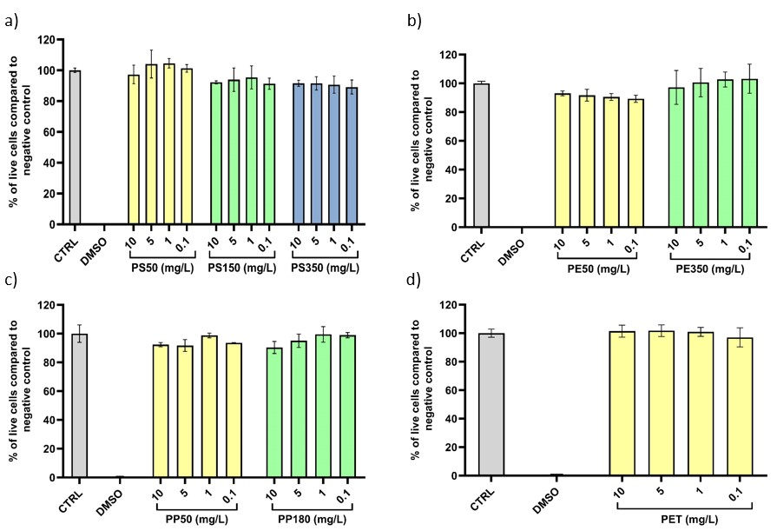
Figure S1. Cell viability for AR-EcoScreen GR KO M1 cell line treated with 10, 5, 1 and 0.1 mg/L of: a) PS50, PS150, PS350, b) PE50, PE350, c) PP50, PP180 and d) PET. Cells treated with 10% DMSO were used as positive control (DMSO) and non-treated cells were used as negative control (CTRL). Results are expressed as mean value of replicates from two experiments and standard deviations are given as error bars.

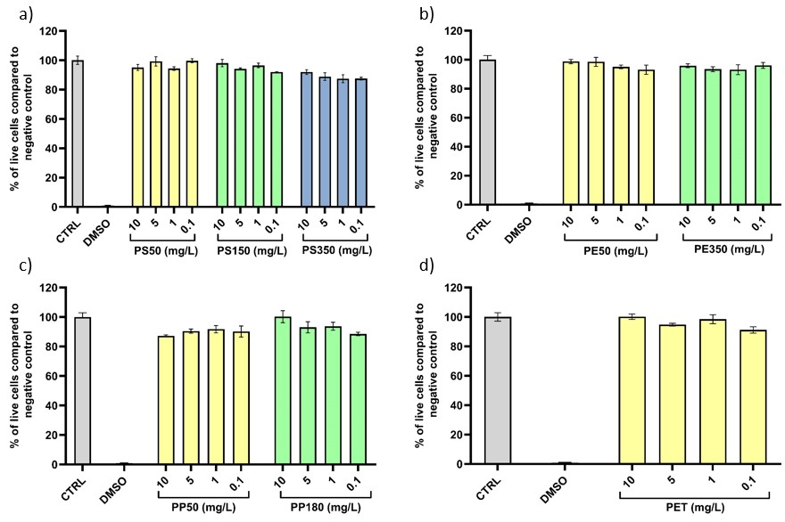
Figure S2. Cell viability for HeLa-9903 cell line treated with 10, 5, 1 and 0.1 mg/L of: a) PS50, PS150, PS350, b) PE50, PE350, c) PP50, PP180 and d) PET. Cells treated with 10% DMSO were used as positive control (DMSO) and non-treated cells were used as negative control (CTRL). Results are expressed as mean value of replicates from two experiments and standard deviations are given as error bars.

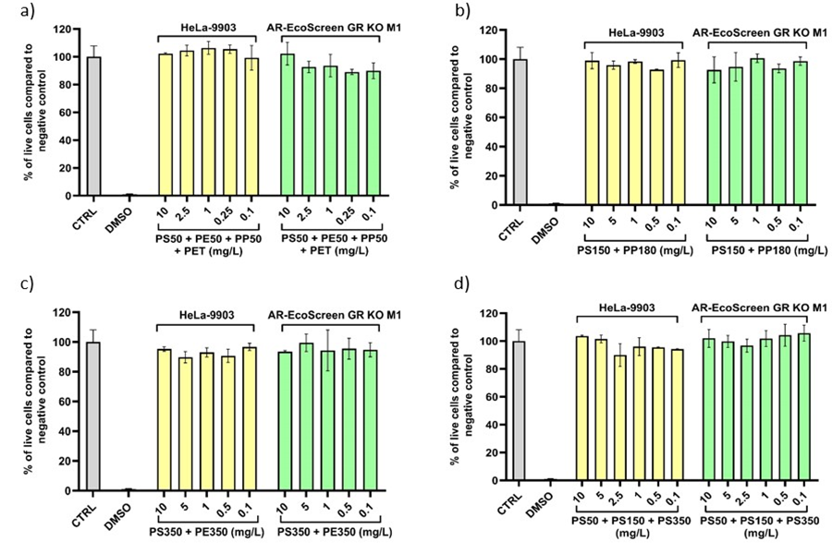
Figure S3. Cell viability for AR-EcoScreen GR KO M1 and HeLa-9903 cell lines treated with: a) 10, 2.5, 1, 0.25 and 0.1 mg/L of PS50, PE50, PP50 and PET, b) 10, 5, 1, 0.5, 0.1 mg/L of PS150 and PP180, c) 10, 5, 1, 0.5, 0.1 mg/L of PS350 and PE350, d) 10, 5, 2.5, 1, 0.5, 0.1 mg/L PS50, P150 and PS350. Mixtures were prepared by combining each nanoparticle type in the same concentration. Cells treated with 10% DMSO were used as positive control (DMSO) and non-treated cells were used as positive control (CTRL). Results are expressed as mean value of replicates from two experiments and standard deviations are given as error bars.

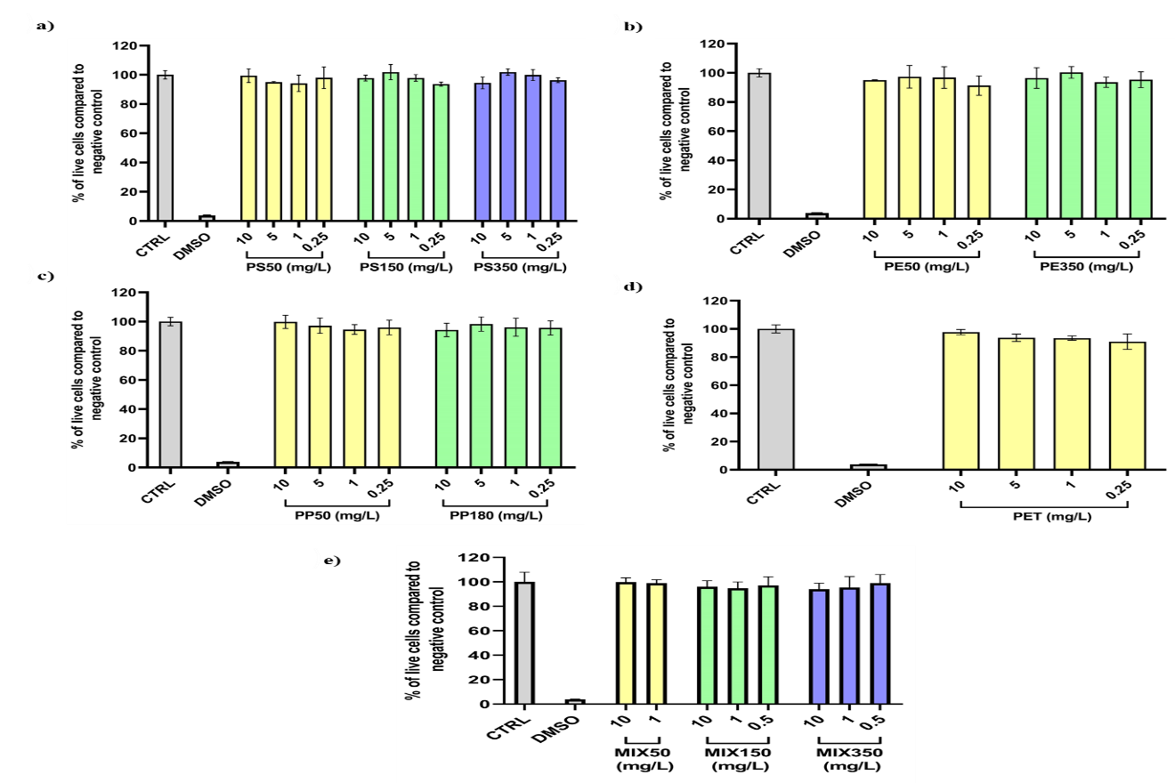
Figure S4. Cell viability for NCI-H295R cell line treated with: 10, 5, 1 and 0.1 mg/L of a) PS50, PS150, PS350; b) PE50, PE350; c) PP50, PP180; d) PET; e) 10, 1 mg/L of PS50, PE50, PP50 and PET; 10, 1, 0.5 mg/L of PS150 and PP180; 10, 1, 0.5 mg/L of PS350 and PE350. Mixtures were prepared by combining each nanoparticle type in the same concentration. Cells treated with 10% DMSO were used as positive control (DMSO) and non-treated cells were used as positive control (CTRL). Results are expressed as mean value of replicates from two experiments and standard deviations are given as error bars.

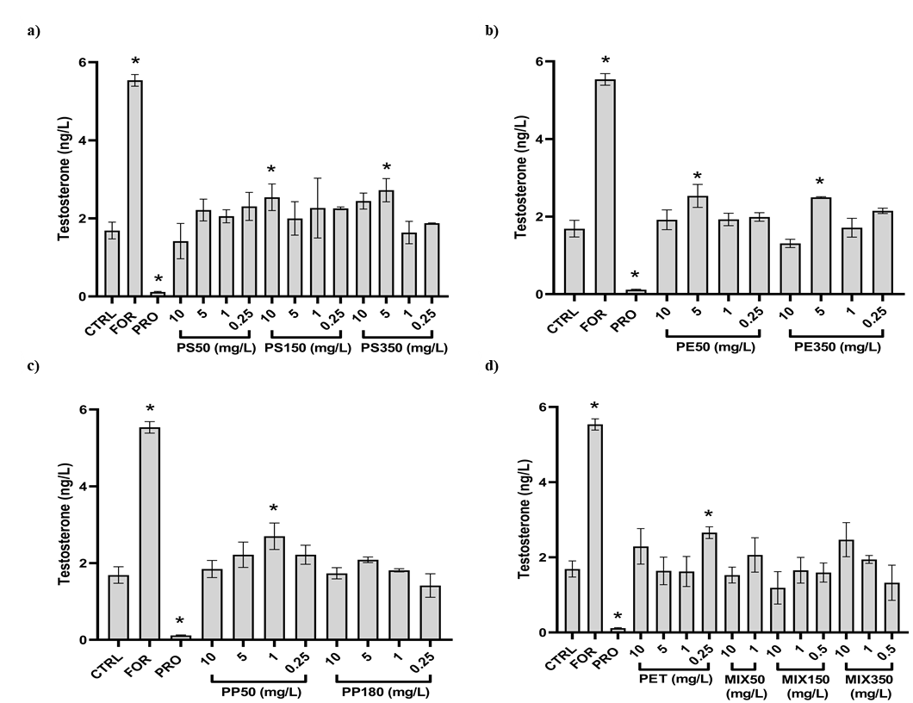
Figure S5. Testosterone concentration in NCI-H295R culture media upon exposure to: a) 10, 5, 1 and 0.25 mg/L of PSNP 50 nm, PSNP 150 nm, PSNP 350 nm; b) 10, 5, 1 and 0.25 mg/L PENP 50 nm, PENP 350 nm; c) 10, 5, 1 and 0.25 mg/L PPNP 50 nm, PPNP 180 nm and d) 10, 5, 1, 0.25 mg/L PET, 10 and 1 mg/L MIX50, 10, 1 and 0,5 mg/L MIX150, 10 and 1 mg/L MIX350. Results are expressed as a mean value of triplicates from two individual experiments. Statistically significant changes (* p < 0.05) relative to the negative control were calculated with one-way ANOVA and Dunnett’s multiple comparisons test in GraphPad Prism.
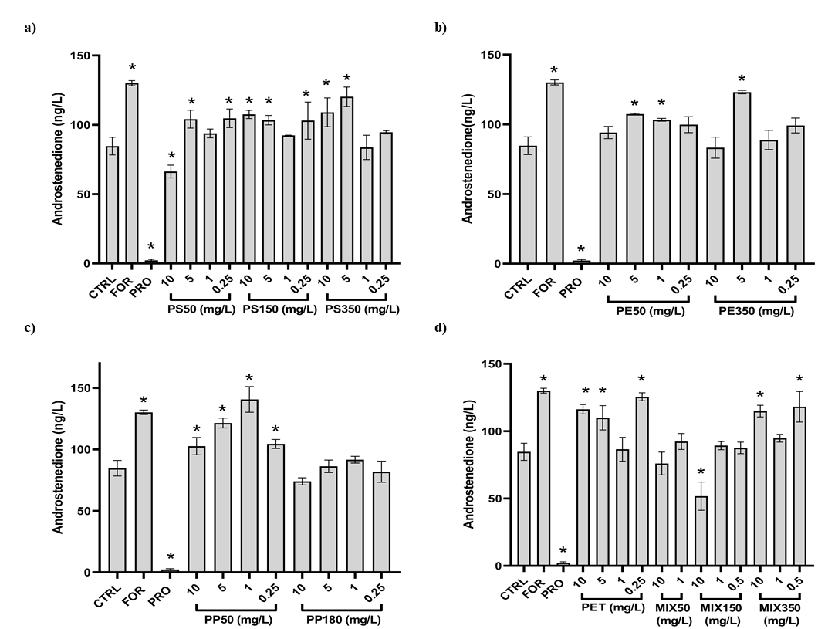
Figure S6. Androstenedione concentration in NCI-H295R culture media upon exposure to: a) 10, 5, 1 and 0.25 mg/L of PSNP 50 nm, PSNP 150 nm, PSNP 350 nm; b) 10, 5, 1 and 0.25 mg/L PENP 50 nm, PENP 350 nm; c) 10, 5, 1 and 0.25 mg/L PPNP 50 nm, PPNP 180 nm and d) 10, 5, 1, 0.25 mg/L PET, 10 and 1 mg/L MIX50, 10, 1 and 0,5 mg/L MIX150, 10 and 1 mg/L MIX350. Results are expressed as a mean value of triplicates from two individual experiments. Statistically significant changes (* p < 0.05) relative to the negative control were calculated with one-way ANOVA and Dunnett’s multiple comparisons test in GraphPad Prism.

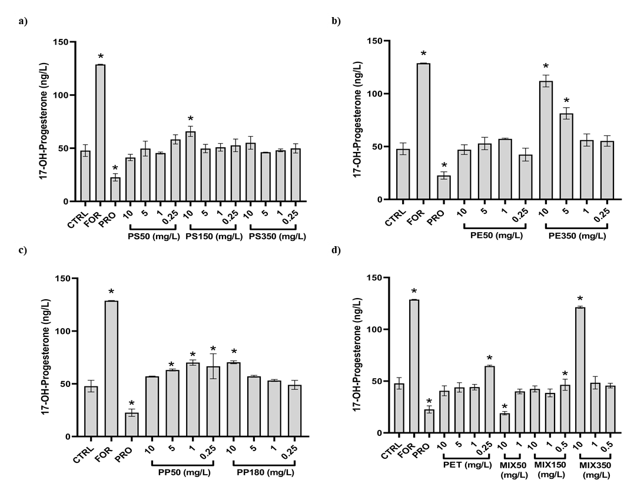
Figure S7. 17-OH-Progesterone concentration in NCI-H295R culture media upon exposure to: a) 10, 5, 1 and 0.25 mg/L of PSNP 50 nm, PSNP 150 nm, PSNP 350 nm; b) 10, 5, 1 and 0.25 mg/L PENP 50 nm, PENP 350 nm; c) 10, 5, 1 and 0.25 mg/L PPNP 50 nm, PPNP 180 nm and d) 10, 5, 1, 0.25 mg/L PET, 10 and 1 mg/L MIX50, 10, 1 and 0,5 mg/L MIX150, 10 and 1 mg/L MIX350. Results are expressed as a mean value of triplicates from two individual experiments. Statistically significant changes (* p < 0.05) relative to the negative control were calculated with one-way ANOVA and Dunnett’s multiple comparisons test in GraphPad Prism.
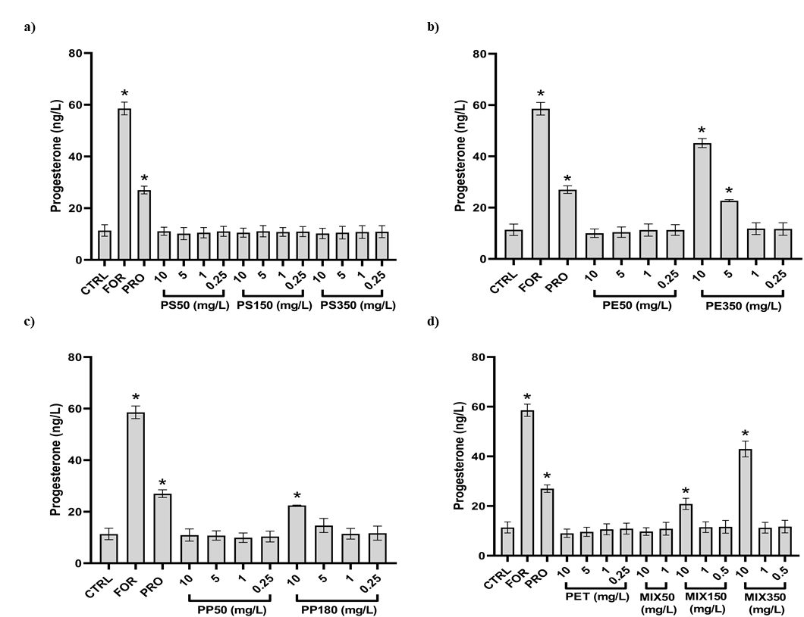
Figure S8. Progesterone concentration in NCI-H295R culture media upon exposure to: a) 10, 5, 1 and 0.25 mg/L of PSNP 50 nm, PSNP 150 nm, PSNP 350 nm; b) 10, 5, 1 and 0.25 mg/L PENP 50 nm, PENP 350 nm; c) 10, 5, 1 and 0.25 mg/L PPNP 50 nm, PPNP 180 nm and d) 10, 5, 1, 0.25 mg/L PET, 10 and 1 mg/L MIX50, 10, 1 and 0,5 mg/L MIX150, 10 and 1 mg/L MIX350. Results are expressed as a mean value of triplicates from two individual experiments. Statistically significant changes (* p < 0.05) relative to the negative control were calculated with one-way ANOVA and Dunnett’s multiple comparisons test in GraphPad Prism.

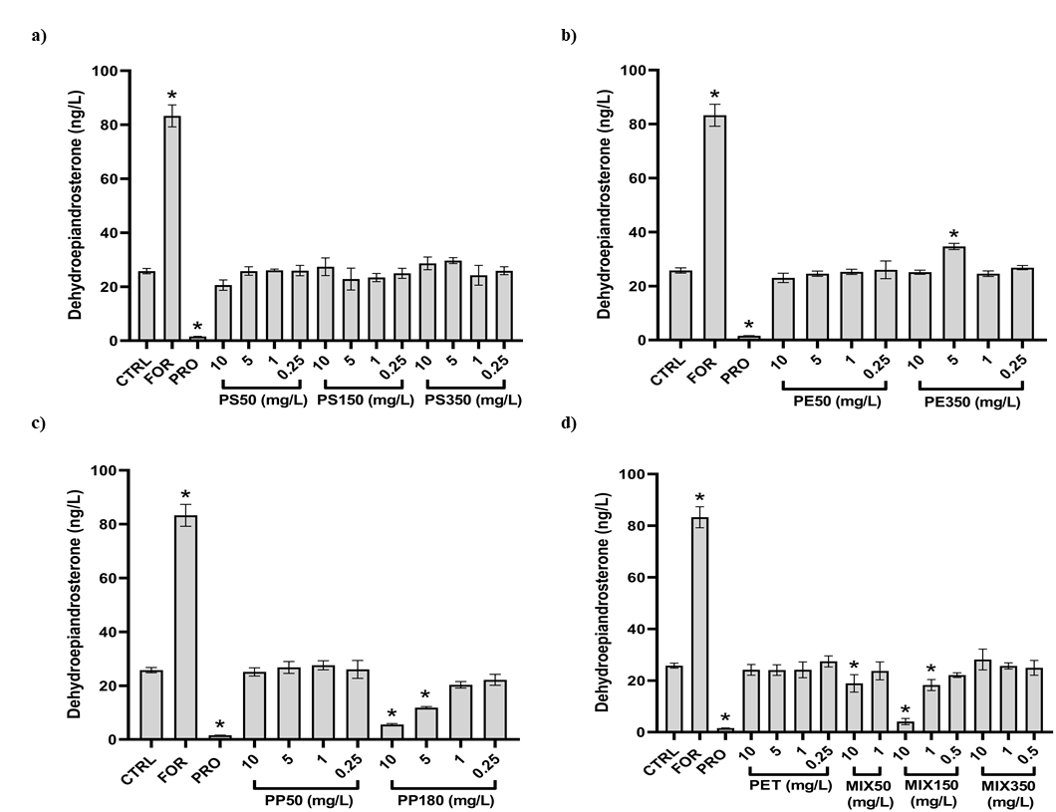
Figure S9. Dehydroepiandrosterone concentration in NCI-H295R culture media upon exposure to: a) 10, 5, 1 and 0.25 mg/L of PSNP 50 nm, PSNP 150 nm, PSNP 350 nm; b) 10, 5, 1 and 0.25 mg/L PENP 50 nm, PENP 350 nm; c) 10, 5, 1 and 0.25 mg/L PPNP 50 nm, PPNP 180 nm and d) 10, 5, 1, 0.25 mg/L PET, 10 and 1 mg/L MIX50, 10, 1 and 0,5 mg/L MIX150, 10 and 1 mg/L MIX350. Results are expressed as a mean value of triplicates from two individual experiments. Statistically significant changes (* p < 0.05) relative to the negative control were calculated with one-way ANOVA and Dunnett’s multiple comparisons test in GraphPad Prism.
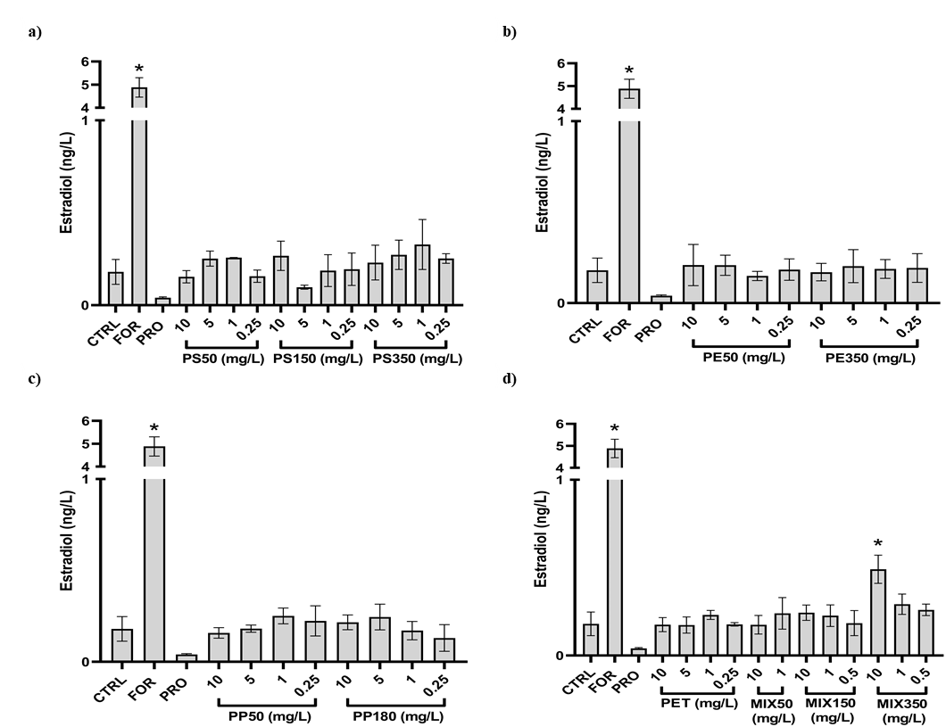
Figure S10. Estradiol concentration in NCI-H295R culture media upon exposure to: a) 10, 5, 1 and 0.25 mg/L of PSNP 50 nm, PSNP 150 nm, PSNP 350 nm; b) 10, 5, 1 and 0.25 mg/L PENP 50 nm, PENP 350 nm; c) 10, 5, 1 and 0.25 mg/L PPNP 50 nm, PPNP 180 nm and d) 10, 5, 1, 0.25 mg/L PET, 10 and 1 mg/L MIX50, 10, 1 and 0,5 mg/L MIX150, 10 and 1 mg/L MIX350. Results are expressed as a mean value of triplicates from two individual experiments. Statistically significant changes (* p < 0.05) relative to the negative control were calculated with one-way ANOVA and Dunnett’s multiple comparisons test in GraphPad Prism.

