Table S1. Study design overview

Item | Enrollment |  | Woodstove users |  |  |  | Non-woodstove users (NM)
Item | Enrollment |  | Non (NM) | Low | High |  | High
Sample size
NM |  |  | 49 | 19 | 50 |  | 18
MT/ID |  |  |  | 31 | 32
AK |  |  |  | 24 | 26
Months
NM |  |  | May-Sep | Oct Nov | Jan Feb |  | Jan Feb
MT |  |  |  | Oct Nov | Jan Feb
ID |  |  |  | April May | Jan Feb
AK |  |  |  | April May | Jan Feb
Questionnaire
Screener | X
Consent | X
Baseline questionnaire | X
Woodstove update |  |  |  | X | X |  | X
Tobacco use update |  |  | X | X | X |  | X
Daily diary |  |  |  | X | X
Additional smoke exposure |  |  | X | X | X |  | X
Woodstove use behavior |  |  |  | X | X
St. George's Resp Ques |  |  | X | X | X |  | X
Mouthwash form |  |  | X | X | X |  | X
Bio-specimen
Sputum |  |  | X | X | X |  | X
Mouthwash |  |  | X | X | X |  | X
Blood (NM) |  |  | X |  | X |  | X
First-void urine (NM) |  |  | X |  | X |  | X
Nasal brush (NM) |  |  | X |  | X |  | X
Buccal scrape (NM) |  |  | X |  | X |  | X
Indoor PM_{2.5} monitor |  |  | X | X | X |  | X

Abbreviations: NM, New Mexico; MT, Montana; ID, Idaho; AK, Alaska.

Table S2. The LODs and calibration curve of laboratory measurements

Measurements | LOD | Detection rate | Ranges of calibration curves | R²
LG | 0.2 | 99.09% | 0-20 µg/mL | >0.998
IFN-gamma | 0.333, 0.369 | 100% | 0-1420 pg/mL | >0.999
IL-1beta | 0.068, 0.058 | 25.42% | 0-570 pg/mL | >0.999
IL-10 | 0.027, 0.031 | 97.46% | 0-1290 pg/mL | >0.999
IL-12p70 | 0.066, 0.109 | 38.98% | 0-240 pg/mL | >0.999
IL-13 | 0.490, 0.554 | 16.1% | 0-730 pg/mL | >0.999
IL-2 | 0.095, 0.128 | 75.42% | 0-534 pg/mL | >0.999
IL-4 | 0.012, 0.012 | 31.36% | 0-380 pg/mL | >0.999
IL-6 | 0.109, 0.147 | 99.15% | 0-495 pg/mL | >0.999
IL-8 | 0.045, 0.049 | 100% | 0-560 pg/mL | >0.999
TNF-alpha | 0.087, 0.202 | 100% | 0-362 pg/mL | >0.998

Abbreviations: LOD, limit of detection; LG, levoglucosan; IFN, interferon; IL, interleukin.
Note: LG in urine and cytokines in plasma were reported in µg/mL and pg/mL, respectively. Cytokine measurements were performed on two assay plates; therefore, two plate-specific LODs were presented.
Table S3. Comparison of urinary Levoglucosan by woodstove use behaviors in high-heating season in New Mexico

Wood burning behavior | N (Yes/No) | N with LG measurements (Yes/No) | Yes | No | P
Always burn woods during sleeping | 22/27 | 22/26 | 0.16 (0.12, 0.23) | 0.16 (0.12, 0.21) | 0.96
Always tend the fire in the stove/fireplace | 14/34 | 14/33 | 0.23 (0.16, 0.35) | 0.14 (0.11, 0.18) | 0.027
Ever feel the smoke in the room | 28/21 | 27/21 | 0.17 (0.13, 0.24) | 0.15 (0.11, 0.20) | 0.506
Always staying close to the stove/fireplace | 16/33 | 15/33 | 0.15 (0.11, 0.22) | 0.17 (0.13, 0.22) | 0.721
Always start the fire in the stove/fireplace | 20/29 | 20/28 | 0.24 (0.18, 0.33) | 0.12 (0.09, 0.16) | 0.001

Abbreviations: LG, levoglucosan
Note: Levoglucosan/creatinine values are presented as geometric means (95% confidence interval) and log2-transformed in comparisons. Unpaired t tests were applied to assess differences of urinary levoglucosan levels between people with different wood burning behaviors. Comparisons were conducted in the high-heating season in New Mexico stove users due to levoglucosan data availability. No significant association was identified between total burning hours per week and creatinine adjusted urinary LG.

Table S4. Comparison of effect biomarkers by season in New Mexico

Variable | N | IFN-γ | IL-1β | IL-10 | IL-12p70 | IL-13 | IL-2 | IL-4 | IL-6 | IL-8 | TNF-α
Exposure metrics
Users/High-heating | 49 | 11.91 ± 35.02 | 0.05 ± 0.04 | 0.89 ± 4.56 | 0.1 ± 0.15 | 0.34 ± 0.33 | 0.15 ± 0.11 | 0.01 ± 0.01 | 0.88 ± 0.65 | 5.76 ± 7.84 | 2.52 ± 2.51
Users/Non-heating | 48 | 6.6 ± 5.03 | 0.07 ± 0.12 | 0.38 ± 0.87 | 0.1 ± 0.24 | 0.41 ± 0.73 | 0.24 ± 0.36 | 0.01 ± 0.03 | 0.81 ± 0.55 | 4.97 ± 7.93 | 2.14 ± 1.15
Non-users/High-heating | 18 | 5.48 ± 2.99 | 0.07 ± 0.08 | 0.50 ± 1.26 | 0.06 ± 0.03 | 0.26 ± 0.06 | 0.21 ± 0.12 | 0.01 ± 0.01 | 0.72 ± 0.56 | 4.63 ± 3.23 | 1.94 ± 0.47
Comparison
Users High vs. Non |  | 0.288 | 0.407 | 0.338 | 0.955 | 0.306 | 0.062 | 0.879 | 0.254 | 0.05 | 0.247
High: Non-users vs. Users |  | 0.209 | 0.380 | 0.591 | 0.084 | 0.111 | 0.042 | 0.689 | 0.333 | 0.409 | 0.131

Abbreviations: IFN, interferon; IL, interleukin; TNF, tumor necrosis factor.
Note: Blood cytokines and chemokines were measured in 49 woodstove users and 18 non-stove users in the high-heating season, and 48 woodstove users in the non-heating seasons. Paired t tests were applied to examine the differences of biomarkers between the high- and low- heating seasons, while unpaired t tests were applied to examine the differences of the non-users with the users during the high-heating season. Markers with >50% of values below LOD (IL-1β, IL-12p70, IL-13, IL-4) were also dichotomized as detected and undetected. Chi-square tests were applied to assess the differences and no statistical significances were observed.

Figure S1. Diameter distribution of macrophages and black carbon particles.

Figure S2. Distribution of black carbon particle size in high- and non-heating seasons in New Mexico.

Figure S3. Spearman correlations between ambient (n=48) and indoor PM_{2.5} (n=37) and MaCL measures in woodstove users and non-users in the high-heating season in New Mexico. Note: Correlation coefficients are listed on top of p-values.
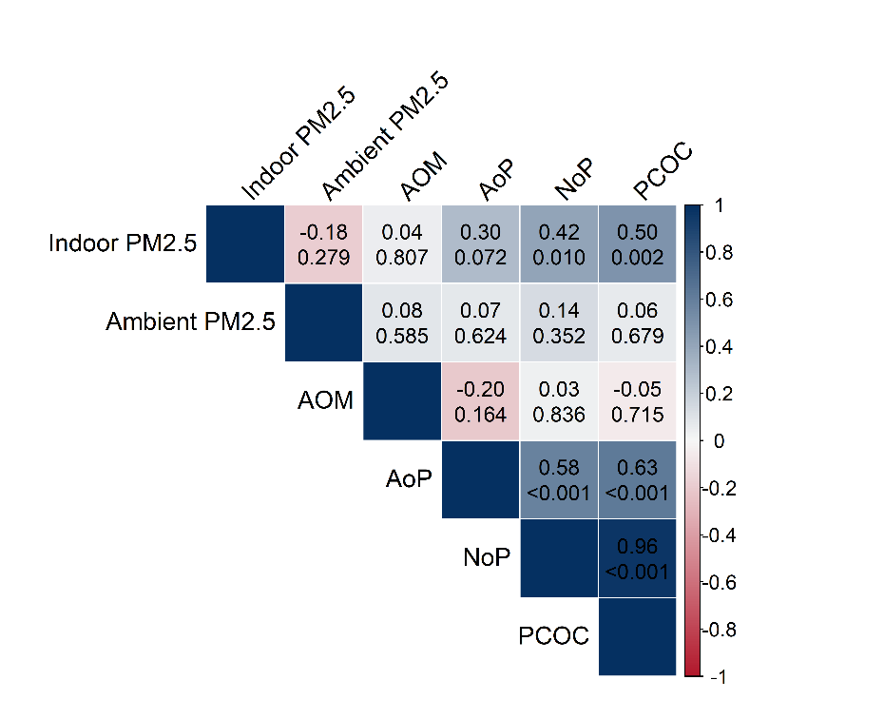

Figure S4. Distribution of urinary Levoglucosan.

Figure S5. Scatter plots and Pearson correlations between MaCL and urinary levoglucosan in 34 woodstove users in the high-heating season in New Mexico. Obviously, there are participants with higher urinary LG not caused by increase in MaCL, suggesting other routes of exposure to woodsmoke such as through dietary intake.

