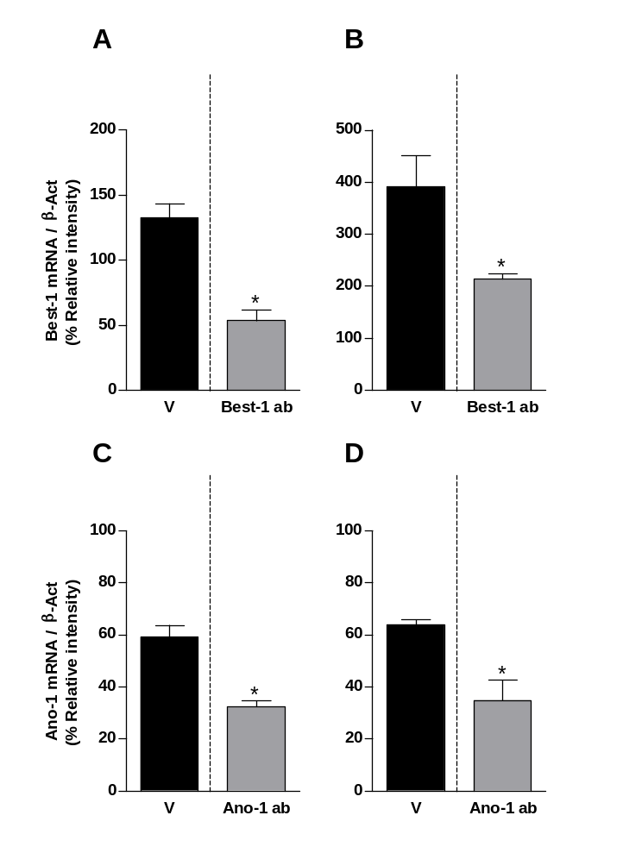
DRG
SC
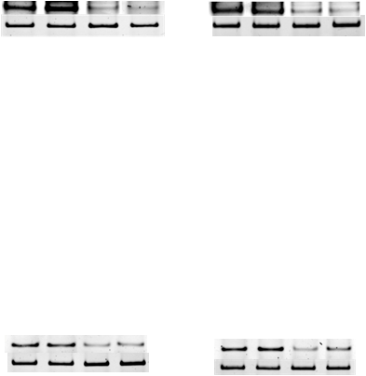
Best–1
β-actin

DRG
SC
Ano–1
β-actin

Fig. S5. Pineda-Farias et al.

