Supplementary material to Emotion dysregulation and impulsivity as overlapping symptoms in adult Attention-Deficit/Hyperactivity Disorder and Borderline Personality Disorder: Severity profiles and associations with childhood traumatization and personality functioning by Kenézlői et al.
Supplementary Table 1. Descriptive statistics of the regression model.
Outcome variable: DERS; Predictors: Gender, SES, CTQ
After carrying out the outlier detection, the descriptive statistics of the variables used in the regression variables are in Supplementary Table 1.
 |  | DERS |  | SES |  | CTQ
Valid |  | 252 |  | 252 |  | 252
Missing |  | 0 |  | 0 |  | 0
Mean |  | 94.214 |  | 49.164 |  | 43.04
Std. Deviation |  | 28.717 |  | 10.560 |  | 14.053

Supplementary Figure 1. Collinearity diagnostics of the regression model.

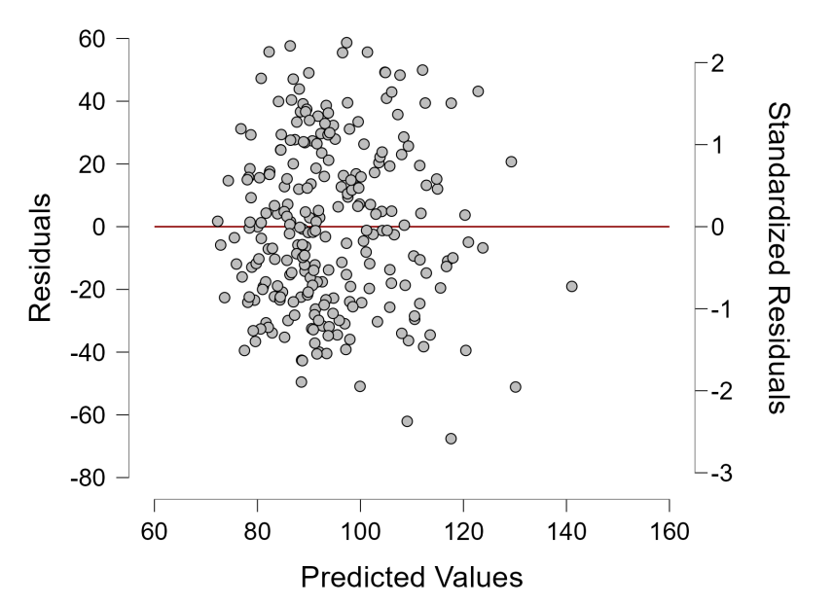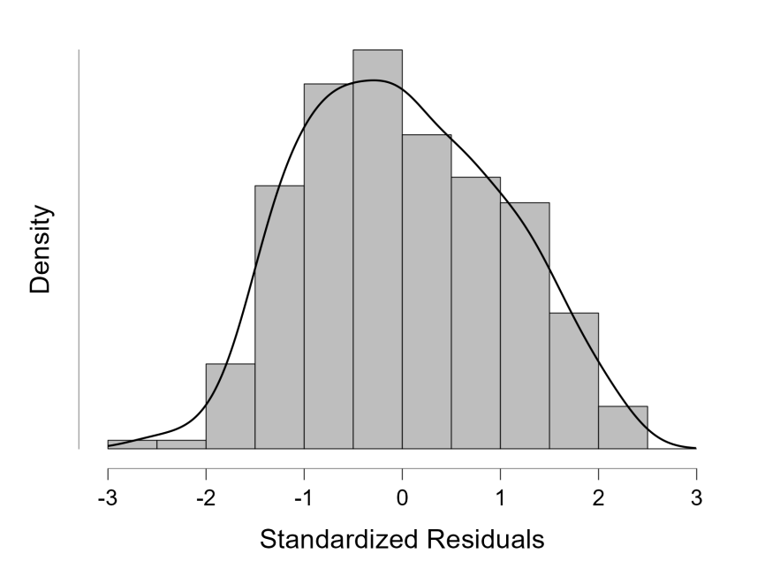
According to collinearity diagnostics, there is no collinearity and multicollinearity among the predictors. The correlation between the predictors: -0.194. The tolerance measures for gender = 99.1% SES=96.3%, CTQ=96.0%. The independence of the predictors makes it possible to detect their prediction value clearly in the regression. Based on the point diagram of the standardized predicted values and standardized residuals meet the requirements of homoscedasticity and linearity. The histogram of the standardized residuals shows normal distribution.

Supplementary Table 2. Descriptive statistics of the regression model.
Outcome variable: BIS-11; Predictors: Gender, SES, CTQ
After carrying out the outlier detection, the descriptive statistics of the variables used in the regression variables are in Supplementary Table 2.
 |  | BIS-11 |  | SES |  | CTQ
Valid |  | 254 |  | 254 |  | 254
Missing |  | 0 |  | 0 |  | 0
Mean |  | 66.764 |  | 49.025 |  | 43.063
Std. Deviation |  | 13.091 |  | 10.682 |  | 14.063

Supplementary Figure 2. Collinearity diagnostics of the regression model.

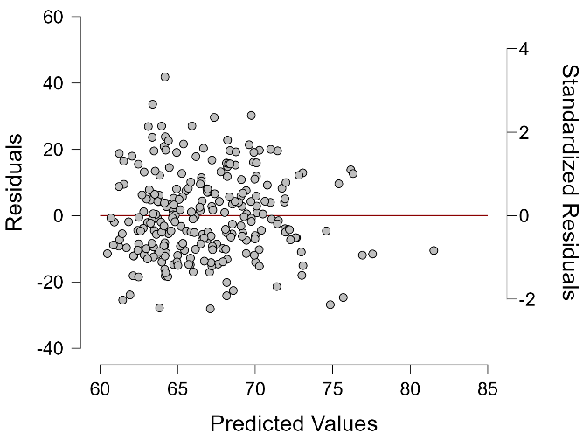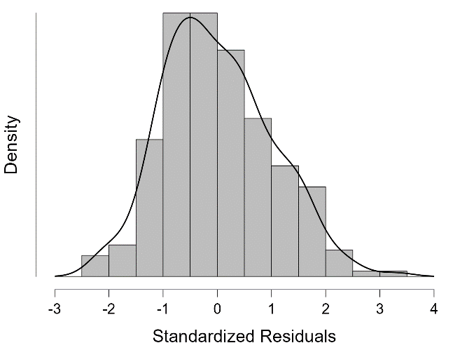

According to collinearity diagnostics, there is no collinearity and multicollinearity among the predictors. The correlation between the predictors: -0.194. The tolerance measures for gender = 99.2% SES=96.1%, CTQ=95.7%. The independence of the predictors makes it possible to detect their prediction value clearly in the regression. Based on the point diagram of the standardized predicted values and standardized residuals meet the requirements of homoscedasticity and linearity. The histogram of the standardized residuals shows normal distribution.

