Additional file
List of Appendices
Table S1: Variance Inflation Factors for all Variables in Models
Table S2: Stepwise Introduction of Variables with GDP-squared, All Countries
Table S3: Stepwise introduction of Variables with GDP-squared, Stratified by LMICs and HICs
Table S4: Imputed main models with no time lags
Table S5: Unimputed Main Models with time lags
Table S6: Alternative Women’s Empowerment Measures (Unimputed Main Models with Time Lags)
Table S7: Models with Female Educational Attainment as an Alternative Measure of Women’s Empowerment

Table S1: Variance Inflation Factors for all Variables in Models
Variable | VIF | 1/VIF
L5.dr_eg | 22.76 | 0.043934
L5.dr_sg | 24.94 | 0.0401
L5.wdi_gdpc | 13.64 | 0.073332
L5.gdpc_square | 5.78 | 0.173051
L5.wdi_urban | 11.96 | 0.083626
L5.vdem_gender | 21.34 | 0.046855
L5.p_polity2 | 1.87 | 0.535221
L2.fat_supply | 27.75 | 0.036034
L2.protein_supply | 44.42 | 0.022515
L2.wdi_co2 | 3.21 | 0.311221
year
1986 | 1.59 | 0.629963
1987 | 1.59 | 0.626973
1988 | 1.6 | 0.625523
1989 | 1.61 | 0.62245
1990 | 1.6 | 0.623077
1991 | 1.61 | 0.622296
1992 | 1.61 | 0.621841
1993 | 1.6 | 0.623201
1994 | 1.6 | 0.623269
1995 | 1.62 | 0.617142
1996 | 1.64 | 0.609915
1997 | 1.72 | 0.582004
1998 | 1.75 | 0.571351
1999 | 1.77 | 0.565937
2000 | 1.78 | 0.561184
2001 | 1.79 | 0.55925
2002 | 1.8 | 0.555904
2003 | 1.82 | 0.550724
2004 | 1.83 | 0.547177
2005 | 1.85 | 0.53989
2006 | 1.85 | 0.540975
2007 | 1.87 | 0.535769
2008 | 1.88 | 0.532806
Mean VIF | 6.58

Table S2: Stepwise Introduction of Variables with GDP-squared, All Countries
*time fixed effects entered but not shown. Significance level: * p<.05, ** for p<.01, and *** for p<.001
Table S3: Stepwise introduction of Variables with GDP-squared, Stratified by LMICs and HICs
*time fixed effects entered but not shown. Significance level: * p<.05, ** for p<.01, and *** for p<.00

Table S4: Main models with no time lags
*time fixed effects entered but not shown. Significance level: * p<.05, ** for p<.01, and *** for p<.001
Table S5: Unimputed Main Models with time lags
*time fixed effects entered but not shown. Significance level: * p<.05, ** for p<.01, and *** for p<.001

Table S6: Alternative Women’s Empowerment Measures (Unimputed Main Models with Time Lags)
*time fixed effects entered but not shown. Significance level: * p<.05, ** for p<.01, and *** for p<.001

Table S7: Models with Female Educational Attainment as an Alternative Measure of Women’s Empowerment
*time fixed effects entered but not shown. Significance level: * p<.05, ** for p<.01, and *** for p<.001

Figure S1 Graphs A1-A4: Relationship between GDP and BMI, 1980-2008
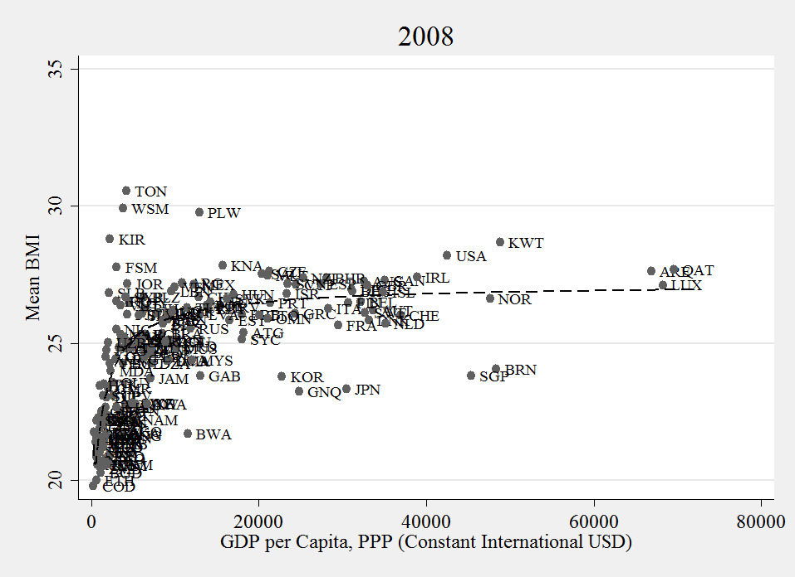
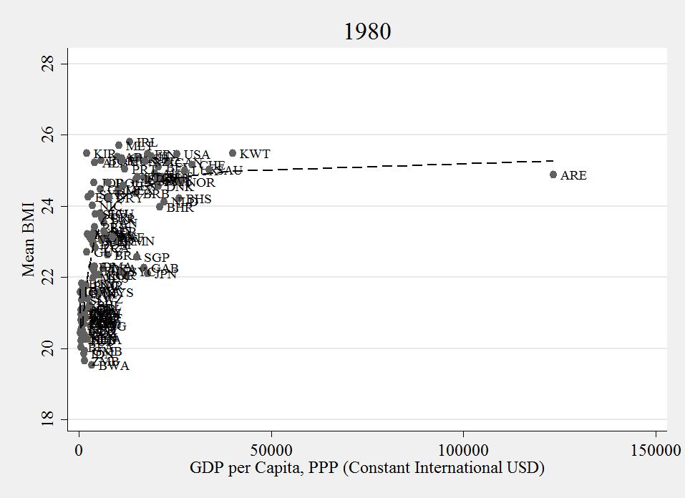
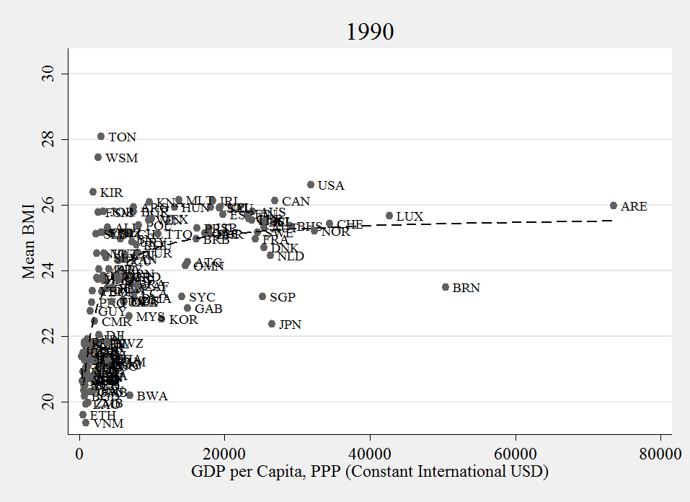
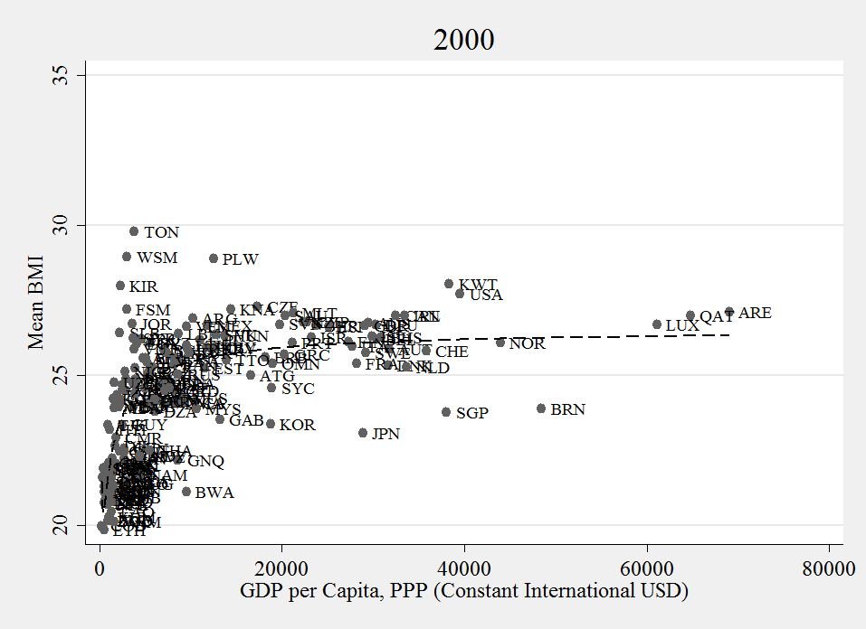

Figure S2

Graphs A1-A4: Relationship between GDP and BMI, NO LABELS, 1980-2008
1990
1980

2008
2000

Graphs from paper with no labels

Figure S3: Quadratic Plots of the Relationship between GDP and BMI, 1980-2008

Figure S4: Change in BMI by Change in GDP per capita (1980-2008)
Men
Women

