Supplementary tables and figures
Sup table 1. Search strategy
 | Search strategy | screened items | items selected for abstract review
meningitis | (("Meningitis"[MeSH Major Topic] AND "COVID-19"[Title]) OR "SARS-COV2"[Title] OR "SARS-COV-2"[Title] OR "Pandemic"[Title] OR "Quarantine"[Title]) AND "Meningitis"[Title] | 23 | 9
Stroke | (("stroke"[MeSH Major Topic] AND "COVID-19"[Title]) OR "SARS-COV2"[Title] OR "SARS-COV-2"[Title] OR "Pandemic"[Title] OR "Quarantine"[Title]) AND "Stroke"[Title] | 205 | 95
seizures | ((((("Seizures"[MeSH Major Topic] AND "COVID-19"[Title]) OR "SARS-COV2"[Title] OR "SARS-COV-2"[Title] OR "Pandemic"[Title] OR "Quarantine"[Title]) AND "Non-convulsive ‎status epilepticus"[Title] AND (alladult[Filter])) NOT (Case Report[Title]) AND (alladult[Filter]) ) NOT (Case Series[Title]) AND (alladult[Filter])) AND (Non-convulsive ‎status epilepticus) | 6 | 0
 | ((((("Seizures"[MeSH Major Topic] AND "COVID-19"[Title]) OR "SARS-COV2"[Title] OR "SARS-COV-2"[Title] OR "Pandemic"[Title] OR "Quarantine"[Title]) AND "Seizures"[Title] AND (Non-convulsive ‎status epilepticus) | 2 | 0
aneurysm | (("aneurysm"[MeSH Major Topic] AND "COVID-19"[Title]) OR "SARS-COV2"[Title] OR "SARS-COV-2"[Title] OR "Pandemic"[Title] OR "Quarantine"[Title]) AND "Aneurysm"[Title] | 25 | 15
Cardiac Tamponade | ((("Cardiac Tamponade"[MeSH Major Topic] AND "COVID-19"[Title]) OR "SARS-COV2"[Title] OR "SARS-COV-2"[Title] OR "Pandemic"[Title] OR "Quarantine"[Title]) AND "Cardiac Tamponade"[Title]) AND (Tamponade[Title]) NOT (Case Report[Title]) AND (alladult[Filter]) ) NOT (Case Series[Title]) AND (alladult[Filter])) | 9 | 0
gastrointestinal hemorrhage | ((((((gastrointestinal hemorrhage[MeSH Major Topic]) AND (COVID-19[Title])) OR (SARS-COV2[Title])) OR (SARS-COV-2[Title])) OR (Pandemic[Title])) OR (Quarantine[Title])) AND (gastrointestinal hemorrhage) | 33 | 5
Diabetic Ketoacidosis | (("Diabetes Mellitus"[MeSH Major Topic] AND ("COVID-19"[Title] OR "SARS-COV2"[Title] OR "SARS-COV-2"[Title] OR "Pandemic"[Title] OR "Quarantine"[Title]) AND "Diabetic Ketoacidosis"[Title] | 24 | 7
Diabetic Ketoacidosis | (("Diabetes Mellitus"[MeSH Major Topic] AND ("COVID-19"[Title] OR "SARS-COV2"[Title] OR "SARS-COV-2"[Title] OR "Pandemic"[Title] OR "Quarantine"[Title]) AND ("Diabetic Ketoacidosis"[Title] OR "type 1 diabetes"[Title]) | 74 | 45
Hypoglycemia | (("Diabetes Mellitus"[MeSH Major Topic] AND ("COVID-19"[Title] OR "SARS-COV2"[Title] OR "SARS-COV-2"[Title] OR "Pandemic"[Title] OR "Quarantine"[Title]) AND ("Hypoglycemia"[Title]) AND (alladult[Filter]) | 4 | 2
Addison's and adrenocortical insufficiency | ("COVID-19"[Title] OR "SARS-COV2"[Title] OR "SARS-COV-2"[Title] OR "Pandemic"[Title] OR "Quarantine"[Title]) AND ("Addison's?"[Title]) | 0 | 0
Addison's and adrenocortical insufficiency | ("COVID-19"[Title] OR "SARS-COV2"[Title] OR "SARS-COV-2"[Title] OR "Pandemic"[Title] OR "Quarantine"[Title]) AND ("adrenocortical ‎insufficiency"[Title]) | 0 | 0
Addison's and adrenocortical insufficiency | (("Adrenal Cortex Hormones"[MeSH Major Topic] AND ("COVID-19"[Title] OR "SARS-COV2"[Title] OR "SARS-COV-2"[Title] OR "Pandemic"[Title] OR "Quarantine"[Title]) AND ("adrenocortical ‎insufficiency"[Title]) AND (alladult[Filter]) AND (alladult[Filter]) | 0 | 0
Phaeochromocytoma | ("COVID-19"[Title] OR "SARS-COV2"[Title] OR "SARS-COV-2"[Title] OR "Pandemic"[Title] OR "Quarantine"[Title]) AND ("Phaeochromocytoma"[Title]) AND (alladult[Filter]) | 0 | 0
Hypercalcaemia | ("COVID-19"[Title] OR "SARS-COV2"[Title] OR "SARS-COV-2"[Title] OR "Pandemic"[Title] OR "Quarantine"[Title]) AND ("Hypercalcaemia"[Title]) | 0 | 0
Thyroid Crisis | (("Thyroid Crisis"[MeSH Major Topic] AND ("COVID-19"[Title] OR "SARS-COV2"[Title] OR "SARS-COV-2"[Title] OR "Pandemic"[Title] OR "Quarantine"[Title]) AND ("Thyroid Crisis"[Title]) | 0 | 0
Thyroid Crisis | (("Thyroid Crisis"[MeSH Major Topic] AND ("COVID-19"[Title] OR "SARS-COV2"[Title] OR "SARS-COV-2"[Title] OR "Pandemic"[Title] OR "Quarantine"[Title]) AND ("Thyroid"[Title]) | 0 | 0
Scleroderma | (("Connective Tissue Diseases"[MeSH Major Topic] AND ("COVID-19"[Title] OR "SARS-COV2"[Title] OR "SARS-COV-2"[Title] OR "Pandemic"[Title] OR "Quarantine"[Title]) AND ("Scleroderma ‎"[Title]) | 4 | 0
Vasculitis | (("Vasculitis"[MeSH Major Topic] AND ("COVID-19"[Title] OR "SARS-COV2"[Title] OR "SARS-COV-2"[Title] OR "Pandemic"[Title] OR "Quarantine"[Title]) AND ("Vasculitis?"[Title]) | 41 | 3
Myxedema | (("Connective Tissue Diseases"[MeSH Major Topic] AND ("COVID-19"[Title] OR "SARS-COV2"[Title] OR "SARS-COV-2"[Title] OR "Pandemic"[Title] OR "Quarantine"[Title]) AND ("Myxedema"[Title]) | 0 | 0
Nephrotic Syndrome | (("Kidney Diseases"[MeSH Major Topic] AND ("COVID-19"[Title] OR "SARS-COV2"[Title] OR "SARS-COV-2"[Title] OR "Pandemic"[Title] OR "Quarantine"[Title]) AND ("Nephrotic Syndrome"[Title]) | 6 | 0
 | (("Kidney Diseases"[MeSH Major Topic] AND ("COVID-19"[Title] OR "SARS-COV2"[Title] OR "SARS-COV-2"[Title] OR "Pandemic"[Title] OR "Quarantine"[Title]) AND ("Nephrotic Syndrome"[Title]) | 1 | 0
Appendicitis | (("Abdominal Pain"[MeSH Major Topic] AND ("COVID-19"[Title] OR "SARS-COV2"[Title] OR "SARS-COV-2"[Title] OR "Pandemic"[Title] OR "Quarantine"[Title]) AND ("Acute"[Title]) | 11 | 1
Appendicitis | ("COVID-19"[Title] OR "SARS-COV2"[Title] OR "SARS-COV-2"[Title] OR "Pandemic"[Title] OR "Quarantine"[Title]) AND ("Acute abdomen"[Title] OR "Abdominal pain"[Title] OR "Appendicitis"[Title] AND ((alladult[Filter]) AND (2019:2022[pdat])) AND (alladult[Filter]) | 501 | 31
Hernia | ("COVID-19"[Title] OR "SARS-COV2"[Title] OR "SARS-COV-2"[Title] OR "Pandemic"[Title] OR "Quarantine"[Title]) AND ("Acute abdomen"[Title] OR "Abdominal pain"[Title] OR "Appendicitis"[Title] AND ((alladult[Filter]) AND (2019:2022[pdat])) AND (alladult[Filter]) | 501 | 31
ACS | ((("Heart Diseases"[MeSH Major Topic] AND "COVID-19"[Title]) OR "SARS-COV2"[Title] OR "SARS-COV-2"[Title] OR "Pandemic"[Title] OR "Quarantine"[Title]) AND "Myocardial Infarction"[Title]) AND (ST Elevation Myocardial Infarction[Title]) NOT (Case Report[Title]) AND (alladult[Filter]) ) NOT (Case Series[Title]) AND (alladult[Filter])) | 23 | 8
ACS | ("COVID-19"[Title] OR "SARS-COV2"[Title] OR "SARS-COV-2"[Title] OR "Pandemic"[Title] OR "Quarantine"[Title]) AND "Acute Coronary Syndrome"[Title]) | 71 | 38
Obstruction | ("COVID-19"[Title] OR "SARS-COV2"[Title] OR "SARS-COV-2"[Title] OR "Pandemic"[Title] OR "Quarantine"[Title]) AND ("Intestinal ‎"[Title] OR "Intestinal Obstruction"[Title] OR "Obstruction"[Title] | 1482 | 1
Esophageal varices | (("Esophageal Diseases"[MeSH Major Topic] AND ("COVID-19"[Title] OR "SARS-COV2"[Title] OR "SARS-COV-2"[Title] OR "Pandemic"[Title] OR "Quarantine"[Title]) AND ("bleeding"[Title] OR "varices"[Title] OR "esophageal varices"[Title] AND (alladult[Filter]) | 205 | 2
Ectopic pregnancy | ("COVID-19"[Title] OR "SARS-COV2"[Title] OR "SARS-COV-2"[Title] OR "Pandemic"[Title] OR "Quarantine"[Title]) AND ("Ectopic Pregnancy?"[Title] OR "Ectopic"[Title] OR "Pregnancy Complications"[Title] | 603 | 5
ovarian torsion | ("COVID-19"[Title] OR "SARS-COV2"[Title] OR "SARS-COV-2"[Title] OR "Pandemic"[Title] OR "Quarantine"[Title]) AND ("Adnexal Torsion"[Title] OR "Ovarian Torsion"[Title] OR "Torsion"[Title] | 20 | 0
 | ((("Ovarian Diseases"[MeSH Major Topic] AND ("COVID-19"[Title] OR "SARS-COV2"[Title] OR "SARS-COV-2"[Title] OR "Pandemic"[Title] OR "Quarantine"[Title]) AND ("Adnexal Torsions"[Title] OR "Ovarian "[Title] OR "Ovarian Torsions"[Title] OR "Torsion"[Title] AND ((alladult[Filter]) AND (2019:2022[pdat]))) AND Covid-19 | 10 | 0
abortion | ((("Pregnancy Complications"[MeSH Major Topic] AND ("COVID-19"[Title] OR "SARS-COV2"[Title] OR "SARS-COV-2"[Title] OR "Pandemic"[Title] OR "Quarantine"[Title]) AND ("Miscarriage"[Title] OR "Spontaneous"[Title] OR "Abortion"[Title] OR "Pregnancy Complications"[Title] AND Covid-19 NOT "pneumothorax" NOT "pneumomediastinum" | 261 | 70
PROM | ("COVID-19"[Title] OR "SARS-COV2"[Title] OR "SARS-COV-2"[Title] OR "Pandemic"[Title] OR "Quarantine"[Title]) AND ("PROM "[Title] OR "Premature Rupture of Fetal Membranes"[Title] OR "Premature Rupture"[Title] OR "Fetal Membranes"[Title] AND ((alladult[Filter]) | 79 | 0
Urinary Retention | ("COVID-19"[Title] OR "SARS-COV2"[Title] OR "SARS-COV-2"[Title] OR "Pandemic"[Title] OR "Quarantine"[Title]) AND ("PROM "[Title] OR "Premature Rupture of Fetal Membranes"[Title] OR "Premature Rupture"[Title] OR "Fetal Membranes"[Title] AND ((alladult[Filter]) | 245 | 25
Fournier Gangrene | Bacterial Infections[MeSH Major Topic] AND ("COVID-19"[Title] OR "SARS-COV2"[Title] OR "SARS-COV-2"[Title] OR "Pandemic"[Title] OR "Quarantine"[Title]) AND (("Gangrene"[Title] OR " Fournier Gangrene"[Title] OR "Fournier "[Title]) | 3 | 0
Hematuria | Urologic Diseases[MeSH Major Topic] AND ("COVID-19"[Title] OR "SARS-COV2"[Title] OR "SARS-COV-2"[Title] OR "Pandemic"[Title] OR "Quarantine"[Title]) AND (("Acute"[Title] OR " Urinary "[Title] OR "Hematuria"[Title] OR "Severe Hematuria"[Title]) NOT " COVID-19 Patients" NOT "Patients with COVID-19" NOT "COVID-19 associated" NOT "with COVID-19" | 98 | 27

Supplementary Fig 1. Forrest plot of CVA symptoms onset to ED door time
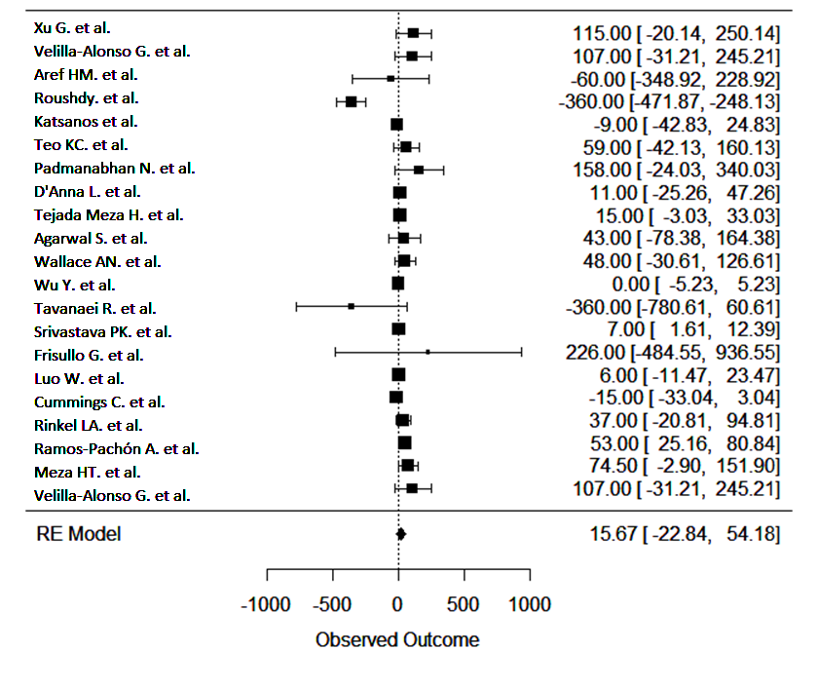

Supplementary Fig 2. Funnel plot of CVA symptoms onset to ED door time
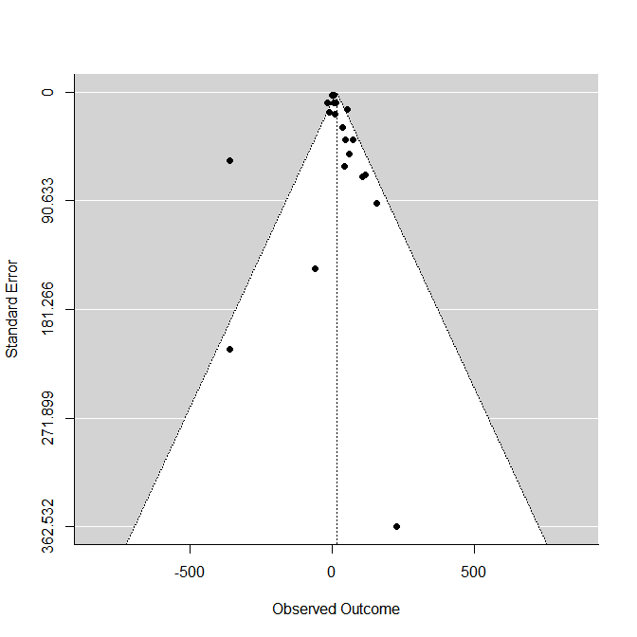

Supplementary Fig 3. Forrest plot of rt-PA administration proportion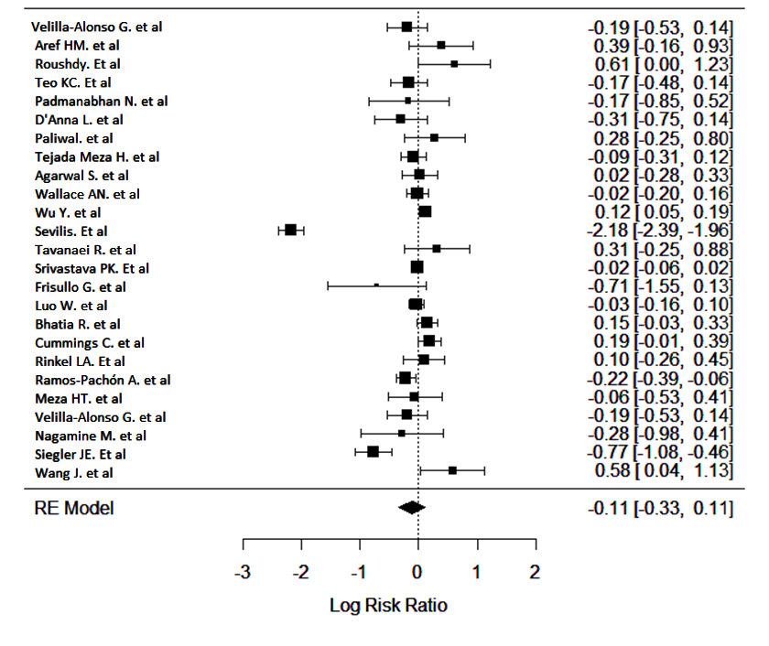
Supplementary Fig 4. Funnel plot of rt-PA administration proportion 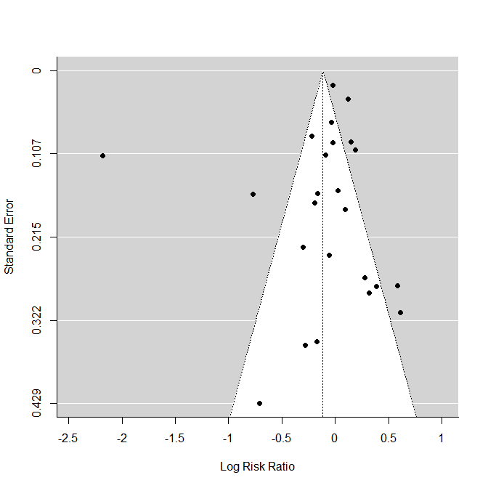

Supplementary Fig 5. Forest and Funnel plot of SAH Vasospasm

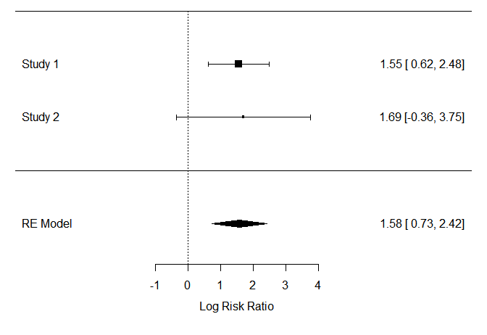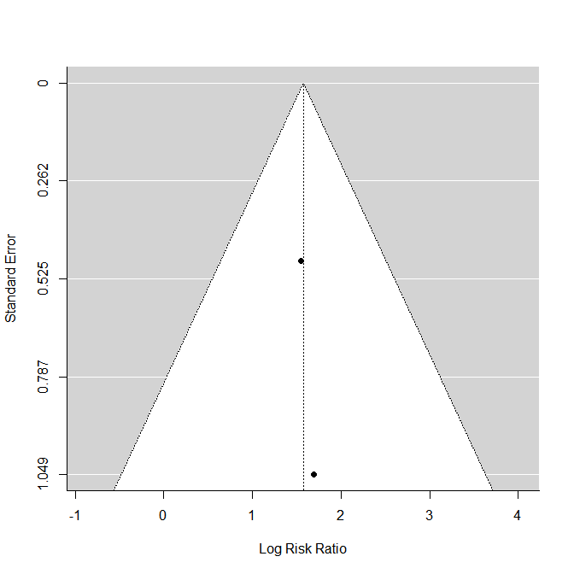
(study 1, Fiorindi et al.; study 2, Aboukaïs et al.)

Supplementary Fig 6. Forest and Funnel plot of Fisher grade>2
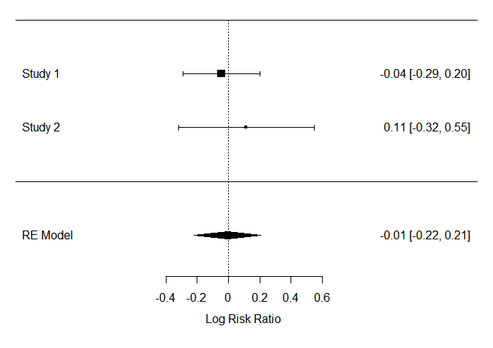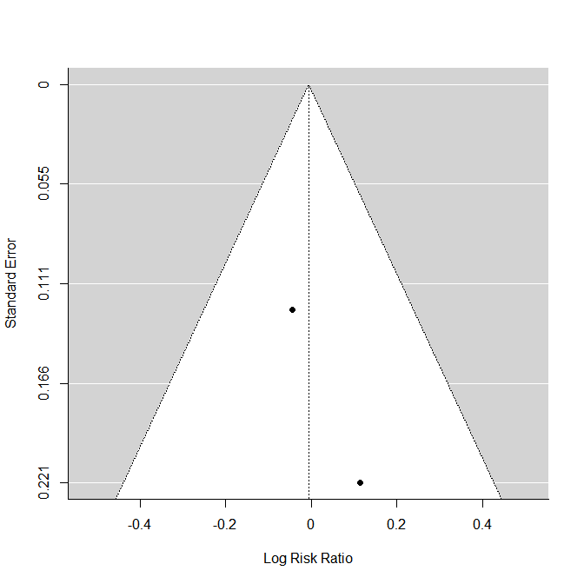
(study 1, Fiorindi et al.; study 2, Aboukaïs et al.)

Supplementary Fig 7. Forest and Funnel plot of WFNS > 3
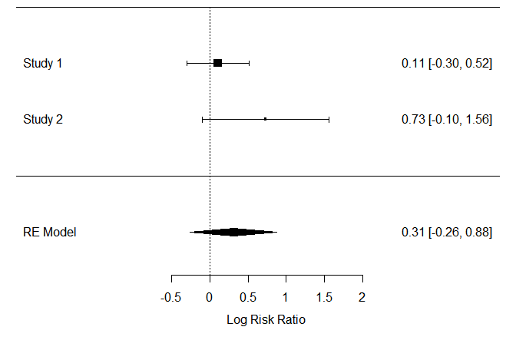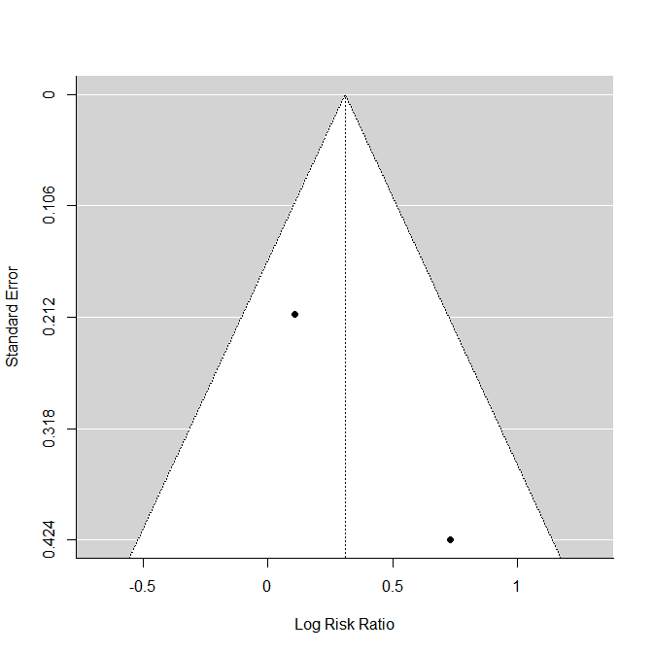
(study 1, Fiorindi et al.; study 2, Aboukaïs et al.)

Supplementary Fig 8. Forrest plot of Orchiectomy rate in testicular torsion 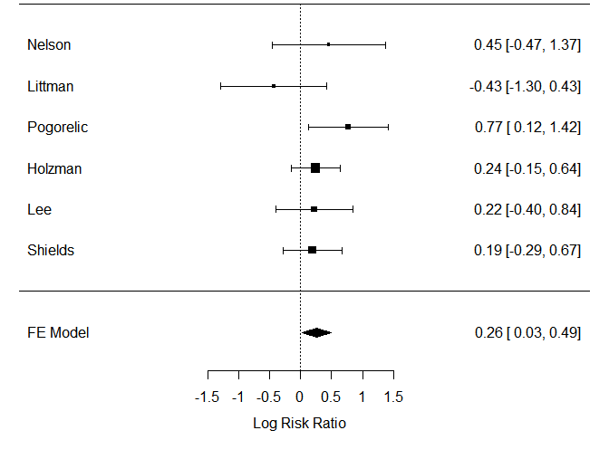
Supplementary Fig 9. Funnel plot of Orchiectomy rate in testicular torsion

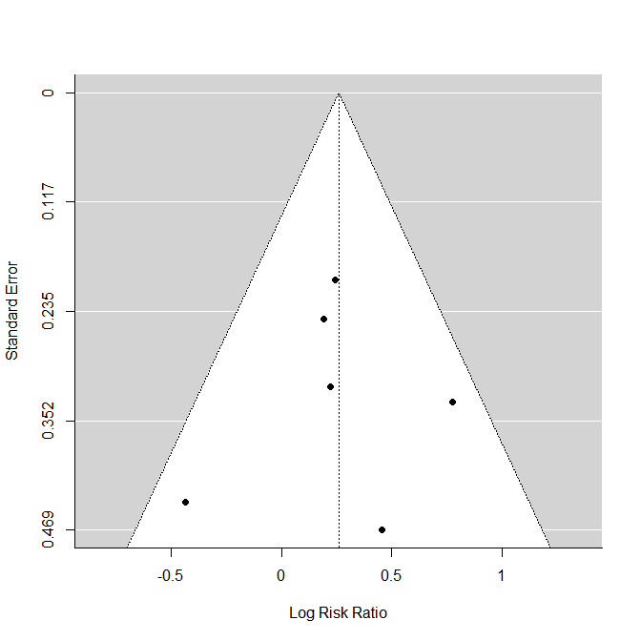

Supplementary Fig 10. Forrest plot of DKA presentation among newly diagnosed T1DM patients

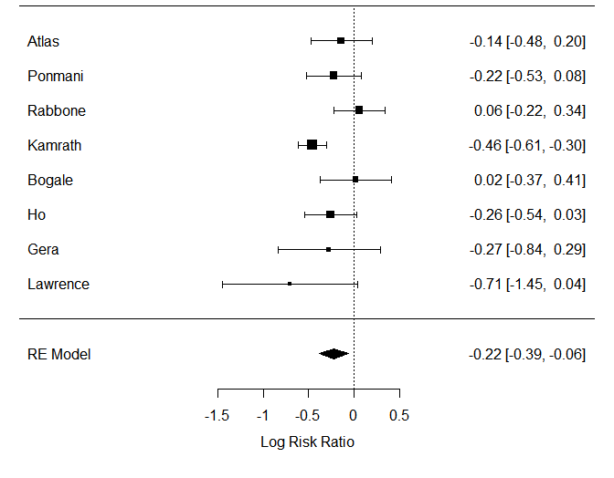
Supplementary Fig 11. Funnel plot of DKA presentation among newly diagnosed T1DM patients

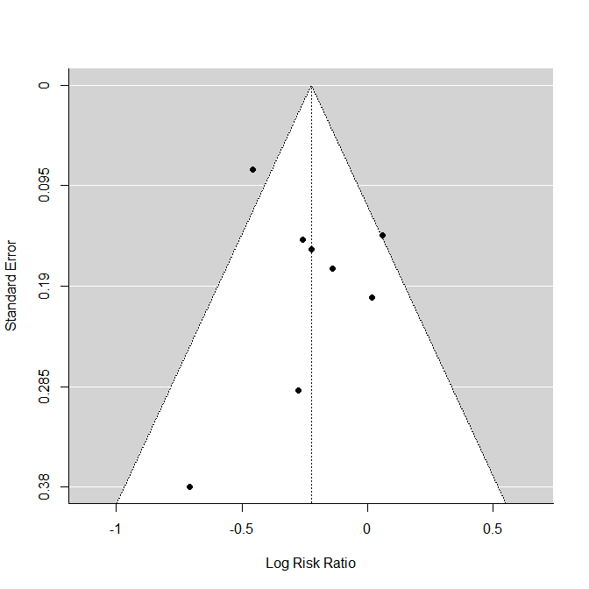

Supplementary Fig 12. Forrest plot of Perforated ectopic pregnancy

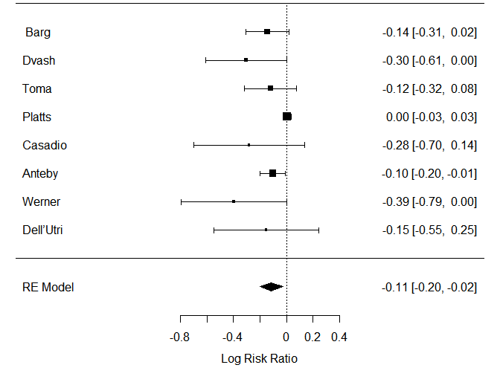
Supplementary Fig 13. Funnel plot of Perforated ectopic pregnancy

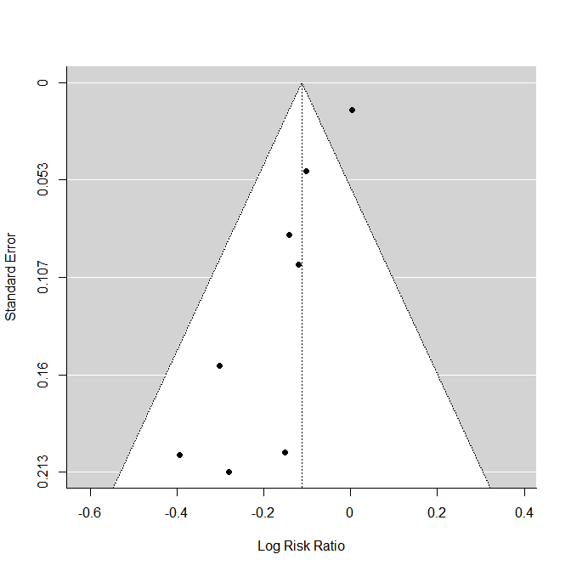

Supplementary Fig 14. trim-filled Forrest plot of Perforated ectopic pregnancy
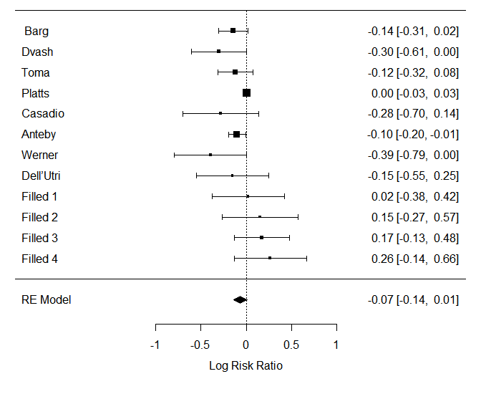

Supplementary Fig 15. trim-filled Funnel plot of Perforated ectopic pregnancy
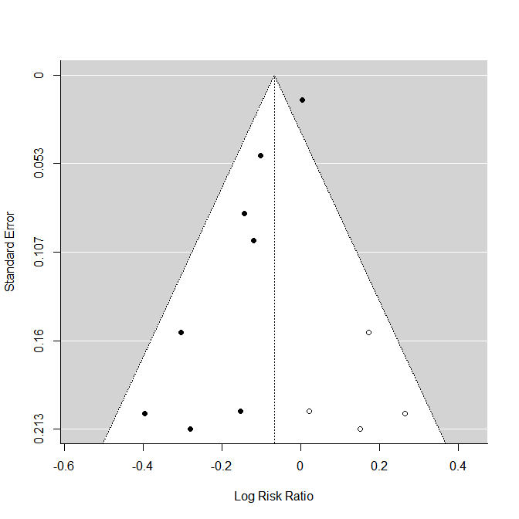

Supplementary Fig 16. Forest plot of perforated appendicitis proportion
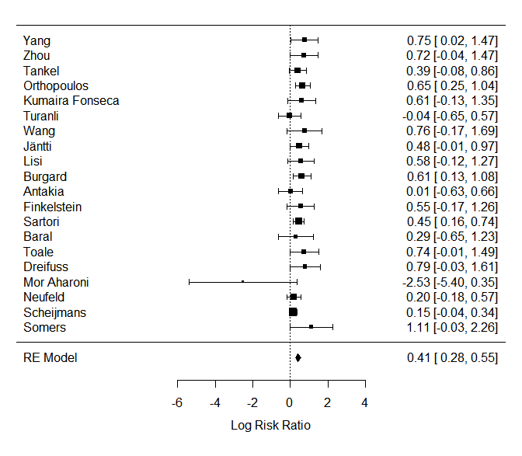

Supplementary Fig 17. Funnel plot of perforated appendicitis proportion
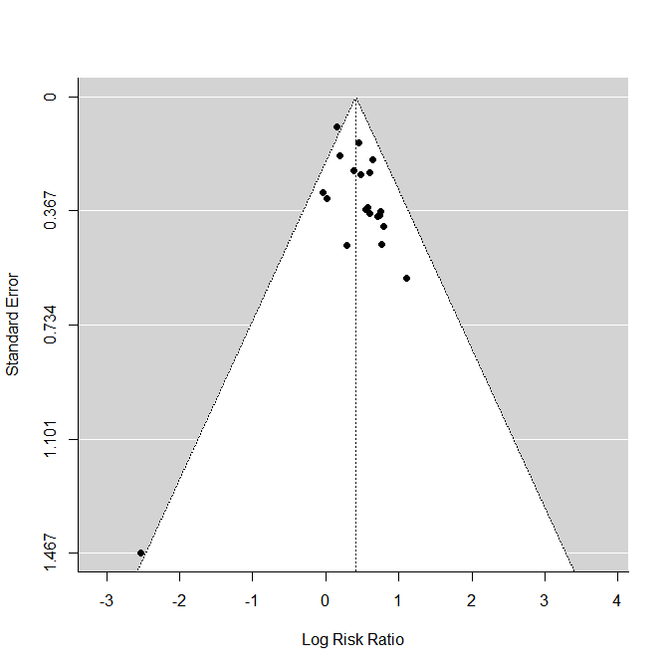

Supplementary Fig 18. Forest plot of delayed appendicitis presentation

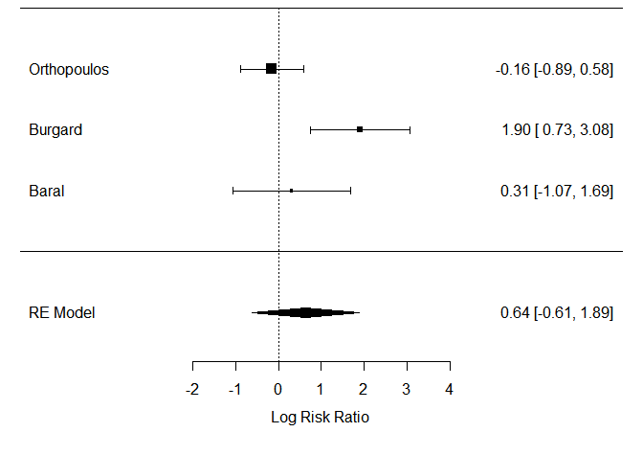
Supplementary Fig 19. Funnel plot of delayed appendicitis presentation
