Additional file 1. WHO policy recommendations for NCD prevention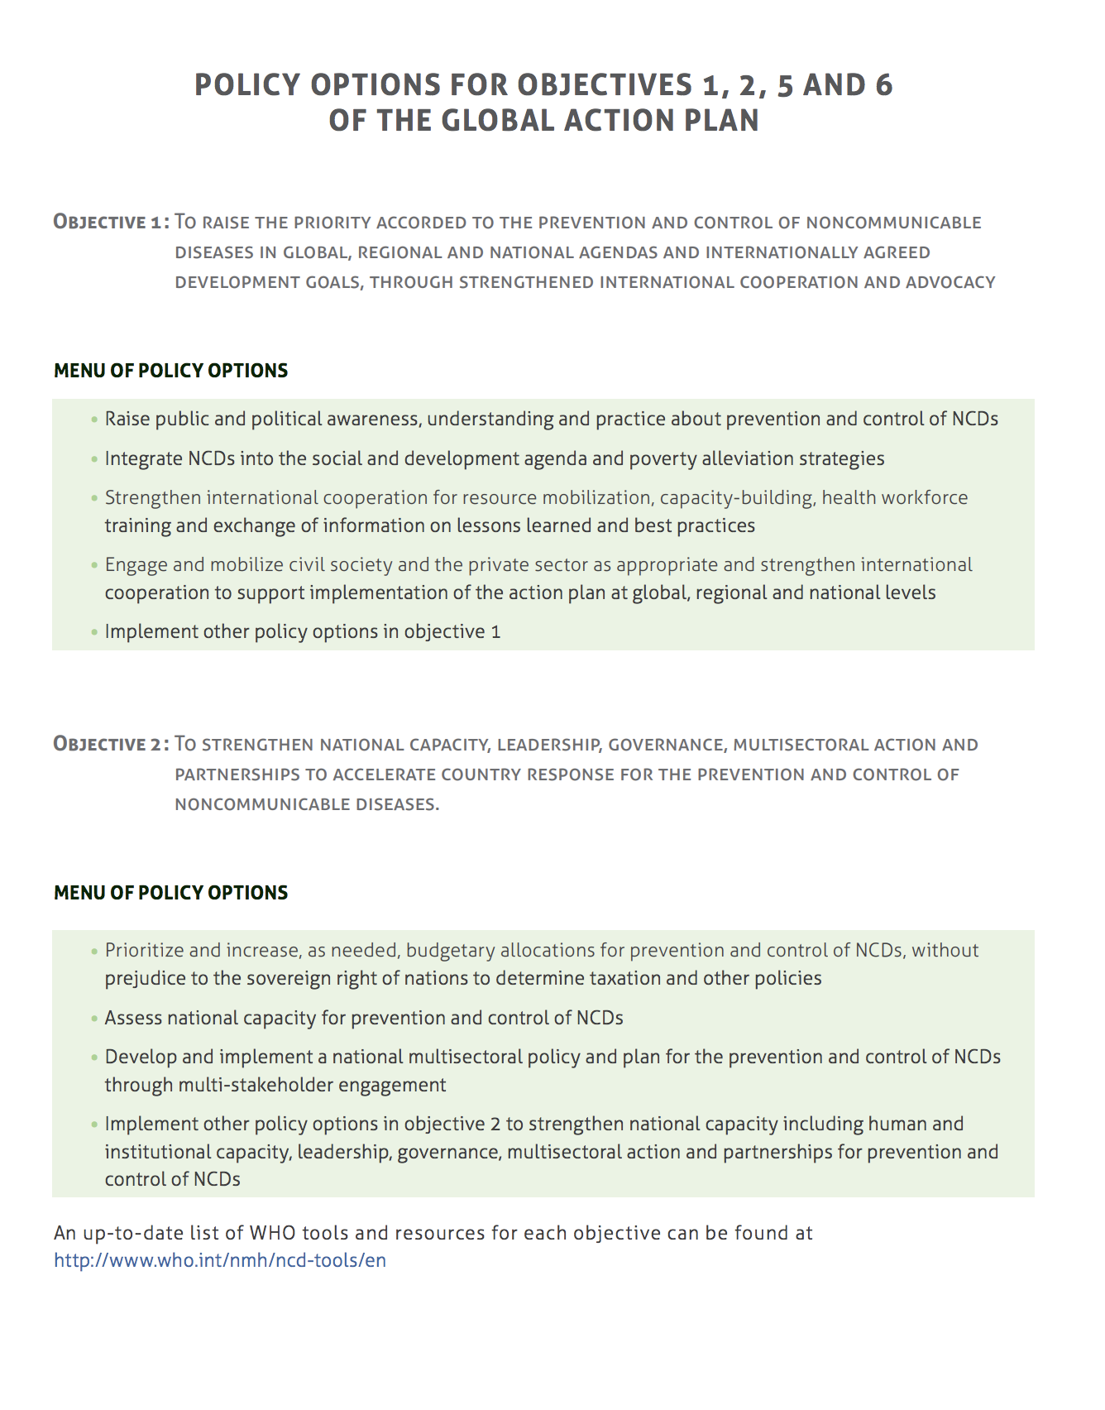

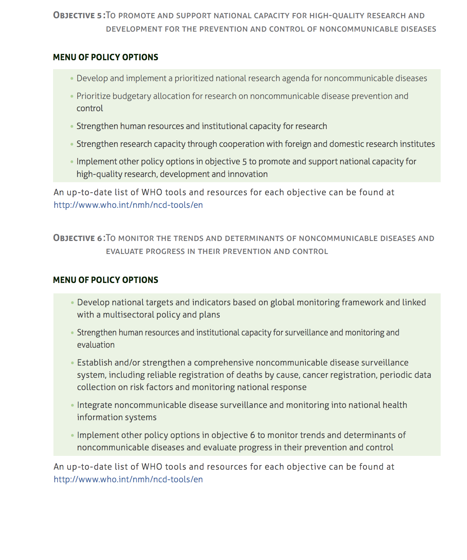
Source: WHO (2017) [3]

