Appendix A. Timeline of Collaborative SARS Response

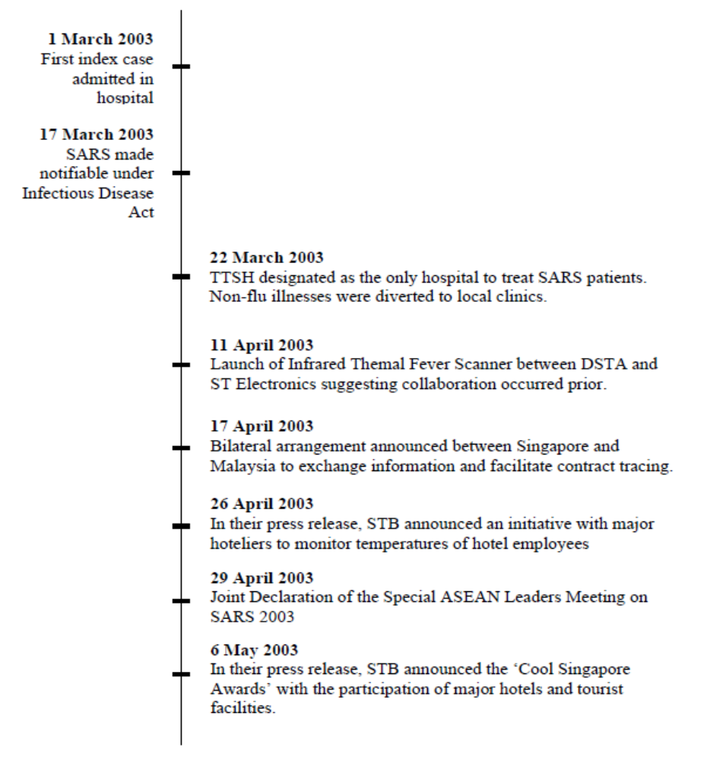

Appendix B. Timeline of Collaborative COVID-19 Response

