Annex 1: Questionnaire
What is your affiliation (dropdown list)
WHO
HNAP
Ocha
UNFPA
WFP
SIG
UNHCER
MPHSS TWG
NCD TWG
EWARN
PAC
UOSSM
PHR
SAMS
HIS Unit
Other (specify)

Common Questions for all interviewees:
- When was the dataset established?
Please insert the year of establishment
- What is the type of funding the dataset receives? (one or more options)
- Syria Humanitarian Pooled Fund
- Syria Recovery Trust Fund
- UN agencies
- Institutional donor (e.g. FCDO, ECHO, OFDA…etc)
- Unrestricted funding from NGOs
- Other (specify)
- What was the approach for establishing the dataset at the first place?
- Bottom-up: i.e., the dataset emerged from field networks
- Top-down: i.e., the dataset emerged from senior structures in an entity (such as UN agency or NGO) based on pre-allocated funding.
- A collation of datasets: i.e., the dataset emerged from merging several datasets together.
- Other (specify)
- What is the technical support the dataset receives? (one or more options)
- Experts from UN agencies
- Experts from philanthropic foundations (e.g. Gates foundation)
- Experts from International NGOs
- Local experts.
- No available technical support.
- Other (specify)
- Methods used for data collection: (one or more options)
- Prospective surveillance
- Population sample survey
- Analysis of program data
- Others. (specify)
- The use of technology in data collection: (one or more options)
- Kobo toolbox
- DHIS2
- Locally developed software (Please provide more details)
- The use of social media (e.g. WhatsApp) (Give more details)
- Other: (specify)
- How often are reports generated? (one or more options)
- Weekly
- Monthly
- Quarterly
- Semi-annually
- Annually, and
- On time
- Other (specify)
- To whom reports are disseminated: (one or more options)
- Internal reports
- Doners
- UN agency
- National entities (Directorates)
- Central HIS Unit
- Other (specify)
- How do you utilize your reports? (one or more options)
- Fulfilling the donor requirements
- Advocacy
- Program design
- Urgent decisions
- Coordination purposes
- Other: (specify)
- Please describe challenges at the different aspect of data management. (Minimum 3 challenges)
- Please tell stories of success.

Questions specific to each domain:
The questions here will investigate the methodologies available for each domain. We will assign 1 value for the used method or 0 value when it is not available. Also, if other methods not mentioned in the checklist are used, they will be written in a textbox.
 |  |  | Comment
1 | Affected population  size and composition | Community-based demographic surveillance
1 | Affected population  size and composition | Residential structure tally and structure occupancy estimation
1 | Affected population  size and composition | Vaccination or nutritional screening data combined with expected age structure
1 | Affected population  size and composition | Other: (write in the column to the right)
2 | Exposure to armed attacks or mechanical force of nature | Facility-based surveillance of injuries and attacks against health care
2 | Exposure to armed attacks or mechanical force of nature | Retrospective survey of individual exposure to injury
2 | Exposure to armed attacks or mechanical force of nature | Conflict analysis (tracking of media and other informant reports)
2 | Exposure to armed attacks or mechanical force of nature | Other: (write in the column to the right)
3 | Sexual and gender-based violence | Facility-based surveillance of sexual and gender-based violence cases
3 | Sexual and gender-based violence | Retrospective survey of individual exposure to sexual and gender-based violence
3 | Sexual and gender-based violence | Conflict analysis (tracking of media and other informant reports)
3 | Sexual and gender-based violence | Other: (write in the column to the right)
4 | Food security and feeding practices | Household livelihoods, resilience and coping, food access, food consumption, and feeding practices survey
4 | Food security and feeding practices | Agricultural production monitoring
4 | Food security and feeding practices | market analysis
4 | Food security and feeding practices | household focus groups
4 | Food security and feeding practices | risk assessment of desk-based food security
4 | Food security and feeding practices | Other: (write in the column to the right)
5 | Nutritional status | Repeated anthropometric sampling from sentinel communities
5 | Nutritional status | Anthropometric survey
5 | Nutritional status | Trend analysis from community-based or facility based anthropometric screening, and community-based management of acute malnutrition admissions
5 | Nutritional status | Desk-based nutritional risk assessment
5 | Nutritional status | Other: (write in the column to the right)
6 | Communicable diseases | EWARN for epidemic alert and response
6 | Communicable diseases | Other: (write in the column to the right)
7 | Non-Communicable diseases | Survey to measure point prevalence of chronic diseases or retrospective prevalence of acute disease syndromes
7 | Non-Communicable diseases | Analysis of facility-based morbidity and mortality data
7 | Non-Communicable diseases | Other: (write in the column to the right)
8 | Morbidity data | Analysis of facility-based morbidity and mortality data
8 | Morbidity data | Desk-based disease risk assessment and situation analysis
8 | Morbidity data | tracing and tracking of people in need of treatment continuation
8 | Morbidity data | Other: (write in the column to the right)
9 | Service availability and functionality | HeRAMS (with updated geographical database of facilities)
9 | Service availability and functionality | Who, what, where, when (4Ws)
9 | Service availability and functionality | Other: write in the column to the right)
10 | Service coverage | Coverage survey (eg, vaccination, health services, or nutritional programme) – (Add details in the column in the right)
10 | Service coverage | Comparison of actual programme outputs vs target beneficiaries – (Add details in the column in the right)
10 | Service coverage | Other: (write in the column to the right)
11 | Service quality or effectiveness | Analysis of HMIS data (eg, on cure rates)
11 | Service quality or effectiveness | Other: (write in the column to the right)
12 | Population mortality | Community-based demographic surveillance
12 | Population mortality | passive body count surveillance
12 | Population mortality | Retrospective mortality survey (verbal autopsies as add-on to explore causes of death)
12 | Population mortality | Census (post-war) and demographic modelling
12 | Population mortality | capture–recapture analysis
12 | Population mortality | indirect (model-based) estimation
12 | Population mortality | Other: write in the column to the right)

Annex 2: COREQ (Consolidated Criteria for Reporting Qualitative Research) Checklist
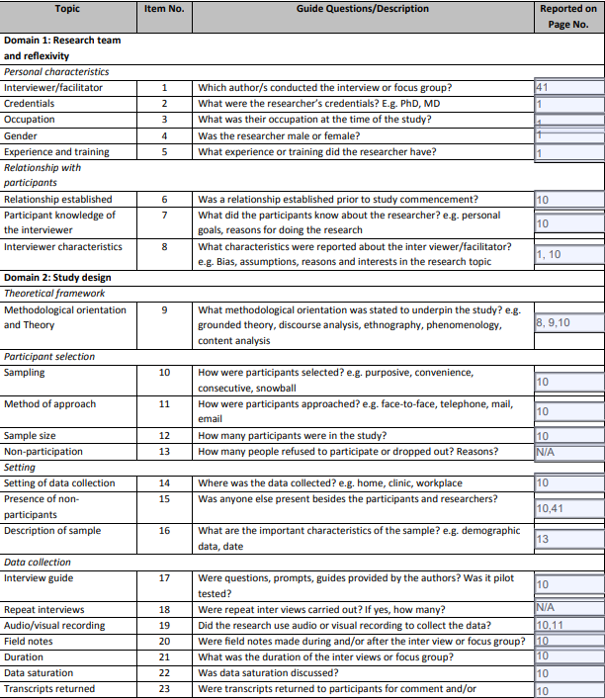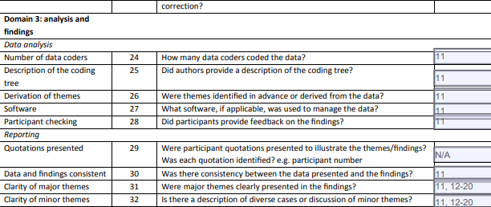
Annex 3: Scoring Sheet for the Number and Quality of Available Public Health Information Domains in NWS
Dimension  Score | Number of Available Sets | Data Completeness | Data Accuracy | Data Consistency | Data Frequency
0 | No dataset is available | Variables are not sufficient to calculate required or expected outcomes | Dataset does not match other available datasets or includes values that are unrealistic compared to what is known in the literature | Datasets are inconsistent and provide largely varying results across different facilities and/or sights in an unrealistic way | Data is entered once and never updated or rarely updated over the years.
0.5 | 1-5 Datasets are available | Variable can be used to calculate some but not all required or expected outcomes | Dataset values the does not match other available datasets or includes values that are unrealistic compared to what is known in the literature, and outliers are not justified or explained | Datasets are inconsistent and provide largely varying results across different facilities and/or sights in an unrealistic way | Data is updated in a timely manner (monthly or yearly depending on the type of data)
1.00 | 5 or more datasets are available | Variables can be used to calculate required or expected outcomes | Dataset variable match other available datasets or includes values that are unrealistic compared to what is known in the literature, and outliers are explained and justified | ___ | ___

