Food packaging: identifying the socio-economic drivers and reduction opportunities through system dynamics modelling
Sabrina Chakori ^{a,b*}, Ammar Abdul Azizª, Russell Richards ^{c,d}
ª School of Agriculture and Food Sciences, The University of Queensland, Brisbane, Queensland, 4072, Australia
^{b} Leeder Centre for Health Policy, Economics and Data, Sydney School of Public Health, The University of Sydney, Sydney, NSW, Australia
^{c} School of Business, The University of Queensland, Brisbane, Queensland, 4072, Australia
^{d} Coastal and Marine Research Centre, Griffith University, Gold Coast Campus, Gold Coast, Queensland, 4222, Australia

*Corresponding author: sabrina.chakori@uq.net.au

Supplementary material
Section 1 – Detail of stock and flow model
A stock and flow model (SFM) is a graphical representation of a system of coupled ordinary differential equations (see Figure S1). It has four core elements: stocks, which are the state variables, flows, which control the rate of change for the stocks, converters, which contain a constant or a variable, and connectors, which connect the stocks, flows and converters.
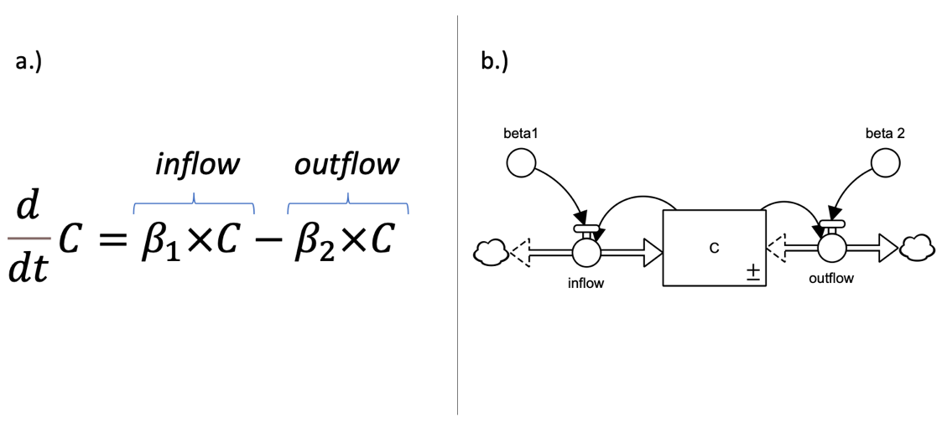
Figure S1. (a) Is an example of ordinary differential equation (ODE). (b) Is the ODE represented as a stock and (bi-directional) flow model created in Stella (C = stock; inflow, outflow = flows).
The value of each stock is calculated using the Euler integration method [1]. At the current time step (t, t ≠ 0) the stock’s value is calculated based on its value at the preceding time step (t – dt) and the sum of the inflows and outflows over the intervening period (dt). For the initial time step, where there is no previous time step, an initial value or condition is applied.
Stock (t) = Stock (t – dt) + ∫ (Flow) dt [1]

Section 2 – Model Parameters
Table S1 – Model parameters used to build the Stock and Flow Model
Globalisation subsystem (USA)
Variable name | Type | Unit | Type (Endogenous/ Exogenous) | Equation or value | Data Source
Profit coefficient per thousand tonnes of packaged food | Converter | Million US Dollars/thousand tonnes | Exogenous | 0.141 (Calibration value) | N/A
Actual Profit | Converter | Million US Dollars | Endogenous | Packaged_food*Profit_coefficient_per_thousand_tonnes_of_packaged_food | N/A
Actual profit / normal profit | Converter | Dimensionless | Endogenous | Actual_Profit/Normal_profit | N/A
Normal profit | Converter | Million US Dollars | Exogenous | 21.4 | https://money.cnn.com/magazines/fortune/fortune500_archive/full/1960/
Effect of profit on food trade rate | Graphical function | Dimensionless | Endogenous | Graphical function | N/A
Average annual food trade growth rate | Converter | 1/year | Exogenous | 0.00886 (Calibration value) | N/A
Average food trade growth rate adjusted for effect of profit and trade agreements | Converter | 1/year | Endogenous | Average_food_trade_growth_rate_adjusted_for_effect_of_profit*Effect_of_changes_in_trade_agreements | N/A
Effect of changes in trade agreements | Graphical function | Dimensionless | Exogenous | Graphical function | N/A
Actual trade agreements | Converter | Dimensionless | Exogenous | Trade_agreements/Initial_trade_agreements | N/A
Initial trade agreements | Converter | Number | Exogenous | 6 | World Trade Organization (WTO 2021c)
Trade agreements | Stock | Number | Exogenous | Initial_trade_agreements | World Trade Organization (WTO 2021c) has been used a proxy for USA trade (see also USA trade https://rtais.wto.org/UI/charts.aspx# and U.S. Bureau of Economic Analysis, Imports of goods: Foods, feeds, and beverages [B647RC1Q027SBEA], retrieved from FRED, Federal Reserve Bank of St. Louis; https://fred.stlouisfed.org/series/B647RC1Q027SBEA)
Change in Trade agreements | Flow | Number/year | Exogenous | IF TIME < 1990 THEN Pre_WTO_growth_rate ELSE Post_WTO_growth_rate | N/A
Pre WTO growth rate | Converter | Number/year | Exogenous | 2.84 (Calibration value) | N/A
Post WTO growth rate | Converter | Number/year | Exogenous | 20.8 (Calibration value) | N/A
Trade flow (Import + Export) | Flow | Million US Dollars / Year/ Years | Endogenous | Average_food_trade_growth_rate_adjusted_for_effect_of_profit_and_trade_agreements*"Food_trade_(import_+_export)" | N/A
Food trade (import + export) | Stock | Million US Dollars/Year | Endogenous | Initial_food_trade | World Trade Organization (WTO 2021a)
Normal food trade | Converter | Million US Dollars/ Year | Exogenous | 39408 | World Trade Organization (WTO 2021a)
Actual food trade /Normal food trade | Converter | Dimensionless | Endogenous | "Food_trade_(import_+_export)"/Normal_food_trade | N/A
Effect of global trade on packaged food production rate | Graphical function | Dimensionless | Endogenous | "Actual_food_trade_/_Normal_food_trade" | N/A
Effect of packaged food production adjusted per global food trade adjusted for urbanisation (Longer supply chains) | Converter | Dimensionless | Endogenous | Effect_of_global_trade_on_packaged_food_production_rate*Effect_of_urbanisation_on_rate_of_population_dependent_of_food_purchasing_at_supermarkets | N/A
Urbanisation – supermarket subsystem (USA)
Variable name | Type | Unit | Type (Endogenous/ Exogenous) | Equation or value | Data Source
Effect of food trade on domestic small scale food production and consumption (vulnerability of smaller local farmers) | Graphical function | Dimensionless | Endogenous | Graphical function | N/A
Normal rate constant for urbanisation | Converter | 1/year | Exogenous | 0.013 (Calibration value) | N/A
Urban population growth rate constant adjusted for globalisation food trade | Converter | 1/year | Endogenous | "Effect_of_food_trade_on_domestic_small_scale_food_production_and_consumption_(vulnerability_of_smaller_local_farmers)"*Normal_rate_constant_for_urbanisation | N/A
Migration flow (growth rate) | Flow | People/Years | Endogenous | Urban_population_growth_rate_constant_adjusted_for_globalisation_food_trade*Urban_population | N/A
Urban population | Stock | People | Endogenous | Initial_urban_population | World Bank (2021) -United States
Initial urban population | Converter | People | Endogenous | 126462473 | World Bank (2021) - United States  https://data.worldbank.org/indicator/SP.URB.TOTL?locations=US
Normal urban population | Converter | People | Exogenous | 126462473 | World Bank (2021) - United States https://data.worldbank.org/indicator/SP.URB.TOTL?locations=US
Actual urban population /  normal urban population | Converter | Dimensionless | Endogenous | Urban_population/Normal_urban_population | N/A
Effect of urbanisation on rate of population dependent of food purchasing at supermarkets | Converter | Dimensionless | Endogenous | "Actual_urban_population_/_normal_urban_population" | N/A
Household subsystem (USA)
Variable name | Type | Unit | Type  (Endogenous/ Exogenous) | Equation or value | Data Source
Indicated employment of women | Graphical function | Dimensionless | Endogenous | Graphical function | N/A
Women employment gap | Converter | Dimensionless | Endogenous | Indicated_employment_of_women - Employment_women | N/A
Employment women delay | Converter | Year | Exogenous | 13.5 (Calibration value) | N/A
Employment women | Stock | Dimensionless  (%) | Endogenous | Initial_employment_women | U.S. Bureau of Labor Statistics (2021)
Initial employment women | Converter | Dimensionless | Endogenous | 0.3775833333 | U.S. Bureau of Labor Statistics (2021)
Women employment flow | Flow | 1/year | Endogenous | Women_employment_Gap/ Employment_women_delay | N/A
Normal employment women | Converter | 1/year | Exogenous | 0.3775833333 | U.S. Bureau of Labor Statistics (2021)
Actual employment women/ Normal employment women | Converter | Dimensionless | Endogenous | Employment_women/ Normal_employment_women | N/A
Effect of employment women on packaged food production rate | Graphical function | Dimensionless | Endogenous | Graphical function | N/A
Rate of packaged food production adjusted per food time | Converter | Thousand Tonnes/year | Endogenous | Effect_of_food_time_on_packaged_food_production_rate*"Initial_packaged_food_production_rate_(1960s)" | N/A
Initial packaged food production rate (1960s) | Converter | Thousand Tonnes/year | Exogenous | 27370 (Calibration value but linked to data) | N/A
Packaged food subsystem (USA)
Variable name | Type | Unit | Type (Endogenous/ Exogenous) | Equation or value | Data Source
Packaged food production rate  adjusted for global trade, food time and urbanisation | Converter | Thousand Tonnes/year | Endogenous | "Effect_of_packaged_food_production_adjusted_per_global_food_trade_adjusted_for_urbanisation_(Longer_supply_chains)"*Rate_of_packaged_food_production_adjusted_per_food_time | N/A
"Packaged_food_production_rate_adjusted_for_global_trade,_food_time_and_urbanisation" | Flow | Thousand Tonnes/year | Endogenous | "Packaged_food_production_rate_adjusted_for_global_trade,_food_time_and_urbanisation" | N/A
Packaged Food | Stock | Thousand Tonnes | Endogenous | 27370 (initial value) - time series | United States Environmental Protection Agency (EPA 2018b)
Household subsystem (USA) – extra variables
Variable name | Type | Unit | Type  (Endogenous/ Exogenous) | Equation or value | Data Source
Effect of employment women on food time | Graphical function | Dimensionless | Endogenous | Graphical function | N/A
Initial food time | Converter | hours/day | Exogenous | 2 | World Development Indicators
Food time adjusted on the effects of women employment | Converter | hours/day | Endogenous | Initial_food_time*Effect_of_employment_women_on_food_time | N/A
Adjusted food time /effect of employment rate | Converter | Dimensionless | Endogenous | Food_time_adjusted_on_the_effects_of_women_employment/Initial_food_time | N/A
Effect of food time on packaged food production rate | Graphical function | Dimensionless | Endogenous | "Adjusted_food_time_/_effect_of_employment_rate" | N/A

Section 3 – Dimensionless multipliers
Dimensionless multipliers allow quantification of cause-effect relationships where relationships between components of a model are not known analytically but are crucial to modelling the problem (Eker et al., 2014; Maani & Cavana, 2007). Given a predictor variable and a response variable, a dimensionless multiplier takes as its input the ratio of the predictor to a reference value for this predictor and converts this into a dimensionless output value that is used to modify the response variable (Figure S2a). The functional form of the relationship between the input and output value of a dimensionless multiplier can be defined using a graphical function (Figure S2b), a look-up table (both options are available in Stella), or through defining the functional form as an equation (e.g. using a sigmoid equation).
Figure S2. (a) Dimensionless multiplier (in yellow) model structure used in stock and flow models to connect a predictor variable to an effect variable. (b) Graphical function form for the dimensionless multiplier using Stella’s built-in s-shape growth (x and y axes have dimensionless units).
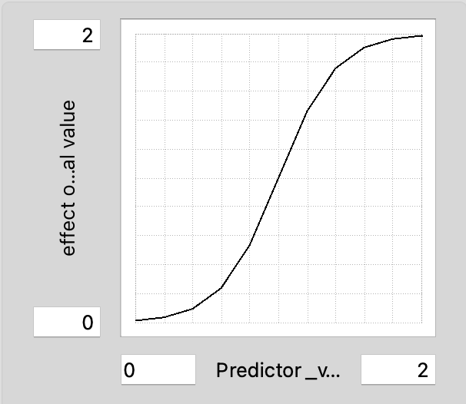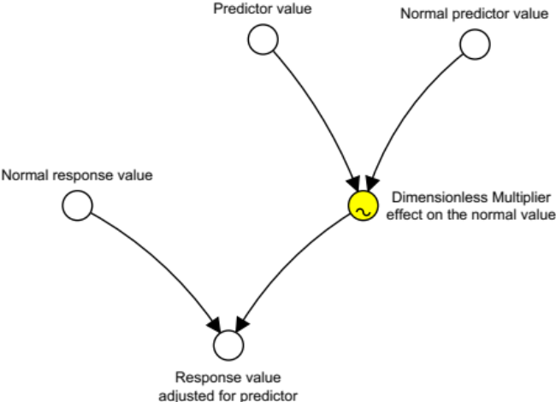
b.)
a.)

Section 4 – Model testing
The three statistical measures of fit used in the model testing are summarised in Table 2S. The R² describes the proportion of the variance in the measured data that the model explains. U₀ represents a summary measure of the overall discrepancy between the model’s outputs and the historical trends that it is being compared against. MAPE is a commonly-used measures that is used in conjunction with R² and U₀ (Turner et al., 2016) and provides a dimensionless metric for the errors that are easier to interpret (Jeon et al., 2016).
Table S2. Statistical formulae for measures of fit. Y_{sim} and Y_{obs} correspond to the simulated and observed values of the tested parameters respectively.
Test | Equation | Notes
R², Coefficient of determination | R² = $\left(\frac{Cov(Ysim-Yobs)}{σYsim σYobs }\right)$ | Output ranges 0 - 1, (1 = perfect goodness of fit, 0 = no fit).  C$ov$ () is the covariance between model output and the observed values.  σY_{sim} and σY_{obs} are the standard deviations of the model output and observed data respectfully.
U⁰, Discrepancy coefficient | U₀ = $\frac{\sqrt{∑{(Ysim-Yobs)}^{2}}}{\sqrt{∑{Ysim}^{2}}+ \sqrt{∑{Yobs}^{2}}}$ | Output ranges 0 - 1, (0 = ‘perfect prediction’, 1 = ‘worse prediction’.
MAPE, Mean Absolute percentage error | MAPE=$\frac{100}{n}∑|\frac{Ysim-Yobs}{Yobs}|$ | Output ranges 0 – 1 (0 – 100%):  0% – 10%: Very accurate prediction  10% – 15%: Relatively accurate prediction  20% – 50%: very reasonable prediction  > 50%: inaccurate prediction  (Jeon et al. 2016).

Section 5 - Extreme condition testing
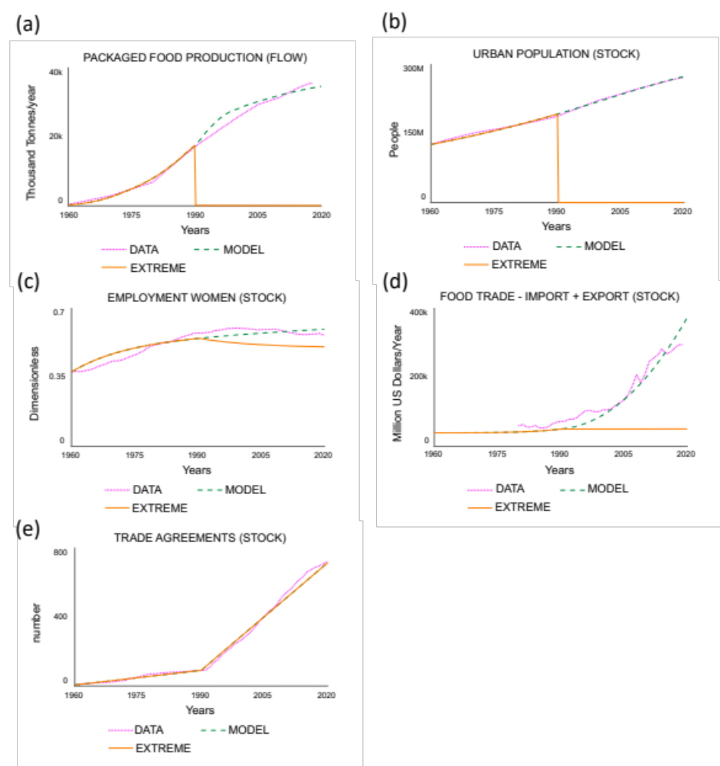
Figure S3. Extreme condition testing of the stock and flow model. The model was run as business-as-usual from 1960 – 1990, and with Urban Population = 0 for 1990 – 2020.

Section 6 - Degrowth policy proposals
Table S3. Packaged food reduction policies: degrowth proposals.
Strategy | Variable name | Degrowth proposal(s)  (Adapted from Chakori, Russell, et al. (2022); Cosme et al. (2017) | Degrowth category  (Adapted from Cosme et al. (2017)
1 | Effect of profit on average food trade growth rate | - Limit/regulate advertising  - Tax environmental externalities  - Tax waste generation  - Tax resource use  - Create regulatory bans for very harmful activities/technologies  - Encourage the breaking up of large corporations to avoid monopolies  - Tax international capital movement  - Not-for-profit food economy | - Consumption  - Equity  - Pollution  - Resource use
2 | Effect of global trade on packaged food production rate | - Tax environmental externalities  - Tax waste generation  - Tax the extraction of resources at origin and remove harmful subsidies for resource extraction  - Promote the use of local resources  - Create a moratorium/put cap on resource use and extraction  - Limit trade distances and volume  - Create incentives for local production and consumption  - Promote voluntarily reductions in commerce and trade  - Encourage the breaking up of large corporations to avoid monopolies  - Tax international capital movement | - Equity  - Pollution  - Resource use  - Trade
3 | Effect of employment women on packaged food production rate | - Promote changes in consumption patterns  - Tax consumption  - Create a basic citizen’s income  - Promote work-sharing and job-sharing  - Reduce working hours  - Increase shared (cooking) tasks women and men – Reduced gender inequality | - Access to goods and services  - Consumption  - Free time  - Socio-economic opportunities
4 | Effect of urbanisation on rate of population dependent of food purchasing at supermarket | - Promote organic farming/sustainable agriculture  - Promote the use of local resources  - Create incentives for local production and consumption  - Create a basic citizen’s income  - Promote work-sharing and job-sharing  - Encourage small, local enterprises | - Access to goods and services  - Production  - Resource use  - Socio-economic opportunities  - Trade

