Supplementary file 3. Cosine similarity of the top 50 investors in the network, sorted by closeness to the Big Three

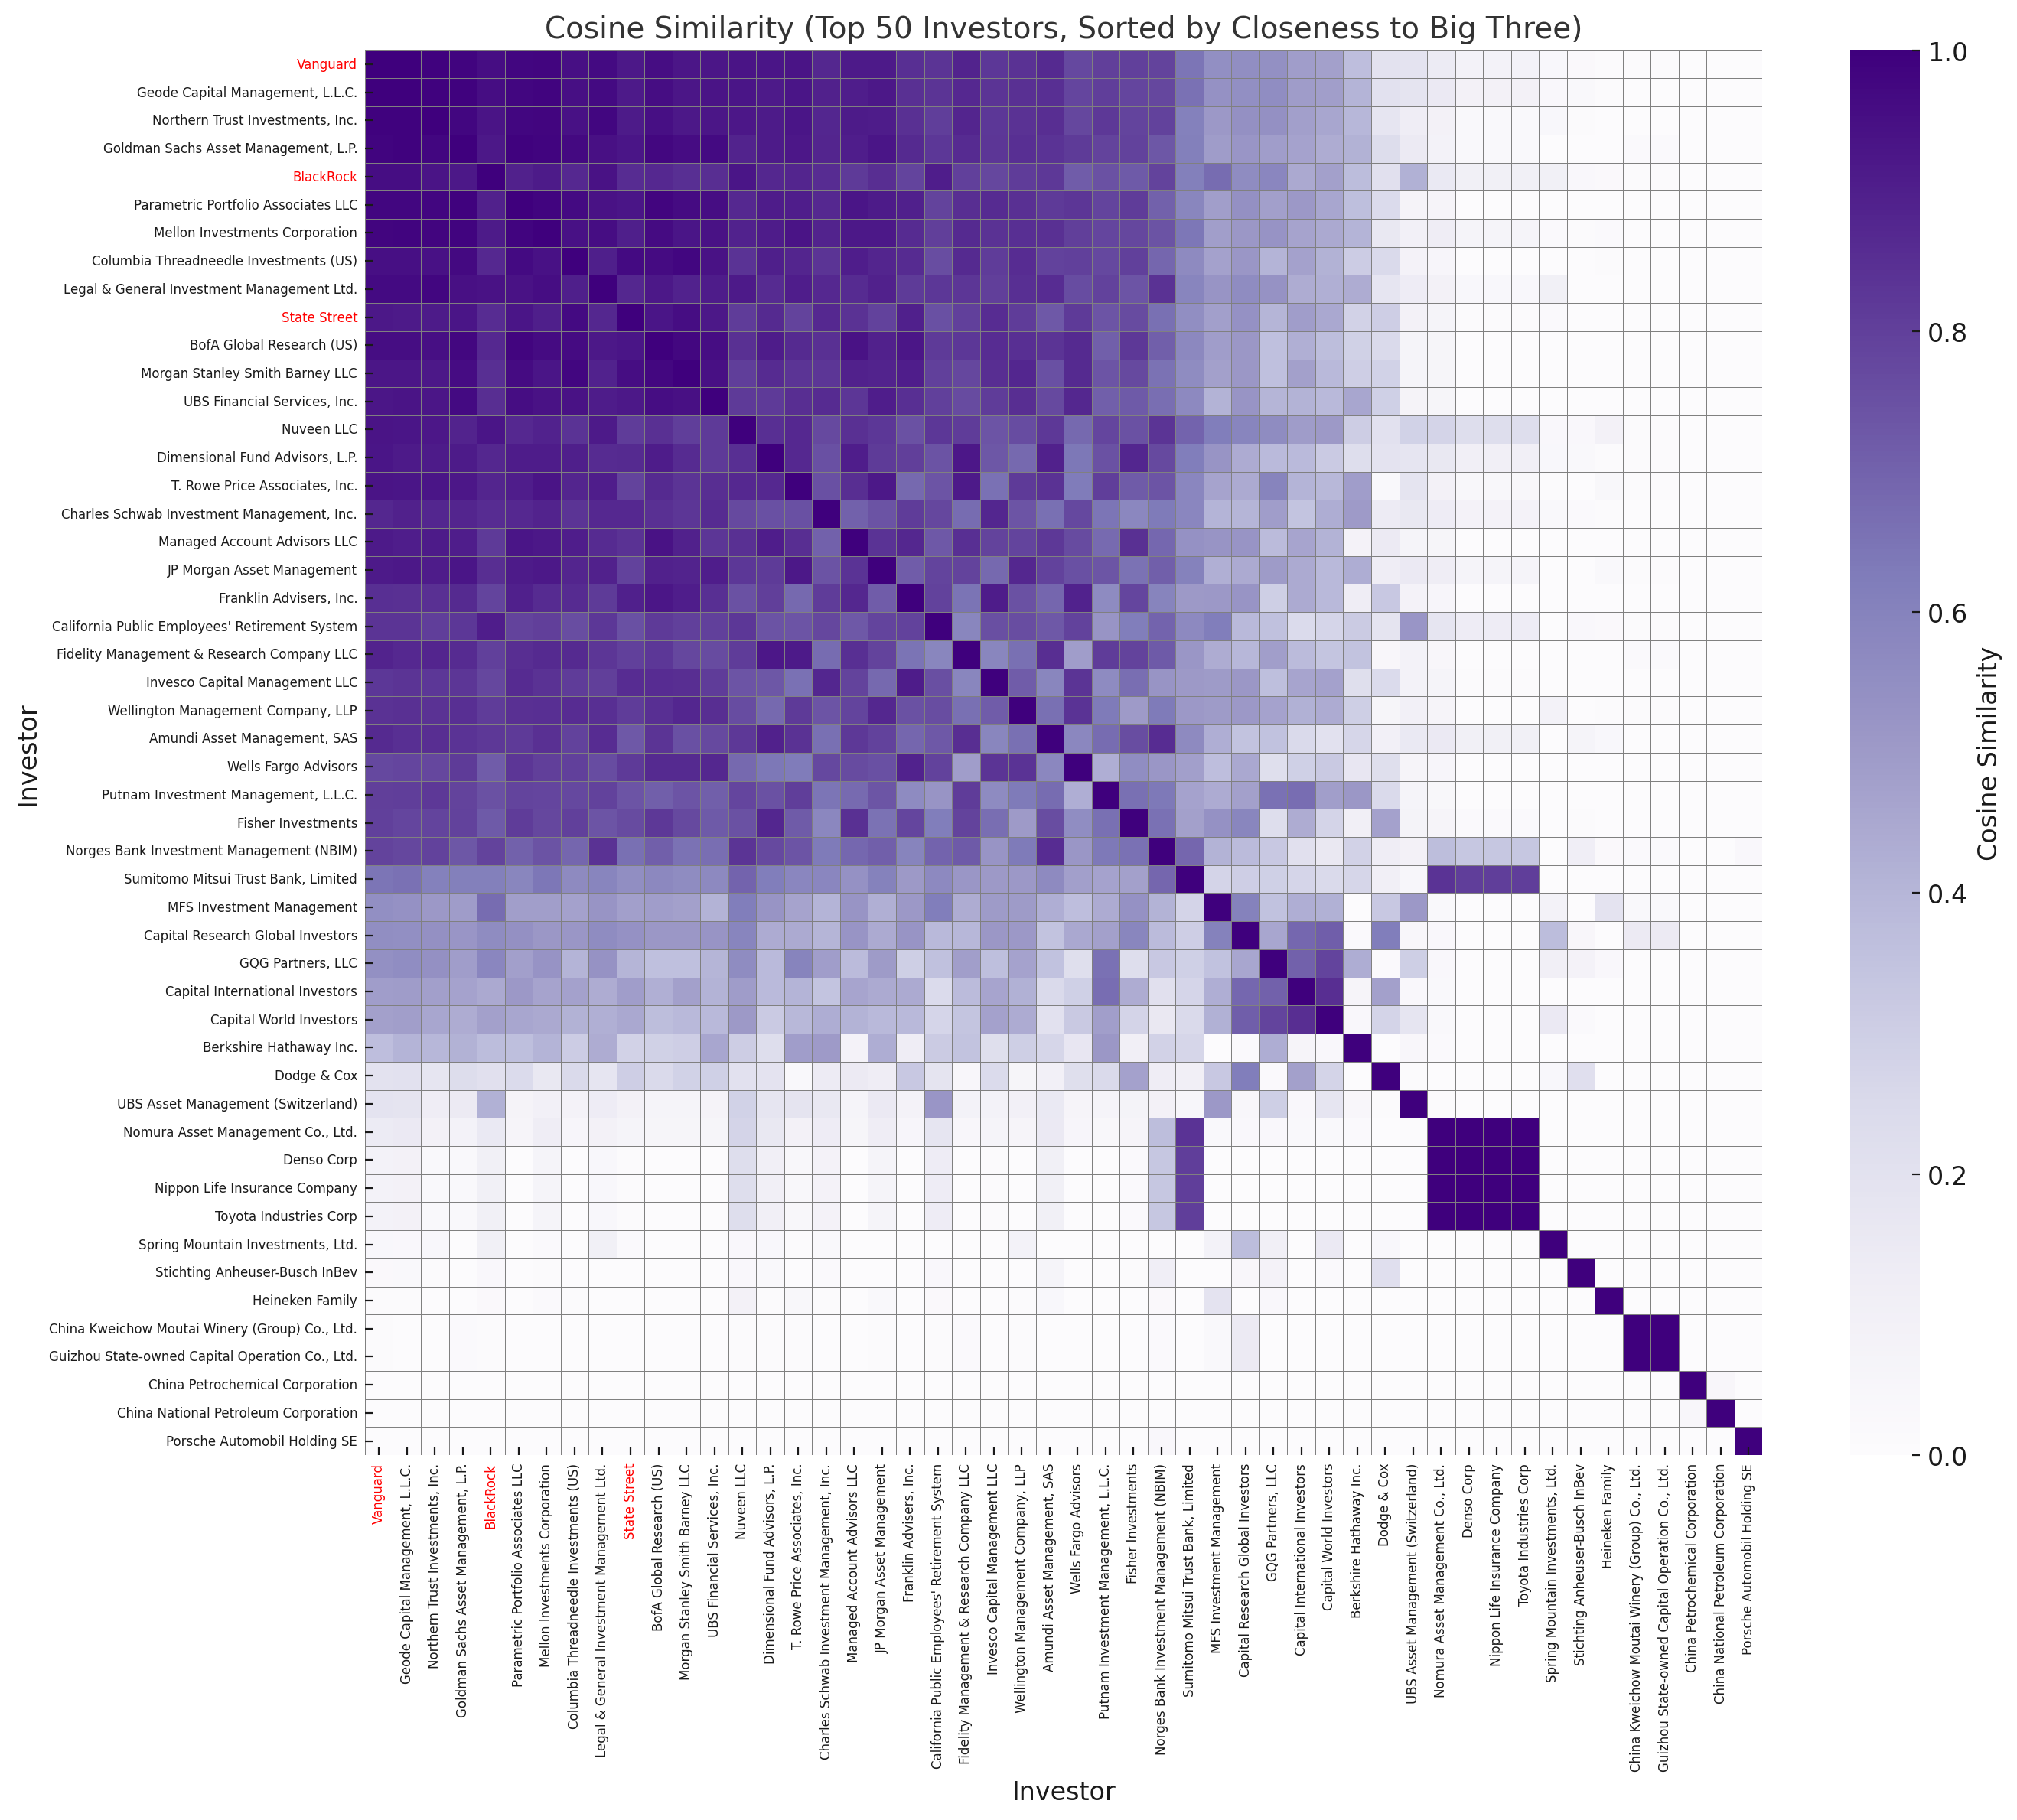
Data sources: This diagram includes the top 50 shareholders based on the total value of shares held in the four leading publicly listed corporations in terms of 2023 revenues across the following 10 health-harming commodity industries: tobacco manufacturing, fossil fuel production, alcohol manufacturing, ultra-processed food manufacturing, weapons manufacturing, gambling, intensive meat production, agricultural chemicals, automobile manufacturing, and fast food retail.

