Additional file 3:Figure S1.
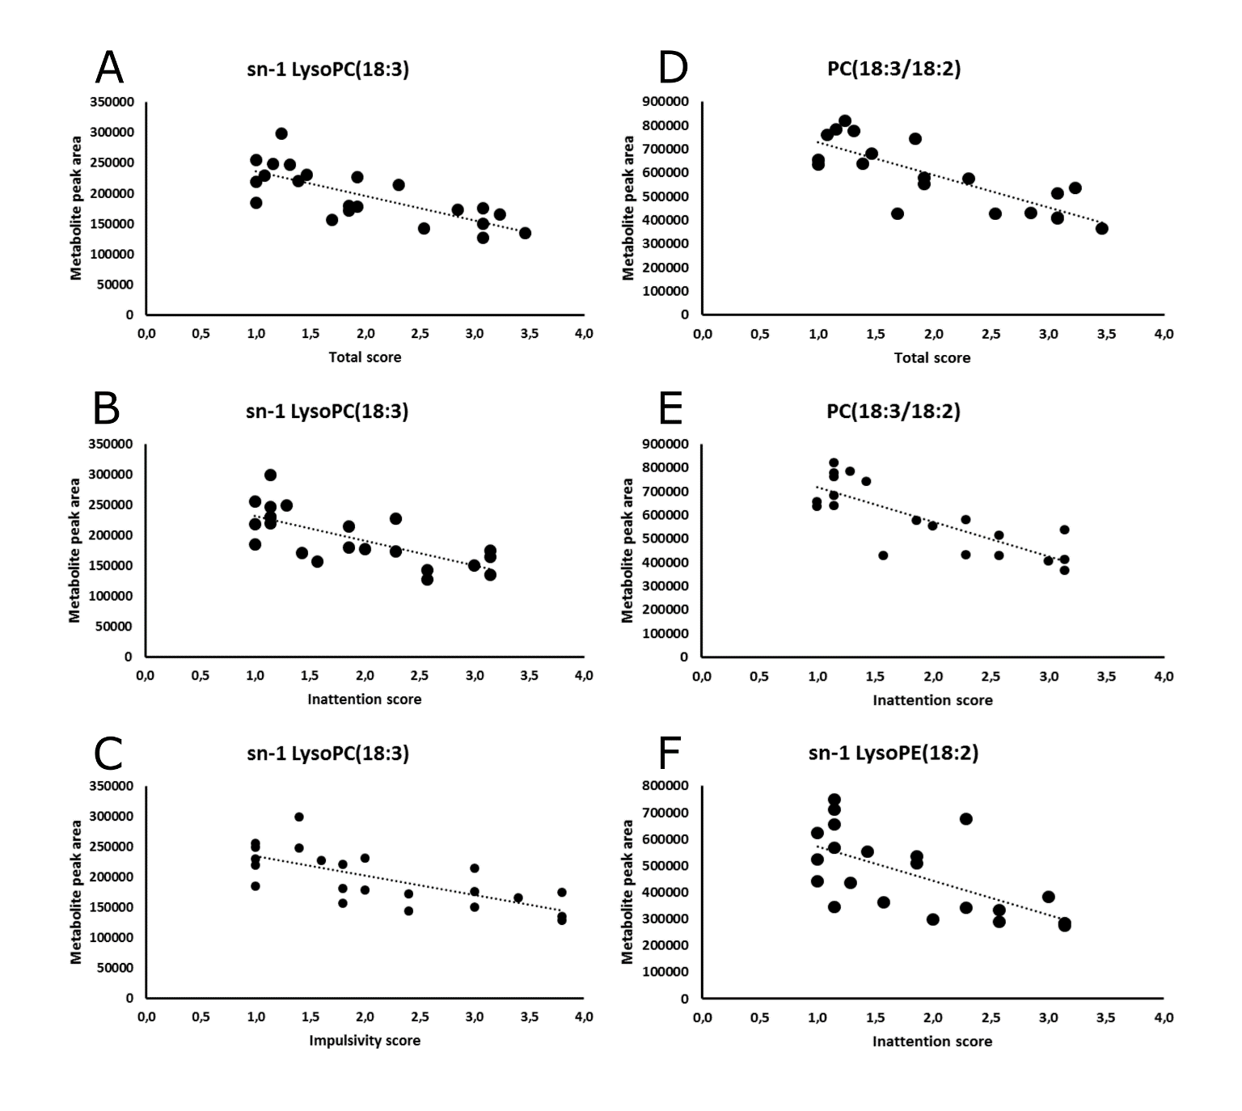Sample distributions for sn-1 LysoPC(18:3) (A-C), PC(18:3/18:2) (D-E), and sn-1 LysoPE(18:2) (F). The ADHD-like behavioral scores (total, inattention and impulsivity) are along the x-axis, whereas the metabolite peak areas along the y-axis.

