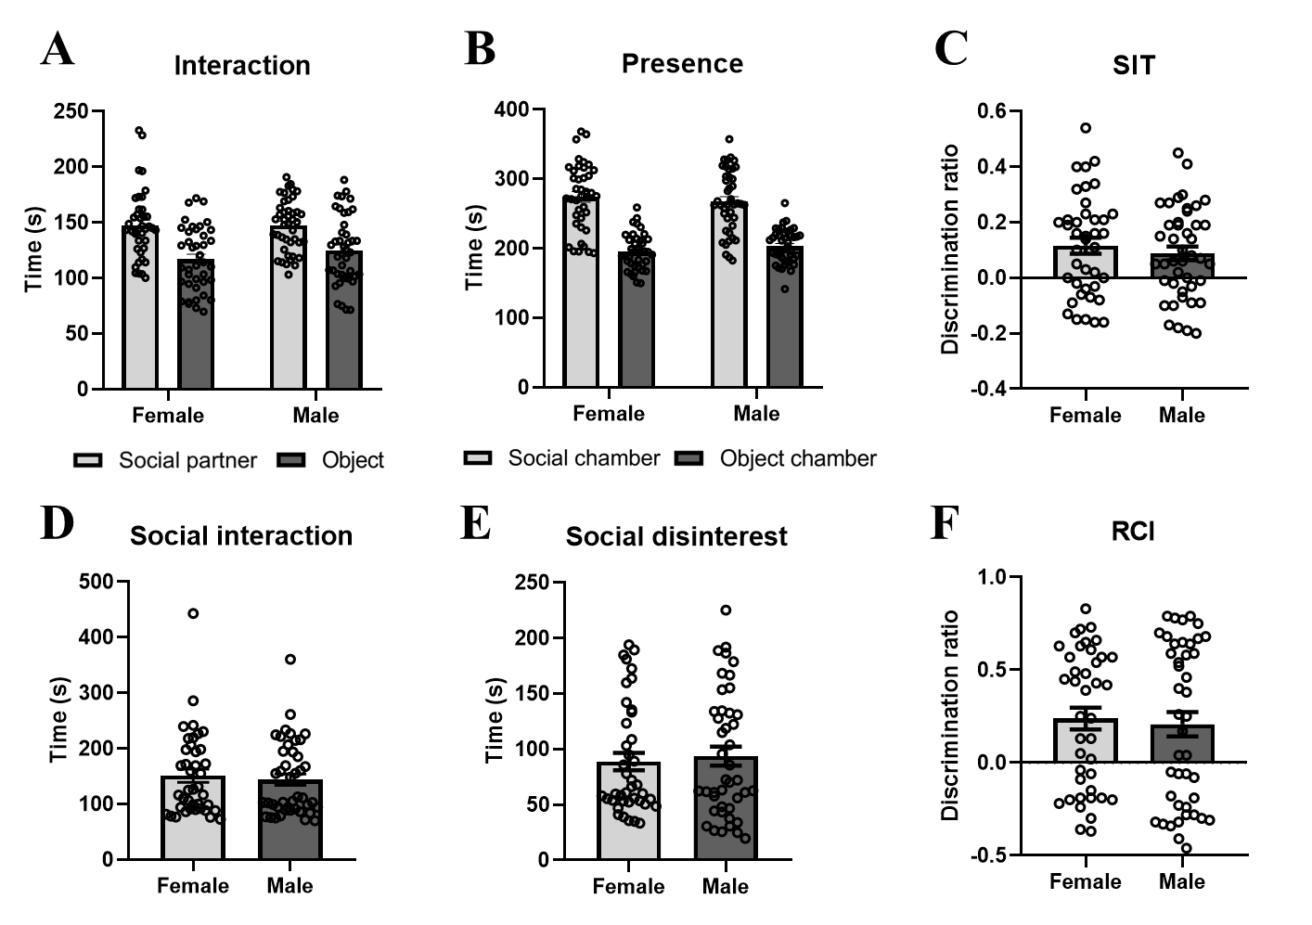
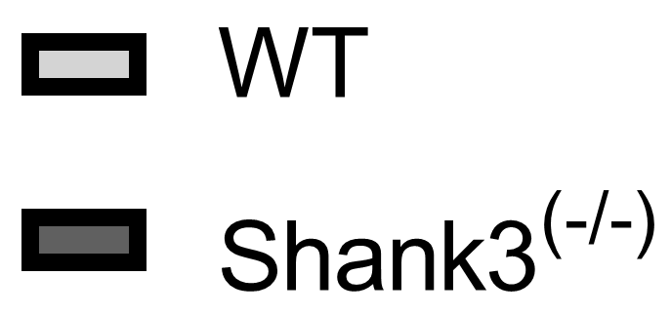
Fig. S1. Body weight measurement prior to the behavioral assessment. WT Wild-type animal; Shank3^{(-/-)} Shank3-deficient animal.
Fig. S2. Sex comparison in A. cumulative time spent in interaction with a social partner animal and an inanimate object in Three-Chamber Social Interaction test (SIT), B. cumulative time spent in a chamber with a social partner animal and an inanimate object in SIT, C. discrimination ratio as computed in SIT, D. cumulative time spent in interaction with a social partner animal in the Reciprocal Interaction Test (RCI), E. cumulative time spent without interest in social contact with a social partner animal in RCI, F. discrimination ratio as computed in RCI. WT Wild-type animal; Shank3^{(-/-)} Shank3-deficient animal.
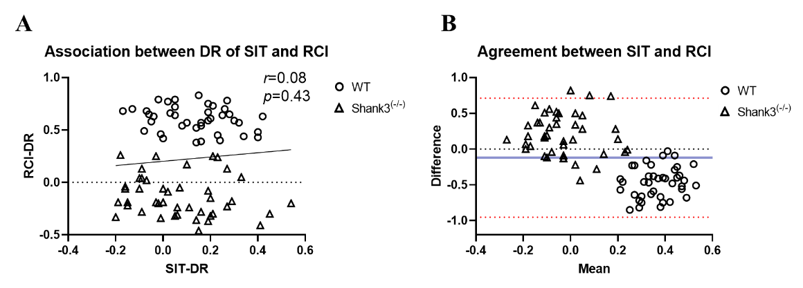
Fig. S3. A. Correlation between Discrimination ratio (DR) as computed in the Three-Chamber Social Interaction test (SIT) and in the Reciprocal interaction test (RCI). B. Bland-Altman plot computed to assess the agreement between the DR of SIT and RCI. r Pearson correlation coefficient; p probability. - - - Difference of 0. - - - Mean difference. - - - 95% Confidence intervals WT Wild-type animal; Shank3^{(-/-)} Shank3-deficient animal.

