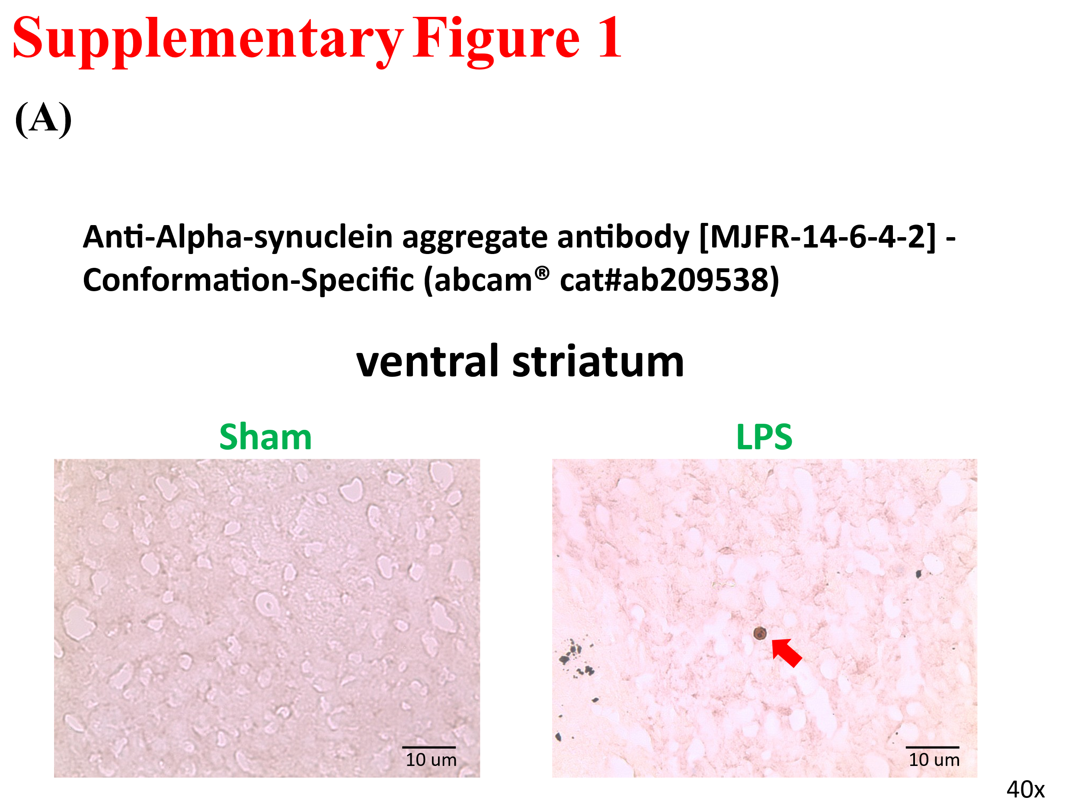

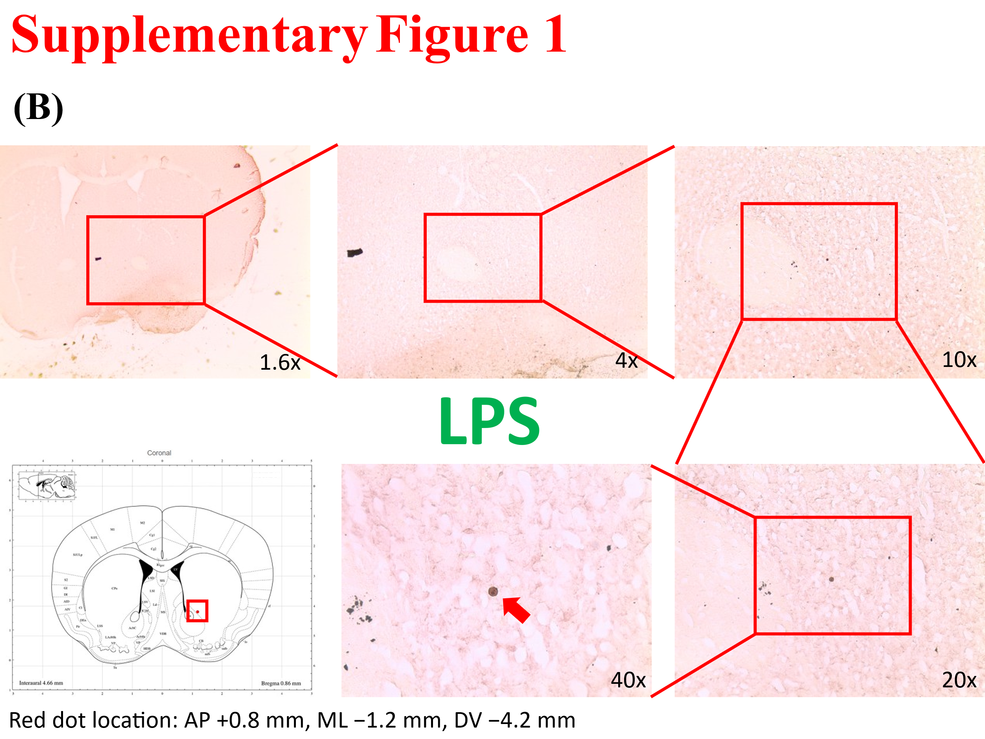

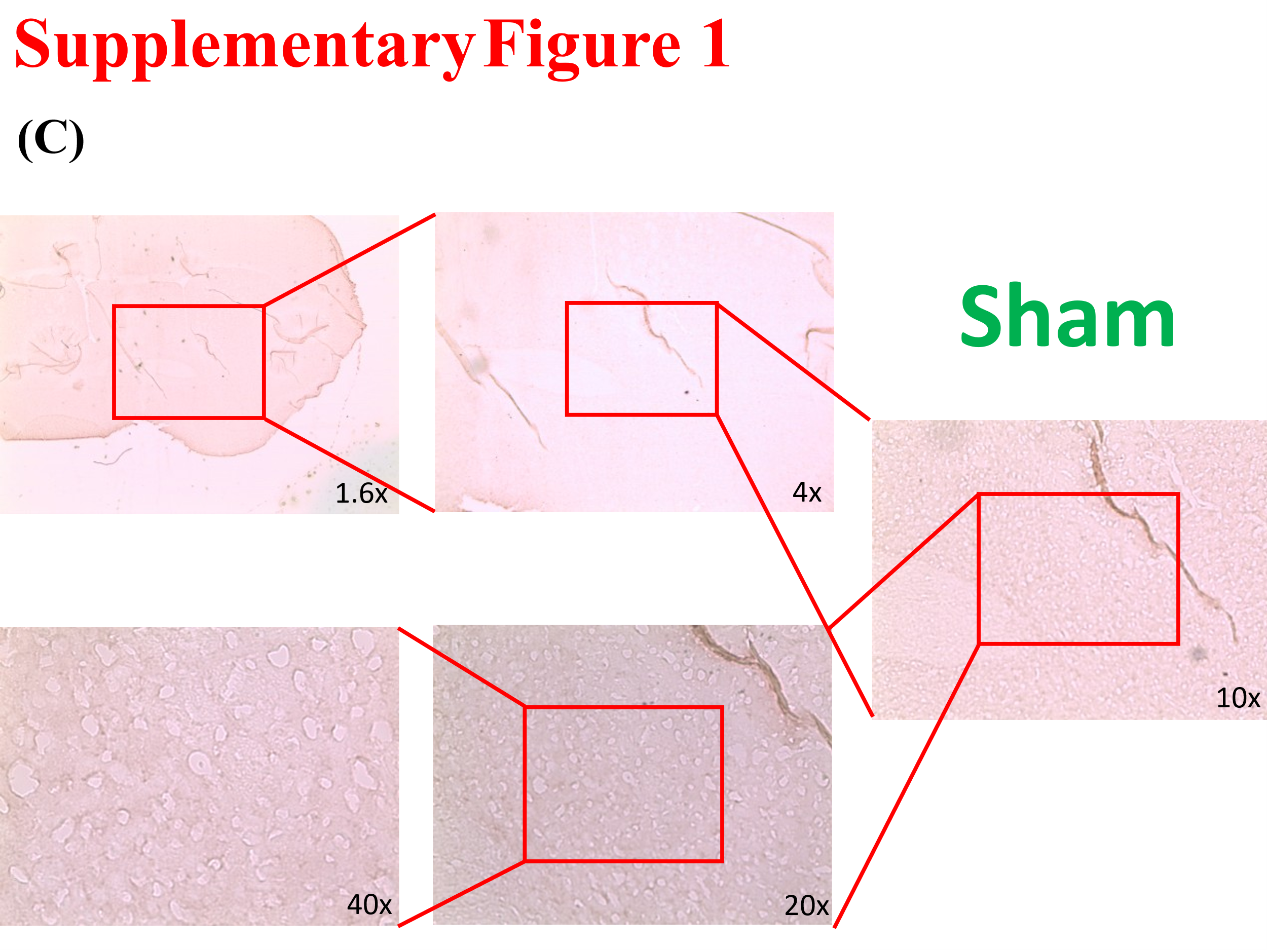
Supplementary Figure 1. Representative IHC images showing α-synuclein aggregate signals in the LPS group and Sham group. The staining was performed using a conformation-specific antibody MJFR-14-6-4-2 (Abcam®, cat# ab209538) for aggregated forms of α-synuclein. (A) High-magnification (40×) image of the LPS group showing sparse α-synuclein aggregates, with a representative aggregate indicated by a red arrow. (B) Stepwise magnification series (1.6×, 4×, 10×, 20×, 40×) used to localize the ventral striatum in the LPS group. The anatomical reference from the mouse brain atlas is shown in the lower-left corner. (C) Stepwise brain region localization in the sham group, used as a control. Sparse aggregate signals were detected in the ventral striatum of LPS-treated mice, while no clear staining was observed in the sham group.

