Supplemetary material
Sex-specific neurological dysregulation may underpin distinctly different male and female behavioural phenotypes in autism spectrum disorder

L Pretorius¹*, T Moodley¹, C Smith¹

¹Experimental Medicine, Department of Medicine, Faculty of Medicine and Health Sciences, Stellenbosch University, Cape Town, 7500, South Africa.

*Corresponding author: lesha@sun.ac.za

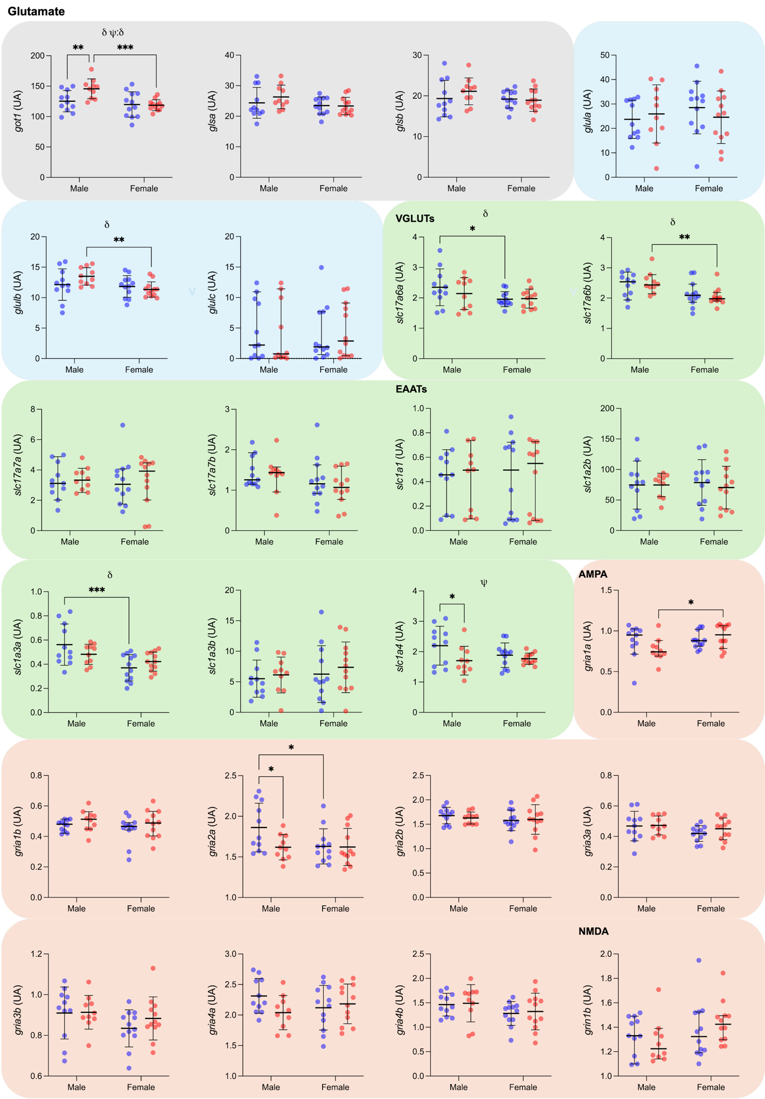
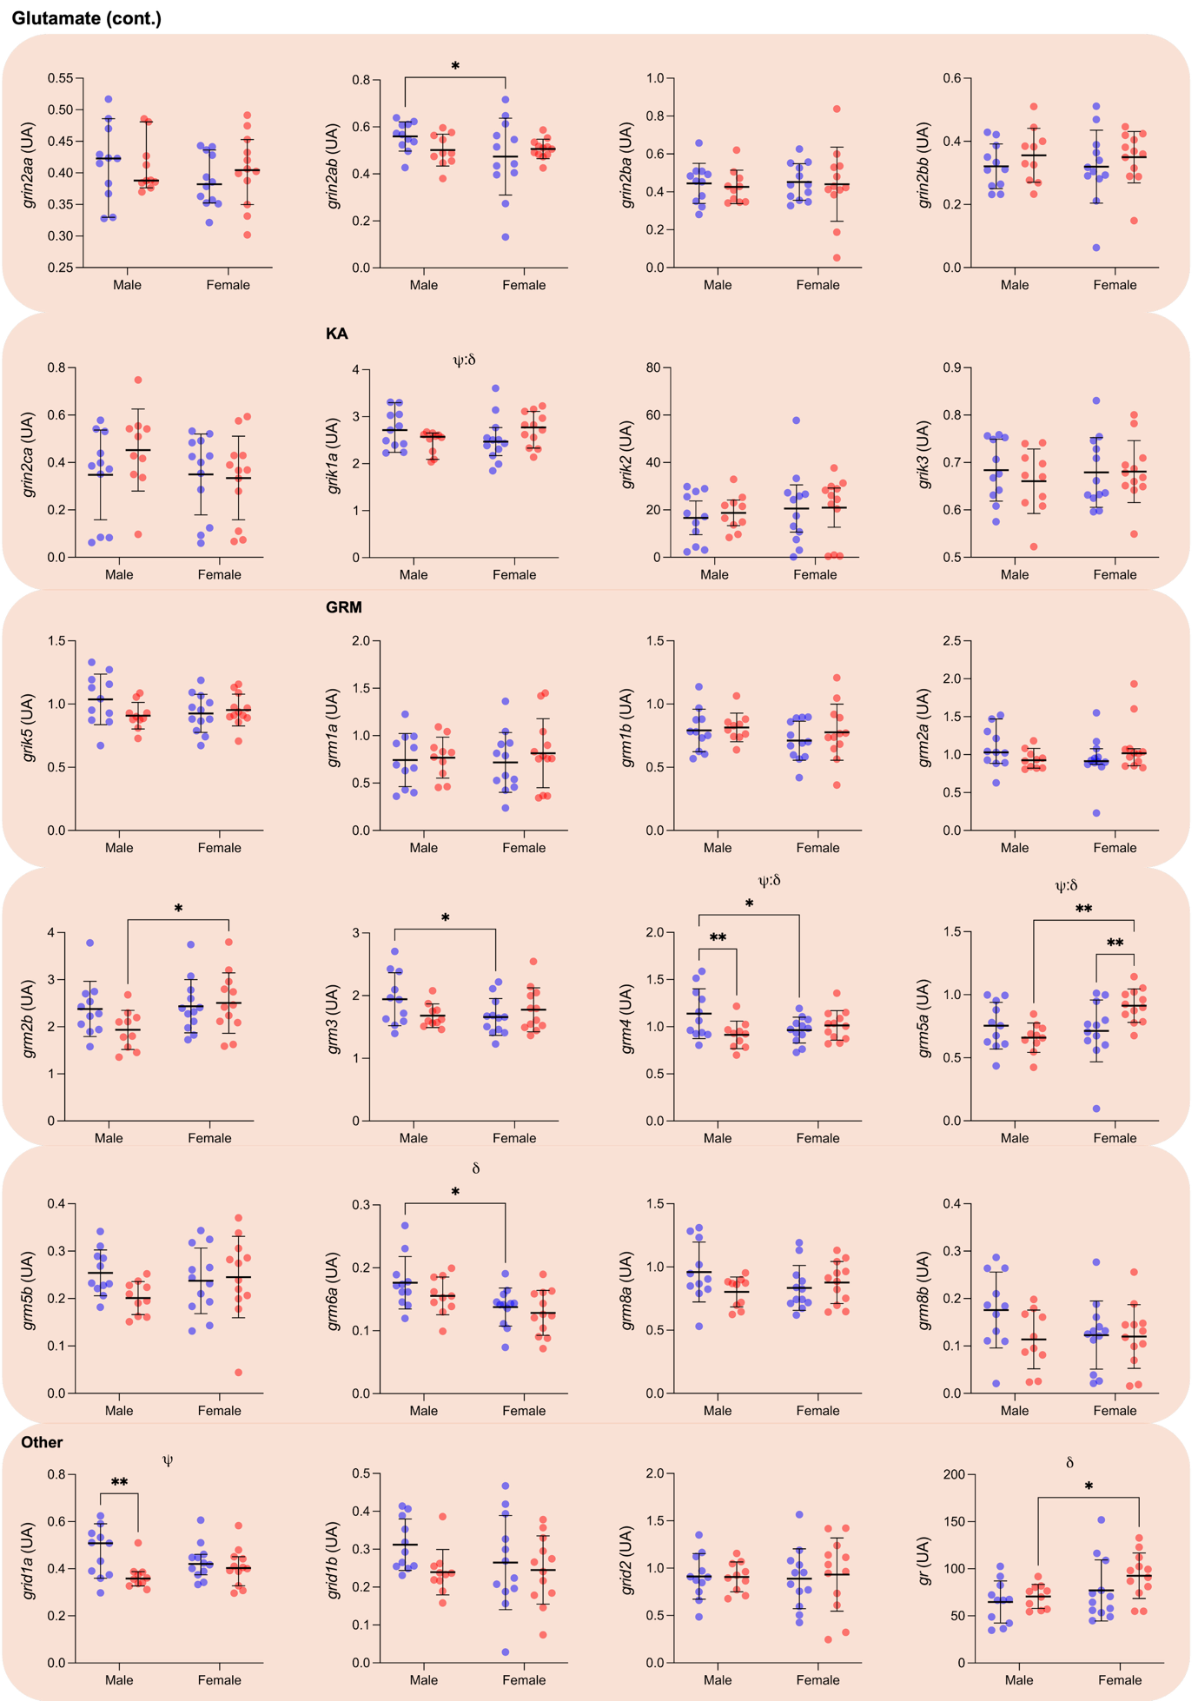

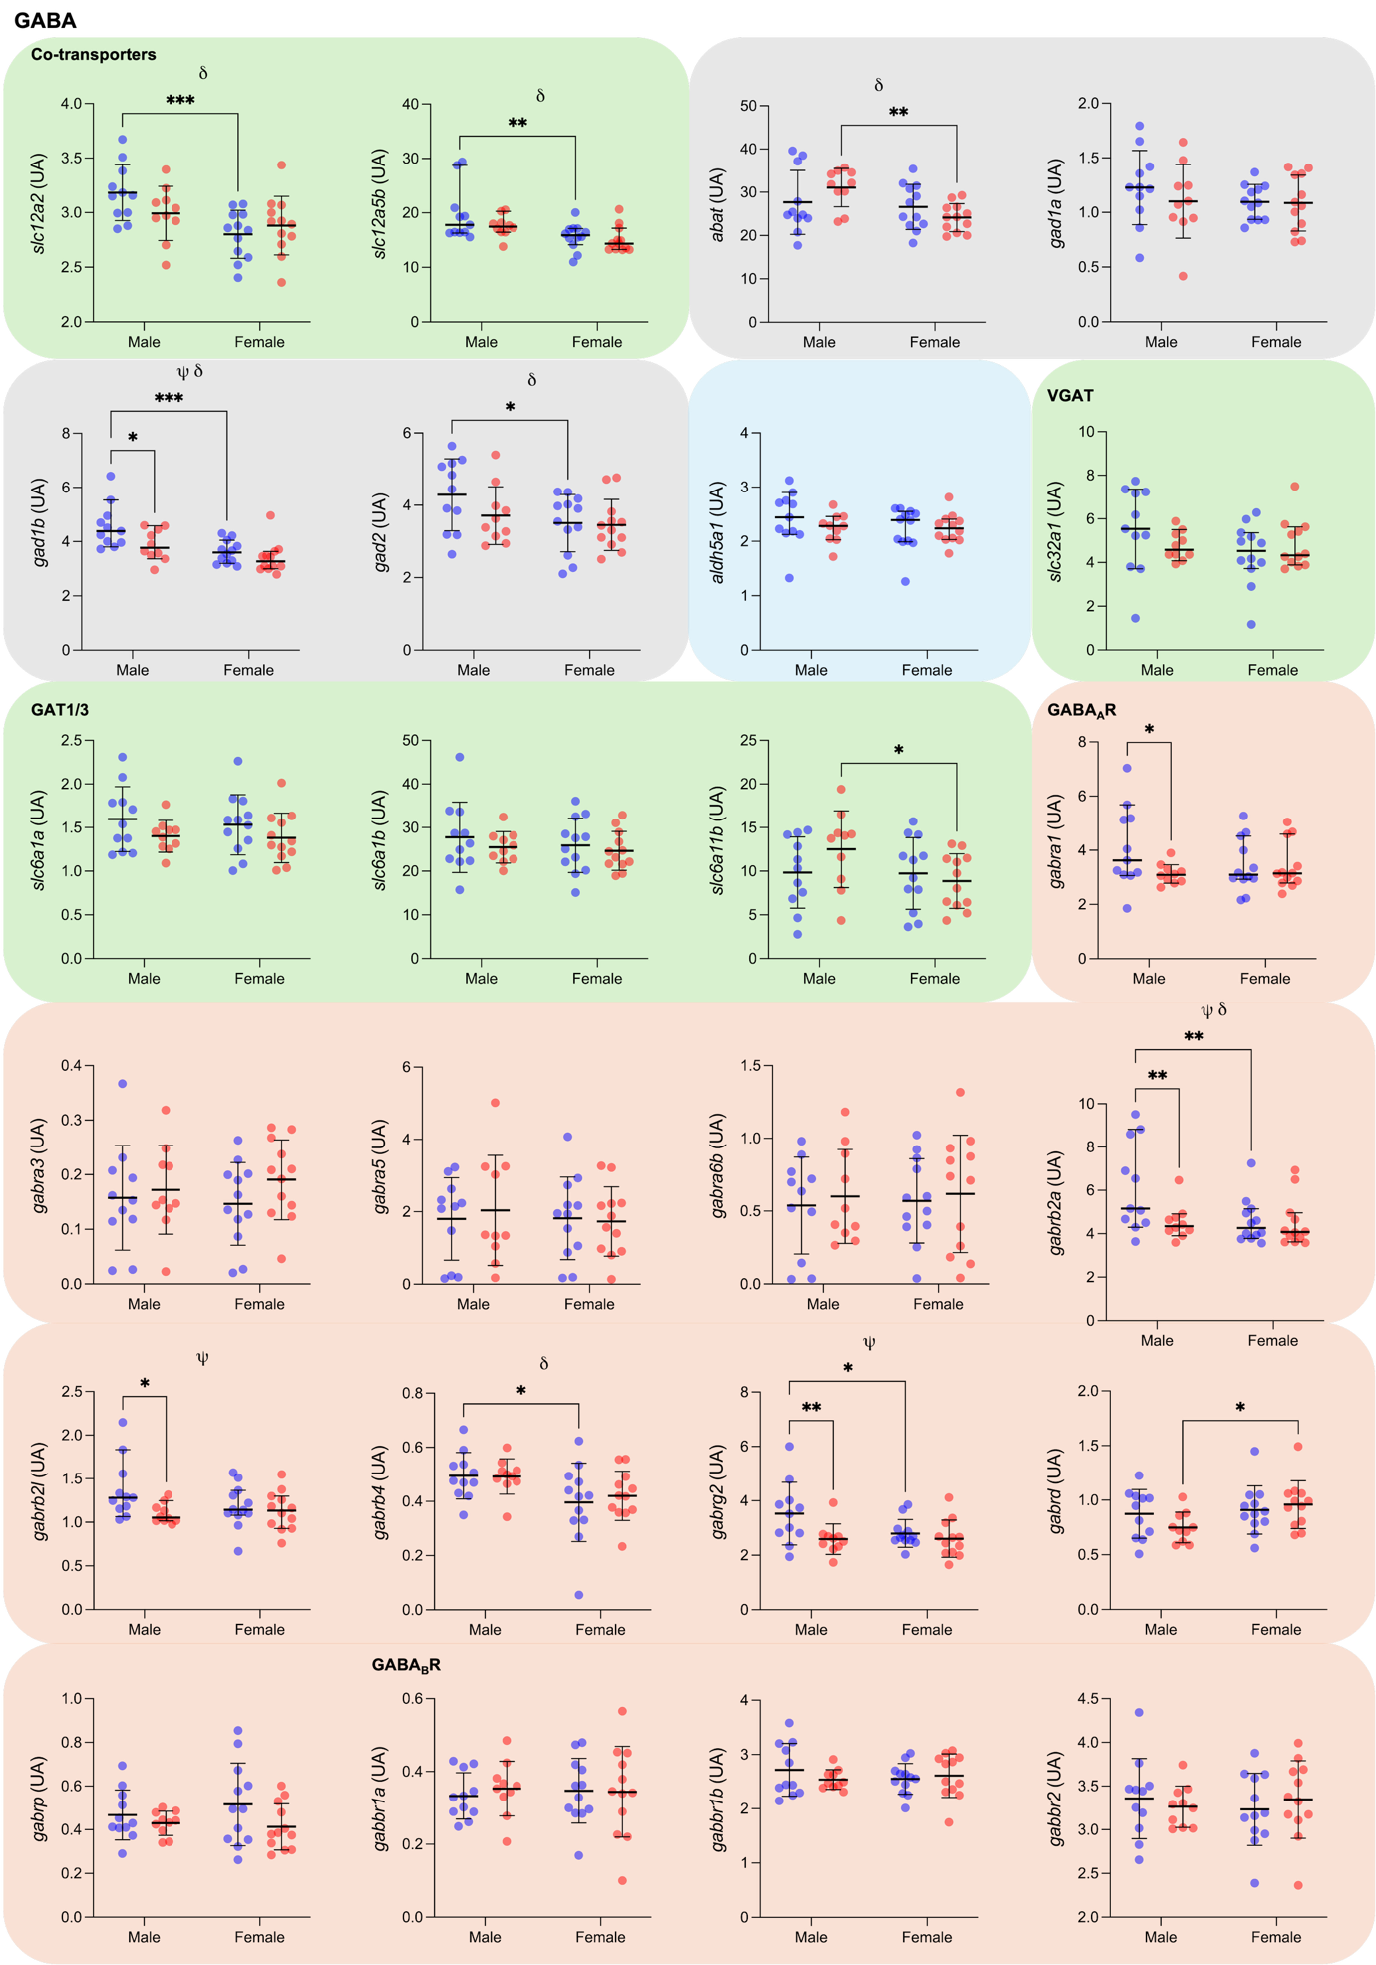

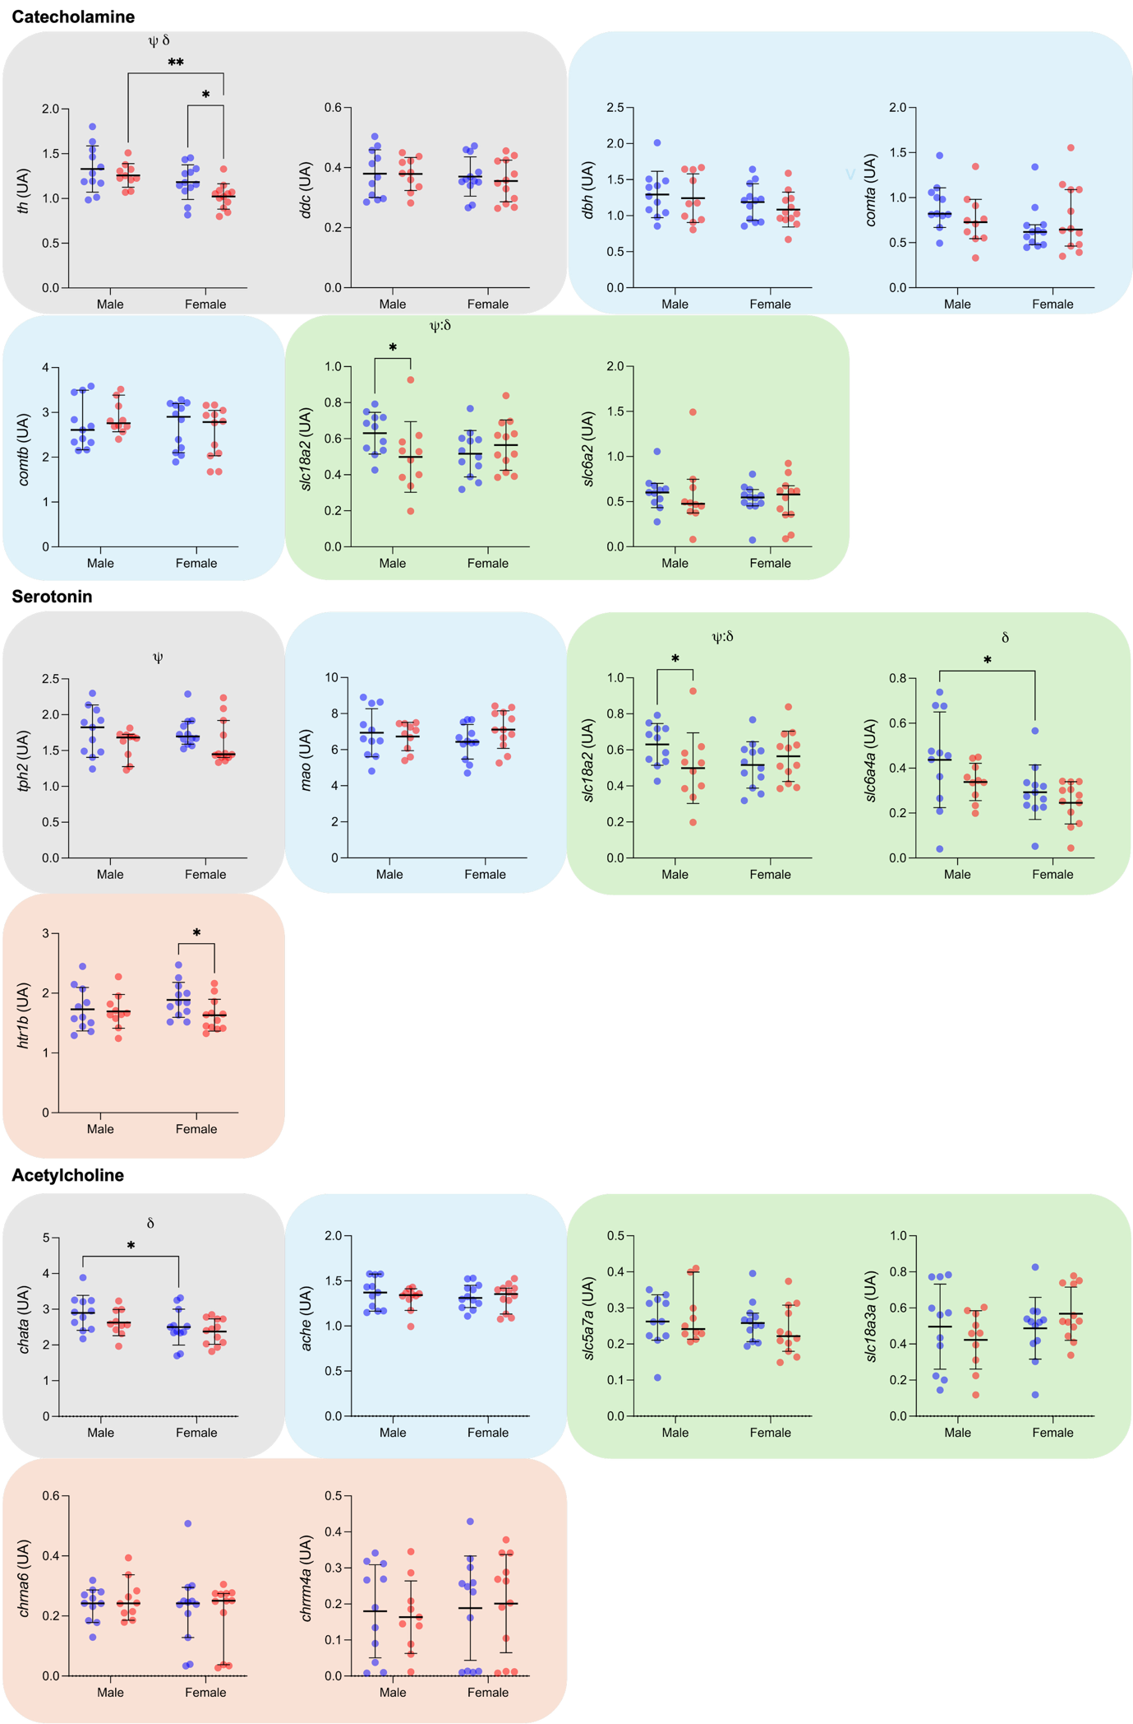
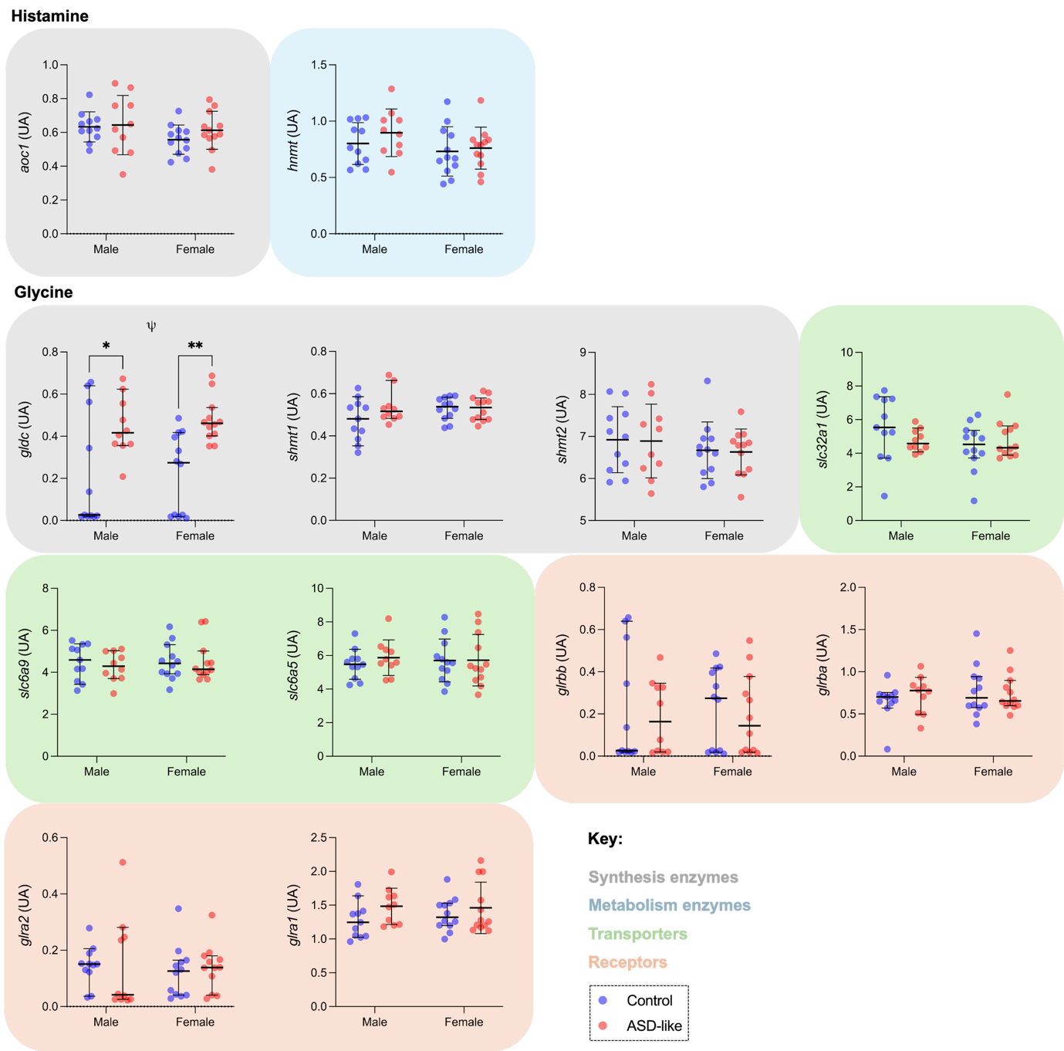
SM Figure 1: Differential neurotransmission-specific brain proteome results comparing control male and female and ASD-like male and female zebrafish at 7 mpf. Data are presented as scattered dot plots with mean ± SD (parametric) or median ± 95% CI (non-parametric), n=12/sex/group. Statistical analysis: 2-way ANOVA – main ANOVA effects of sex (δ), ASD induction (ψ) and/or their interaction (ψ:δ) are indicated – with Fisher’s LSD multiple comparison test, * p<0.05, ** p<0.01 and *** p<0.001.

