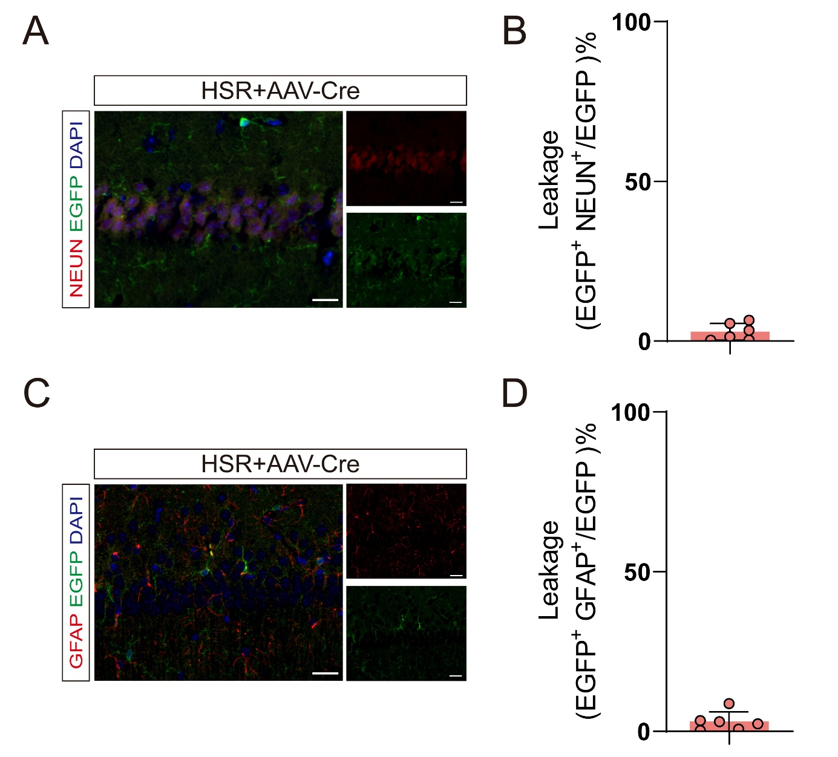

Supplemental figure1. (A) Representative confocal images showing co‑immunofluorescence staining of EGFP (green) with NeuN (red, upper panel) in the hippocampal CA1 region of HSR + AAV‑Cre mice. Scale bars: 50 μm (B) Quantification of off‑target Cre leakage in NeuN⁺ neurons, expressed as the percentage of EGFP⁺ NeuN⁺ cells among total EGFP⁺ cells. (C) Representative confocal images showing co‑immunofluorescence staining of EGFP (green) with GFAP (red) in the hippocampal CA1 region of HSR + AAV‑Cre mice at higher magnification, confirming the absence of EGFP expression in astrocytes. Nuclei were counterstained with DAPI (blue). Scale bars: 50 μm.(D) Quantification of off‑target Cre leakage in GFAP⁺ astrocytes, expressed as the percentage of EGFP⁺GFAP⁺ cells among total EGFP⁺ cells.

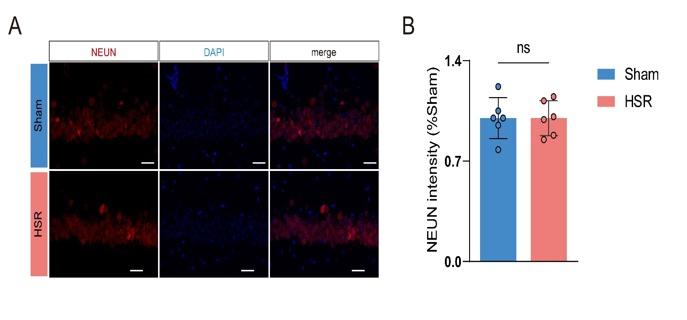

Supplemental figure 2. (A) Representative confocal images showing immunofluorescence staining of NeuN (red) and nuclear counterstaining with DAPI (blue) in the hippocampal CA1 region. Merged images (merge) are shown. Scale bars: 50 μm. (B) Quantification of NeuN intensity in the CA1 region, expressed as percentage of the Sham group. Data are presented as mean ± SD (n =6 per group).

