Supporting information Legend
Table S1 Demographic characteristic of the THS patients and TCE contacts
Table S2 RNA yield and quality assessment in 10 serum samples
Table S3 The clinical characteristics of 39 THS patients
Table S4 69 differentially expressed miRNAs between THS patients and TCE contacts
Table S5 Liver functions of THS patients and TCE contacts
Figure S1 Heat map and hierarchical clustering of differential miRNAs.
Figure S2 The target genes prediction of miR-21 and miR-339

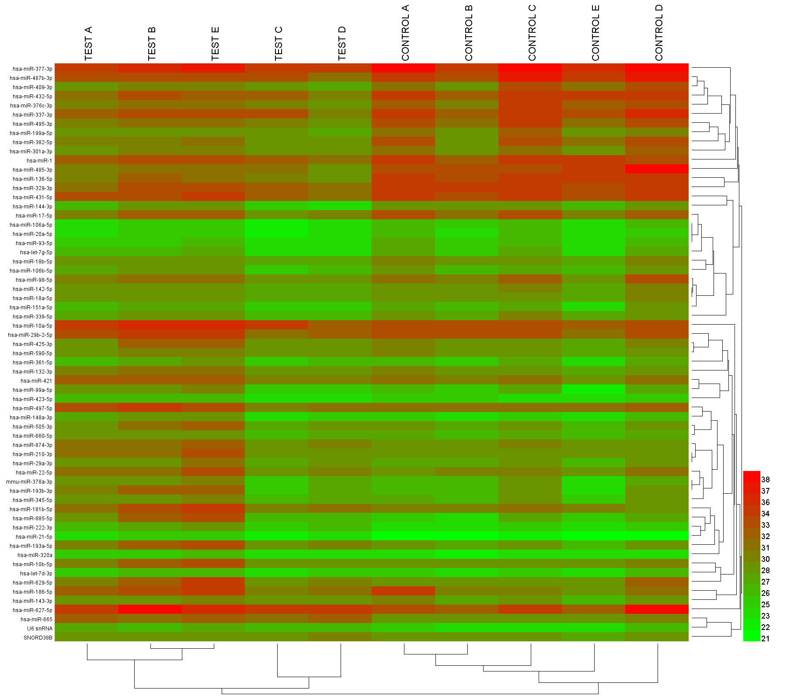
Figure S1 Heat map and hierarchical clustering of differential miRNAs. The heat map indicates the results of a two-way hierarchical clustering of miRNAs and samples. The upper test A, B, C, D, E represent the THS patient samples, while the control A, B, C, D, E represent the TCE contact samples. Each row represents a miRNA and each column represents a sample. The miRNA clustering tree is shown on the right. The color scale displays the relative expression level of a miRNA in the certain slide: red, high relative expression level; green, low relative expression level.

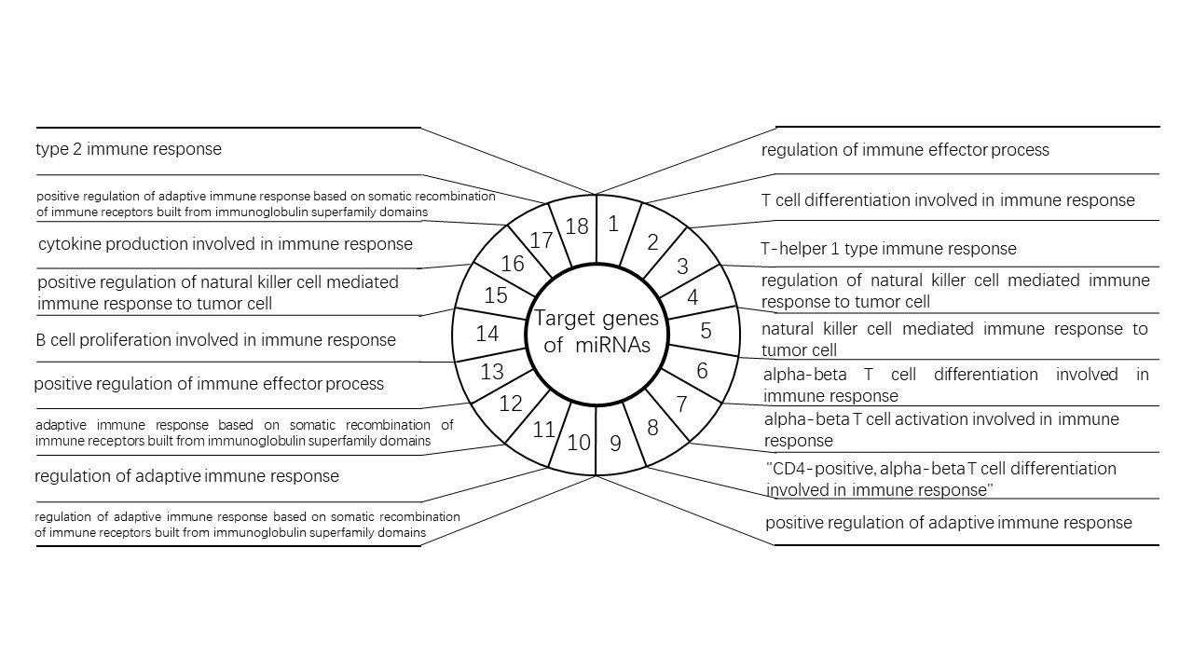
Figure S2 The target genes prediction of miR-21 and miR-339

Table S1 Demographic characteristic of the THS patients and TCE contacts (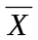±SEM)
Groups | Items | Total
THS patients | Male / Female | 26 / 13
THS patients | Average age (Years) | 25.5±6.2
THS patients | Exposure period (Working days) | 31.1±2.2***
TCE contacts | Male / Female | 25 / 14
TCE contacts | Average age (Years) | 25.9±9.3
TCE contacts | Exposure period (Working days) | 562.1±101.2
*** p< 0.001 vs TCE contacts.

Table S2 RNA yield and quality assessment in 10 serum samples
Sample | OD₂₆₀ | OD₂₈₀ | OD₂₆₀/OD₂₈₀ | RNA concentration (μg/μL)
Patient 1 | 1.2 | 0.7 | 1.7 | 48.8
Patient 2 | 1.0 | 0.6 | 1.6 | 41.6
Patient 3 | 1.1 | 0.8 | 1.4 | 43.1
Patient 4 | 0.8 | 0.5 | 1.6 | 32.2
Patient 5 | 1.0 | 0.6 | 1.7 | 40.8
TCE contact 1 | 1.6 | 0.9 | 1.7 | 62.1
TCE contact 2 | 1.6 | 1.0 | 1.6 | 62.8
TCE contact 3 | 1.5 | 1.0 | 1.5 | 60.3
TCE contact 4 | 1.6 | 0.9 | 1.7 | 61.8
TCE contact 5 | 1.4 | 0.8 | 1.7 | 57.4

Table S3 The clinical characteristics of 39 THS patients
Symptoms | Headache | Appetite decrease | Fatigue | Vomiting | Fever
Positive patients | 12 | 31 | 15 | 10 | 33
Positive rate (%) | 30.8 | 79.5 | 38.5 | 25.6 | 84.6
signs | Rash | Lymph node enlargement | Eyes lesion | Liver damage
Positive patients | 39 | 24 | 22 | 32
Positive rate (%) | 100 | 61.5 | 56.4 | 82.1

Table S4 69 differentially expressed miRNAs between THS patients and TCE contacts
miRNAs | p | Change Folds
Up-regulated miRNAs
has-miR-885-5p | 0.04 | 12.86
has-miR-193a-5p | 0.00 | 8.72
has-miR-203a | 0.02 | 7.71
has-miR-34a-5p § | 0.03 | 7.46
has-miR-193b-3p § | 0.02 | 6.90
has-miR-665 | 0.01 | 5.77
has-miR-21-5p § | 0.02 | 5.47
has-miR-181b-5p | 0.02 | 5.33
has-miR-222-3p | 0.01 | 4.67
U6 snRNA | 0.00 | 4.61
has-miR-99a-5p | 0.04 | 4.41
has-miR-505-3p | 0.00 | 4.26
has-miR-452-5p | 0.04 | 4.24
mmu-miR-378a-3p | 0.03 | 4.13
has-miR-210-3p | 0.02 | 3.75
has-miR-627-5p | 0.03 | 3.57
has-miR-629-5p | 0.04 | 3.54
has-miR-148a-3p | 0.04 | 3.31
has-miR-10b-5p | 0.04 | 3.18
has-miR-29a-3p | 0.02 | 3.12
has-miR-149-5p | 0.04 | 2.97
has-miR-320a | 0.02 | 2.87
has-miR-10a-5p § | 0.02 | 2.81
SNORD38B | 0.03 | 2.76
has-miR-660-5p | 0.00 | 2.71
has-miR-874-3p | 0.02 | 2.71
has-miR-22-5p | 0.04 | 2.63
has-miR-497-5p | 0.02 | 2.58
has-miR-345-5p | 0.03 | 2.54
has-miR-132-3p | 0.03 | 2.46
has-miR-421 | 0.00 | 2.45
has-miR-186-5p | 0.03 | 2.30
has-miR-425-3p | 0.01 | 2.25
has-miR-423-5p | 0.03 | 2.02
has-let-7d-3p | 0.03 | 1.89
has-miR-143-3p | 0.04 | 1.72
has-miR-29b-2-5p | 0.01 | 1.69
has-miR-590-5p | 0.01 | 1.64
has-miR-361-5p | 0.03 | 1.61
Down-regulated miRNAs
hsa-miR-106b-5p | 0.04 | -1.28
hsa-miR-151a-5p | 0.03 | -1.47
hsa-let-7g-5p | 0.01 | -1.53
hsa-miR-142-5p | 0.00 | -1.60
hsa-miR-93-5p | 0.01 | -1.72
hsa-miR-17-5p | 0.01 | -1.73
hsa-miR-18a-5p | 0.00 | -1.81
hsa-miR-18b-5p | 0.00 | -1.86
hsa-miR-20a-5p | 0.00 | -1.89
hsa-miR-106a-5p | 0.00 | -1.97
hsa-miR-339-5p § | 0.01 | -2.04
hsa-miR-431-5p | 0.04 | -2.08
hsa-miR-98-5p | 0.00 | -2.12
hsa-miR-144-3p | 0.02 | -2.52
hsa-miR-377-3p | 0.01 | -2.71
hsa-miR-301a-3p | 0.01 | -2.77
hsa-miR-1 | 0.04 | -2.86
hsa-miR-337-3p | 0.04 | -2.88
hsa-miR-199a-5p | 0.01 | -3.14
hsa-miR-301b | 0.01 | -3.61
hsa-miR-382-5p | 0.01 | -3.71
hsa-miR-432-5p | 0.03 | -3.90
hsa-miR-495-3p | 0.00 | -4.05
hsa-miR-376b-3p | 0.01 | -4.08
hsa-miR-376c-3p | 0.00 | -4.15
hsa-miR-329-3p | 0.01 | -4.65
hsa-miR-409-3p | 0.01 | -5.09
hsa-miR-487b-3p | 0.01 | -6.25
hsa-miR-136-5p | 0.00 | -9.09
hsa-miR-485-3p | 0.01 | -12.22
§ These miRNAs were selected for larger sample validation.

Table S5 Liver functions of THS patients and TCE contacts (±SEM)
Groups | TP | ALB | GLB | TBIL | DBIL | IBILI | ALT | AST | GGT | ALP
THS | 59.3±8.1 * | 34.0±4.8 * | 29.1±21.4 * | 45.1±59.7 * | 25.0±31.9 * | 20.1±28.6 * | 385.4±401.9 * | 183.8±349.2 * | 186.3±152.5 * | 157.3±93.3 *
Control | 74.0±4.2 | 44.1±3.9 | 29.2±6.1 | 9.5±2.3 | 4.3±1.9 | 5.9±1.9 | 18.7±10.7 | 19.2±4.7 | 21.1±10.2 | 93.4±53.8
* p< 0.05 vs TCE contacts. TP, total protein; ALB, albumin; GLB, globulin; TBIL, total bilirubin; DBIL, direct bilirubin; IBIL, indirect bilirubin; ALT, alanine aminotransferase; AST, aspartate aminotransferase; GGT, glutamyl transpeptidase; ALP, alkaline phosphatase.

