Additional File 1

Table AF 1: Inclusion and exclusion criteria for study participation.
Inclusion criteria | Exclusion criteria
female and/or male | female subjects: Pregnancy or lactation
between 18 and 70 years of age | conditions which exclude a participation or might influence the test reaction/evaluation such as concomitant medications having the potential to interfere with the study (e.g. anti-inflammatories and photosensitizing drugs)
written Informed Consent to participate in the study | AIDS, HIV positive or infectious hepatitis if known to the subjects
healthy skin in the test areas | drug addicts, alcoholics
willingness to actively participate in the study and to come to the scheduled visits | participation or being in the waiting period after participation in similar cosmetic and/or pharmaceutical studies
 | documented allergies to sunscreen products
 | active skin disease at the test area
 | any topical medication at the test areas
 | irregularly tanned skin on the test areas
 | regular use of tanning beds
 | moles, tattoos, scars, irritated skin, hairs, etc. at the test areas that could influence the investigation
 | no medical history of dysplastic nevi or melanoma, of abnormal response to sunlight

Figure AF 1:
Figure title: Evaluation of absorption time.
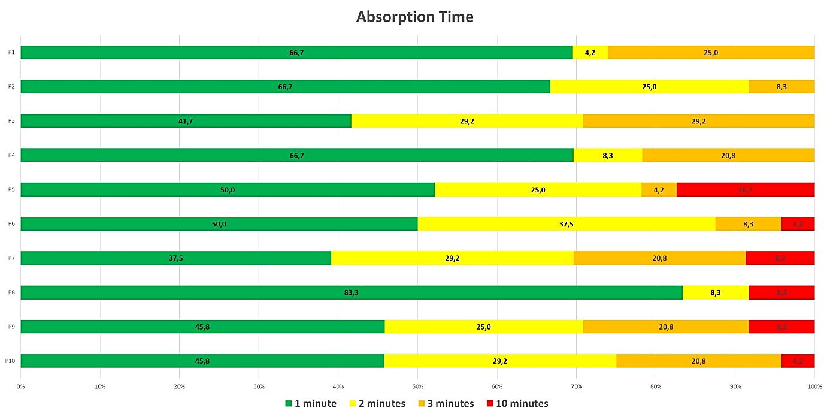
Figure legend: Absorption time was assessed 1, 2, and 3 minutes after test product application and, if applicable, 10 minutes after application, if not yet absorbed after 3 minutes. Data show percentages of “yes” ratings at assessment time. Single subjects stated an absorption time of 10 minutes regarding products P5 – P 10 while none of the subjects stated an absorption time longer than 3 minutes for codes P1, P2, P3 and P4. The shortest time to be absorbed was found for code P8.
Figure AF 2:
Figure title: Evaluation of subjective evaluation of skin feeling on wood.
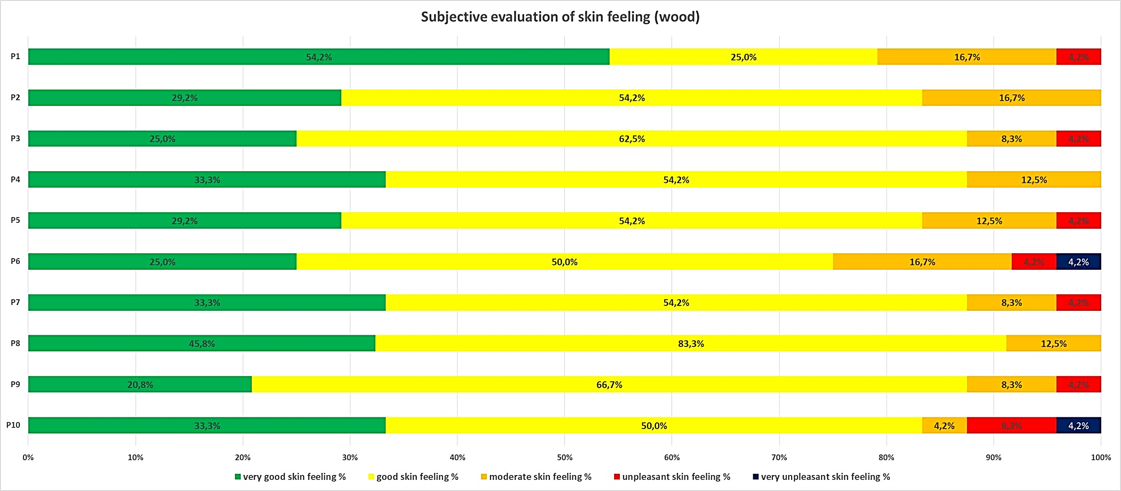
Figure legend: Subjective evaluation of skin feeling on a wooden bar after an absorption time of 3 minutes. Participants rated subjective skin feeling on a 5-point Likert scale. Favorable: Includes the answers for "very good skin feeling", "good skin feeling" and "moderate skin feeling". Unfavorable: Includes the answers for "unpleasant skin feeling" and "very unpleasant skin feeling".

Figure AF 3:
Figure title: Evaluation of subjective evaluation of skin feeling on metal.
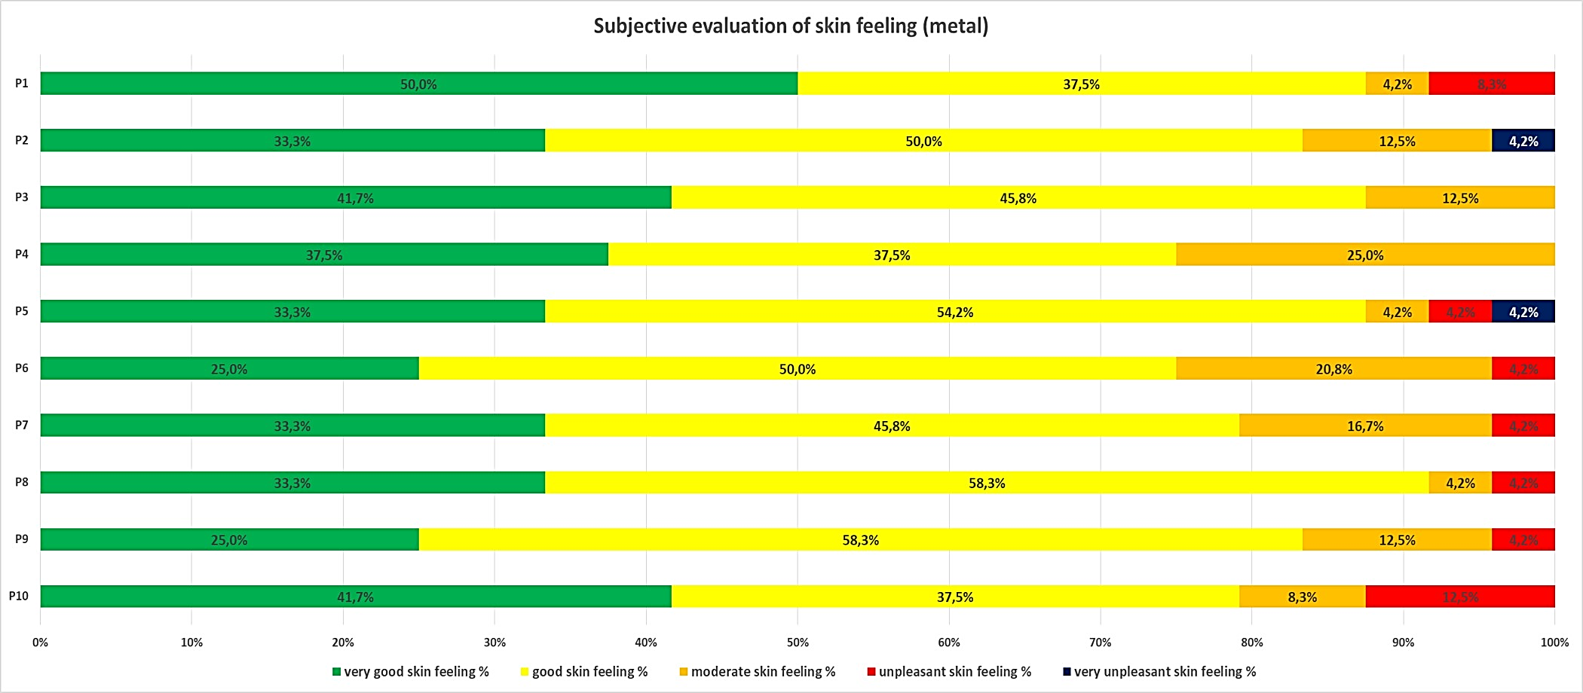
Figure legend: Subjective evaluation of skin feeling on a metal bar after an absorption time of 3 minutes. Participants rated subjective skin feeling on a 5-point Likert scale. Favorable: Includes the answers for "very good skin feeling", "good skin feeling" and "moderate skin feeling". Unfavorable: Includes the answers for "unpleasant skin feeling" and "very unpleasant skin feeling".

Figure AF 4:
Figure title: Evaluation of non-slip grip on wood.
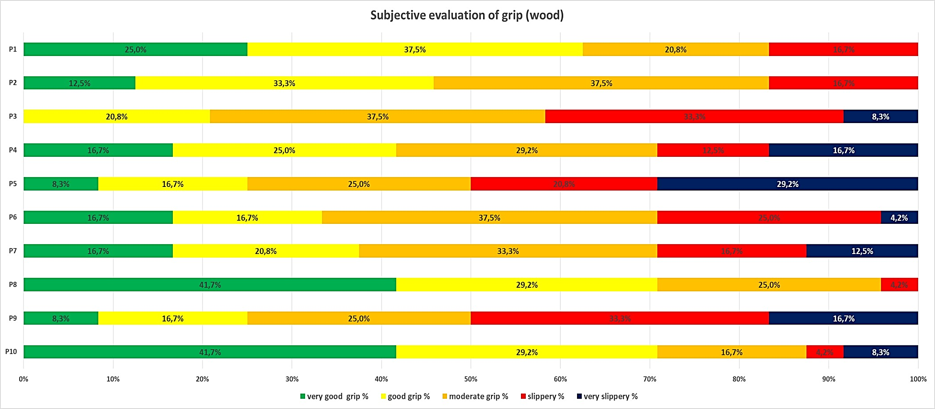
Figure legend: Subjective evaluation of non-slip grip on a wooden bar after an absorption time of 3 minutes. Participants rated subjective grip on a 5-point Likert scale. The best assessment for grip 3 minutes after product application was achieved by product P8 (about 96% favorable answers). Lowest frequencies of favorable answers were obtained for products P5, P9 and P3 (between 50% and 58% favorable answers). Favorable: Includes the answers for "very good grip", "good grip" and "moderate grip". Unfavorable: Includes the answers for "slippery" and "very slippery".
Figure AF 5:
Figure title: Evaluation of non-slip grip on metal.
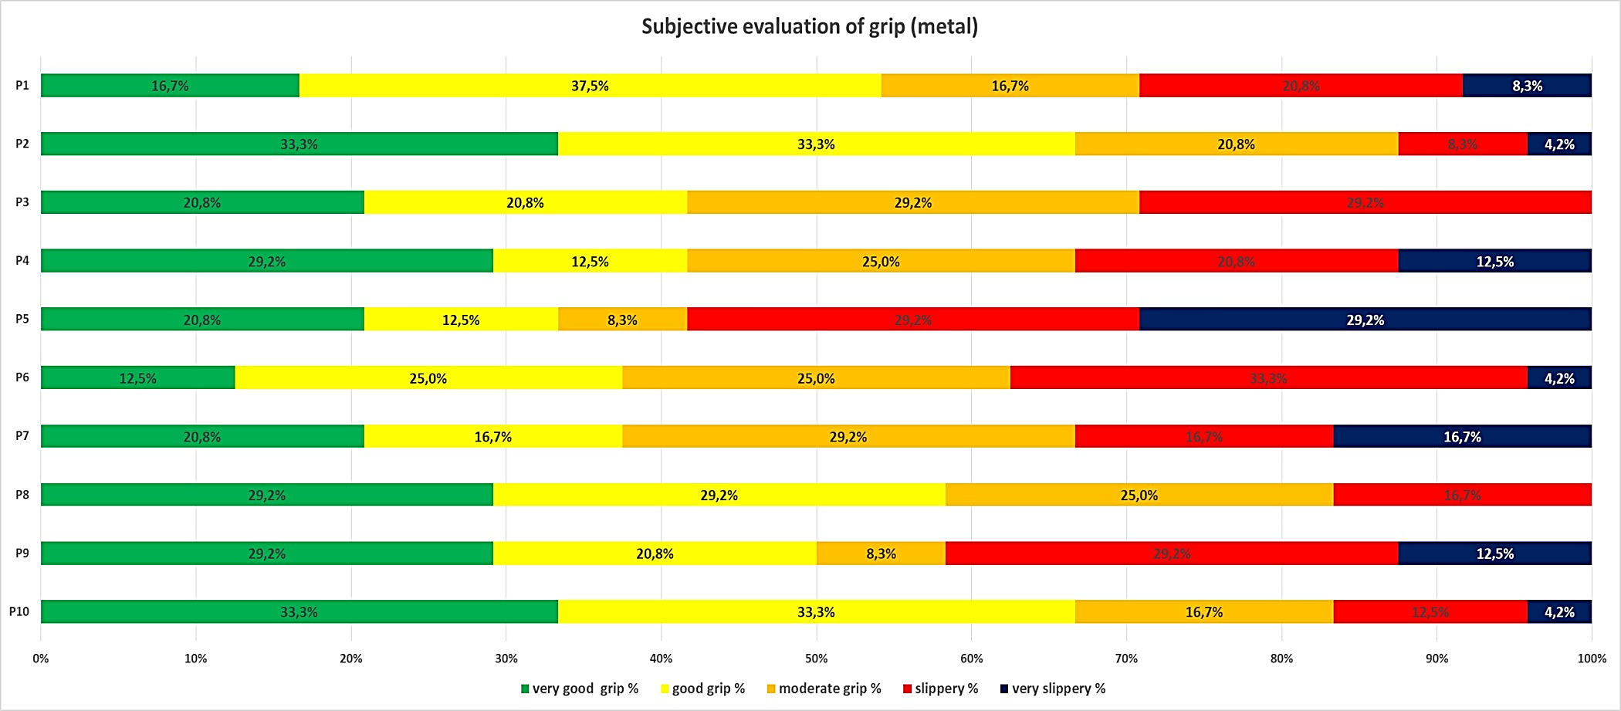
Figure legend: Subjective evaluation of non-slip grip on a metal bar after an absorption time of 3 minutes. Participants rated subjective grip on a 5-point Likert scale. The best assessment for grip 3 minutes after product application was achieved by product P2 (about 88% favorable answers). Lowest frequencies of favorable answers were obtained for products P5 and P9 (between 42% and 58% favorable answers). Favorable: Includes the answers for "very good grip", "good grip" and "moderate grip". Unfavorable: Includes the answers for "slippery" and "very slippery".

