Supplementary materials:
- Supp table 1 : Eight measured biomarkers concentration
- Supp table 2: Description (canonic structure) of the two-biomarker model
- Supp table 3: Performance of the eight-biomarker model
- Supp table 4: Description (canonic structure) of the eight-biomarker model
- Supp figure 1: Receiver operating characteristic curve for each biomarker used in the two-biomarker model

Supplementary materials

Supplementary Material Table 1: Eight measured biomarkers concentration
Biomarker  Median [IQR], missing data | No COPD  n = 279 | COPD  n = 21 | Total  n=300 | p-value
Lactate (µmol/L) | 2.4 [0.8-4.6], 6 | 0.4 [0.2-2.1], 0 | 2.2 [0.6-4.5], 6 | <0.001
MDA (pg/mL) | 255.5 [146.7-407.6], 3 | 288.8 [203.2-432.5], 0 | 261.2 [150.4-410.6], 3 | 0.12
Butyrate (µmol/L) | 0.9 [0.5-1.7], 6 | 0.8 [0.5-1.1], 0 | 0.9 [0.5-1.7], 6 | 0.38
Nitrite (µmol/L) | 1.1 [0.7-1.8], 6 | 1.0 [0.7-1.7], 0 | 1.1 [0.7-1.8], 6 | 0.60
Formate (µmol/L) | 1.5 [1.1-2.1], 6 | 1.4 [1.0-2.2], 0 | 1.4 [1.1-2.1], 6 | 0.88
Propionate (µmol/L) | 9.3 [4.8-17.1], 6 | 9.8 [5.5-16.6], 0 | 9.3 [4.8-17.1], 6 | 0.98
Nitrate (µmol/L) | 12.6 [8.8-15.9], 6 | 10.9 [8.4-17.7], 0 | 12.5 [8.8-16.0], 6 | 0.70
Acetate (µmol/L) | 35.1 [23.2-55.5], 6 | 41.5 [21.6-55.5], 0 | 35.1 [22.9-55.5], 6 | 0.81

Abbreviations: COPD Chronic obstructive pulmonary disease, IQR Interquartile range, MDA Malondialdehyde. Associations with a p-value of <0.20 are bolded.

Supplementary Material Table 2: Description (canonic structure) of the two-biomarker model
 | Standardized canonical discriminant function coefficients | Canonical structure coefficients  (β)
Lactate | -0.923 | -0.802
MDA | 0.610 | 0.427

Abbreviations: MDA Malondialdehyde
Supplementary Material Table 3: Performance of the eight-biomarker model

All anions
n=293
Linear discriminant analysis p-value | <0.001
Performance
AUC | 0.80
Sensitivity (%) | 67
Specificity (%) | 75
Positive Predictive value (%) | 17
Negative Predictive value (%) | 97
Youden Index | 0.41
Prevalence (%) | 7
Error rate (%) | 26
Success rate (%) | 74

Notes: All anions: Lactate, Formate, Acetate, Butyrate, MDA, Nitrate, Nitrite, Propionate. Abbreviations: AUC Area Under the Curve, MDA Malondialdehyde

Supplementary Material Table 4: Description (canonic structure) of the eight-biomarker model

 | Standardized canonical discriminant function coefficients | Canonical structure  coefficients  (β)
MDA | 0.710 | 0.393
Acetate | 0.516 | - 0.129
Butyrate | - 0.254 | - 0.135
Formate | - 0.087 | - 0.114
Lactate | - 0.953 | - 0.739
Nitrate | - 0.142 | 0.163
Nitrite | - 0.429 | - 0.126
Propionate | - 0.084 | - 0.089

Abbreviations: MDA Malondialdehyde

Supplementary Material Figure 1 : Receiver operating characteristic curve for each biomarker used in the model
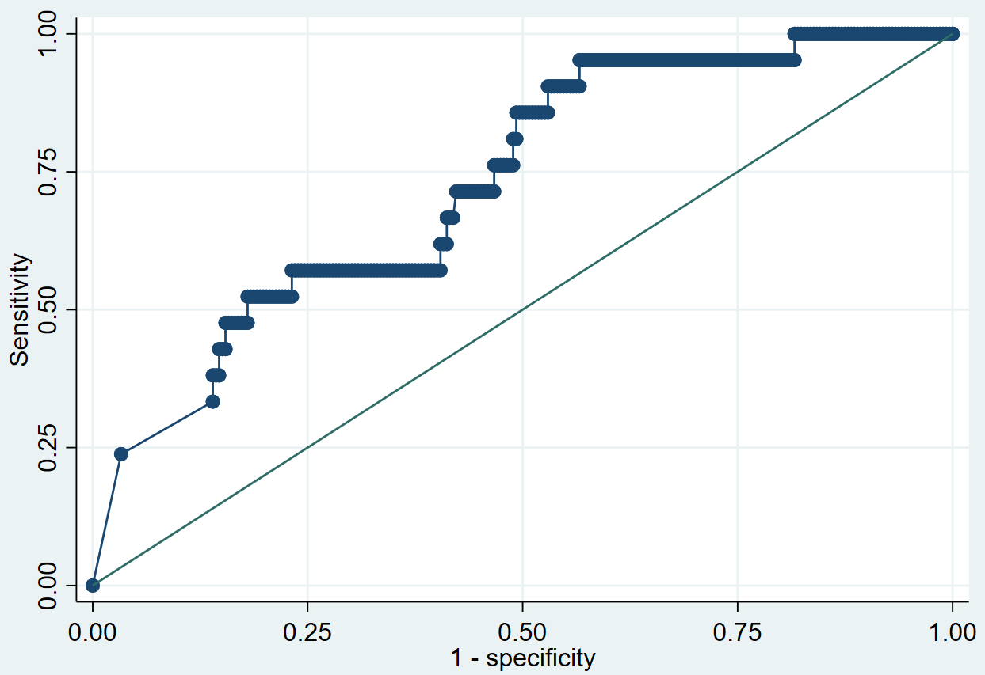
Lactate
AUC = 0.73

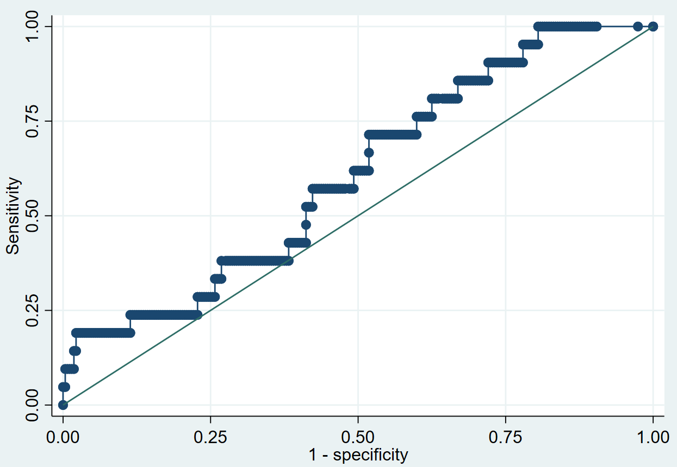
MDA
AUC = 0.61

Notes: Linear discriminant analysis (LDA); Abbreviations: AUC Area Under the Curve, MDA Malondialdehyde

