Additional file 1: Search strategy

Medline
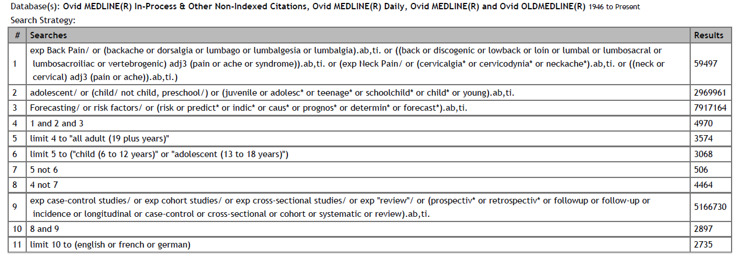

Pubmed
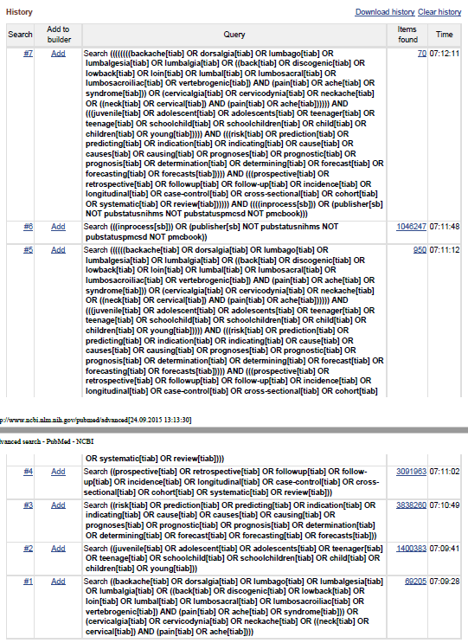
Embase
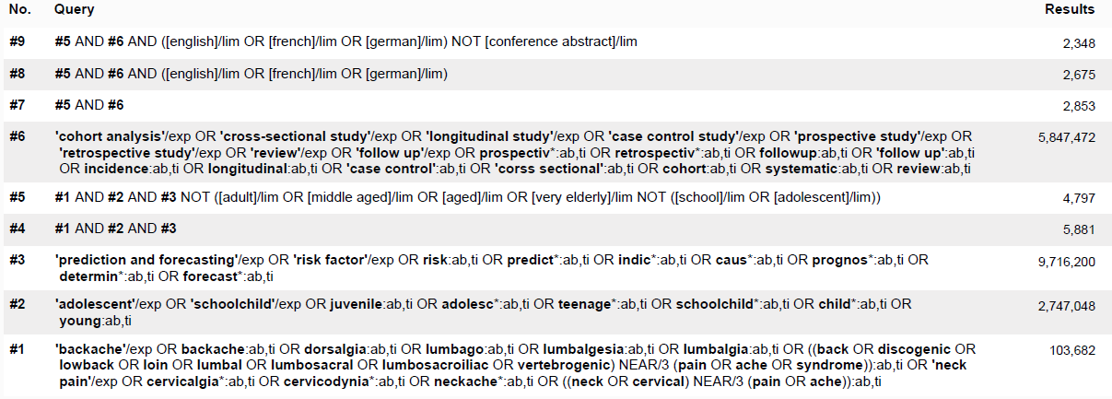

Cinahl
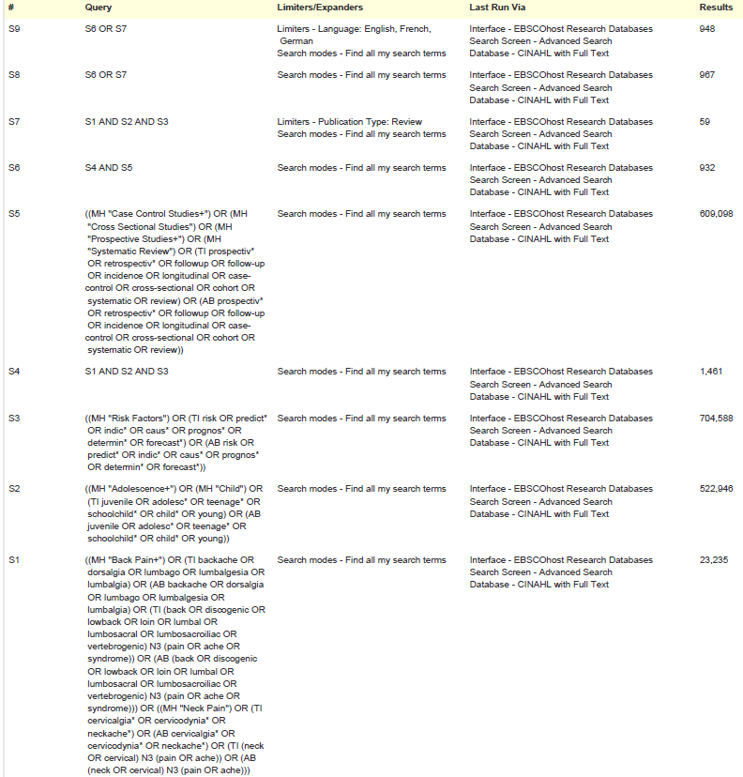
Cochrane
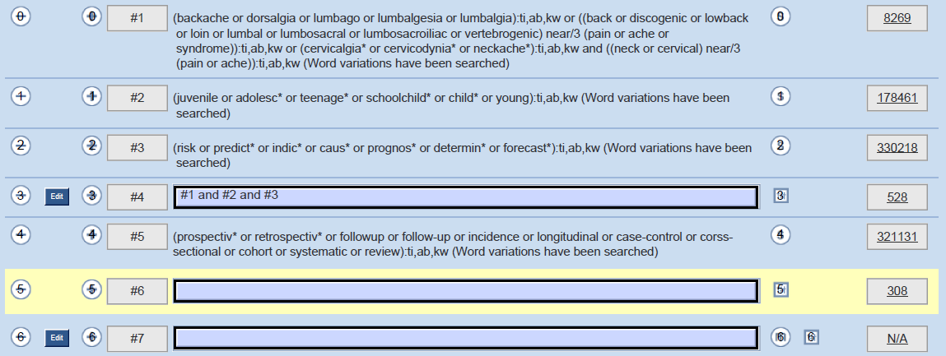

PsychInfo
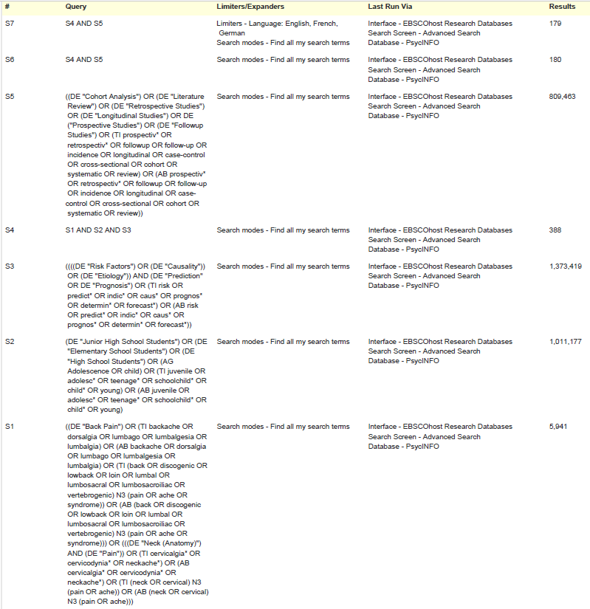

Pedro
Back pain adolescen* | 14 records
Back pain child* | 47 records
Neck pain adolescen* | 19 records
Neck pain child* | 36 records
Pooled | 96 records

