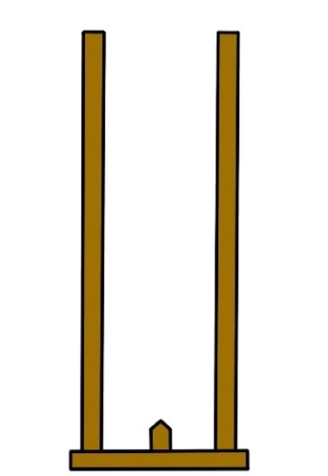
Figure A1. The self-treatment stick

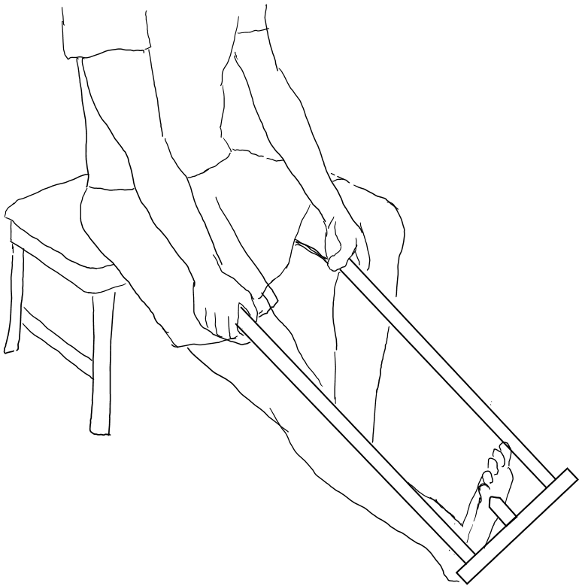
Figure A2. Self-administered foot massage performed with the self-treatment stick

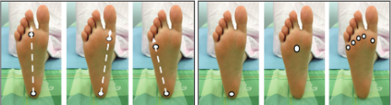
Figure A3. Specific lines and points for applying self-administered Thai massage on the plantar surface of the foot.

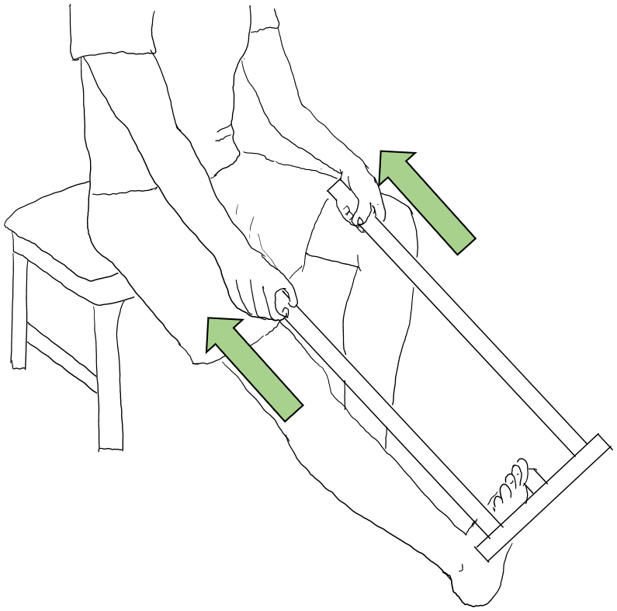
Figure A4. Self-administered gastrocnemius stretch performed with the self-treatment stick

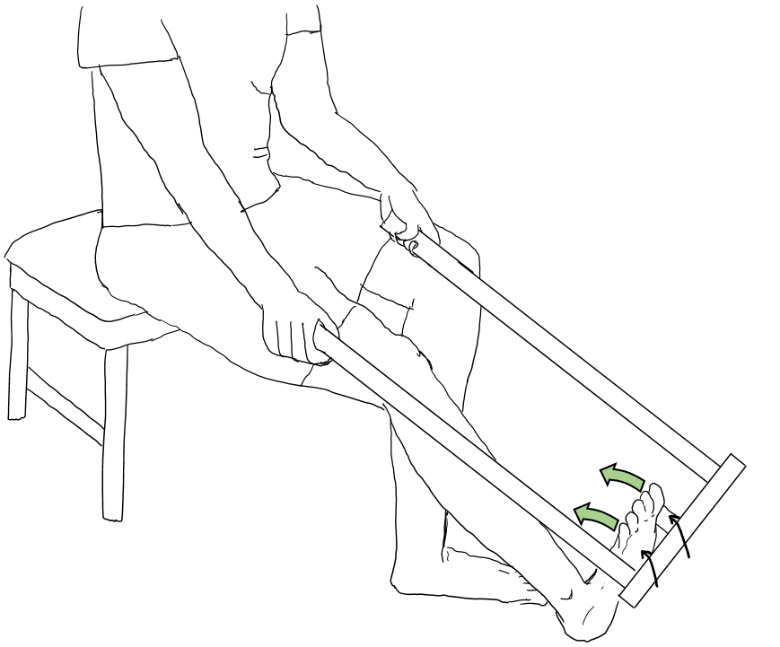

Figure A5. Self-administered soleus stretch performed with the self-treatment stick

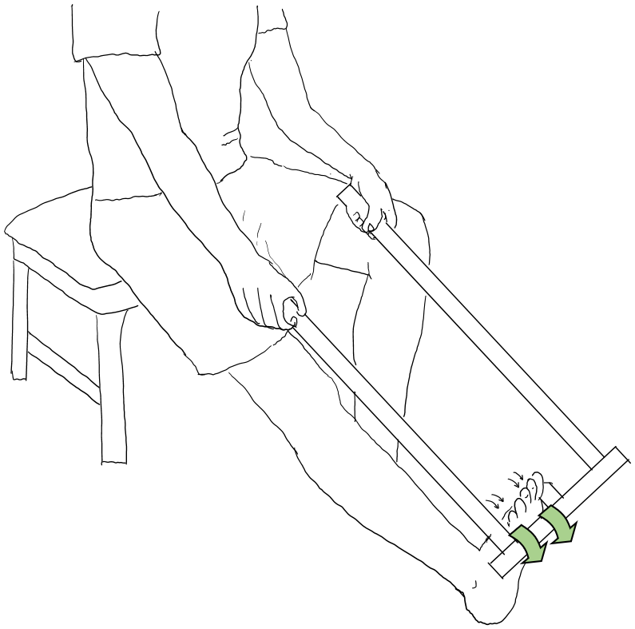

Figure A6. Self-administered exercise to strengthen the calf muscles performed with the self-treatment stick

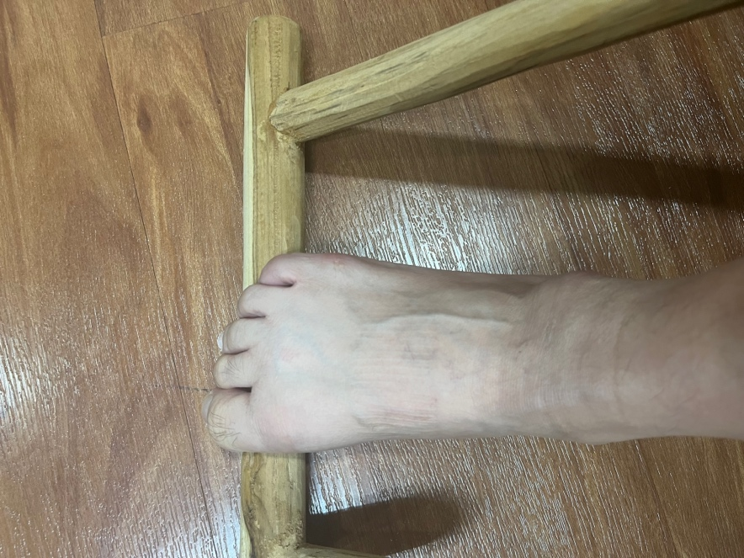
Figure A7. Self-administered toe strengthening exercise

