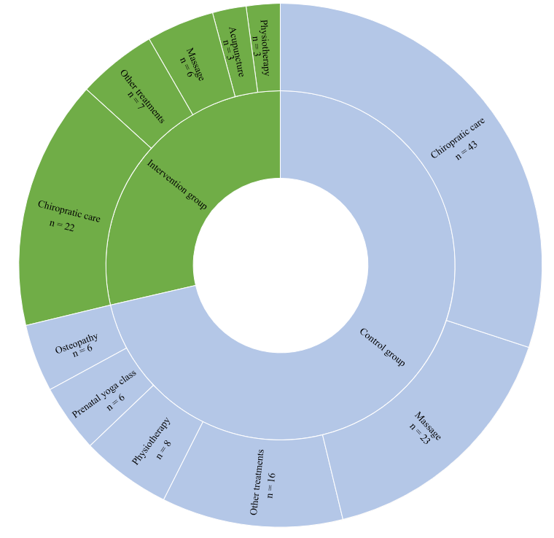

Additional file 1

Title: Proportion of treatment received by participants outside of the study.

Description: The intervention group is shown in green, and the control group is shown in blue. "N" presented refers to the number of treatment sessions received by the participants.

