Figure S1
A. Histogram of intensity levels for all positive detected nuclei in both the central and invasive area.
B. Ascendingly plotted standard deviations per tumor (3 sections).

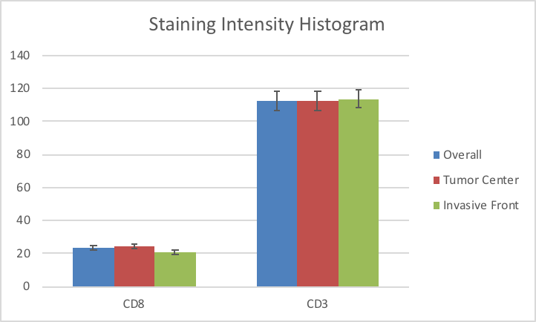
A
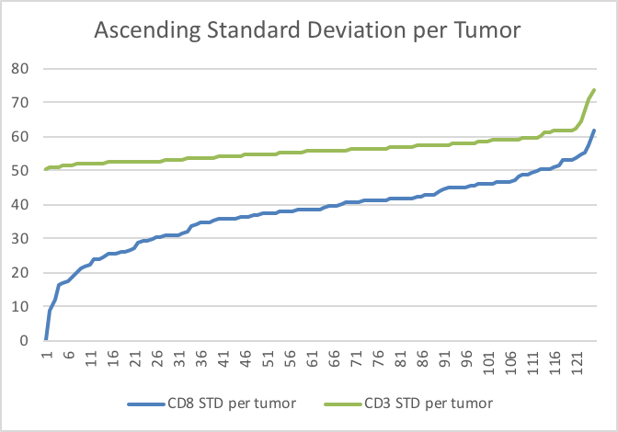
B

