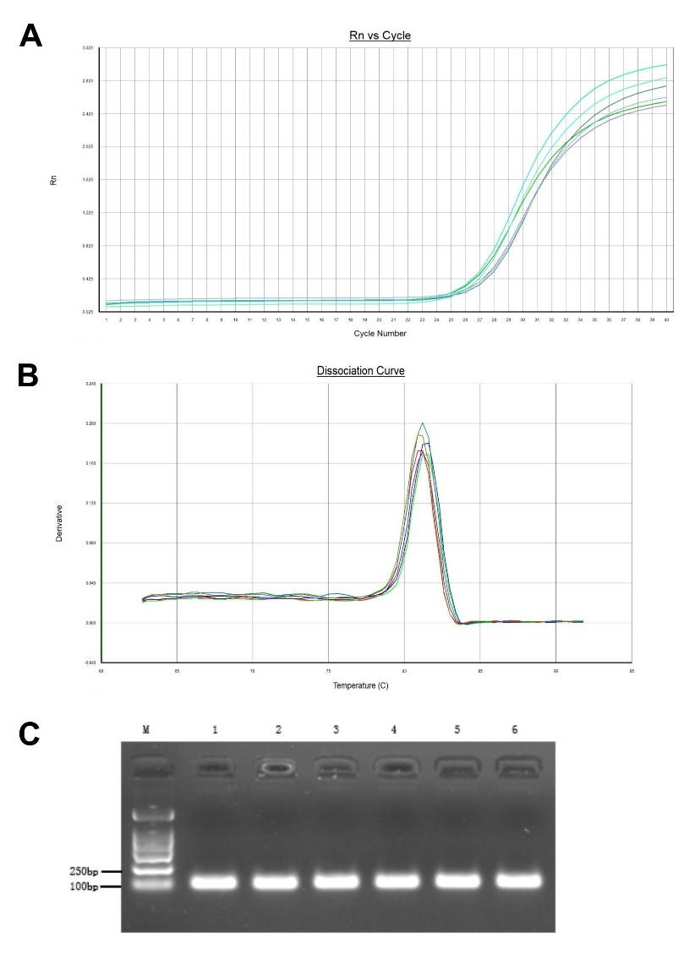
Figure 1 qRT-PCR results and electrophoresis band for CircRNA NRIP1 before (Figure 1C, lane:1-3) and after treatment (Figure 1C, lane:4-6) with RNase R.

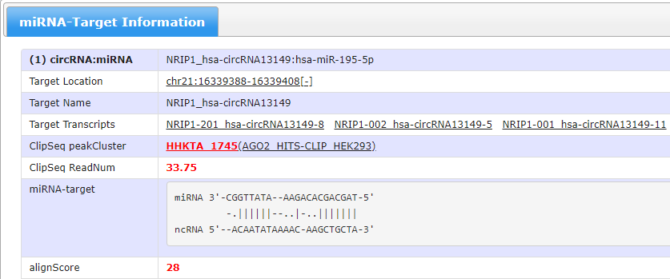 Figure 2 prediction results of the miRNAs viable binding sites in CircRNA NRIP1

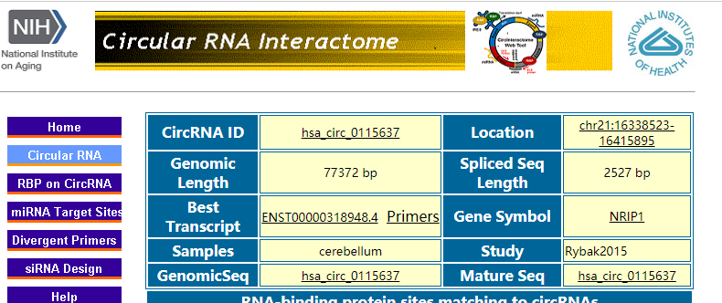
Figure 3 CircRNA NRIP1 ID is hsa_circ_0115637 on Circ Interactome

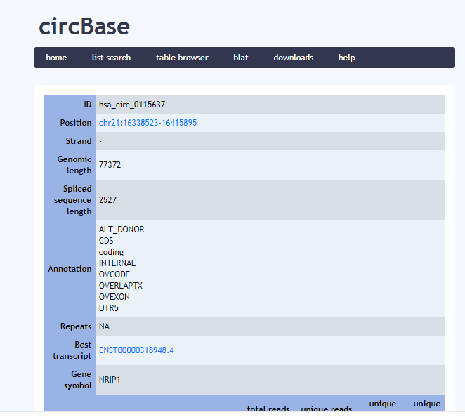
Figure 4 CircRNA NRIP1 ID is hsa_circ_0115637 on circBase

