Supplementary Table 1 Associations between LVI and BVI assessed by IHC.
 |  |  | BVI
 |  |  | Negative (n, %) |  | Positive (n, %) |  |  |  |  |  | OR (95% CI) |  | p value
LVI
negative |  |  | 142 (67) |  | 58 (72)
positive |  |  | 69 (33) |  | 23 (28) |  |  |  |  |  | 0.8 (0.5-1.4) |  | 0.48
P value was obtained using Pearson´s χ² test.
Supplementary Table 2 Associations between VI assessed by HAS, and LVI and BVI assessed by IHC.
 |  | VI assessed by HAS
 |  | Negative (n, %) |  | Positive (n, %) |  |  |  |  | OR (95% CI) |  |  | p value
BVI  Negative | 176 (88) |  |  | 35 (38)
positive | 25 (12) |  |  | 56 (62) |  |  |  |  | 11.3 (6.2-20.4) |  |  | <0.001
LVI
negative | 153 (76) |  |  | 47 (52)
positive | 48 (24) |  |  | 44 (48) |  |  |  |  | 2.9 (1.8-5.0) |  |  | <0.001
P values were obtained using Pearson´s χ² test.
Supplementary Table 3: Multivariable analyses of associations between regional lymph node metastasis and various clinicopathological variables including BVI and LVI (logistic regression) (n=240)
Variables | Categories |  | OR (95% CI) |  |  |  |  |  | P value
Gender |  | Male |  |  |  | 1
 |  | Female |  | 1.9 (0.9-4.3) |  |  |  |  |  | 0.10
Age |  | 40-68 |  | 1
 |  | 69-76  77-88 |  | 1.2 (0.5-2.7)  0.9 (0.4-2.3) |  |  |  |  |  | 0.64  0.99
Pathological stage |  | pT1+2 |  | 1
 |  | pT3+4 |  | 6.2 (2.9-13.4) |  |  |  |  |  | <0.001
Micropapillary div. diff. |  | Negative |  | 1
 |  | Positive |  | 4.5 (1.5-14.2) |  |  |  |  |  | 0.009
BVI |  | Negative |  | 1
 |  | Positive |  | 2.4 (1.2—4.8) |  |  |  |  |  | 0.018
LVI |  | Negative  Positive |  | 1  2.7 (1.4-5.2) |  |  |  |  |  | 0.003
Neoadjuvant chemotherapy |  | No  Yes |  | 1  0.6 (0.2-1.5) |  |  |  |  |  | 0.25
Abbreviations: OR, odds ratio, 95% CI; 95% confidence interval.

Supplementary Table 4: Multivariable analyses of associations between higher pathological stages and various clinicopathological variables including BVI and LVI (logistic regression) (n=240)
Variables | Categories |  | OR (95% CI) |  |  |  |  | P value
Gender |  | Male |  |  | 1
 |  | Female |  |  | 1.4 (0.7-2.9) |  |  |  | 0.31
Age |  | 40-68 |  |  | 1
 |  | 69-76  77-88 |  |  | 0.7 (0.3-1.4)  1.2 (0.5-2.6) |  |  |  | 0.33  0.60
Lymph node metastasis |  | pN0 |  |  | 1
 |  | pN1-3 |  |  | 6.2 (2.9-13.5) |  |  |  | <0.001
Micropapillary div. diff. |  | Negative |  |  | 1
 |  | Positive |  |  | 0.4 (0.1-1.3) |  |  |  | 0.13
BVI |  | Negative |  |  | 1
 |  | Positive |  |  | 3.9 (1.8-8.8) |  |  |  | 0.001
LVI |  | Negative  Positive |  |  | 1  1.5 (0.8-2.9) |  |  |  | 0.23
Neoadjuvant chemotherapy |  | No  Yes |  |  | 1  1.4 (0.6-2.9) |  |  |  | 0.42
Abbreviations: OR, odds ratio, 95% CI; 95% confidence interval.

Supplementary Figure 1.
A B
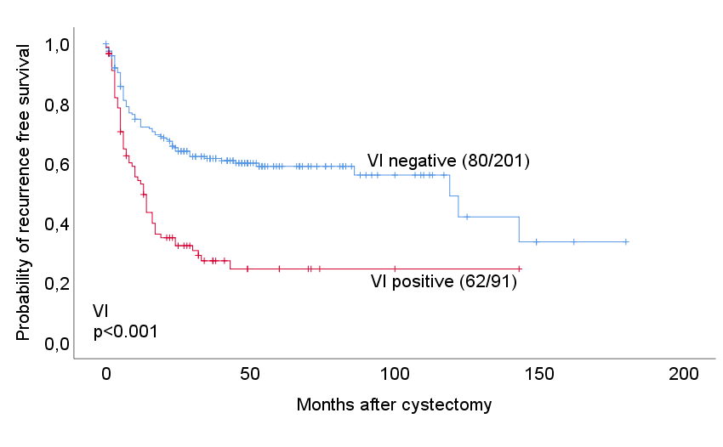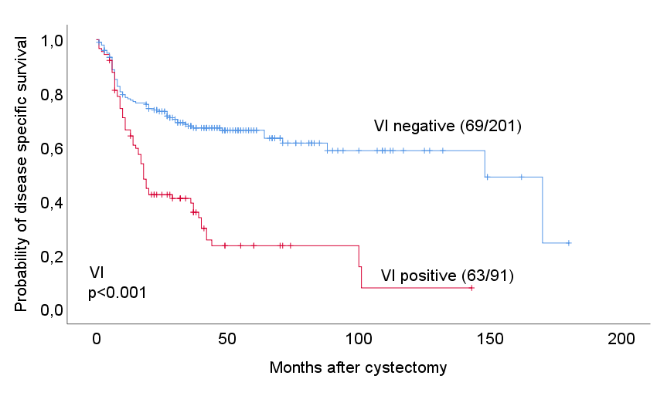
Supplementary Figure 2.
A B 