FORM PROVIDED TO VERIFY THE FACTORS INFLUENCING THE AVERSION OF STUDENTS TOWARDS REPTILES

SCORE 1: . SCORE 2: .

Educational Institute: .
Grade/Class: Level: ( ) Elementary School ( ) High School ( ) University
Volunteer:
Age: Sex: ( ) M ( ) F

Photograph Nº

- Do you know this animal? ( ) Yes ( ) No
If yes, what is the name of this animal_____________________________________?

- Have you ever visited live educational exhibitions of animal, zoos, gardens, museums or other? ( ) Yes ( ) No
If yes, which _______________________________________ _?

- Do you have a pet animal? ( ) Yes ( ) No
If yes, which _?

- Have you ever handled this animal? ( ) Yes ( ) No
If yes, where ?

- Are you scared of this animal? ( ) Yes ( ) No
Why_____________________________________________________________ ?

- Do you consider this animal to be important? ( ) Yes ( ) No
Why_____________________________________________________________?

Check where you agree with the statements.

(information not in the form provided to the student: the follow 10 statements are related to aversive attitudes)
- I would not touch this animal.

Completely agree Agree Unsure Disagree Completely disagree

- I would not touch this animal, even if it was dead.

Completely agree Agree Unsure Disagree Completely disagree

- If I saw this animal in a cage, I would be scared.

Completely agree Agree Unsure Disagree Completely disagree

- If I saw this animal in person outside, I would be scared.

Completely agree Agree Unsure Disagree Completely disagree

- Even thinking about this animal scares me.

Completely agree Agree Unsure Disagree Completely disagree

- This animal is ugly.

Completely agree Agree Unsure Disagree Completely disagree

- This animal is disgusting.

Completely agree Agree Unsure Disagree Completely disagree

- I would not work with this animal.

Completely agree Agree Unsure Disagree Completely disagree

- If the teacher brought this animal alive to class, I would prefer to leave the class.

Completely agree Agree Unsure Disagree Completely disagree

- This animal represents risks, danger.

Completely agree Agree Unsure Disagree Completely disagree

(information not in the form provided to the student: the follow 10 statements are related to non-conservationist attitudes)
- It is not important to protect this animal.

Completely agree Agree Unsure Disagree Completely disagree

- This animal should not exist.

Completely agree Agree Unsure Disagree Completely disagree

- This animal is useless

Completely agree Agree Unsure Disagree Completely disagree

- This animal should be dead.

Completely agree Agree Unsure Disagree Completely disagree

- This animal should be extinct.

Completely agree Agree Unsure Disagree Completely disagree

- This animal should not be protected.

Completely agree Agree Unsure Disagree Completely disagree

- The world would be better without this animal.

Completely agree Agree Unsure Disagree Completely disagree

- I do not need this animal therefore, it should not exist.

Completely agree Agree Unsure Disagree Completely disagree

- Nothing or no one needs this animal, therefore it should not exist.

Completely agree Agree Unsure Disagree Completely disagree

- If I could, I would eliminate this animal.

Completely agree Agree Unsure Disagree Completely disagree

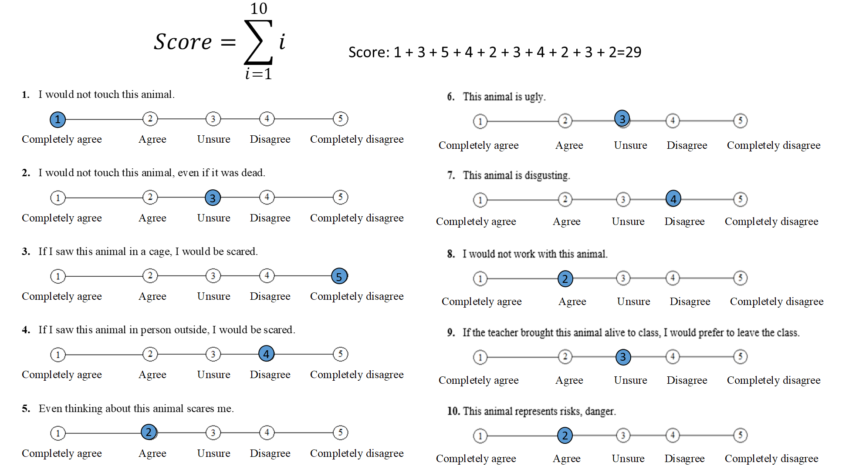

Figure 1. example of how the final aversion score was calculated

