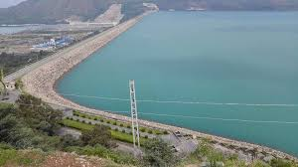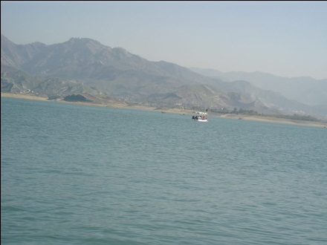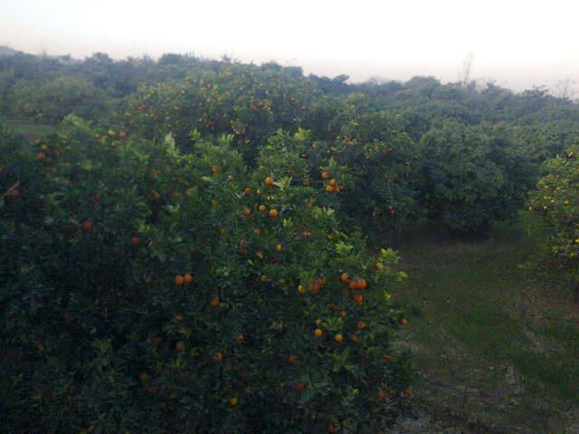
Tarbela dam Khanpur Dam Orange fields
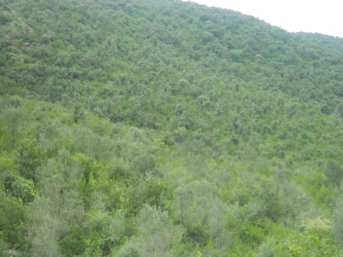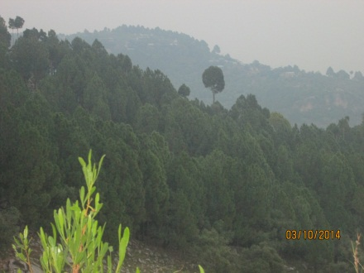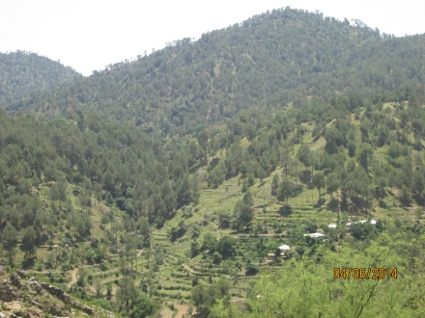
“Kaho” & “Phulai” forest Thick “Chir” forest A village in the study area
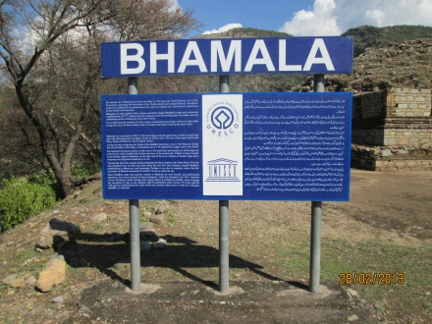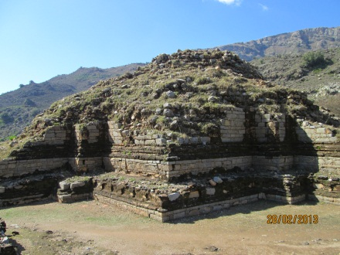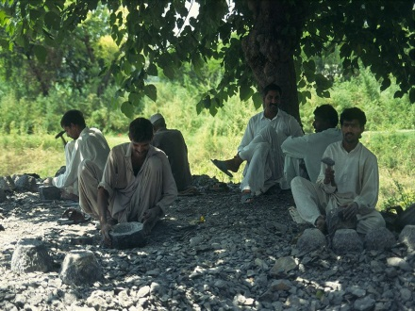
Bhamala Stupa (an ancient Gandhara Civilization remains) & traditional stone workers
S1 Fig. Description of the study area, Haripur District, Khyber Pakhtunkhwa, Pakistan

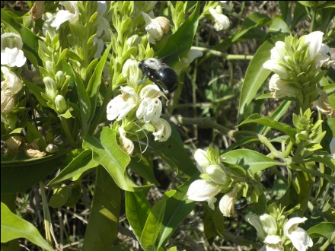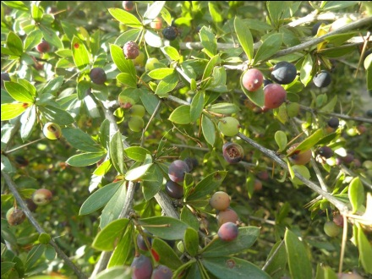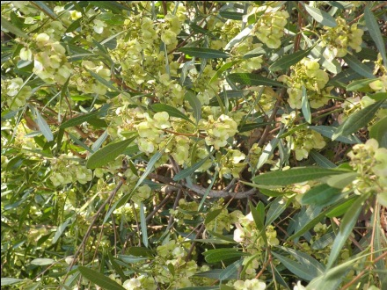
Adhatoda vasica Nees Berberis lycium Royle Dodonaea viscosa (L.) Jacq.
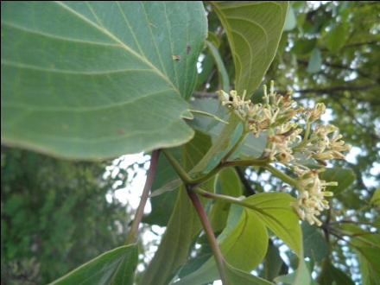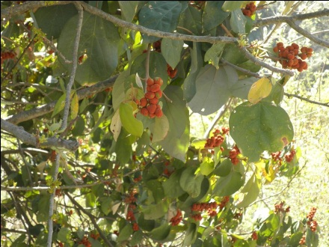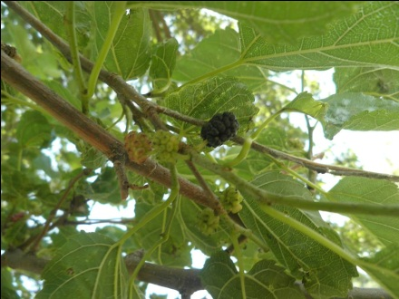
Ficus benghalensis L. Mallotus philippinensis Muell. Morus nigra L.
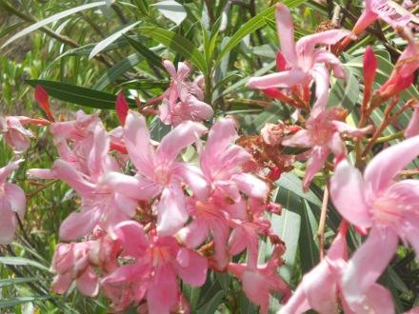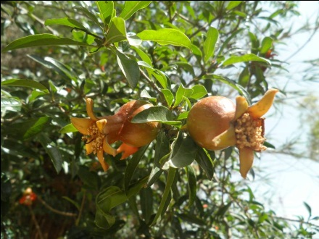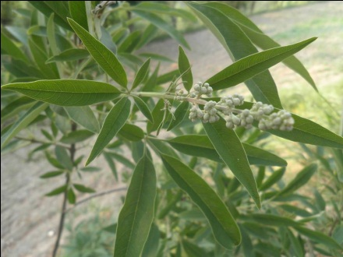
Nerium Indicum L. Punica granatum L. Vitex negundo L.
S2 Fig. Images of some ethnoveterinary medicinal plants of District Haripur

S1 Table. Summary Stats for Relative Frequency Citation (RFC) and Use Value (UV)

 | Correlations | RFC | UV
RFC | Pearson Correlation | 1 | .371**
RFC | Sig. (2-tailed) |  | .001
RFC | N | 80 | 80
UV | Pearson Correlation | .371** | 1
UV | Sig. (2-tailed) | .001
UV | N | 80 | 80
**. Correlation is significant at the 0.01 level (2-tailed).

