Additional file 1
Appendix 1. Results for the Generalized Linear Model for the influence of age and ethnicity on the number of species known be the local meliponiculturists.
Difference in the influence of age and ethnicity on local people knowledge
Subject Classes | Estimate | Standard Error | t value | Pr (>|z|)
Adult-Guarani vs Young-Guarani | 0.16 | 0.411 | 0.39 | 0.698
Adult-Guarani vs Adult-Mestizo | -0.072 | 0.247 | -0.294 | 0.77
Adult-Guarani vs Adult- Quechua | -0.245 | 0.411 | -0.596 | 0.554
Adult-Guarani vs Young-Mestizo | -0.271 | 0.446 | -0.608 | 0.545
Adult-Guarani vs Young-Quechua | -0.08 | 0.612 | -0.131 | 0.896

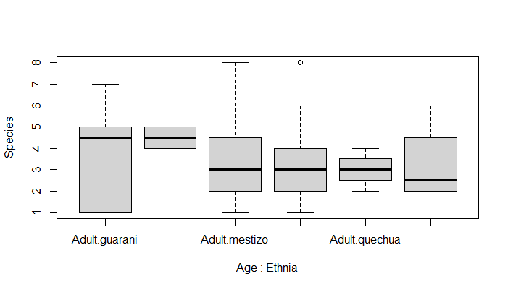
Appendix 2. Influence of age and ethnicity on the knowledge of stingless bees' species

Appendix 3. Categories of uses (#C), and specific uses (#U) of all the reported bee species (Common names) in the region of Monteagudo. Abbreviations: H = honey; Po = pollen; Pr= propolis; Ce= Cerumen.
 |  | Bee species
Categories of use (#C) | Specific uses (#U) | Señorita | Negro | Tancarillo | Sapito | Burro | Burra | Apis
Comercialization | Sell (H) | x | x | x | x | x | x | x
Comercialization | Sell (Pr) | x
Comercialization | Sell (Po) | x
Comercialization | Sell (Ce) | x
Comercialization | Barter (H) | x
food | Honey | x | x | x | x |  |  | x
food | Pollen | x | x
food | Propolis | x |  |  |  |  |  | x
food | Cerumen | x
Medicine | Eye problem (H) | x
Medicine | External wounds (H) | x |  |  |  |  |  | x
Medicine | External wounds (Pr) | x |  |  |  |  |  | x
Medicine | Sprains (Ce) | x
Medicine | Stomach problems (H) | x | x
Medicine | Stomach problems (Pr) | x
Medicine | Stomach problems (Po) | x
Medicine | Respiratory problems (H) | x | x |  |  |  |  | x
Medicine | Sore throat (H) | x |  |  |  |  |  | x
Medicine | Sore throat (Pr) | x
Medicine | Common cold (H) | x | x |  |  |  |  | x
Medicine | Common cold (Pr) | x
Medicine | Common cold (Po) | x | x
Medicine | Anemia (Po) | x
Medicine | Anemia (H) | x
Medicine | Internal wounds (H) | x
Others | Fertility (H) |  |  |  |  | x | x
Others | Energizing (H) | x
Others | Energizing (Po) | x
Others | gives appetite (Po) | x
Others | to strengthen the hives (Ce) | x
Total #C=4 | Total #U=30 | #U=29 | #U= 7 | #U=2 | #U=2 | #U=2 | #U=2 | #U=8

