Effect of Socioeconomic and Anthropogenic Variables on the Richness of Medicinal Species on a Macroscale

Aníbal Silva Cantalice, Thiago Gonçalves-Souza, and Ulysses Paulino Albuquerque

Supplementary Information

This appendix includes:
Supplementary 1. List of Articles comprising the Ethnobiological Database.
Fig. S1 - The graphical representation of the Human Development Index (HDI) and its decomposed values in education, health, and income by locality. The dotted blue line represents the average.
Table S1 - Classes description of the collection 7 of Mapbiomas Brazil
Fig. S2 - The graphical representation depicts anthropogenic land use (%) by locality. The dotted blue line represents the average.
Table S2 - Input script for analysis in R version 4.4 - “Puppy Cup”.

Fig. S3 - Represents the effect scales for each buffer, with the 5 km buffer being the best representation of the relationship between richness and anthropogenic land use.

Supplementary S1 - List of Articles comprising the Ethnobiological Database.[1–27]

1. Albergaria ET, Silva MV, Silva AG. Levantamento etnobotânico de plantas medicinais em comunidades rurais do município de Lagoa Grande, Pernambuco, Brasil. Revista Fitos. 2019;13:137–54.
2. Albuquerque UP. Re-examining hypotheses concerning the use and knowledge of medicinal plants: a study in the Caatinga vegetation of NE Brazil. Journal of Ethnobiology and Ethnomedicine. 2006;2:30–30.
3. Albuquerque UP, Andrade LHC. Uso de recursos vegetais da caatinga: o caso do agreste do estado de pernambuco (nordeste do brasil). Interciência. 2002;27:336–46.
4. Cartaxo SL, Almeida Souza MM, Albuquerque UP. Medicinal plants with bioprospecting potential used in semi-arid northeastern Brazil. Journal of Ethnopharmacology. 2010;131:326–42.
5. Cordeiro JMP, Félix LP. Conhecimento botânico medicinal sobre espécies vegetais nativas da caatinga e plantas espontâneas no agreste da Paraíba, Brasil. Rev bras plantas med. 2014;16:685–92.
6. Costa-Neto EM, Oliveira MV. The use of medicinal plants in the County of Tanquinho, State of Bahia, Northeastern Brazil. Revista Brasileira de Plantas Medicinais. 2000;2:1–8.
7. Macedo JGF, Menezes IRA, Ribeiro DA, Santos MO, Mâcedo DG, Macêdo MJF, et al. Analysis of the Variability of Therapeutic Indications of Medicinal Species in the Northeast of Brazil: Comparative Study. Evid Based Complement Alternat Med. 2018;2018:6769193.
8. Freitas AVL, Coelho MFB, Maia SSS, Azevedo RAB. Plantas medicinais: um estudo etnobotânico nos quintais do Sítio Cruz, São Miguel, Rio Grande do Norte, Brasil. Revista Brasileira de Biociências. 2012;10:48–59.
9. Freitas AVL, Coelho MFB, Pereira YB, Freitas Neto EC, Azevedo RAB. Diversidade e usos de plantas medicinais nos quintais da comunidade de São João da Várzea em Mossoró, RN. Rev bras plantas med. 2015;17:845–56.
10. Gomes TB, Bandeira FPSF. Uso e diversidade de plantas medicinais em uma comunidade quilombola no Raso da Catarina, Bahia. Acta Botanica Brasilica. 2012;26:796–809.
11. Lozano A, Araújo EL, Medeiros MFT, Albuquerque UP. The apparency hypothesis applied to a local pharmacopoeia in the Brazilian northeast. Journal of Ethnobiology and Ethnomedicine. 2014;10:2–2.
12. Marinho MGV, Silva CC, Andrade LHC. Levantamento etnobotânico de plantas medicinais em área de caatinga no município de São José de Espinharas, Paraíba, Brasil. Rev bras plantas med. 2011;13:170–82.
13. Oliveira RLC, Lins Neto EMF, Araújo EL, Albuquerque UP. Conservation priorities and population structure of woody medicinal plants in an area of caatinga vegetation (Pernambuco State, NE Brazil). Environ Monit Assess. 2007;132:189–206.
14. Oliveira FCS, Barros RFM, Moita Neto JM. Plantas medicinais utilizadas em comunidades rurais de Oeiras, semiárido piauiense. Revista Brasileira de Plantas Medicinais. 2010;12:282–301.
15. Paulino RC, Henriques GPSA, Moura ONS, Coelho MFB, Azevedo RAB. Medicinal plants at the Sítio do Gois, Apodi, Rio Grande do Norte State, Brazil. Revista Brasileira de Farmacognosia. 2012;22:29–39.
16. Pereira Júnior LR, Andrade AP, Araújo KD, Barbosa AS, Barbosa FM. Espécies da Caatinga como alternativa para o desenvolvimento de novos fitofármacos. Floresta Ambient. 2014;21:509–20.
17. Ribeiro DA, Macêdo DG, Oliveira LGS, Saraiva ME, Oliveira SF, Souza MMA, et al. Potencial terapêutico e uso de plantas medicinais em uma área de Caatinga no estado do Ceará, nordeste do Brasil. Revista Brasileira de Plantas Medicinais. 2014;16:912–30.
18. Ribeiro DA, Oliveira LGS, Macêdo DG, Menezes IRA, Costa JGM, Silva MAP, et al. Promising medicinal plants for bioprospection in a Cerrado area of Chapada do Araripe, Northeastern Brazil. Journal of Ethnopharmacology. 2014;155:1522–33.
19. Roque AAO, Rocha RM, Loiola MIB. Uso e diversidade de plantas medicinais da Caatinga na comunidade rural de Laginhas, município de Caicó, Rio Grande do Norte (Nordeste do Brasil). Revista Brasileira de Plantas Medicinais. 2010;12:31–42.
20. Santos MO, Almeida BV, Ribeiro DA, Macedo DG, Macedo MJF, Macedo JGF, et al. The conservation of native priority medicinal plants in a Caatinga area in Ceará, northeastern Brazil. Anais da Academia Brasileira de Ciências. 2017;89:2675–85.
21. Santos MO, Ribeiro DA, Macêdo DG, Macêdo MJF, Macêdo JGF, Lacerda MNS, et al. Medicinal Plants: versatility and concordance of use in the caatinga area, Northeastern Brazil. Anais da Academia Brasileira de Ciências. 2018;90:2767–79.
22. Silva CG, Marinho MGV, Lucena MFA, Costa JGM. Levantamento etnobotânico de plantas medicinais em área de Caatinga na comunidade do Sítio Nazaré, município de Milagres, Ceará, Brasil. Rev bras plantas med. 2015;17:133–42.
23. Silva NF, Hanazaki N, Albuquerque UP, Campos JL, Feitosa IS, Araújo EL. Local Knowledge and Conservation Priorities of Medicinal Plants near a Protected Area in Brazil. Evidence-Based Complementary and Alternative Medicine. 2019;2019:1–18.
24. Silva FS, Ramos MA, Hanazaki N, Albuquerque UP. Dynamics of traditional knowledge of medicinal plants in a rural community in the Brazilian semi-arid region. Rev bras farmacogn. 2011;21:382–91.
25. Silva TS, Freire EMX. Abordagem etnobotânica sobre plantas medicinais citadas por populações do entorno de uma unidade de conservação da caatinga do Rio Grande do Norte, Brasil. Rev bras plantas med. 2010;12:427–35.
26. Souza RKD, Silva MAP, Menezes IRA, Ribeiro DA, Bezerra LR, Souza MMA. Ethnopharmacology of medicinal plants of carrasco, northeastern Brazil. J ETHNOPHARMACOL. 2014;157:99–104.
27. Texeira SA, Melo IM. Plantas medicinais utilizadas no município de Jupi, Pernambuco, Brasil. Iheringia. 2006;61:5–11.

Table S1 - Classes description of the collection 7 of Mapbiomas Brazil

Not anthropized
Forest formation | Vegetation types with continuous canopy predominance - Wooded Steppe Savannah, Semi-deciduous and Deciduous Seasonal Forest.
Savanna formation | Vegetation types with predominance of semi-continuous canopy species - Wooded Steppe Savannah and Wooded Savannah.
Grassland formation | Vegetation type with predominance of herbaceous species (Park Steppe Savannah, Herbaceous-Woody Steppe Savannah, Park Savannah, Herbaceous-Woody Savannah) + (Flooded areas with an interconnected pond net, located along waterways and in lowlands areas that accumulate water, vegetation predominantly herbaceous to shrub).
Rivers, soils and lakes | Rivers, lakes, dams, reservoirs and other water bodies.
Rocky outcrops | Naturally exposed rocks without soil cover, often with the partial presence of rupicolous vegetation and high slope.
Anthropized
Pasture | Pasture area, predominantly planted, linked to livestock production activities. Areas of natural pasture are predominantly classified as grassland or wetland, that may or may not be grazed. In Amazon, this class may occur in recently deforested areas, even if farming activities haven't started yet.
Mosaic of uses | Not distinguishable between pasture and agriculture farm areas . It may include peri-urban occupation areas, such as small farms, rural properties, and housing estates.
Other non-vegetated areas | Non-permeable surface areas (infrastructure, urban expansion or mining) not mapped into their classes
Urbanized areas | Urban areas with high density of roads, edifications and predominance of non-vegetated surfaces, including open areas with no buildings and infrastructure.
Other temporary crops | Areas occupied with short or medium-term agricultural crops, generally with a vegetative cycle of less than one year, which after harvesting need to be planted again to produce.
Sugarcane | Cultivated areas with sugar cane.
Other perennial crops | Areas occupied with agricultural crops which has a long vegetative cycle (more than one year) and allow successive harvests, without the need for new planting. In this version, the map covers mostly cashew areas on the northeast coast and oil palm in the northeast region of Pará state, but without distinction between them.

Fig. S1 - The graphical representation of the Human Development Index (HDI) and its decomposed values in education, health, and income by locality. The dotted blue line represents the average.

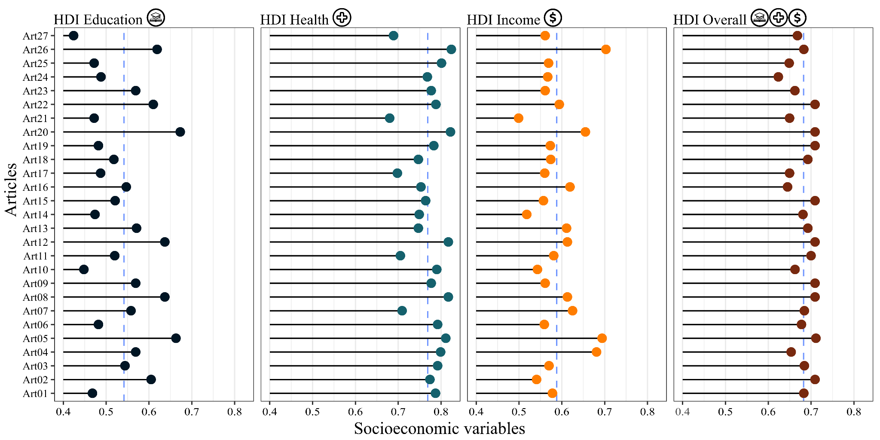

Fig. S2 - The graphical representation depicts anthropogenic land use (%) by locality. The dotted blue line represents the average.

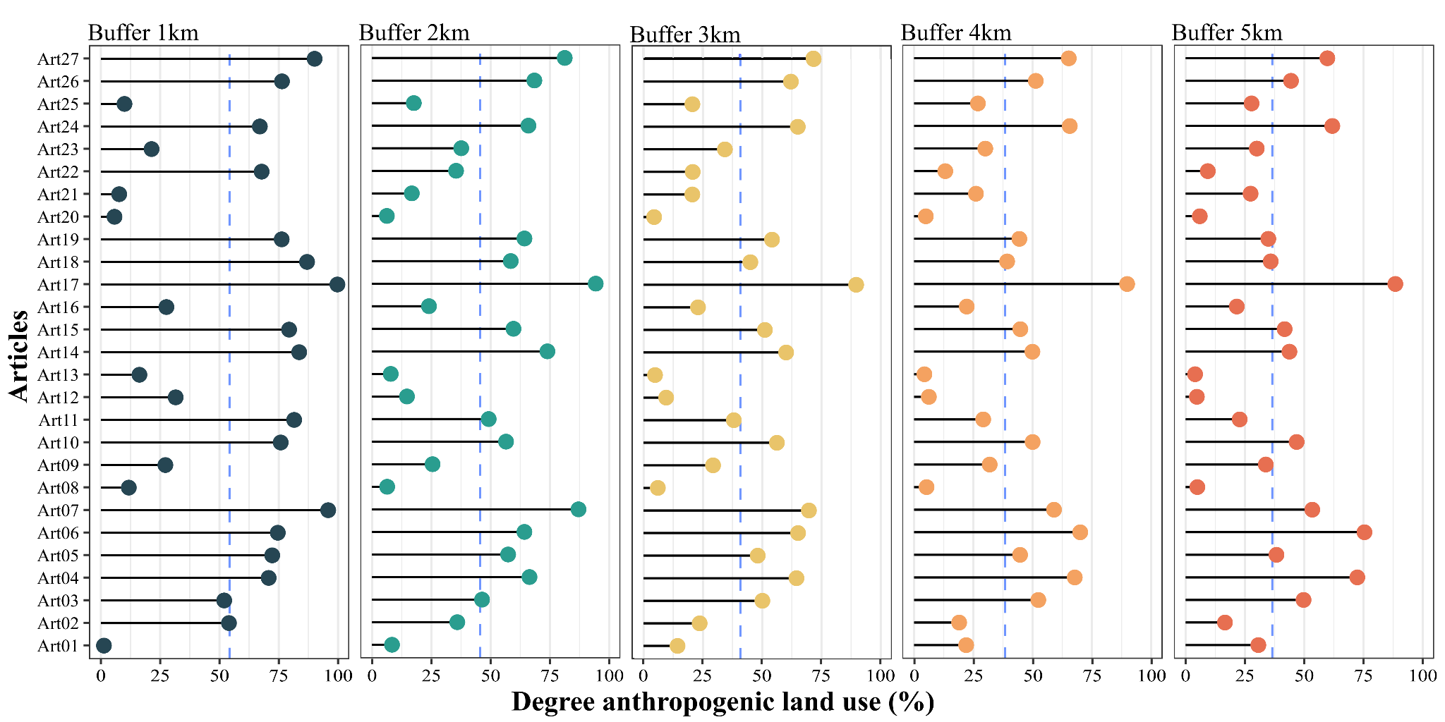

Table S2 - Input script for analysis in R version 4.4 - “Puppy Cup”.

Hypothesis One
Model One | mgcv::gam(richness ~ HDI_grid + s(anthro_perc) + ti(HDI_grid, anthro_perc) + offset(log (N_sample))), data = database, method = 'REML', select = T)
Hypothesis Two
Model Two | MASS::glm.nb(richness ~ HDI_income + HDI_health + offset(log(N_sample)), data = database)
 | Sensitivity Analysis
M1 | mgcv::gam(richness ~ s(anthro_perc_1km) + offset(log (N_sample)))
M2 | mgcv::gam(richness ~ s(anthro_perc_2km) + offset(log (N_sample)))
M3 | mgcv::gam(richness ~ s(anthro_perc_3km) + offset(log (N_sample)))
M4 | mgcv::gam(richness ~ s(anthro_perc_4km) + offset(log (N_sample)))
M5 | mgcv::gam(richness ~ s(anthro_perc_5km) + offset(log (N_sample)))

Fig. S3 - Represents the effect scales for each buffer, with the 5 km buffer being the best representation of the relationship between richness and anthropogenic land use.
