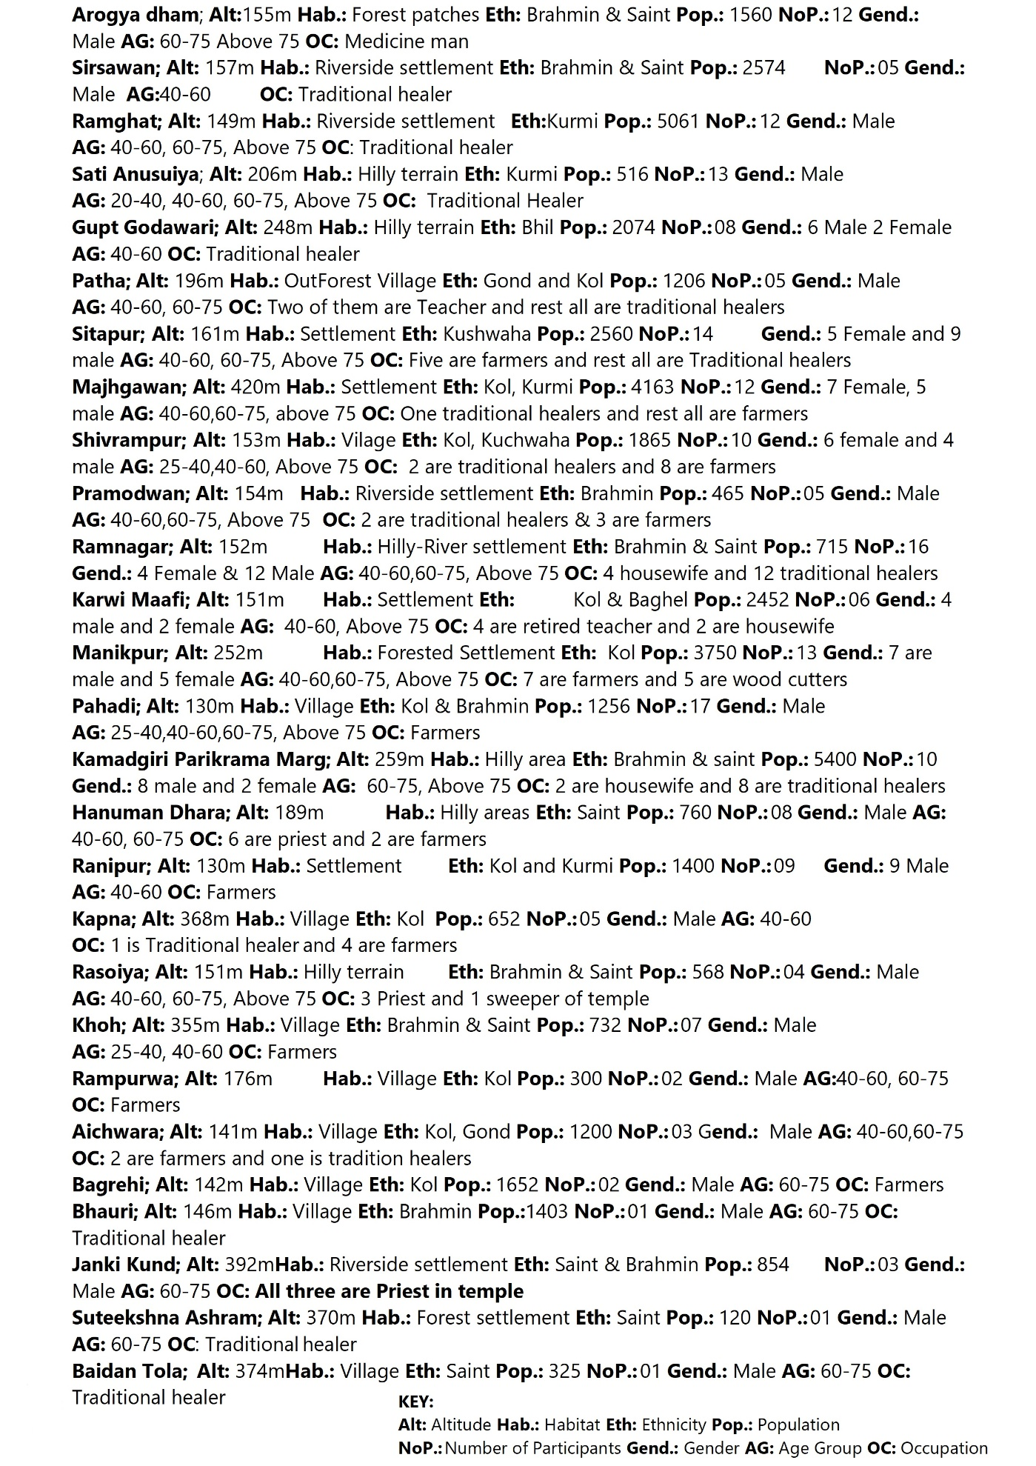
Figure 1B: Demographic information of the participant

