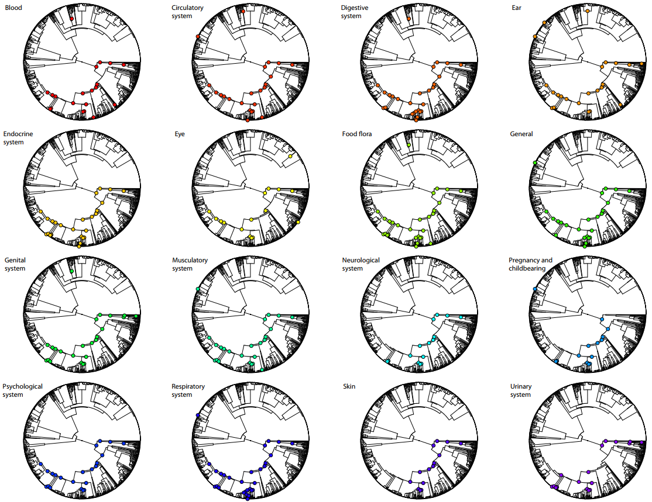

Additional file 6. Mapping of phylogenetic significance for 16 usage categories based on the hot node analysis. The grid displays 15 medicinal categories and the “food flora” category for Mediterranean Lamiaceae. Points denote clades with significant enrichment of the use category.

