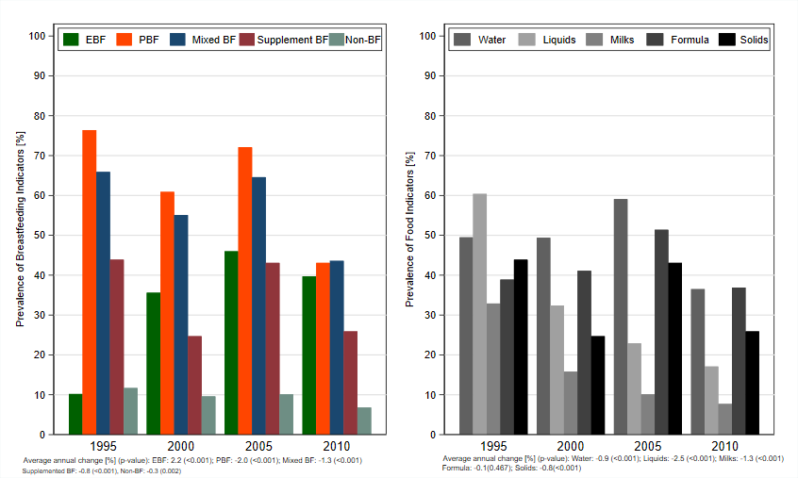
BF: breastfeeding; EBF: exclusive breastfeeding; PBF: predominant breastfeeding.
Figure S3. Prevalence of the breastfeeding and food indicators and average annual changes for indicators for children under six months of age in Colombia according to the year of the survey. DHS, 1990-2010.

