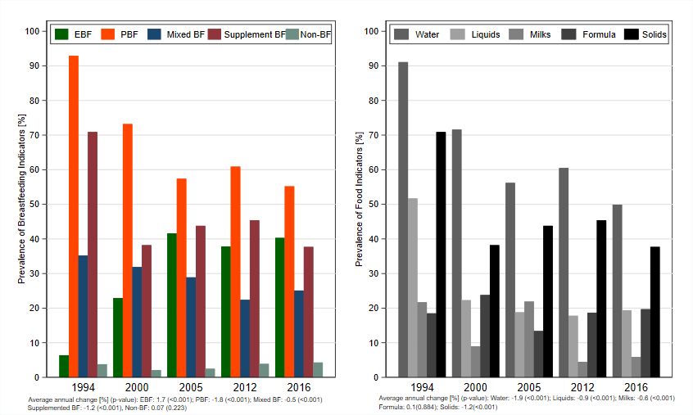
BF: breastfeeding; EBF: exclusive breastfeeding; PBF: predominant breastfeeding.
Figure S6. Prevalence of the breastfeeding and food indicators and average annual changes for indicators for children under six months of age in Haiti according to the year of the survey. DHS, 1990-2016.

