Additional file 2. Ever breastfed group Bayesian network, data from the Mexican National Survey of Demographic Dynamics 2018 N=18564
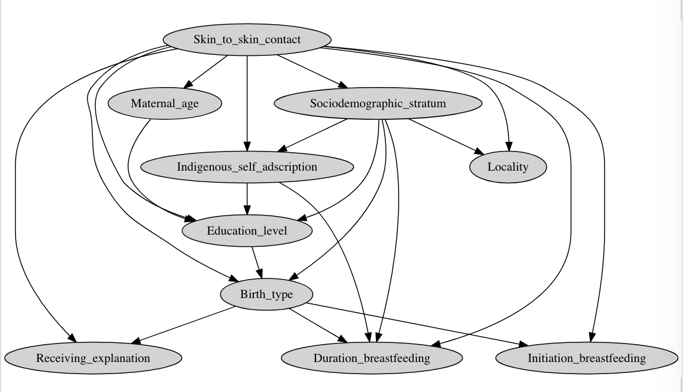

Correctly classified instances 15170 (accuracy 81.7%; sensitivity 97.5%; specificity 12.1%; ROC area 0.693; PRC area 0.795).

