Additional file 3 pooled ORs of EBF determinants.doc. Forest plots of individual determinants of EBF

Pooled ORs of Knowledge of EBF
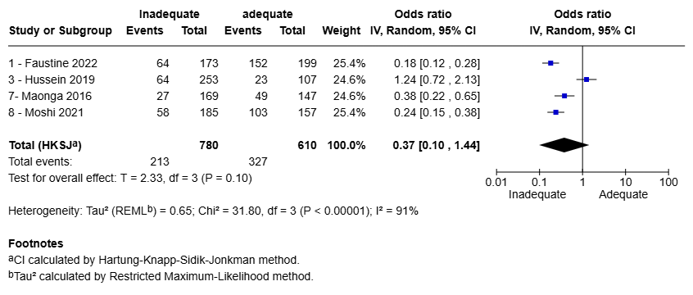

Pooled ORs of level of maternal education
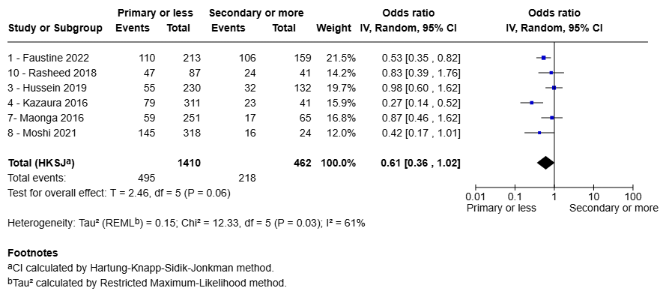

Pooled ORs of parity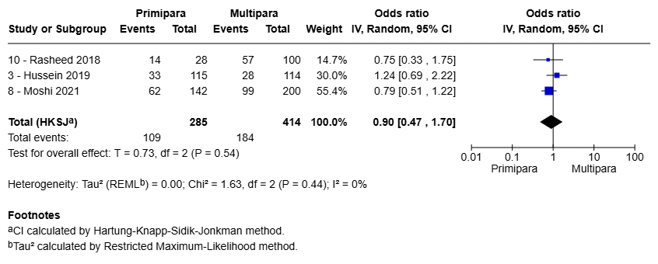

Pooled ORs of Gravidity
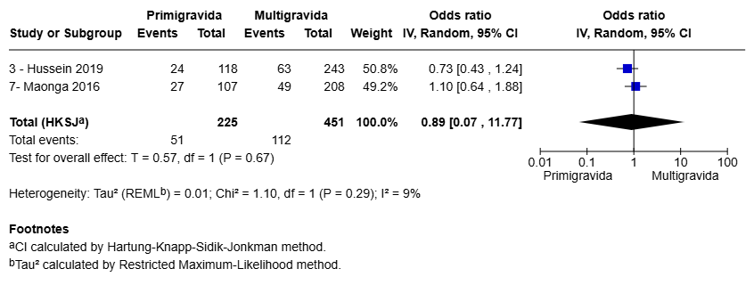
Pooled ORs of maternal age
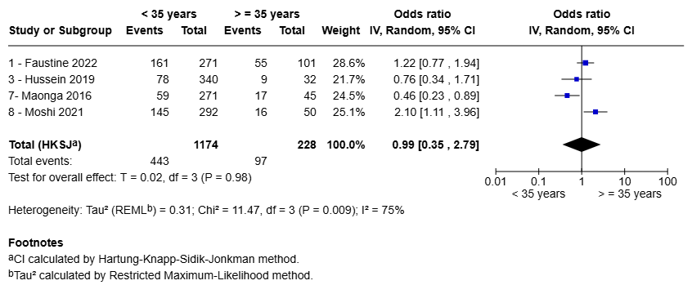
Pooled ORs of infant sex
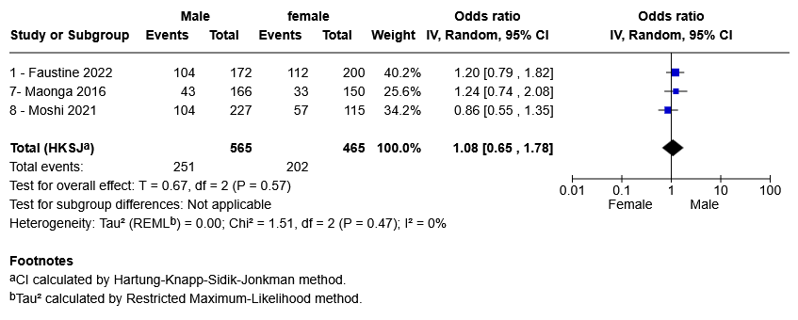

Pooled ORs of residence
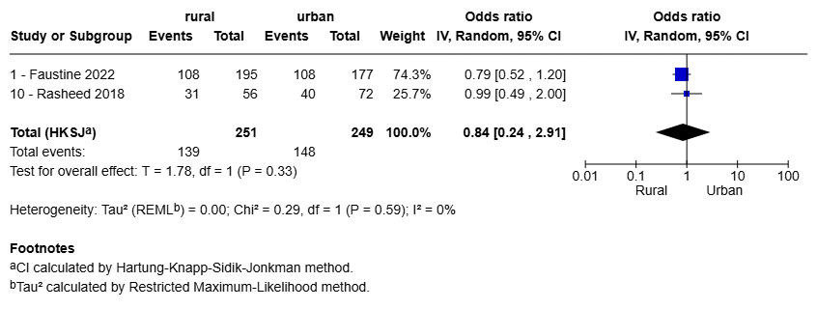

Pooled ORs of Mode of delivery
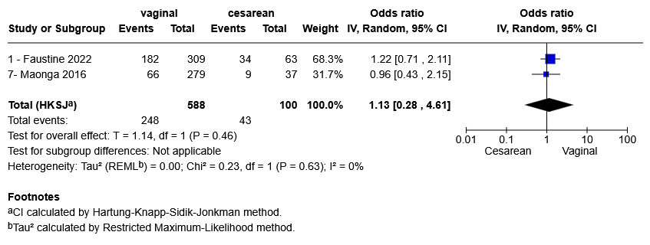

Pooled ORs of Place of delivery
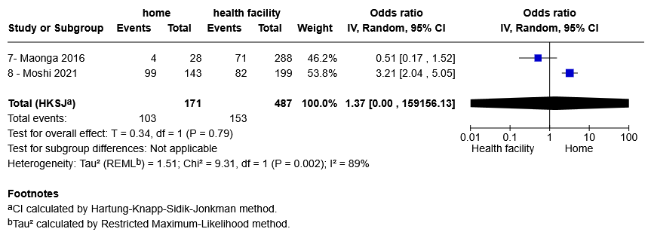

Pooled ORs of Antenatal breastfeeding counseling
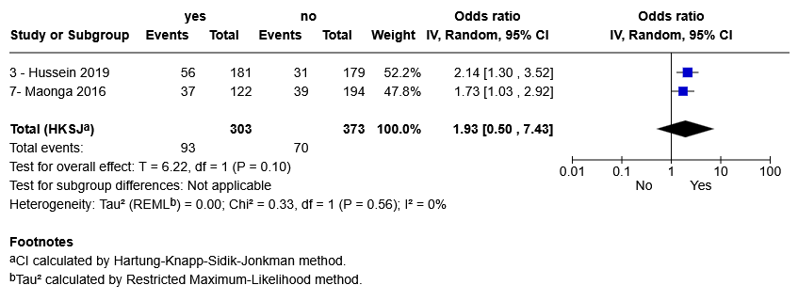

Pooled ORs of Antenatal visits
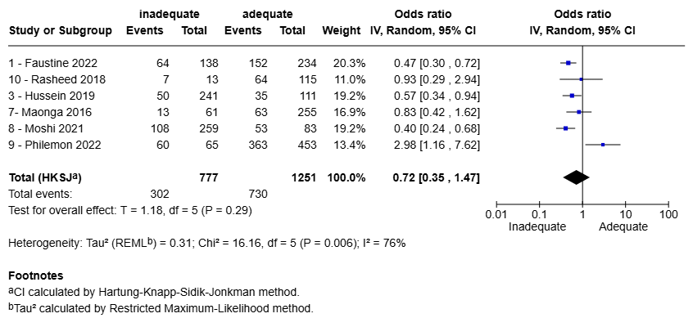

Pooled ORs of Mothers employment status
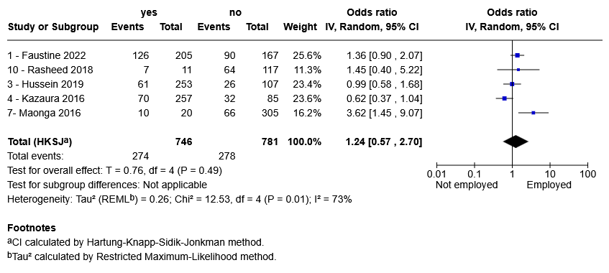

Pooled ORs of Knowledge of duration of EBF
