Supplementary contents

Supplementary Table 1. The detail of the conventional treatment.
Supplementary Table 2. The characteristic of the included studies.
Supplementary Figure 1. Forest plot of the exclusive breastfeeding rates by the subgroups of the mode of delivery.
Supplementary Figure 2. Detection of local inconsistencies for global cognition of exclusive breastfeeding rates.
Supplementary Figure 3. Forest plot for the pairwise meta-analysis of non-pharmacological TCM therapies on exclusive breastfeeding rates.
Supplementary Figure 4. Forest plot of the breast milk volume by the subgroups of the mode of delivery.
Supplementary Figure 5. Forest plot for the pairwise meta-analysis of non-pharmacological TCM therapies on breast milk volume.
Supplementary Figure 6. Forest plot of the lactation initial time by the subgroups of the mode of delivery.
Supplementary Figure 7. Detection of local inconsistencies for global cognition of time to lactogenesis II.
Supplementary Figure 8. Forest plot for the pairwise meta-analysis of non-pharmacological TCM therapies on time to lactogenesis II.
Supplementary Figure 9. Forest plot of the serum prolactin levels by the subgroups of the mode of delivery.
Supplementary Figure 10. Forest plot for the pairwise meta-analysis of non-pharmacological TCM therapies on serum prolactin levels.
Supplementary Figure 11. Funnel plot of non-pharmacological TCM therapies on exclusive breastfeeding rates.
Supplementary Figure 12. Funnel plot of non-pharmacological TCM therapies on breast milk volume.
Supplementary Figure 13. Funnel plot of non-pharmacological TCM therapies on time to lactogenesis II.
Supplementary Figure 14. Funnel plot of non-pharmacological TCM therapies on serum prolactin levels.

Study | Conventional treatment (basic breastfeeding support)
Mitra Savabi Esfahani et al[9], 2015, Iran | (1) Breastfeeding Guidance: Promotion of early suckling, instruction on positioning and expression techniques, and education on benefits.  (2) Health Support: Dietary counseling.  (3) Intervention Restrictions: No TCM non-pharmaceutical therapies.
Atena Mohammadpour et al[12],2018, Iran | (1) Breastfeeding Guidance: Early suckling, on-demand feeding, expression techniques, and positioning.  (2) Intervention Restrictions: No TCM non-pharmaceutical therapies.
Ping Lu et al[31],2019, China | (1) Breastfeeding Guidance: Early suckling, on-demand feeding, and positioning techniques.  (2) Health Support: Dietary guidance.  (3) Psychological Support: Emotional and mental health counseling.  (4) Intervention Restrictions: No TCM non-pharmaceutical therapies.
Isabella Neri et al[52],2011, Italy | (1) Breastfeeding Guidance: On-demand feeding and positioning techniques.  (2) Intervention Restrictions: No TCM non-pharmaceutical therapies.
Fateme Norouzi Nodehi et al[51],2024, Iran | (1) Breastfeeding Guidance: Milk expression techniques and newborn feeding education.  (2) Intervention Restrictions: No TCM non-pharmaceutical therapies.
Yakun Ming et al[33],2010, China | (1) Breastfeeding Guidance: Early skin-to-skin contact, early suckling, and lactation support.  (2) Intervention Restrictions: No TCM non-pharmaceutical therapies.
Yina Wang et al[40], 2015, China | (1) Breastfeeding Guidance: Promote early and frequent suckling to establish supply.  (2) Health Support: Provide dietary guidance and nutritional support to enhance lactation.  (3) Intervention Restrictions: No TCM non-pharmaceutical therapies.
Jieyu Chen et al[23],2020, China | (1) Breastfeeding Guidance: Prioritize early skin-to-skin contact, early suckling, and 24-hour rooming-in.  (2) Health Support: Provide comprehensive guidance on postpartum nutrition and physical activity.  (3) Intervention Restrictions: No TCM non-pharmaceutical therapies.
Lan Yuan[47], 2019, China | (1) Breastfeeding Guidance: Early, frequent, and on-demand suckling; instruction on breastfeeding techniques and milk expression.  (2) Intervention Restrictions: No TCM non-pharmaceutical therapies.
Yunjing Lun[32],2011, China | (1) Breastfeeding Guidance: Early skin-to-skin contact and suckling (within 30 min); guidance on breastfeeding positioning.  (2) Health Support: High-calorie, high-protein diet; avoid spicy/irritant foods.  (3) Intervention Restrictions: No TCM non-pharmaceutical therapies.
Lixia Zhang[49], 2017, China | (1) Breastfeeding Guidance: Early skin-to-skin contact and suckling.  (2) Intervention Restrictions: No TCM non-pharmaceutical therapies.
Pei Zhang[50],2018, China | (1) Breastfeeding Guidance: Early suckling (within 30 min); instruction on positioning and expression (≥10 sessions/24h, ≥30 min/session).  (2) Health Support: Early ambulation and dietary guidance.  (3) Intervention Restrictions: No TCM non-pharmaceutical therapies.
Xuan Chen et al[22], 2021, China | (1) Breastfeeding Guidance: Early skin-to-skin contact (<30 min) and suckling; instruction on on-demand feeding, positioning, and expression.  (2) Health Support: Rooming-in (mother and baby together).  (3) Psychological Support: Maintain positive mood and encourage family support.  (4) Intervention Restrictions: No TCM non-pharmaceutical therapies.
Meilan Wang et al[34],2018, China | (1) Breastfeeding Guidance: Routine instruction on lactation and techniques.  (2) Intervention Restrictions: No TCM non-pharmaceutical therapies.
Zhongqiu Wan et al[37],2022, China | (1) Breastfeeding Guidance: Correct breastfeeding techniques.  (2) Health Support: Dietary guidance.  (3) Intervention Restrictions: No TCM non-pharmaceutical therapies.
Liya Hui et al[29],2022, China | (1) Breastfeeding Guidance: Importance and key precautions.  (2) Health Support: Perineal hygiene and dietary guidance.  (3) Intervention Restrictions: No TCM non-pharmaceutical therapies.
Xiuling Xia[42], 2019, China | (1) Breastfeeding Guidance: Early skin-to-skin contact, early sucking, breast care, and proper positioning.  (2) Psychological Support: Education and confidence building.  (3) Intervention Restrictions: No TCM non-pharmaceutical therapies.
Yanqin Li[45],2024, China | (1) Breastfeeding Guidance: Early sucking, positioning, expression techniques, and inverted nipple care.  (2) Health Support: Dietary guidance.  (3) Psychological Support: Emotional counseling.  (4) Intervention Restrictions: No TCM non-pharmaceutical therapies.
Yao Hong[46],2018, China | (1) Breastfeeding Guidance: Early skin-to-skin contact and breast hygiene;  (2) Health Support: Dietary guidance.  (3) Psychological Support: Emotional counseling.  (4) Intervention Restrictions: No TCM non-pharmaceutical therapies.
Weixia Wu et al[41],2017, China | (1) Breastfeeding Guidance: Early latch, breast hygiene, and proper positioning.  (2) Health Support: High-protein, high-calorie diet; avoid spicy/irritating foods.  (3) Psychological Support: Emotional counseling and role transition assistance.  (4) Intervention Restrictions: No TCM non-pharmaceutical therapies.
Jia Sheng et al[36], 2020, China | (1) Breastfeeding Guidance: Early skin-to-skin contact; milk expression starting within 6h postpartum, at least 6 times daily.  (2) Intervention Restrictions: No TCM non-pharmaceutical therapies.
Dan Xian[43],2017,China | (1) Breastfeeding Guidance: Routine instruction on lactation and techniques.  (2) Health Support: Dietary guidance.  (3) Intervention Restrictions: No TCM non-pharmaceutical therapies.
Fangzhen Wang et al[39],2022,China | (1) Breastfeeding Guidance: Early skin-to-skin contact and rooming-in.  (2) Intervention Restrictions: No TCM non-pharmaceutical therapies.
Xia Chen et al[24],2020,China | (1) Breastfeeding Guidance: Early skin-to-skin contact, early suckling, and guidance on breastfeeding positions and frequency.  (2) Health Support: Dietary guidance.  (3) Intervention Restrictions: No TCM non-pharmaceutical therapies.
Lixia Yang[44], 2020, China | (1) Breastfeeding Guidance: Early suckling and education on the benefits of breastfeeding.  (2) Intervention Restrictions: No TCM non-pharmaceutical therapies.
Lianqun Liu et al[30],2015, China | (1) Breastfeeding Guidance: Routine breast care.  (2) Intervention Restrictions: No TCM non-pharmaceutical therapies.
Min Zeng[48], 2019, China | (1) Breastfeeding Guidance: Early suckling, instruction on manual expression, and proper breastfeeding techniques. (2) Health Support: Dietary guidance.  (3) Intervention Restrictions: No TCM non-pharmaceutical therapies.

Supplementary Table 1. The detail of the conventional treatment.

Authors,  Year,  Country | Study Period | Age, year(M±SD) |  | Mode of delivery | Infant gestational age | Group (sample size) (Education background) |  |  |  | Intervenor |  | Intervention time and sessions |  | Outcomes
Authors,  Year,  Country | Study Period | Control group | Intervention group
Mitra Savabi Esfahani et al[9], 2015, Iran | NA | 24.2±3.7 | 24.5±3.7 | Cesarean section + vaginal delivery | Term | Control (n=30)  (high school:15) | Apr(n=30)  (high school:15) | NA | NA |  | Mother |  | three times a day/  each time for 2-5 min/ for 12 sequential days |  | BMV
Atena Mohammadpour et al[12],2018, Iran | August 2015 to  November 2015 | NA | NA | Cesarean section | Preterm | Con (n=25)  (NA) | Ref(n=25)  (NA) | NA | NA |  | Researcher |  | Each foot separately lasted 20 min for a total of 40 min/one session a day for 6 days |  | BMV
Ping Lu et al[31],2019, China | September 2012 to July 2013 | 28.72±3.58 | 28.76±3.80 | Cesarean section | Term | Con (n=24)  (NA) | Acu-t(n=24)  (NA) | NA | NA |  | NA |  | 48hours postpartum/one session a day for 2 days |  | S-PRL-L
Isabella Neri et al[52],2011, Italy | NA | 33.9±4.5 | 34.9±4.3 | NA | NA | Con (n=45)  (NA) | Apu(n=45)  (NA) | NA | NA |  | Experienced and qualified acupuncturists |  | twice weekly for 3 weeks for a total of six sessions |  | EBR
Fateme Norouzi Nodehi et al[51],2024, Iran | February 2023 to November 2023 | 31.26±5.61 | 32.10±6.41 | NA | Preterm | Con  (n=38)  (NA) | Ref(n=38)  (NA) | NA | NA |  | Researcher |  | performed on day 4 after delivery for 20 min on both feet for seven days |  | BMV
Yakun Ming et al[33],2010, China | December 2008 to December 2009 | NA | NA | Cesarean section | Term | Con  (n=49)  (NA) | Mas+APSP(n=58)  (NA) | NA | NA |  | Nurse |  | Auricular points sticking-pressing were applied 2 hours postpartum/ followed by massage 2 hours later/ for 3 days |  | TL- II
Yina Wang et al[40], 2015, China | June 2013 to March 2014 | 21.97±0.54 | 22.53±0.79 | Vaginal delivery | Term | Con  (n=60) (NA) | Apr(n=60)  (NA) | NA | NA |  | NA |  | 24 hours postpartum/1 times per day/for 3 days |  | S-PRL-L
Chunli Wang et al[38],2023, China | September 2022 to February 2023 | NA | NA | NA | Term | Con  (n=30)  (NA) | Mas+Press needle(n=30)  (NA) | NA | NA |  | NA |  | press needle continued 48h |  | BMV
Qiaoting Du et al[25],2020, China | November 1, 2018 to June 30, 2019 | Mas: 26.82±2.14  Hot c: 26.43±2.06  Mas+Hot c: 25.63±2.12 |  | Cesarean section + Vaginal delivery | Term | Mas(n=30)  (NA) | Hot c(n=30)  (NA) | Mas+Hot c(n=30) | NA |  | Nurse |  | Hot compress:20 - 30 minutes per time, 2 times a day, with an interval of 6 hours each time. Massage: massage each acupoint for about 1 minute, once a day. The treatments lasted for four days. |  | TL- II
Jieyu Chen et al[23],2020, China | January to October in 2018 | 29.61±1.84 | 29.52±1.89 | Cesarean section | Term | Con  (n=45)  (High school or technical secondary school:14  college degree or above:31) | Mas(n=45)  (Junior high school or below:5; senior high school or technical secondary school:11, junior college or above:29) | NA | NA |  | NA |  | each acupoint for about 1 minute/ once a day/for 5 days |  | EBR,  S-PRL-L
Xuetao Duan et al[26],2017, China | May 2014 to March 2015 | NA | NA | Cesarean section + Vaginal delivery | Term | Mas(n=100)  (NA) | Apu+APSP(n=100)  (NA) | NA | NA |  | NA |  | massage:1 time per day/for 3 days |  | BMV
Lan Yuan[47], 2019, China | July 2014 to June 2016 | 25.46±3.38 | 25.32±3.45 | Cesarean section + Vaginal delivery | Term | Mas(n=48)  (NA) | Mas+APSP(n=48)  (NA) | NA | NA |  | Nurse |  | APSP for 3 days |  | EBR,  S-PRL-L
Yunjing Lun[32],2011, China | January 2010 to December 2010 | NA | NA | Vaginal delivery | Term | Con  (n=300)  (NA) | Mas(n=300)  (NA) | NA | NA |  | NA |  | 6 hours postpartum/ 3 times per day/for 3-5 days |  | TL- II
Lixia Zhang[49], 2017, China | February 2014 to January 2016 | 28.4±5.1 | 28.6±5.3 | NA | Term | Con (n=107)  (NA) | Mas(n=107)  (NA) | NA | NA |  | Nurse |  | NA |  | TL- II
Pei Zhang[50],2018, China | June 2015 to June 2016 | NA | NA | Cesarean section | Term | Con (n=110)  (NA) | Mas(n=110)  (NA) | NA | NA |  | Nurse |  | 12 hours after delivery/twice a day, 30 minutes each time/4 times in total |  | EBR,  BMV
Xuan Chen et al[22], 2021, China | August 2018 to June 2020 | 29.05±4.28 | 29.24±4.13 | Cesarean section + Vaginal delivery | Term | Con (n=80)  (NA) | Mas(n=80)  (NA) | NA | NA |  | NA |  | Each side for 15 to 20 minutes/ twice a day/ for 4 sessions |  | TL- II
Meilan Wang et al[34],2018, China | May 2017 to December 2017 | 29.3±6.6 | 28.9±6.4 | Cesarean section + Vaginal delivery | NA | Con (n=45)  (NA) | Mas+APSP(n=45)  (NA) | NA | NA |  | NA |  | NA |  | S-PRL-L
Zhongqiu Wan et al[37],2022, China | June 2019 to December 2020 | 28.56±2.10 | 28.61±2.05 | Cesarean section | Term | Con (n=100)  (NA) | Mas+Apu(n=100)  (NA) | NA | NA |  | NA |  | both for 3 days |  | EBR
Liya Hui et al[29],2022, China | July 2018 to August 2020 | 28.92±5.44 | 28.87±5.39 | Cesarean section + Vaginal delivery | Term | Con (n=71)  (NA) | Mas(n=71)  (NA) | NA | NA |  | Nurse |  | 10 minutes, 40 minutes per time, 1 time per day/for 7 days |  | EBR
Xiuling Xia[42], 2019, China | January 2016 to January 2017 | NA | NA | Vaginal delivery | Term | Con (n=50)  (NA) | Apr(n=50)  (NA) | NA | NA |  | Nurse |  | 30 minutes each time/once a day |  | EBR,  TL- II
Guoqing Lai[27],2018, China | February 2015 to December 2017 | 28.31±3.78 | 28.45±3.89 | Vaginal delivery | Term | Mox(n=43)  (Illiterate:1; primary school:3; junior high school:10; senior high school:16; college:13) | Mas(n=43)  (Illiterate:2; primary school:4; junior high school:6; senior high school:17; college:14) | NA | NA |  | NA |  | NA |  | EBR,  TL- II
Yanqin Li[45],2024, China | July 2022 to June 2023 | 30.49±3.52 | 30.61±3.37 | Cesarean section | Term | Con (n=50)  (NA) | Mas+APSP(n=50)  (NA) | NA | NA |  | NA |  | NA |  | EBR,  BMV,  TL- II
Lan Hu et al[28], 2020, China | January 2019 to December 2019 | 28.61±4.52 | 29.16±4.69 | Cesarean section + Vaginal delivery | NA | Mas(n=450)  (NA) | Mas+Mox(n=450)  (NA) | NA | NA |  | Healthcare Professionals |  | postpartum 3 days/15 - 20 minutes, 1 time per day/ for 1 week in total |  | BMV
Yao Hong[46],2018, China | June 2015 to June 2017 | 28.7±3.9 | 27.9±3.8 | Cesarean section + Vaginal delivery | Term | Con (n=50)  (NA) | Mas(n=50)  (NA) | NA | NA |  | Nurse |  | 24 hours after delivery |  | BMV,  TL- II,  S-PRL-L
Yan Shao[35],2017, China | September 2015 to September 2016 | 27.98±3.27 | 28.77±3.31 | Cesarean section + Vaginal delivery | Term | Mas(n=88)  (NA) | Mas+APSP(n=88)  (NA) | NA | NA |  | NA |  | Three times a day |  | TL- II
Weixia Wu et al[41],2017, China | August 2015 to January 2017 | 29.68±3.71 | 29.36±3.41 | NA | Term | Con (n=59)  (NA) | Mas(n=59)  (NA) | NA | NA |  | Rehabilitation therapist |  | 6 hours postpartum |  | EBR,  TL- II
Jia Sheng et al[36], 2020, China | October 2019 to March 2020 | 31.11±4.76 | Mas:  31.38±5.6  Apr  :30.75±4.83 Mas+Apr:  31.88±3.53 | Cesarean section + Vaginal delivery | Preterm | Con  (n=40)  (NA) | Mas(n=40)  (NA) | Apr  (n=40) | Mas+Apr  (n=40) |  | Nurse |  | NA |  | EBR,  TL- II
Dan Xian[43],2017, China | January 2014 to December 2014 | 27.8±3.2 | 26.5±4.6 | NA | Term | Con  (n=58)  (NA) | Apu(n=58)  (NA) | NA | NA |  | NA |  | Once a day/ for a total of 2 weeks |  | BMV,  S-PRL-L
Fangzhen Wang et al[39], 2022, China | January to December in 2019 | 28.12±4.9 | 27.88±4.6 | Vaginal delivery | Term | Con  (n=300)  (NA) | Mas+Apr(n=300)  (NA) | NA | NA |  | NA |  | 30-40min per time/for 3 days |  | EBR
Xia Chen et al[24],2020, China | June 2017 to December 2018 | 31.18±4.54 | Mas:  30.47±4.5  Mox:  31.18±3.62 Mas+Mox:  32.33±5.00 | Cesarean section + Vaginal delivery | NA | Con  (n=60)  (NA) | Mas(n=60)  (NA) | Mox  (n=55) | Mas+Mox  (n=55) |  | NA |  | NA |  | TL- II
Lixia Yang[44], 2020, China | October 2018 to February 2019 | NA | NA | Cesarean section + Vaginal delivery | Term+ Premature | Con  (n=63)  (NA) | Mas(n=63)  (NA) | NA | NA |  | Nurse |  | 1 time every 4 hours/ 6 times a day/ for a total of 3 days |  | TL- II
Lianqun Liu et al[30],2015, China | December 2011 to March 2013 | 26.22±8.95 | 25.43±10.12 | Cesarean section | Term+ Premature | Con  (n=41)  (Junior high school:18; senior high school or above:23) | Apr(n=42)  (Junior high school:17; senior high school or above:25) | NA | NA |  | Nurse |  | 6 hours postpartum/each acupoint for 3 to 5 repetitions in a cycle, 2 times a day/ for 3 days |  | BMV,  TL- II,  S-PRL-L
Min Zeng[48], 2019, China | July 2017 to January 2019 | 28.64±7.12 | 29.12±7.04 | NA | NA | Con  (n=36)  (NA) | Mas+APSP(n=36)  (NA) | NA | NA |  | NA |  | for 3 days |  | S-PRL-L

Supplementary Table 2. The characteristic of the included studies.
Con=control, Apr=Acupressure, Ref=Reflexology, Acu-t=Acupoint-tuina, Apu=Acupuncture, Mas=Massage, APSP= Auricular points sticking-pressing, Hot C=Hot compress, Mox=Moxibustion, EBR=Exclusive Breastfeeding Rates, BMV=Breast Milk Volume, TL- II = Time to lactogenesis II, S-PRL-L=Serum prolactin levels.

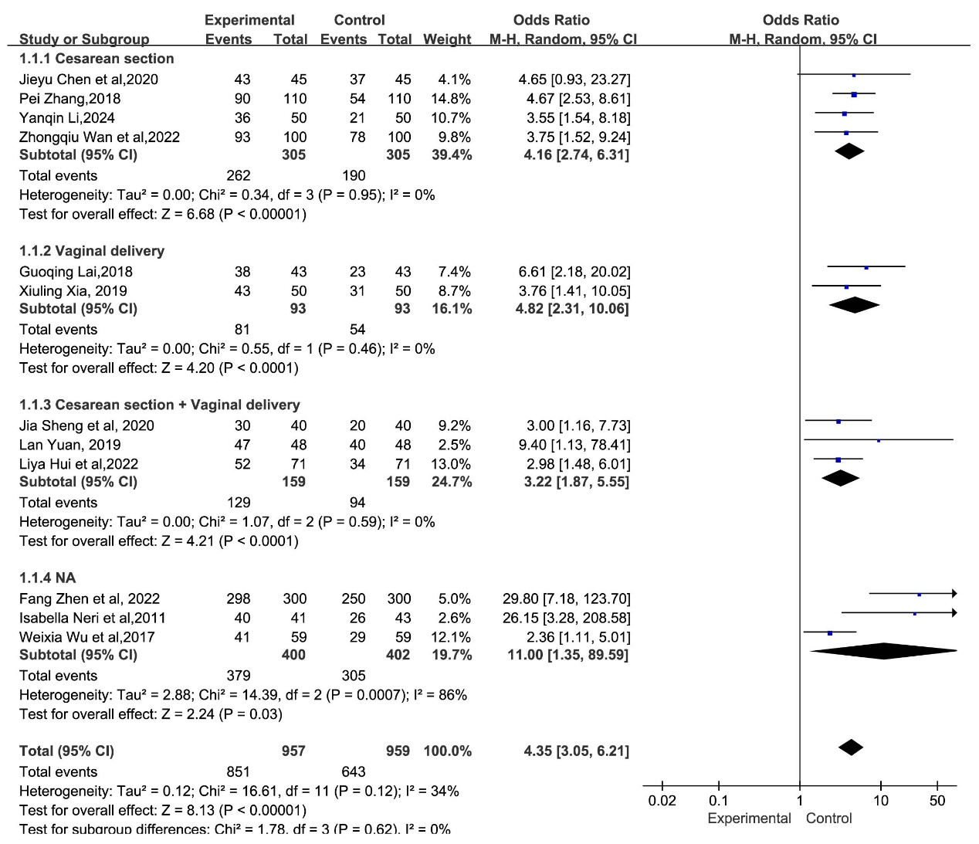
Supplementary Figure 1. Forest plot of the exclusive breastfeeding rates by the subgroups of the mode of delivery.
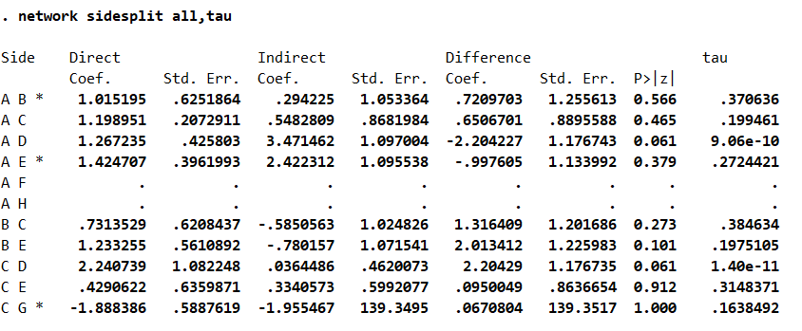
Supplementary Figure 2. Detection of local inconsistencies for global cognition of exclusive breastfeeding rates.

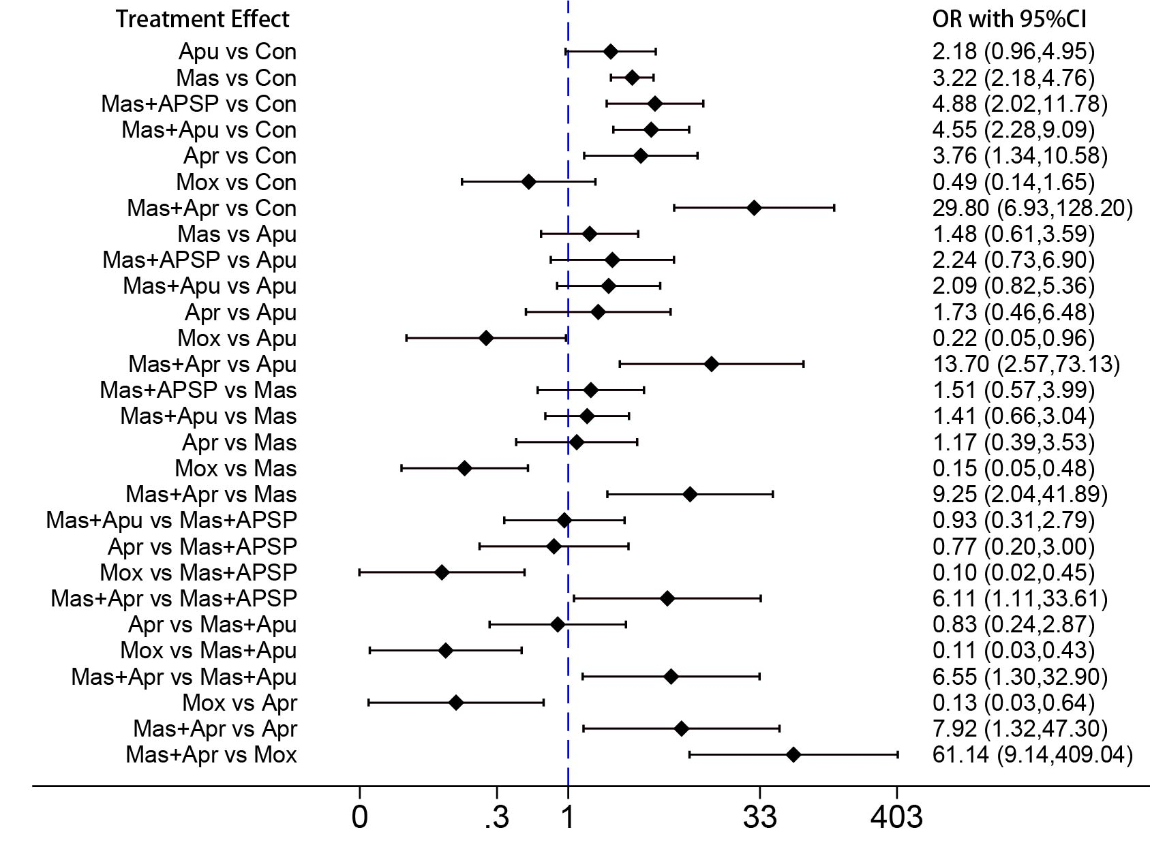
Supplementary Figure 3. Forest plot for the pairwise meta-analysis of non-pharmacological TCM therapies on exclusive breastfeeding rates.
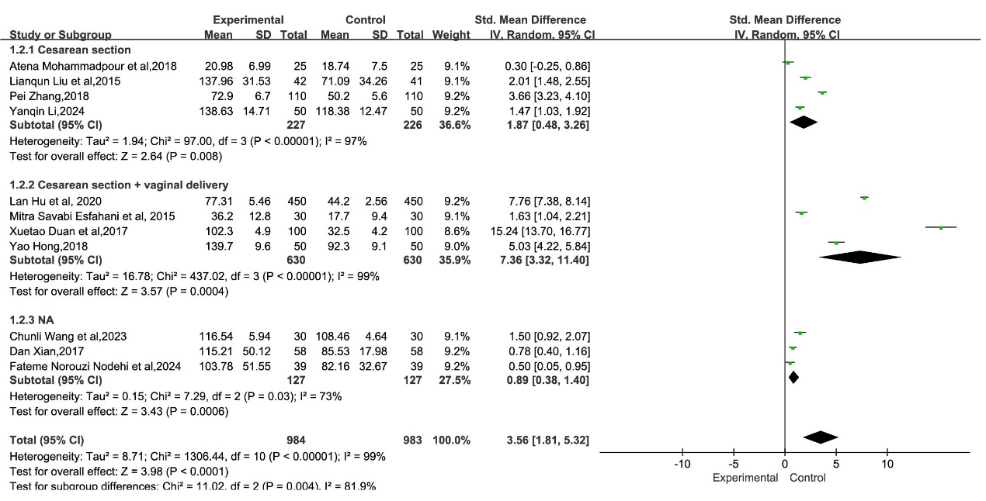
Supplementary Figure 4. Forest plot of the breast milk volume by the subgroups of the mode of delivery.

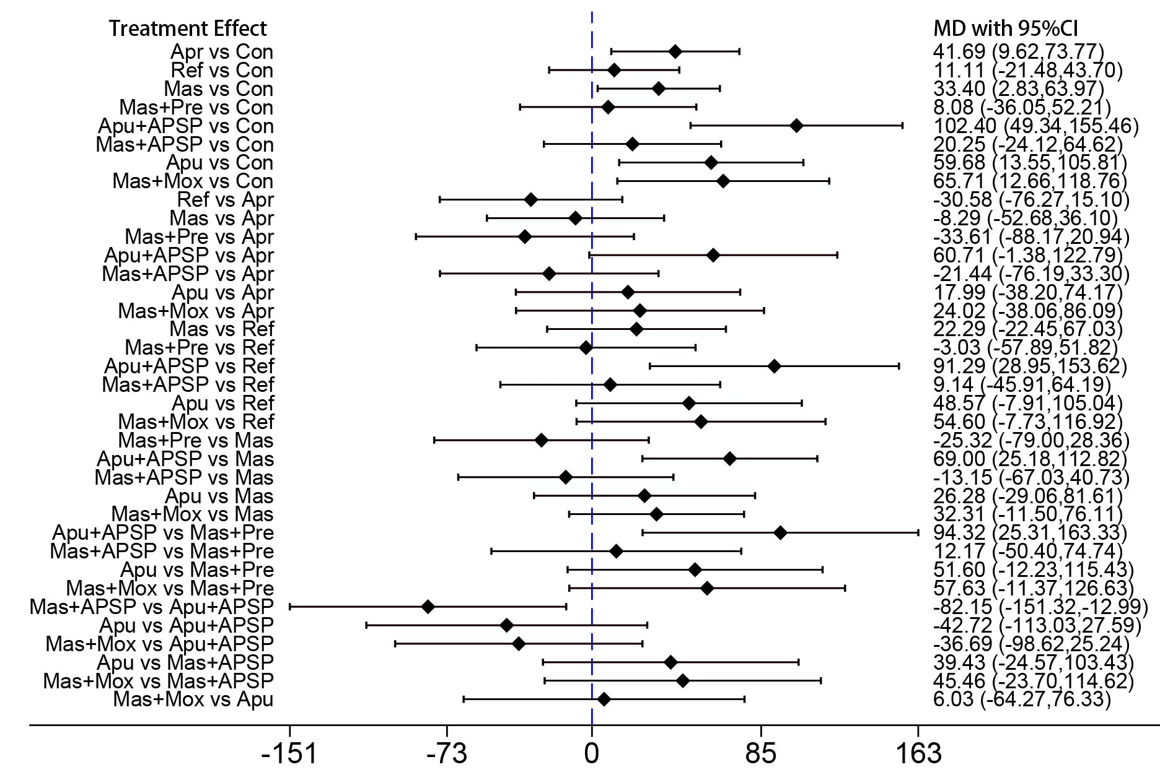
Supplementary Figure 5. Forest plot for the pairwise meta-analysis of non-pharmacological TCM therapies on breast milk volume.
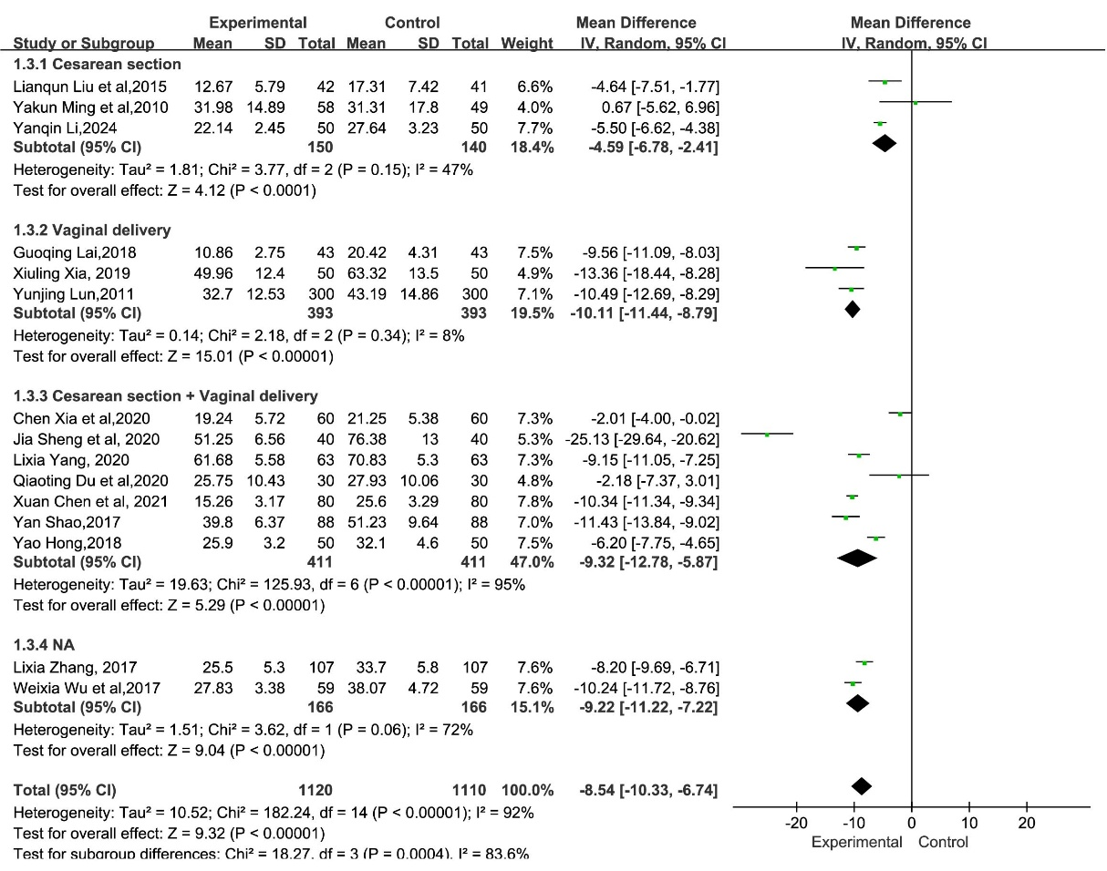
Supplementary Figure 6. Forest plot of the lactation initial time by the subgroups of the mode of delivery.
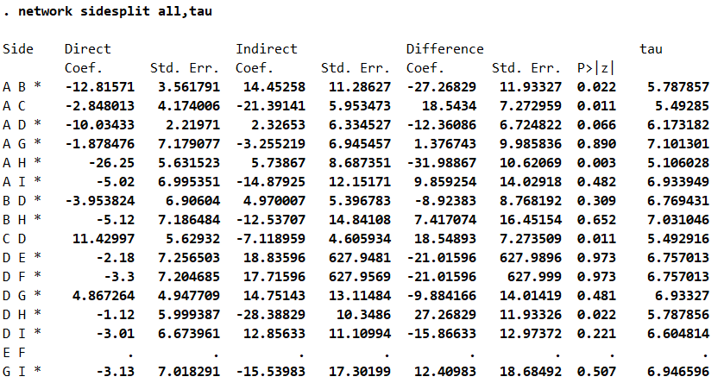
Supplementary Figure 7. Detection of local inconsistencies for global cognition of time to lactogenesis II.
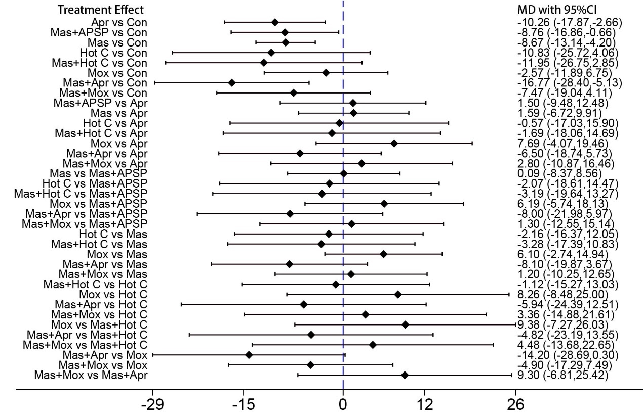
Supplementary Figure 8. Forest plot for the pairwise meta-analysis of non-pharmacological TCM therapies on time to lactogenesis II.
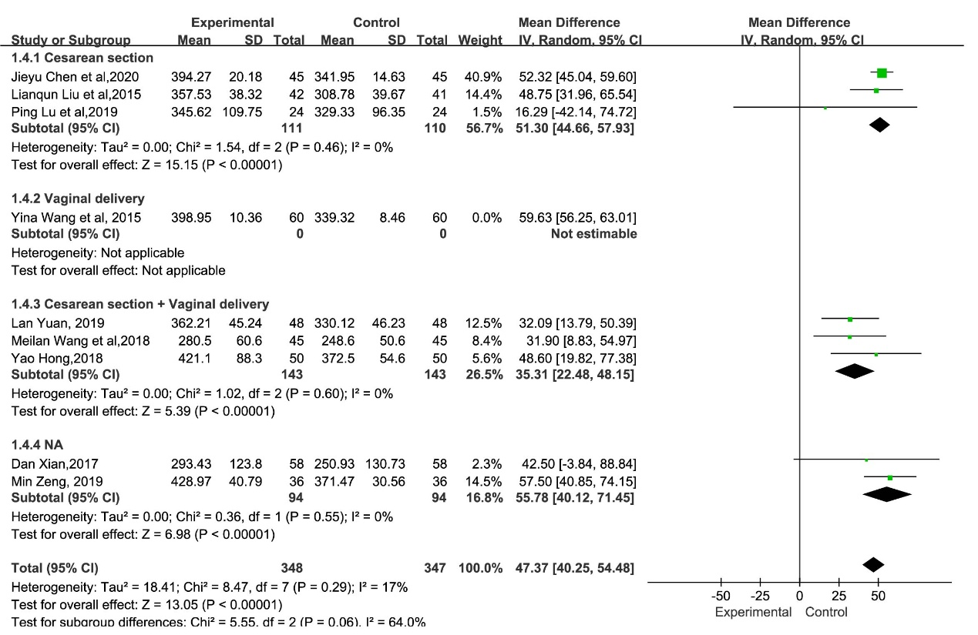
Supplementary Figure 9. Forest plot of the serum prolactin levels by the subgroups of the mode of delivery.

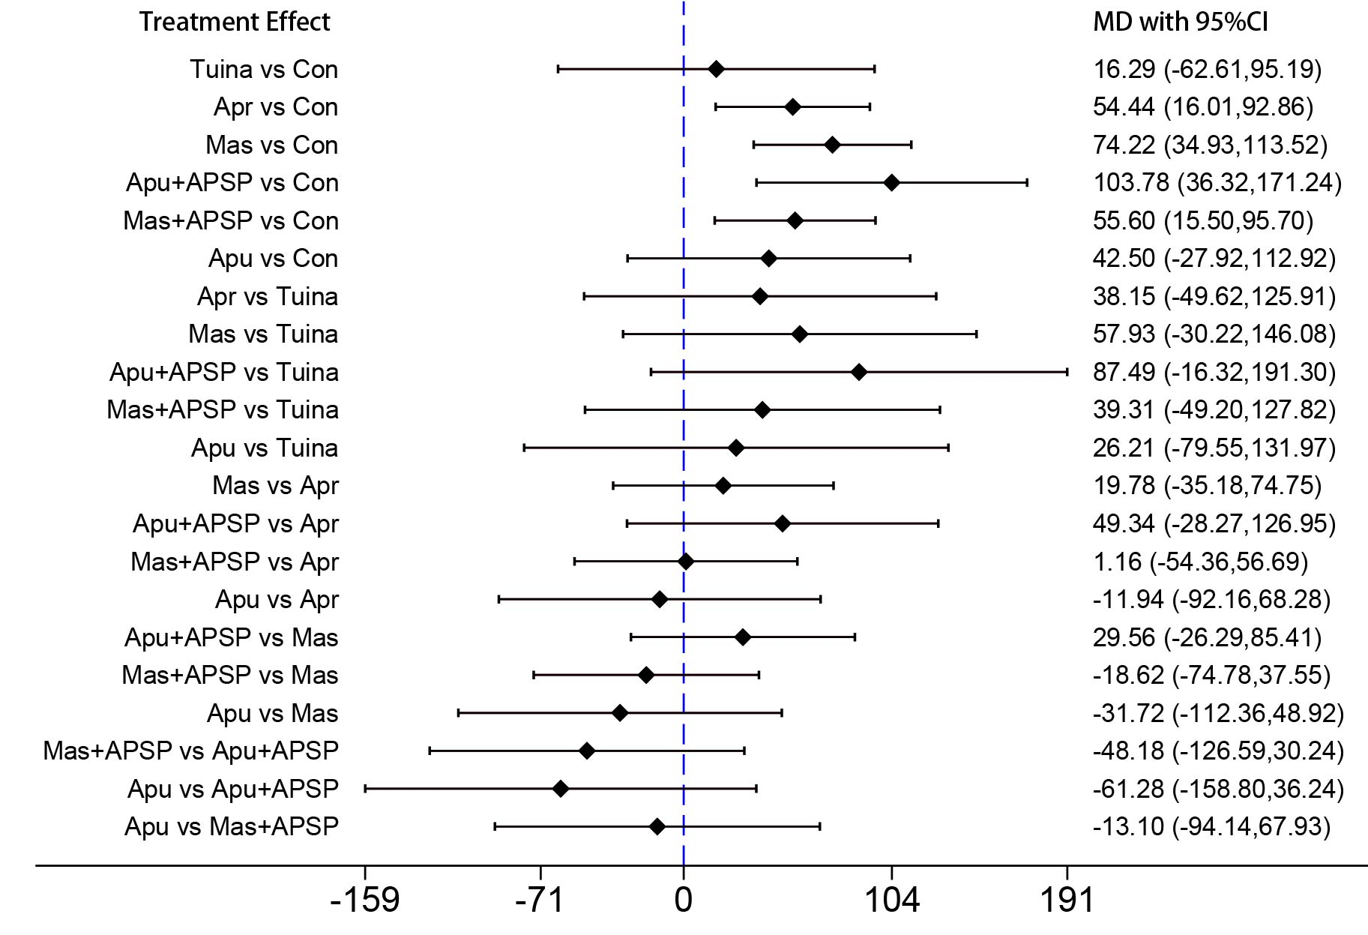
Supplementary Figure 10. Forest plot for the pairwise meta-analysis of non-pharmacological TCM therapies on serum prolactin levels.
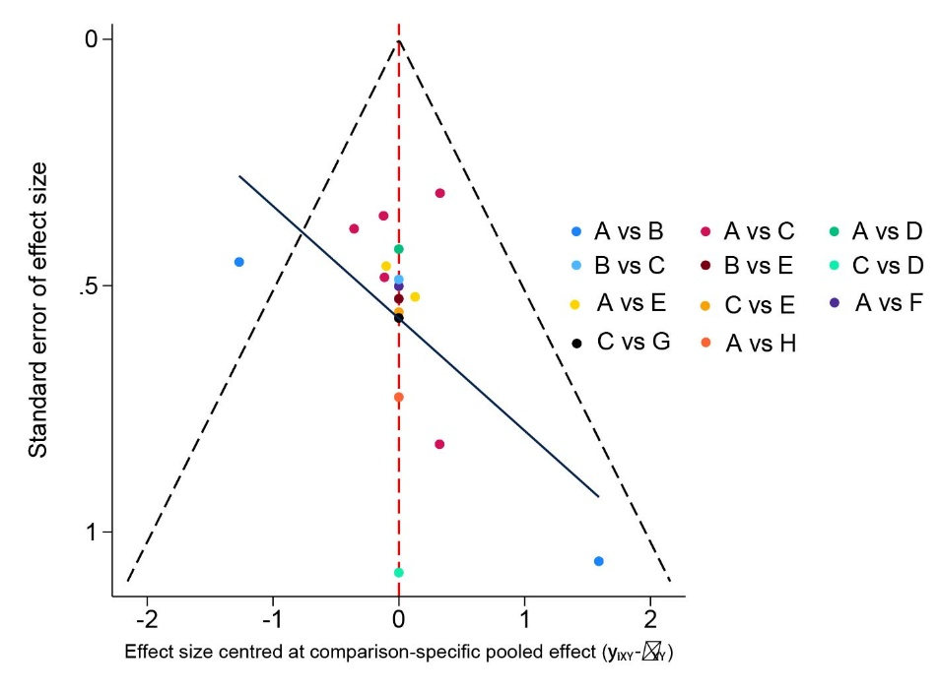
Supplementary Figure 11. Funnel plot of non-pharmacological TCM therapies on exclusive breastfeeding rates. A: Control, B: Acupuncture, C: Massage, D: Massage + APSP, E: Massage + Acupuncture, F: Acupressure, G: Moxibustion, H: Massage + Acupressure.
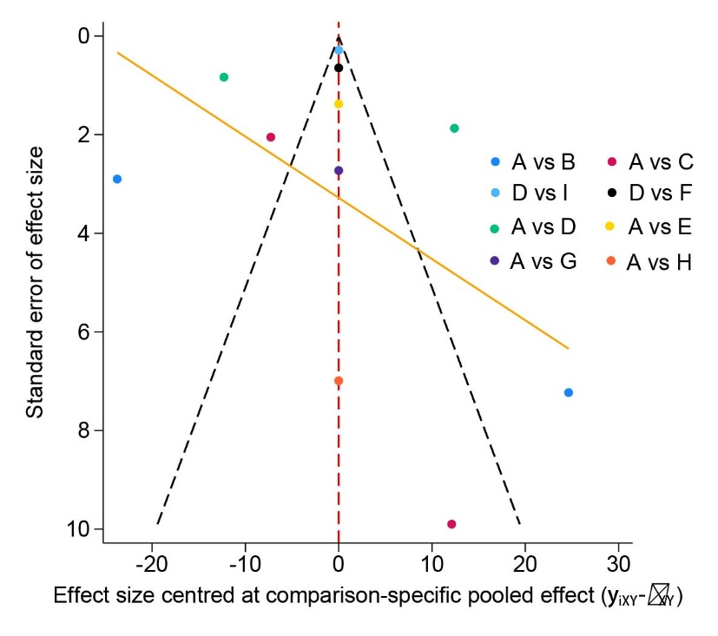
Supplementary Figure 12. Funnel plot of non-pharmacological TCM therapies on breast milk volume.
A: Control, B: Acupressure, C: Reflexology, D: Massage, E: Massage + Press needle, F: Acupuncture + APSP, G: Massage +APSP, H: Acupuncture, I: Massage + Moxibustion.
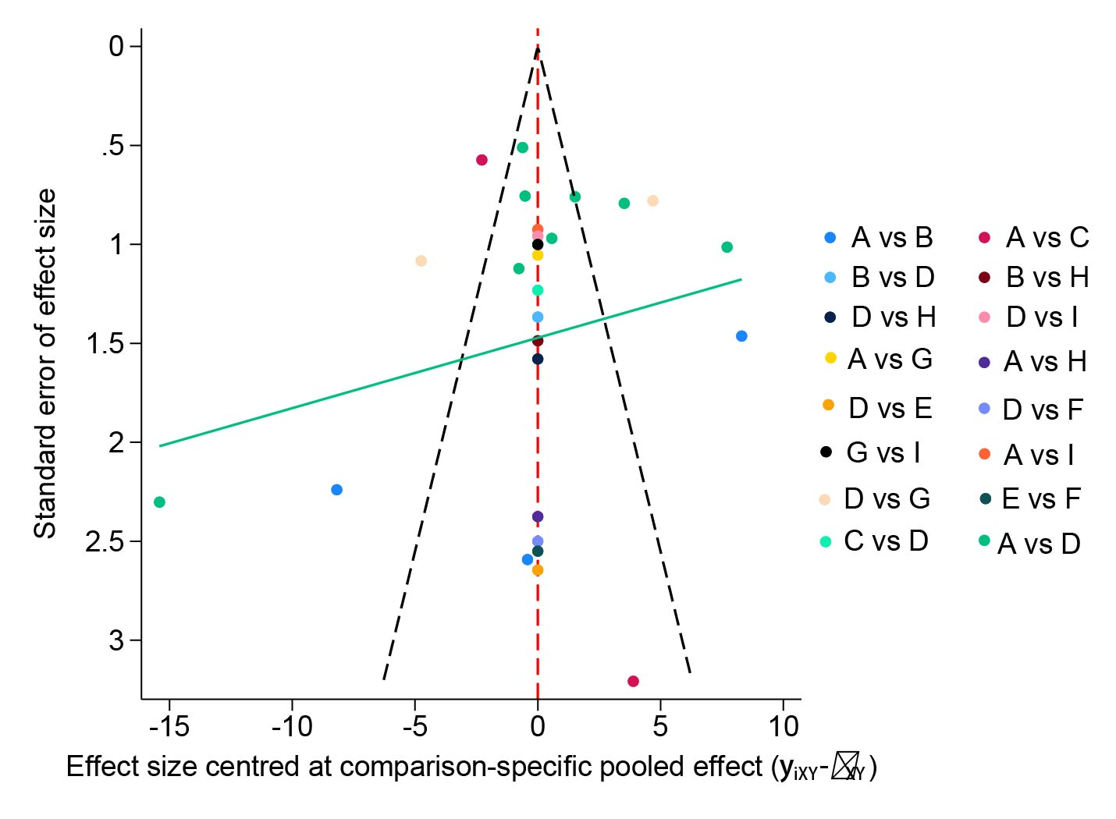
Supplementary Figure 13. Funnel plot of non-pharmacological TCM therapies on time to lactogenesis II. A: Control, B: Acupressure, C: Massage + APSP, D: Massage, E: Hot compress, F: Massage + Hot compress, G: Moxibustion, H: Massage + Acupressure, I: Massage + Moxibustion.
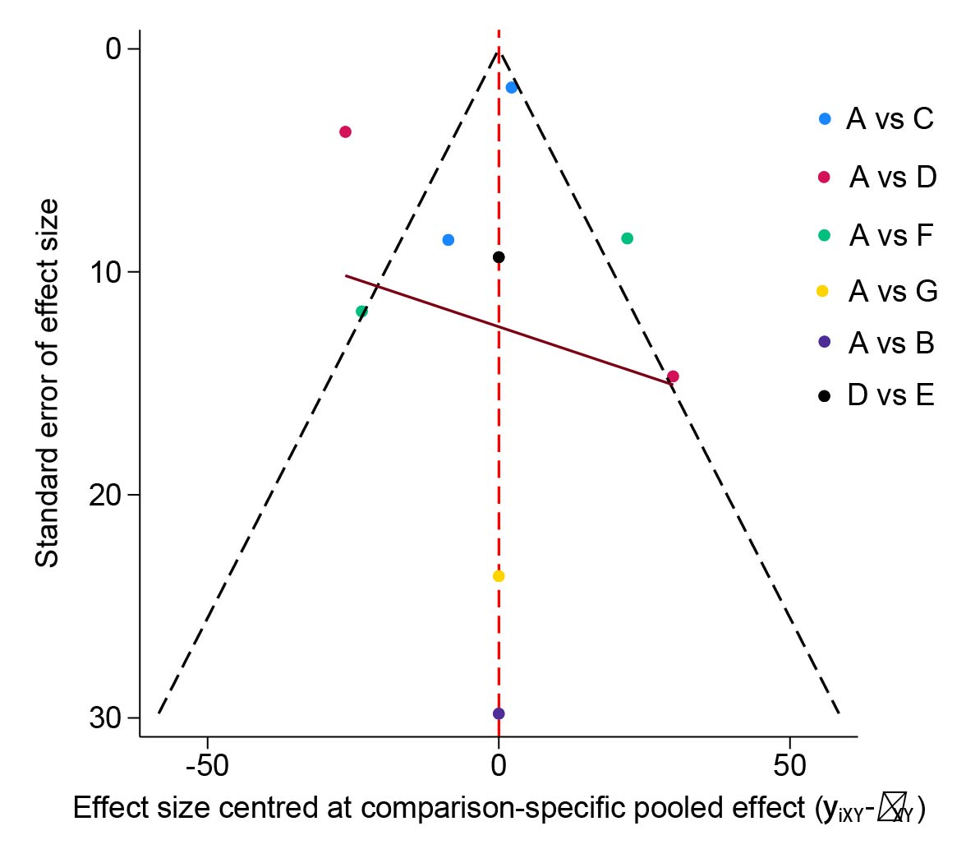
Supplementary Figure 14. Funnel plot of non-pharmacological TCM therapies on serum prolactin levels. A: Control, B: Acupoint-tuina, C: Acupressure, D: Massage, E: Acupuncture + APSP, F: Massage +APSP, G: Acupuncture.

