Additional file
Hazard Ratio curves for breastfeeding cessation of the non proportional effects in the survival analysis (Model 4)

Figure 1 Non-proportional effect of variable “Possibility to work from home before returning to work” 2
Figure 2 Non-proportional effect of variable “Meetings outside of normal working hours a few times per week before returning to work ” 3
Figure 3 Non-proportional effect of variable “Business trips involving sovernight stays of one or more night(s) before returning to work ”. 4
Figure 4 Non-proportional effect of variable “Business trips involving overnight stays for one or more night(s) at least once a month after returning to work » 5

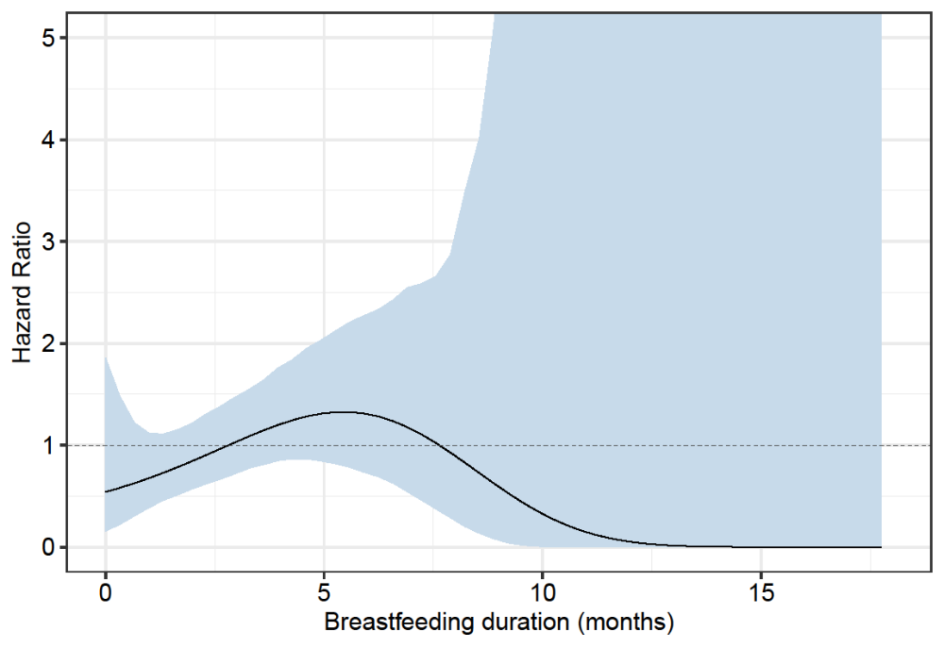
Figure 1. Non-proportional effect of variable “Possibility to work from home before returning to work”.

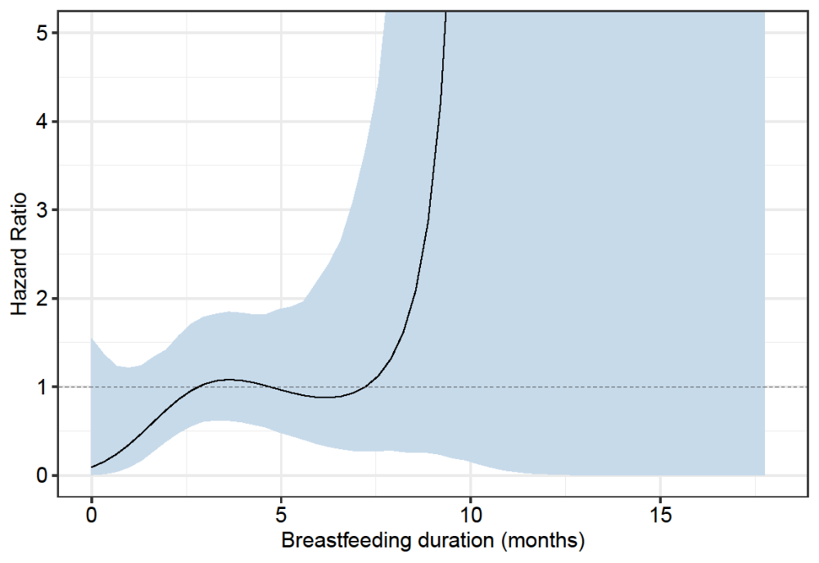
Figure 2. Non-proportional effect of variable “Meetings outside of normal working hours a few times per week before returning to work”.

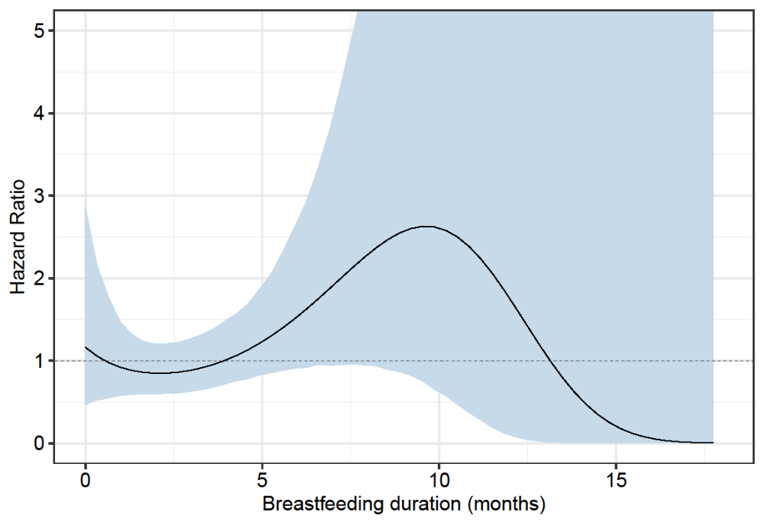
A
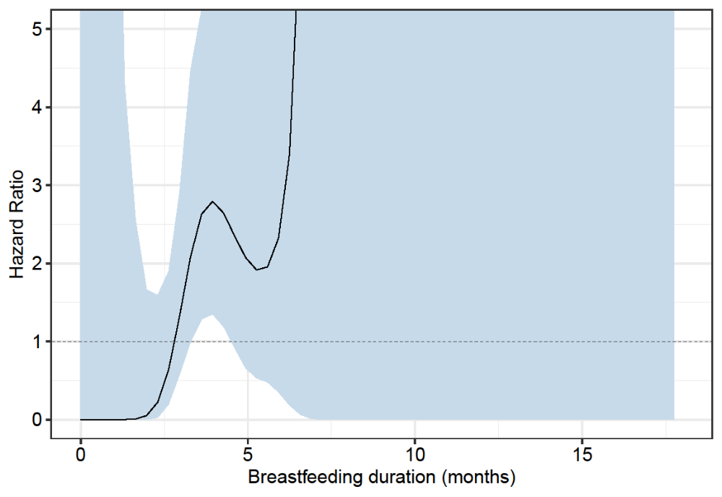
B
Figure 3. Non-proportional effect of variable “Business trips involving overnight stays of one or more night(s) before returning to work”.
A: less than once a month, B: at least once a month.
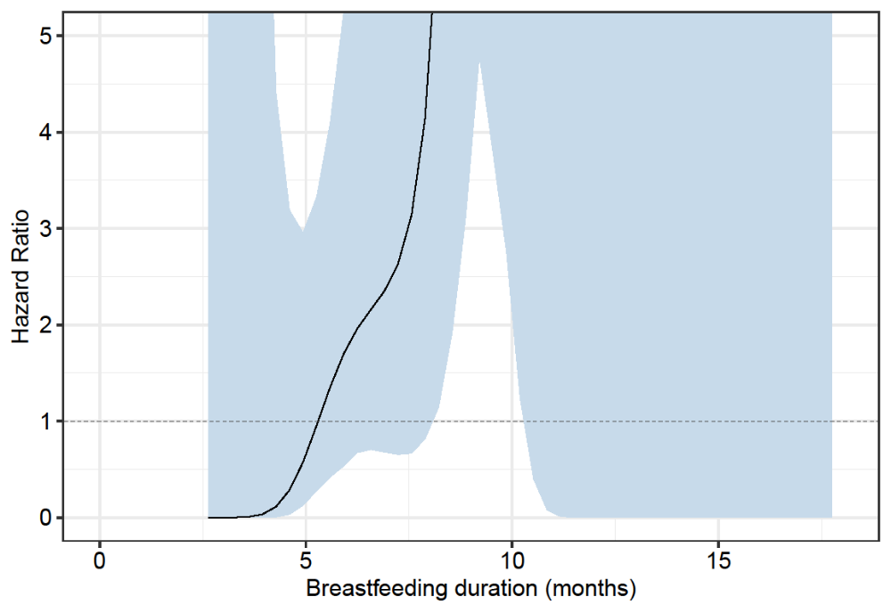
Figure 4. Non-proportional effect of variable “Business trips involving overnight stays of one or more night(s) at least once a month after returning to work”.

