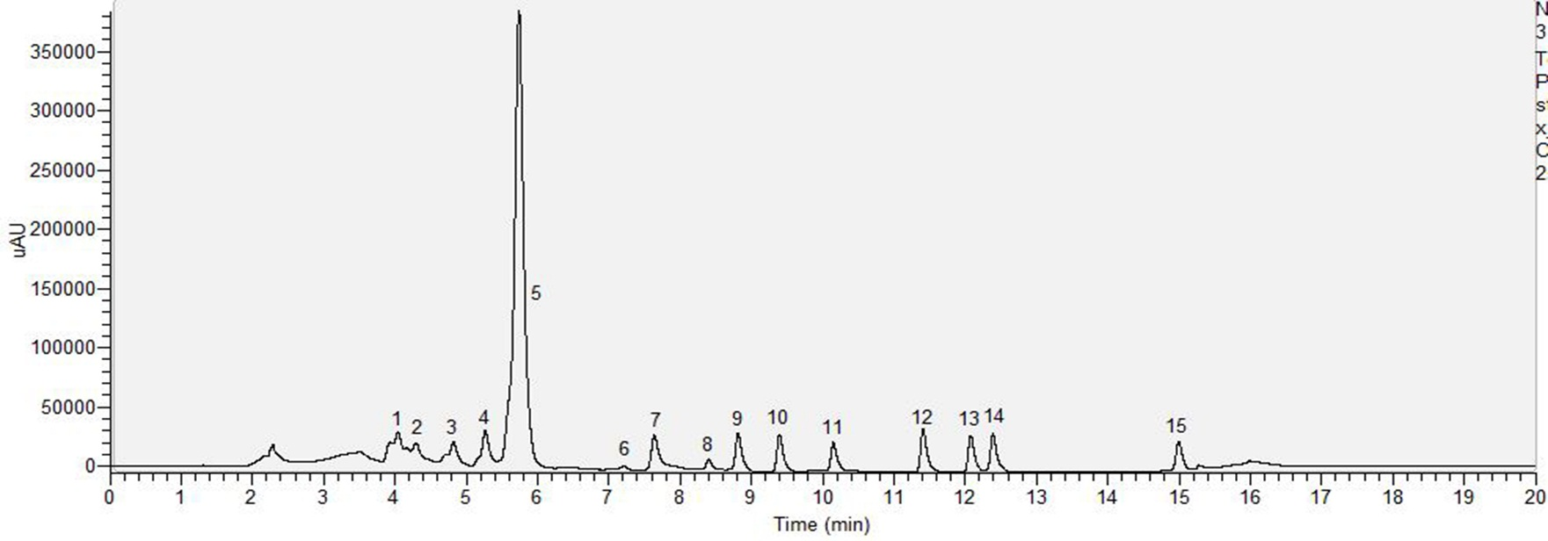
(A)

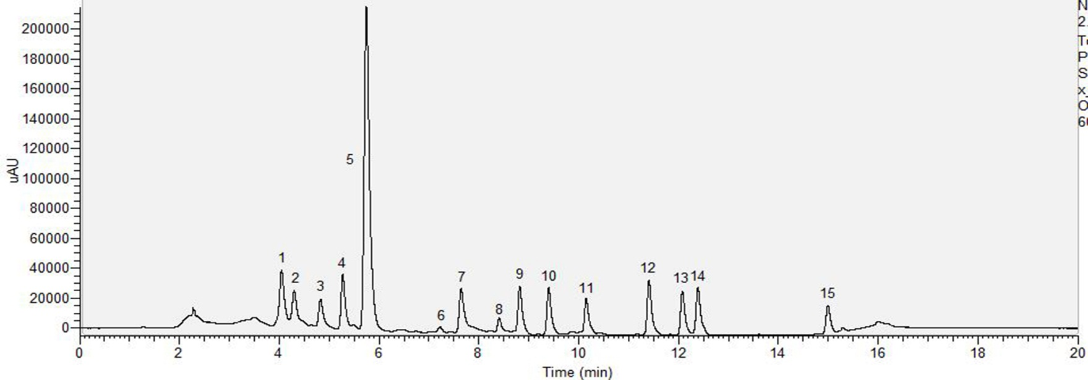
(B)
Additional file 1: Figure S1 HPLC profile of carotenoid standards recorded in the range of 250.00-700.00 nm in different injection solvents. (A) Standard mix dissolved in MeOH:MTBE (25:75) and (B) Standard mix dissolved in MeOH:MTBE (60:40) The compounds are (1) violaxanthin; (2) neoxanthin; (3) anthraxanthin; (4) lutein; (5) zeaxanthin; (6) phytoene; (7) β-cryptoxanthin; (8) phytofluene; (9) α-carotene; (10) β-carotene; (11) ζ-carotene; (12) δ-carotene; (13) γ-carotene; (14) neurosporene; (15) lycopene.

