Additional file 2. Two-step PCR from pilot experiment.
A. Products of first step PCR from the pilot experiment. Amplifications were performed with 5 or 10 ng of pooled DNA in the different dilutions that simulated the inclusion of the mutated individual. Gel was run in 1.5% agarose in TAE 1X at 90V for 40 minutes. Size of marker bands is given in bp. Negative control refers to a PCR with no DNA template.
Samples primer DNA-dilution proportion cultivars
First - marker
1 - 2 S20 5ng-10ng Macbeth:Bethune 1:96
3 - 4 S20 5ng-10ng Macbeth:Bethune 1:64
5 - 6 S20 5ng-10ng Bethune 100%
7 S20 negative negative
8 - 9 S411 5ng-10ng Macbeth:Bethune 1:96
10 - 11 S411 5ng-10ng Macbeth:Bethune 1:64
12 - 13 S411 5ng-10ng Bethune 100%
14 S411 negative negative
15 - 16 S900 5ng-10ng Macbeth:Bethune 1:96
17 - 18 S900 5ng-10ng Macbeth:Bethune 1:64
19 - 20 S900 5ng-10ng Bethune 100%
21 S900 negative negative

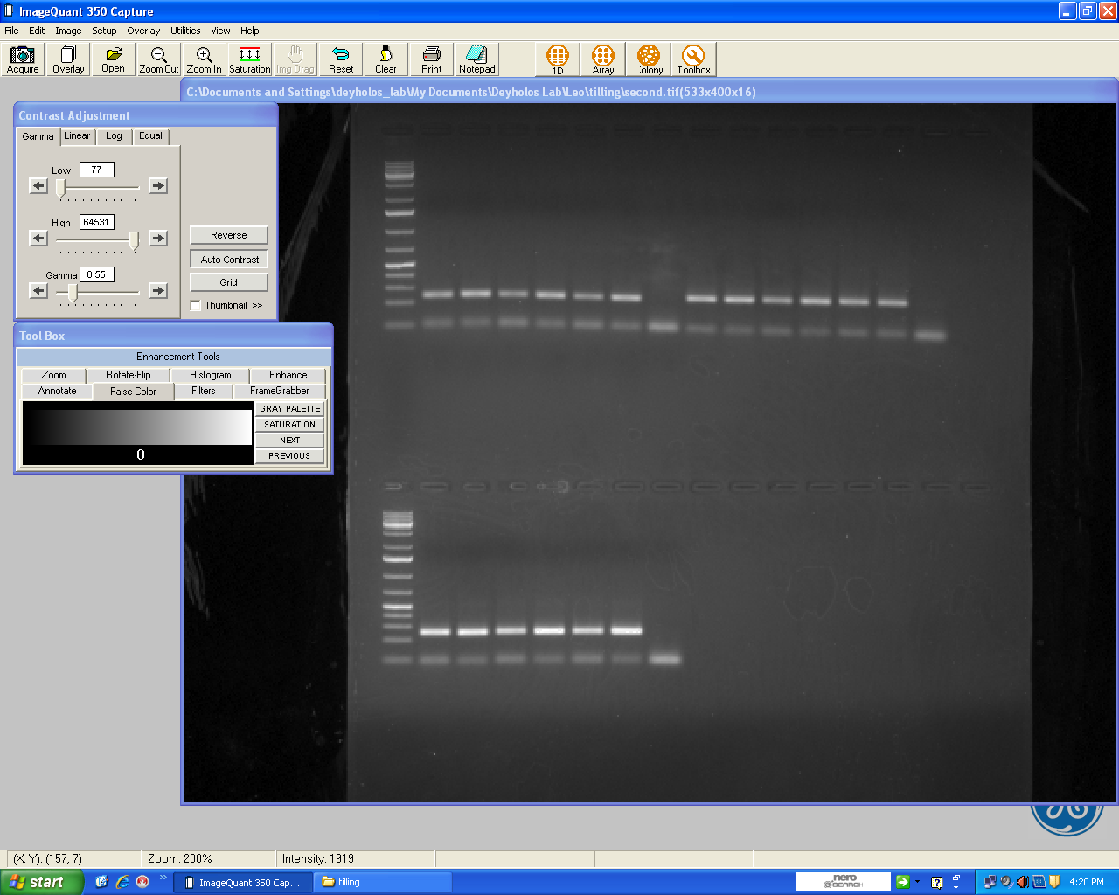
1 2 3 4 5 6 7 8 9 10 11 12 13 14
15 16 17 18 19 20 21

300
500
400
200

B. Products of second step PCR from the pilot experiment. Amplifications were performed with 1:100 dilutions of the first-step PCR mixed products of the three genes (S20, S411, S900). Gel was run in 1.5% agarose in TAE 1X at 90V for 60 minutes. Size of marker bands is given in bp. Negative control refers to a PCR with no DNA template.

samples tRP1 and barcoded primer
First - marker
top 1-14 barcode primers 1-14
bottom 1-14 barcode primers 15-28

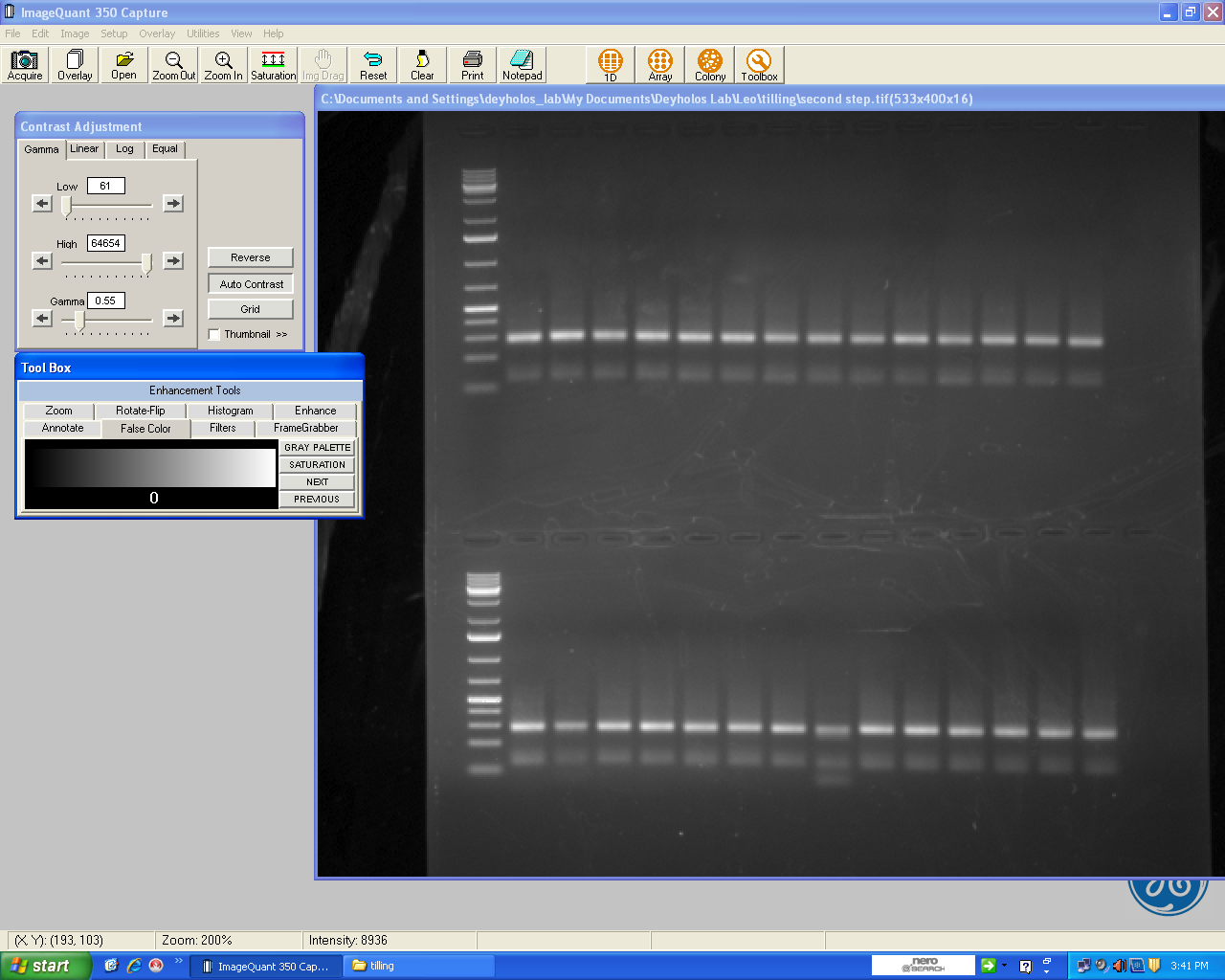
1 2 3 4 5 6 7 8 9 10 11 12 13 14
15 16 17 18 19 20 21 22 23 24 25 26 27 28

300
500
400
200

