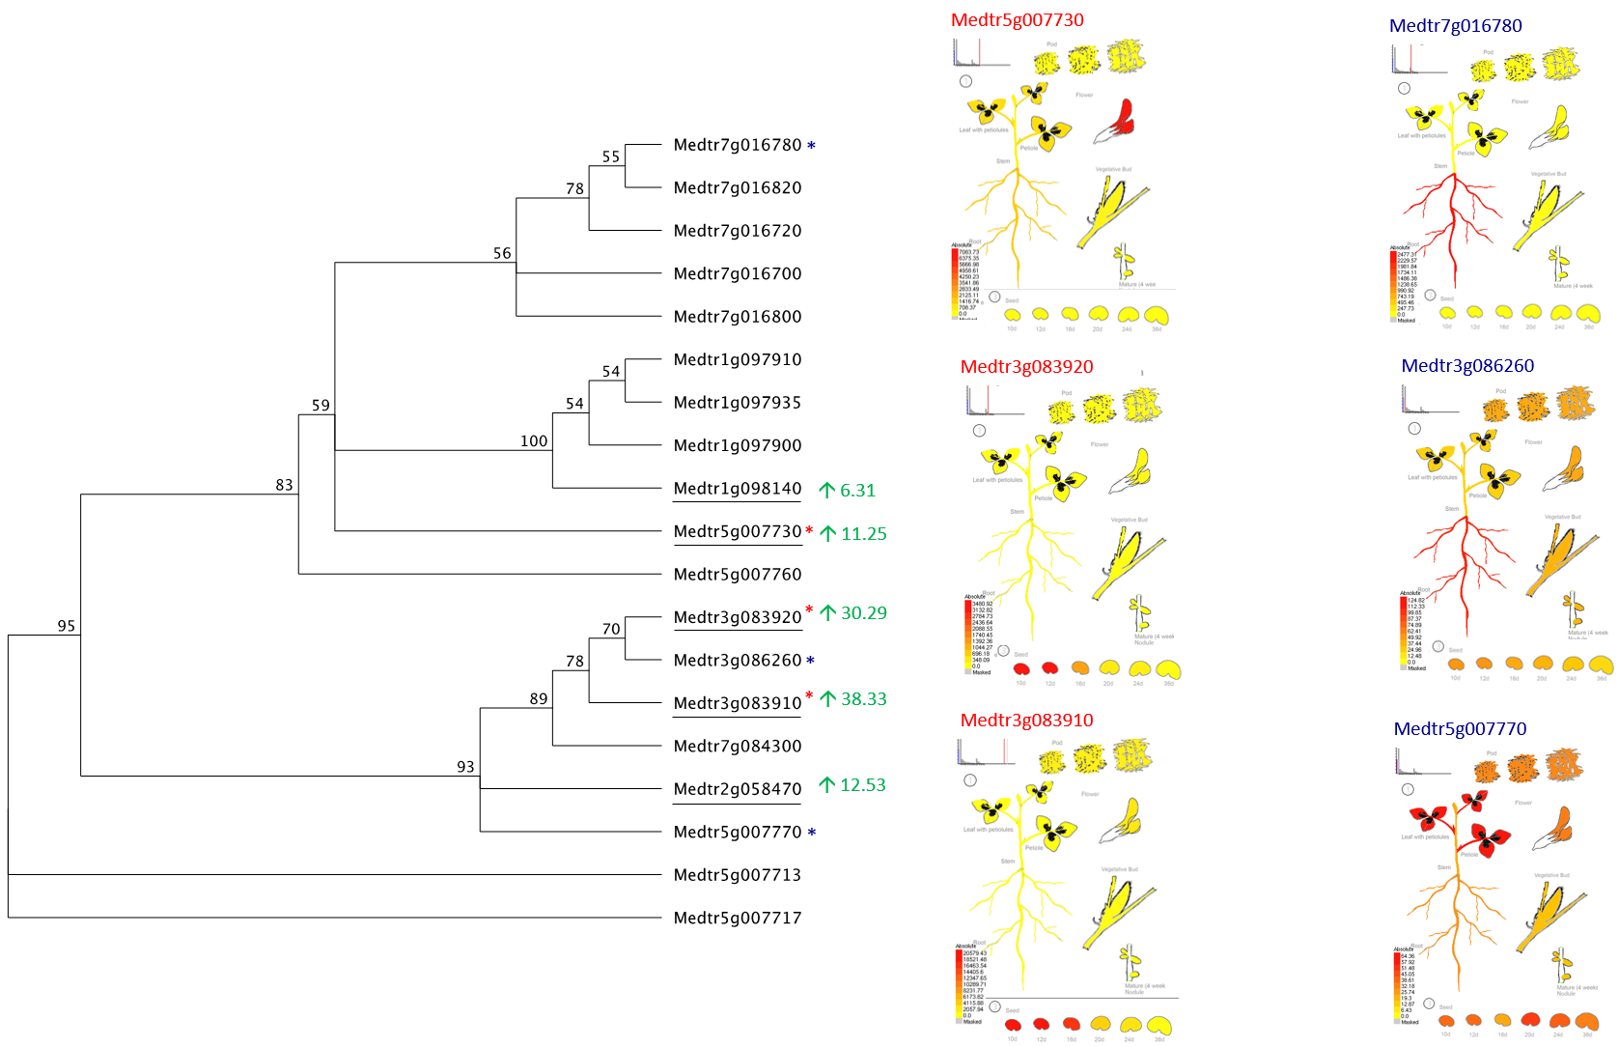
Figure S3 Potential Chalcone Synthase genes in Medicago truncatula.
Phylogenetic tree of Medicago truncatula genes annotated as ‘Chalcone and Stilbene Synthase family protein’ (left). Bootstrap support for key branches is presented (%). Transcripts that are significantly differentially expressed (P-value <0.05) between Control and LAP1 conditions are underlined. Numbers in green are the fold change of expression observed for each significantly differentially expressed (P-value <0.05) gene between Control and LAP1 conditions (Table S1); green represents upregulation. Potential Chalcone Synthase genes display different patterns of expression (right). Expression patterns of three genes (Medtr5g007730, Medtr3g083920 and Medtr3g083910) that are significantly differentially expressed (P-value <0.05) between Control and LAP1 conditions (red *) are predominantly expressed in leaf, floral and seed tissue. In contrast, expression patterns of three other genes (Medtr1g016780, Medtr3g086260 and Medtr5g007770), which are not differentially expressed between Control and LAP1 conditions (blue *), are predominately expressed in roots or show a more general expression pattern. The Medicago electronic fluorescence pictographic (eFP) browser [1–3], via the Bio-Analytic Resource (BAR) for Plant Biology [4], was used to investigate gene expression profiles of potential Chalcone Synthase genes.
1. Benedito VA, Torres-Jerez I, Murray JD, Andriankaja A, Allen S, Kakar K, et al. A gene expression atlas of the model legume Medicago truncatula. Plant J. 2008;55:504–13.
2. Patel R V, Nahal HK, Breit R, Provart NJ. BAR expressolog identification: expression profile similarity ranking of homologous genes in plant species. Plant J. 2012;71:1038–50.
3. Medicago eFP Browser [Internet]. [cited 2016 Jun 3]. Available from: http://bar.utoronto.ca/efpmedicago/cgi-bin/efpWeb.cgi
4. The Bio-Analytic Resource (BAR) for Plant Biology [Internet]. [cited 2016 Jun 3]. Available from: http://bar.utoronto.ca/

