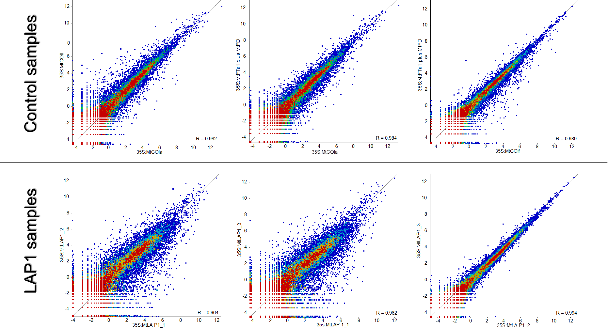
Figure S4 Scatter plots showing correlation between different samples in Control and LAP1 replicate sets.
Each individual point on the different plots represents a probe (an individual Medicago truncatula mRNA), showing the relationship between the quantitated values in the two selected data stores (as stated on the x- and y-axis of each scatter plot). The Pearson correlation value for each test is given within each plot.

