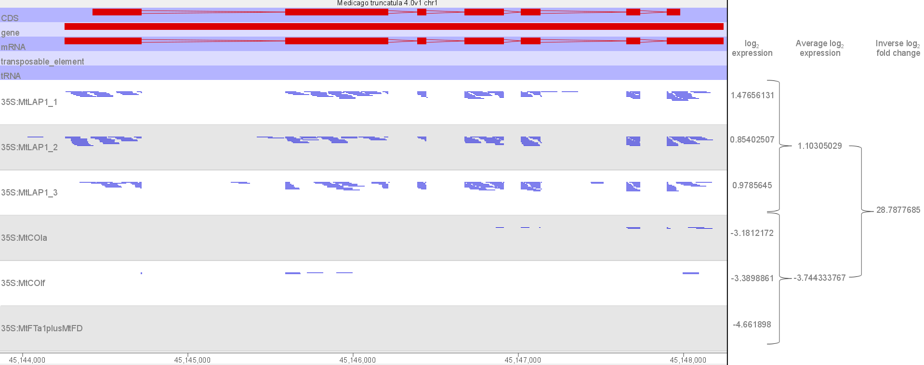
Figure S1 MtMATE2 (Medtr1g100180) up-regulation in response to agroinfiltration of MtLAP1.
Snapshot of RNAseq reads mapping to MtMATE2 (Medtr1g100180 Chr1:45144255-45148243), visualised by SeqMonk [1]. The MtMATE2 gene is on the forward strand (red) and the strand-specific RNAseq reads map to the reverse strand (blue). Log₂ expression of MtMATE2 is given for samples agroinfiltrated with MtLAP1 (top three RNAseq tracks) and control constructs (bottom three RNAseq tracks), as determined by DESeq2 (P-value <0.05; [2]). MtMATE2 is approximately 29-fold higher in MtLAP1-agroinfiltrated samples compared to control samples by this method. However, this did not hold true when the statistical-based fold change Intensity Difference Filter was incorporated (see methods), due to the large variation in expression between replicate samples.
1. Andrews S. SeqMonk [Internet]. [cited 2016 Apr 14]. Available from: http://www.bioinformatics.babraham.ac.uk/projects/seqmonk/
2. Love MI, Huber W, Anders S. Moderated estimation of fold change and dispersion for RNA-seq data with DESeq2. Genome Biol. 2014;15.

