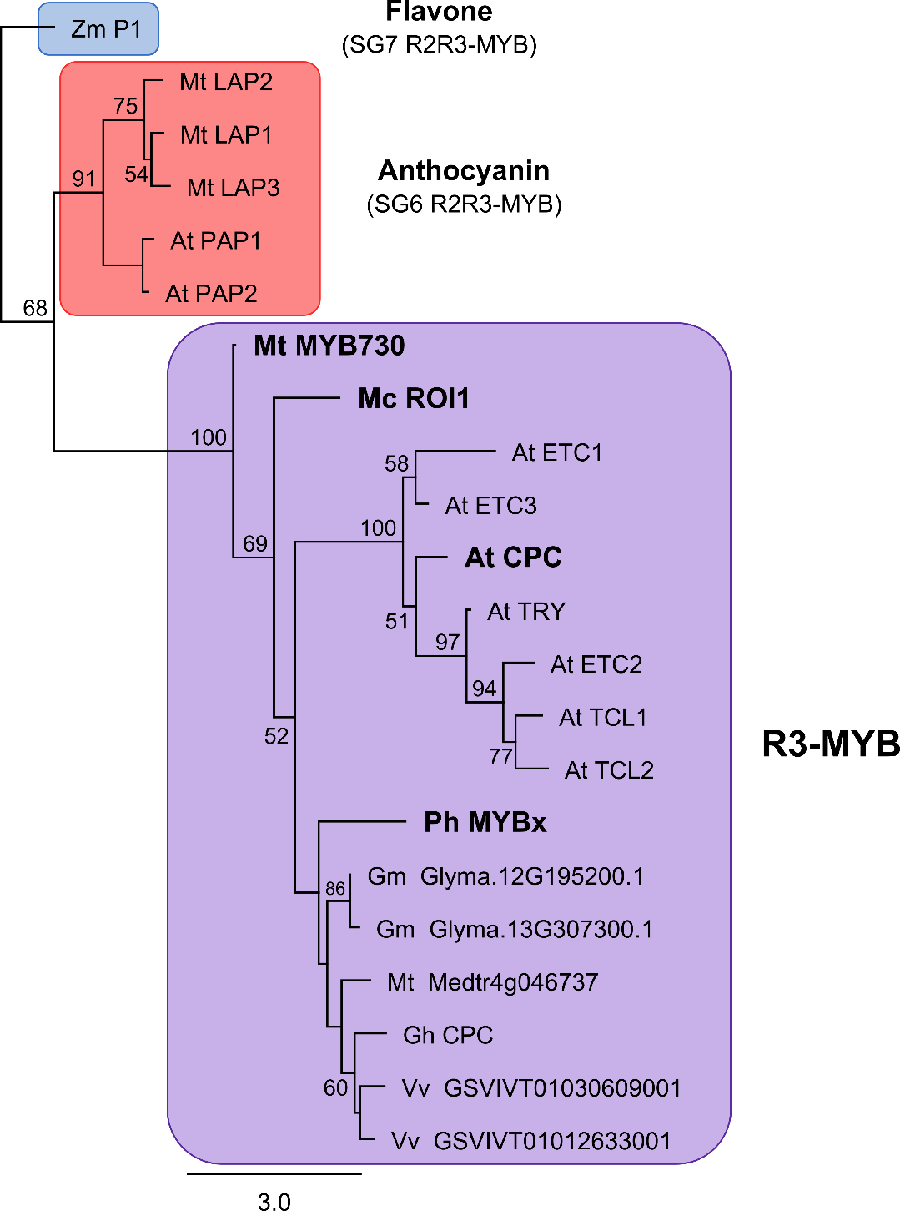
Figure S2 Maximum likelihood phylogenetic tree of Medicago truncatula MYB proteins.
R3-MYB proteins from Arabidopsis thaliana (At), Glycine max (Gm), Gossypium hirsutum (Gh), Medicago truncatula (Mt), Mimulus cardinalis (Mc), Petunia hybrida (Ph) and Vitis vinifera (Vv) were aligned and compared with R2R3-MYB proteins that regulate anthocyanin biosynthesis. The R2R3-MYB P1 from Zea mays (Zm) was used as an outgroup. Nodes with bootstrap support >50% are shown (1000 replicates). The R3-MYB proteins MYBx from Petunia, ROSE INTENSITY1 (ROI1) from Mimulus and CAPRICE (CPC) from Arabidopsis have established roles inhibiting MBW activity for anthocyanin pigmentation [1-3].
1. Zhu H-F, Fitzsimmons K, Khandelwal A, Kranz RG. CPC, a Single-Repeat R3 MYB, Is a Negative Regulator of Anthocyanin Biosynthesis in Arabidopsis. Mol. Plant. 2009;2:790–802.
2. Yuan Y-W, Sagawa JM, Young RC, Christensen BJ, Bradshaw HD. Genetic Dissection of a Major Anthocyanin QTL Contributing to Pollinator-Mediated Reproductive Isolation Between Sister Species of Mimulus. Genetics. 2013;194:255–63.
3. Albert NW, Davies KM, Lewis DH, Zhang H, Montefiori M, Brendolise C, et al. A conserved network of transcriptional activators and repressors regulates anthocyanin pigmentation in eudicots. Plant Cell. 2014;26:962–80.

