Additional file 5

Reference gene identification for reliable normalisation of quantitative RT-PCR data in Setaria viridis

Duc Quan Nguyen¹, Andrew L. Eamens^{1†} and Christopher P. L. Grof^{1*†}

¹ Centre for Plant Science, School of Environmental and Life Sciences, University of Newcastle, University Drive, Callaghan, NSW 2308, Australia

* Correspondence:
Christopher Grof
chris.grof@newcastle.edu.au

† These authors contributed equally to this work

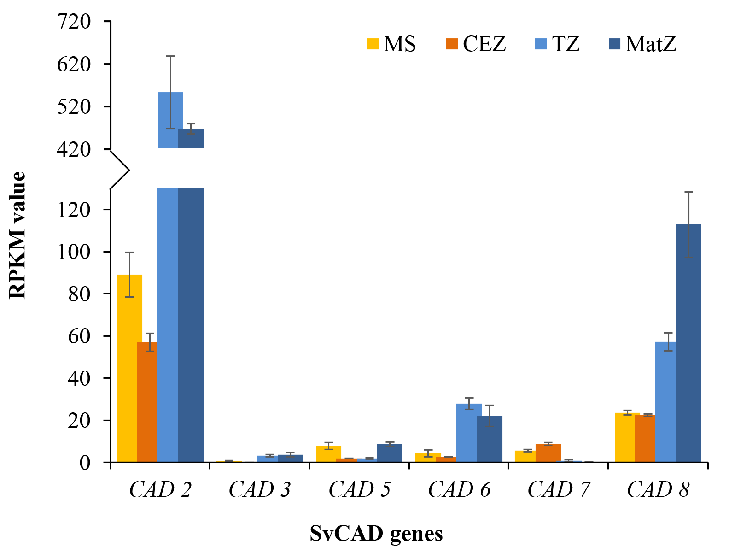
Figure S2: Analysis of Setaria viridis CAD gene expression according to the RNA-Seq dataset published in [1]. The transcript abundance of each of the detected members of the S. viridis CAD gene family across the four developmentally distinct zones of the elongating internode, internode 5, according to the dataset published by Martin et al. [1]. Of the six CADs identified from the [1] dataset, the SvCAD2 (Sevir.1G056800) transcript was determined to be the most abundance in internode 5 and further, SvCAD2 returned an expression profile expected of a gene that encodes a protein that plays a functional role in the formation of secondary cell walls, that is; less abundant in young or undifferentiated tissues and with a greatly enhanced abundance in transitioning and/or mature tissues. RPKM value: Reads Per Kilobase per Million mapped reads.
1. Martin AP, Palmer WM, Brown C, Abel C, Lunn JE, Furbank RT, et al. A developing Setaria viridis internode: an experimental system for the study of biomass generation in a C₄ model species. Biotechnol Biofuels. 2016;9:45-57. doi: 10.1186/s13068-016-0457-6.

