Supporting Information
Simultaneous untargeted and targeted metabolomics profiling of underivatized primary metabolites in sulfur-deficient barley by Ultra-High Performance Liquid Chromatography-Quadrupole/Time-of-Flight Mass Spectrometry
Hikmat Ghosson^{1,2}, Adrián Schwarzenberg^{1,*}, Frank Jamois¹, Jean-Claude Yvin¹
¹Centre Mondial de l’Innovation Roullier (CMI), 18 Avenue Franklin Roosevelt, 35400, Saint-Malo, France.
²UR1, UFR Sciences et propriétés de la matière, Université de Rennes 1, 2 rue du Thabor, CS 46510, 35065 Rennes Cedex, France
Table S1: RSD – ESI+ – Lowest concentration
nc: not calculated
Compound | Concentration (µg/L) | RSD (%) of RT | RSD (%) of PA
Proline | 2.5 | 0.70 | 4.81
Isoleucine | 2.5 | 0.56 | 3.60
Leucine | 2.5 | 0.41 | 5.64
Asparagine | 2 | nc | nc
Glutamine | 2 | 0.51 | 2.21
Lysine | 3 | 0.00 | 2.57
O-Acetyl-Serine | 2 | nc | nc
Methionine | 3 | 0.71 | 4.39
Histidine | 3 | 0.35 | 1.18
Phenylalanine | 4 | 1.71 | 3.35
Arginine | 4 | 0.18 | 7.12
Tyrosine | 4 | 0.00 | 1.48
Tryptophan | 2 | 0.52 | 3.26
Thiamine | 2 | 0.12 | 3.38
Glutathione reduced | 2 | 1.04 | 1.05
S-Adenosyl-Methionine | 2 | 0.51 | 2.49
Glutathione oxidized | 2 | 0.20 | 6.82

Table S2: RSD – ESI+ – Intermediate concentration

Compound | Concentration (µg/L) | RSD (%) of RT | RSD (%) of PA
Proline | 12.5 | 0.68 | 4.98
Isoleucine | 12.5 | 0.29 | 1.78
Leucine | 12.5 | 0.36 | 1.55
Asparagine | 10 | 0.53 | 1.79
Glutamine | 10 | 0.83 | 4.64
Lysine | 15 | 0.00 | 0.76
O-Acetyl-Serine | 10 | 3.00 | 4.51
Methionine | 15 | 0.30 | 3.42
Histidine | 15 | 0.81 | 1.02
Phenylalanine | 20 | 0.00 | 2.04
Arginine | 20 | 0.53 | 2.16
Tyrosine | 20 | 0.32 | 0.41
Tryptophan | 10 | 0.00 | 1.67
Thiamine | 10 | 0.85 | 1.71
Glutathione reduced | 10 | 0.25 | 1.95
S-Adenosyl-Methionine | 10 | 0.86 | 1.59
Glutathione oxidized | 10 | 0.15 | 1.36

Table S3: RSD – ESI+ – Highest concentration
Compound | Concentration (µg/L) | RSD (%) of RT | RSD (%) of PA
Proline | 62.5 | 0.75 | 3.81
Isoleucine | 62.5 | 0.40 | 3.30
Leucine | 62.5 | 0.27 | 1.67
Asparagine | 50 | 0.87 | 1.35
Glutamine | 50 | 0.67 | 3.99
Lysine | 75 | 0.00 | 2.01
O-Acetyl-Serine | 50 | 0.57 | 4.86
Methionine | 75 | 0.60 | 6.54
Histidine | 75 | 1.34 | 0.89
Phenylalanine | 100 | 0.24 | 2.36
Arginine | 100 | 0.81 | 1.73
Tyrosine | 100 | 0.99 | 0.22
Tryptophan | 50 | 0.16 | 3.29
Thiamine | 50 | 1.06 | 1.59
Glutathione reduced | 50 | 0.79 | 0.97
S-Adenosyl-Methionine | 50 | 0.43 | 1.03
Glutathione oxidized | 50 | 0.14 | 3.02

Table S4: RSD – ESI- – Lowest concentration
nc: not calculated
Compound | Concentration (µg/L) | RSD (%) of RT | RSD (%) of PA
Fumaric acid | 200 | 0.42 | 1.09
Succinic acid | 200 | 0.37 | 0.96
Aspartic acid | 100 | 0.65 | 0.33
Malic acid | 100 | 0.00 | 0.30
Glutamic acid | 100 | 0.00 | 0.39
Phospho(enol)pyruvic acid | 200 | nc | nc
Gallic acid | 100 | 0.14 | 2.62
Cis-Aconitic acid | 100 | 0.43 | 7.72
Shikimic acid | 100 | 0.36 | 1.31
Azelaic acid | 20 | 0 | 1.93
Citric acid | 20 | 0.29 | 4.86
Isocitric acid | 20 | 0.37 | 4.77
Gluconic acid | 20 | 0.48 | 5.30
Kaempferol | 20 | 0.00 | 5.81
Chlorogenic acid | 20 | 0.00 | 3.61
Trehalose 6-Phosphate | 20 | 0.00 | 3.39

Table S5: RSD – ESI- – Intermediate concentration
Compound | Concentration (µg/L) | RSD (%) of RT | RSD (%) of PA
Fumaric acid | 1000 | 0.43 | 0.36
Succinic acid | 1000 | 0.38 | 0.33
Aspartic acid | 500 | 0.00 | 0.10
Malic acid | 500 | 0.28 | 0.23
Glutamic acid | 500 | 0.00 | 0.18
Phospho(enol)pyruvic acid | 1000 | 0.00 | 0.43
Gallic acid | 500 | 0.14 | 0.93
Cis-Aconitic acid | 500 | 0.22 | 7.07
Shikimic acid | 500 | 0.41 | 1.83
Azelaic acid | 100 | 0.00 | 0.50
Citric acid | 100 | 0.29 | 2.33
Isocitric acid | 100 | 0.42 | 3.60
Gluconic acid | 100 | 0.48 | 2.17
Kaempferol | 100 | 0.06 | 5.29
Chlorogenic acid | 100 | 0.06 | 1.13
Trehalose 6-Phosphate | 100 | 0.00 | 2.14

Table S6: RSD – ESI- – Highest concentration
Compound | Concentration (µg/L) | RSD (%) of RT | RSD (%) of PA
Fumaric acid | 5000 | 0.00 | 0.15
Succinic acid | 5000 | 0.34 | 0.16
Aspartic acid | 2500 | 0.53 | 0.43
Malic acid | 2500 | 0.00 | 0.66
Glutamic acid | 2500 | 0.00 | 1.25
Phospho(enol)pyruvic acid | 5000 | 0.34 | 2.58
Gallic acid | 2500 | 0.12 | 0.68
Cis-Aconitic acid | 2500 | 0.25 | 3.49
Shikimic acid | 2500 | 0.27 | 0.76
Azelaic acid | 500 | 0.05 | 0.45
Citric acid | 500 | 0.29 | 1.15
Isocitric acid | 500 | 0.00 | 0.81
Gluconic acid | 500 | 0.00 | 0.50
Kaempferol | 500 | 0.08 | 4.69
Chlorogenic acid | 500 | 0.00 | 0.96
Trehalose 6-Phosphate | 500 | 0.31 | 0.88

Table S7: Adducts list
Adduct | Adduct mass | Charge
ESI+
M+3H | 3.0218 | 3
M+2H+Na | 25.0038 | 3
M+2Na+H | 46.9857 | 3
M+2H | 2.0146 | 2
M+H+Na | 23.9965 | 2
M+2Na | 45.9784 | 2
M+H-2H₂O | -35.0139 | 1
M+H-H₂O | -17.003 | 1
M+H | 1.0073 | 1
2M+3H₂O+2H | 28.0231 | 2
M+NH₄ | 18.0338 | 1
M+Na | 22.9892 | 1
M+CH₃OH+H | 33.0335 | 1
M+K | 38.9632 | 1
M+ACN+H | 42.0338 | 1
M+2Na-H | 44.9712 | 1
M+ACN+Na | 64.0158 | 1
2M+H | 1.0073 | 1
2M+NH₄ | 18.0338 | 1
2M+Na | 22.9892 | 1
2M+K | 38.9632 | 1
2M+ACN+H | 42.0338 | 1
2M+ACN+Na | 64.0158 | 1
ESI-
M-3H | -3.0218 | -3
M-2H | -2.0146 | -2
M-H₂O-H | -19.0178 | -1
M-H | -1.0073 | -1
M+Na-2H | 20.9747 | -1
M+Cl | 34.9694 | -1
M+K-2H | 36.9486 | -1
M+FA-H | 44.9982 | -1
2M-H | -1.0073 | -1
2M+FA-H | 44.9982 | -1
2M+Hac-H | 59.0139 | -1
3M-H | -1.0073 | -1

Table S8: Time limits
Ionization polarity | Sample type | Time limits (min)
ESI+ | Leaves | 0.4-5.25
ESI+ | Roots | 0.45-4
ESI- | Leaves | 0.65-9.5
ESI- | Roots | 0.77-9.75

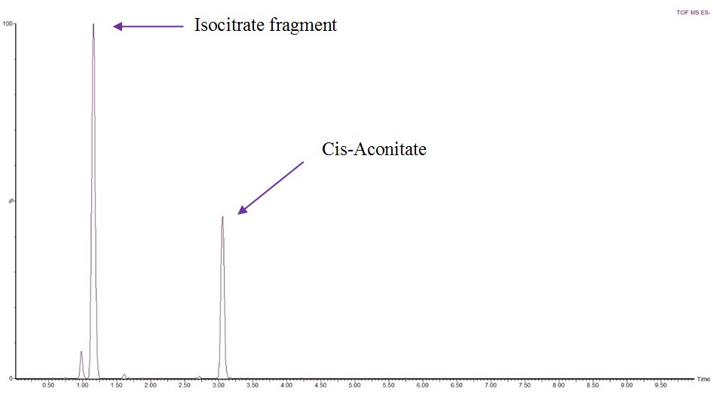
Figure S1: EIC m/z 173.0092

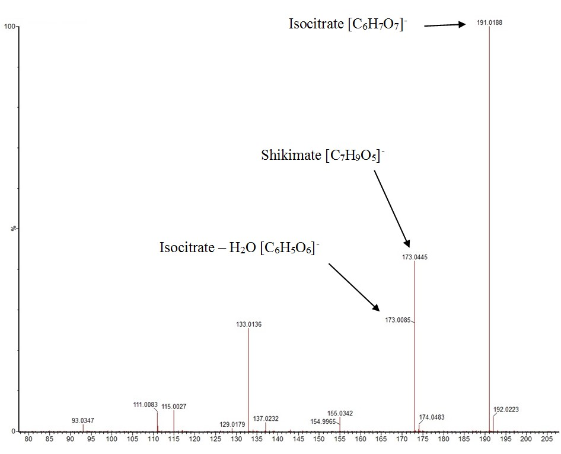
Figure S2: Isocitrate source fragmentation – MS spectrum
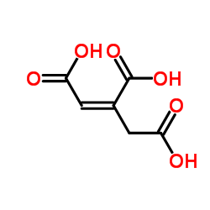  Figure S3: cis-Aconitic acid - C₆H₆O₆ | 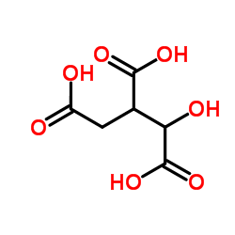  Figure S4: Isocitric acid – C₆H₈O₇

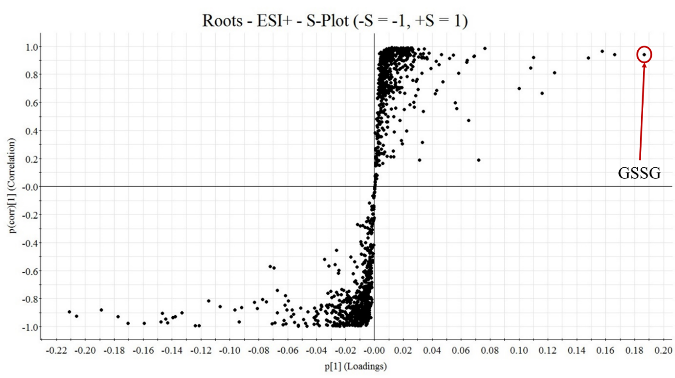
Figure S5: S-Plot - Roots - ESI+

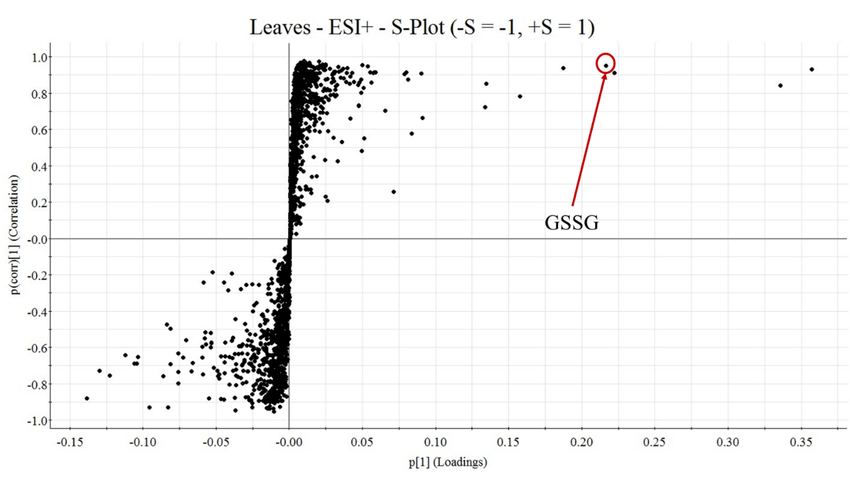
Figure S6: S-Plot - Leaves - ESI+

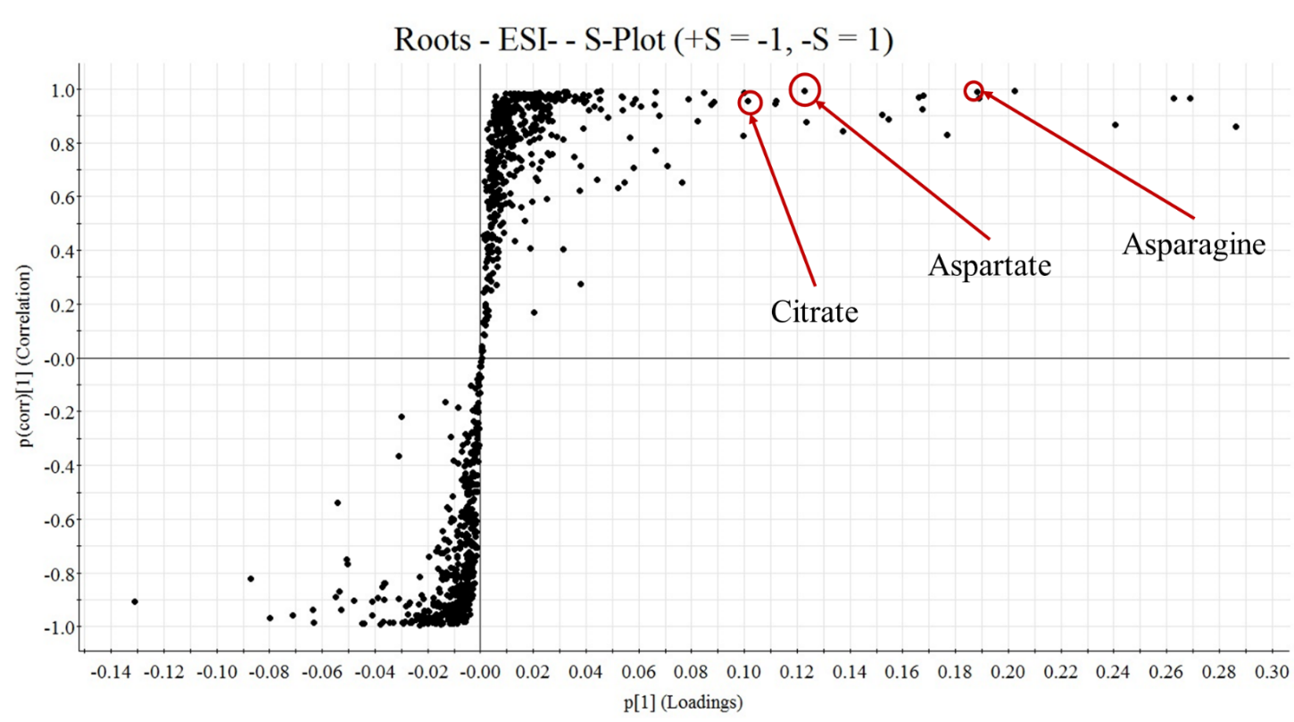
Figure S7: S-Plot - Roots - ESI-

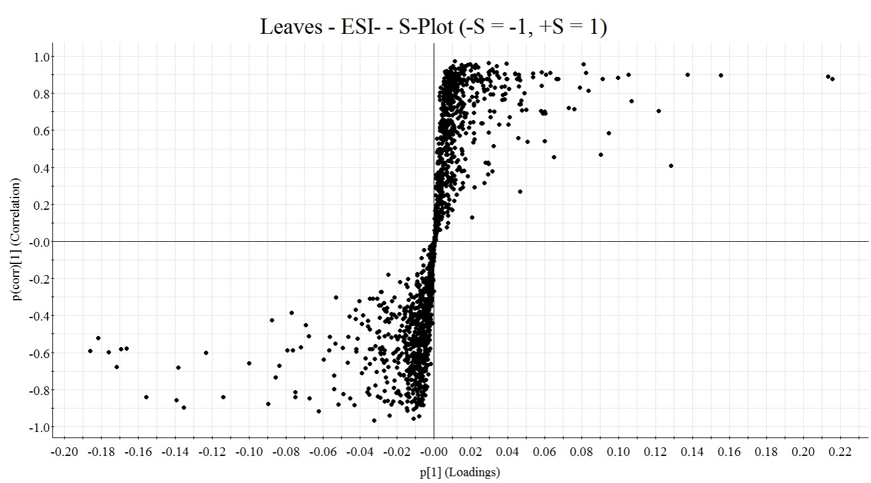
Figure S8: S-Plot - Leaves - ESI-
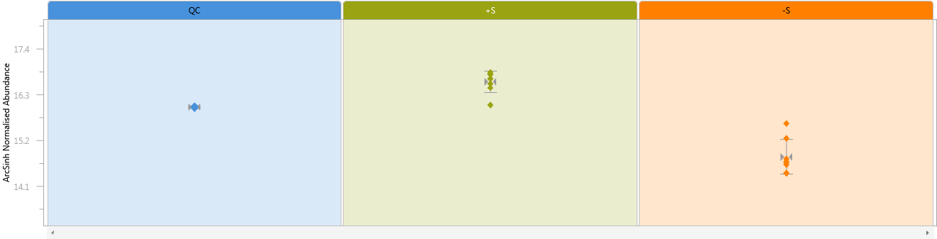
Figure S9: GSSG relative abundance – Roots

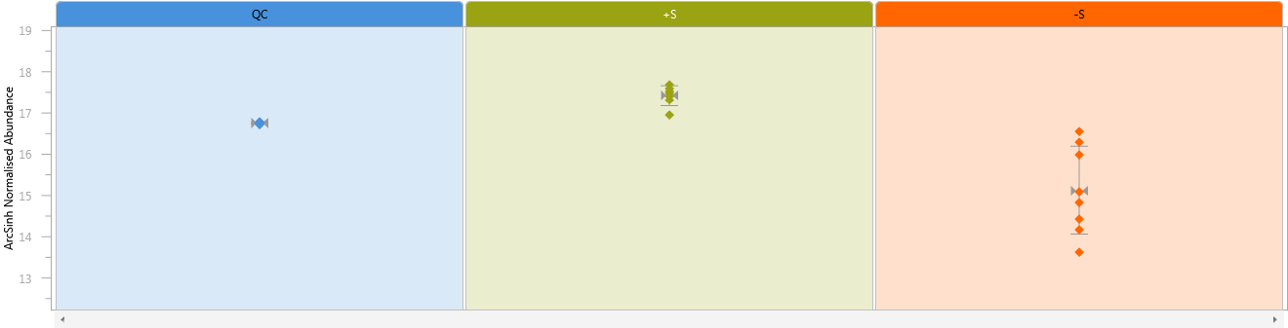
Figure S10: GSSG relative abundance – Leaves

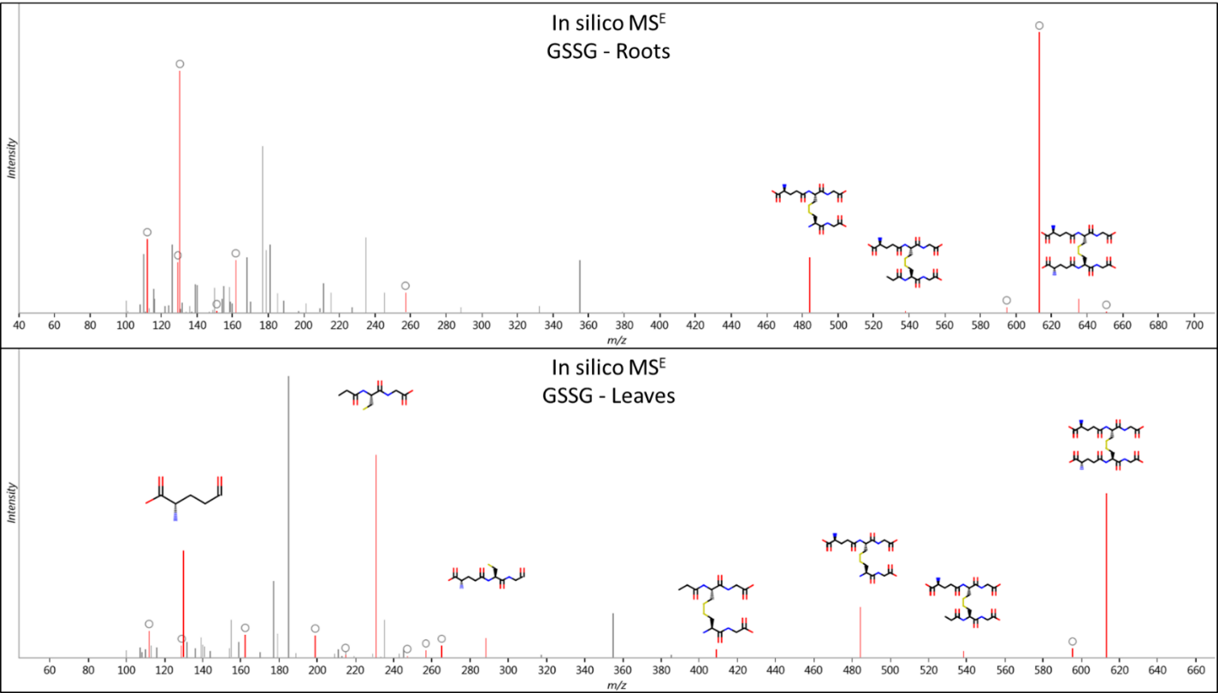
Figure S11: In silico fragmentations from MS^{E} acquisition of GSSG in roots and leaves

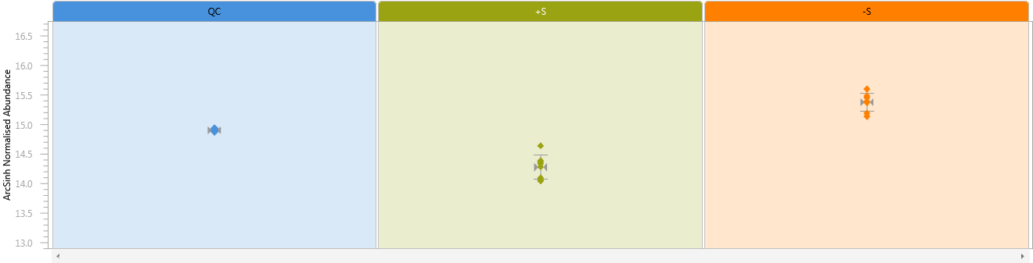
Figure S12: Citrate relative abundance – Roots

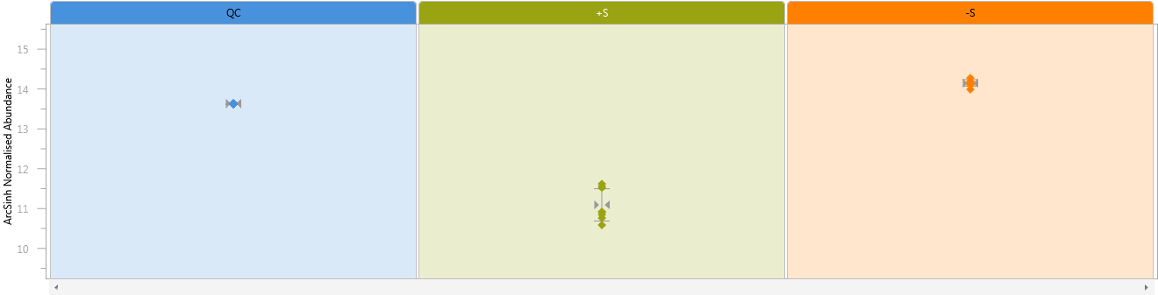
Figure S13: Aspartate relative abundance – Roots
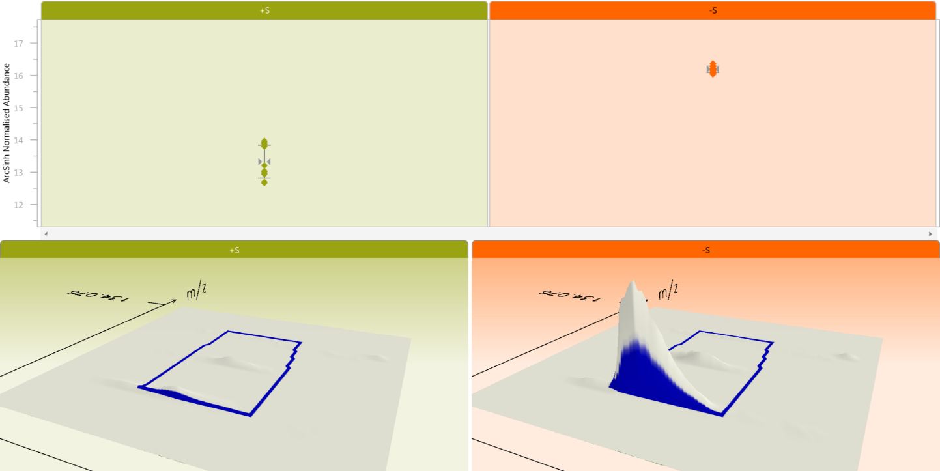
Figure S14: Asparagine relative abundance – Roots

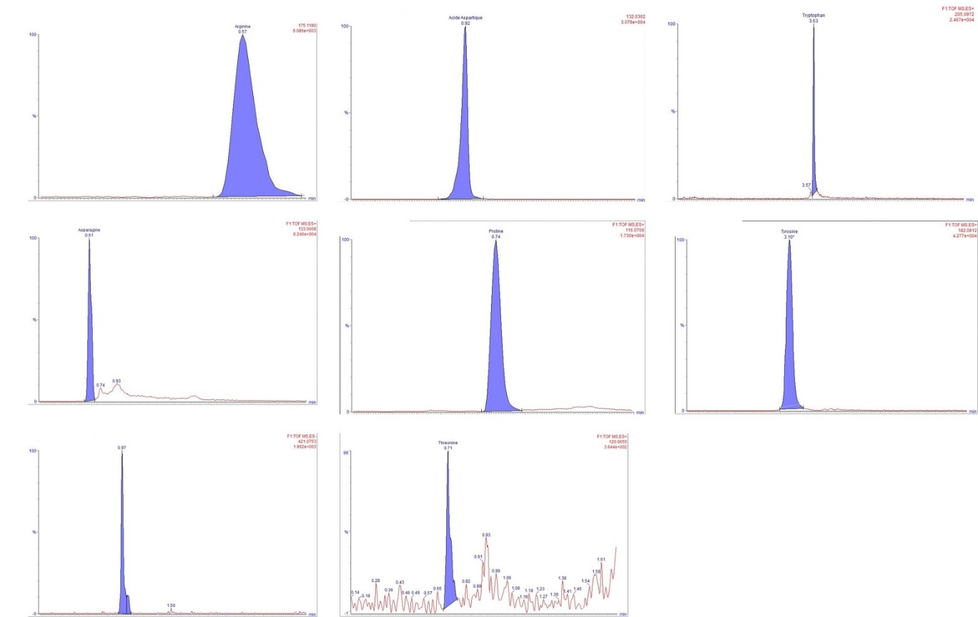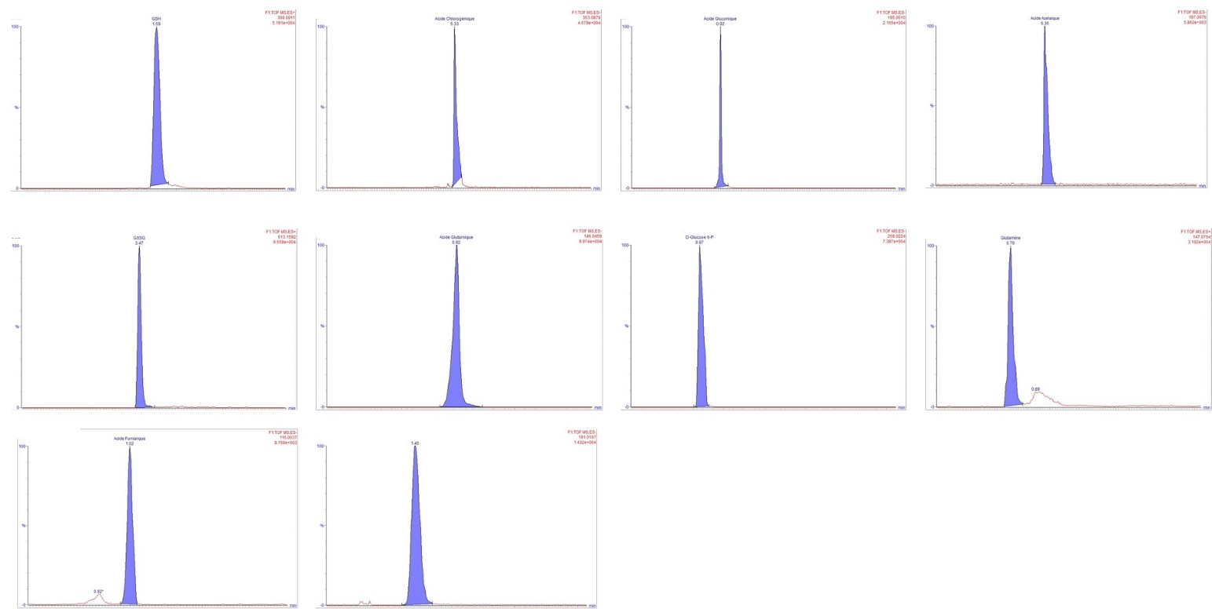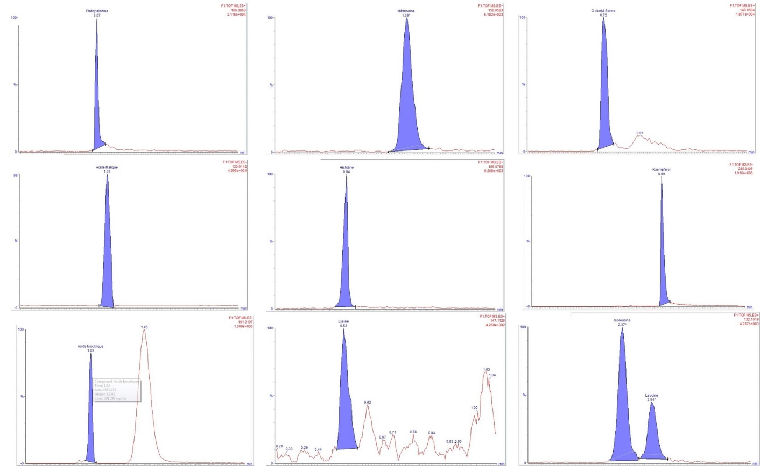
Figure S15: Extracted ion chromatograms

