Additional File 2: Example of different pre-treatment evaluation and band selection approaches.
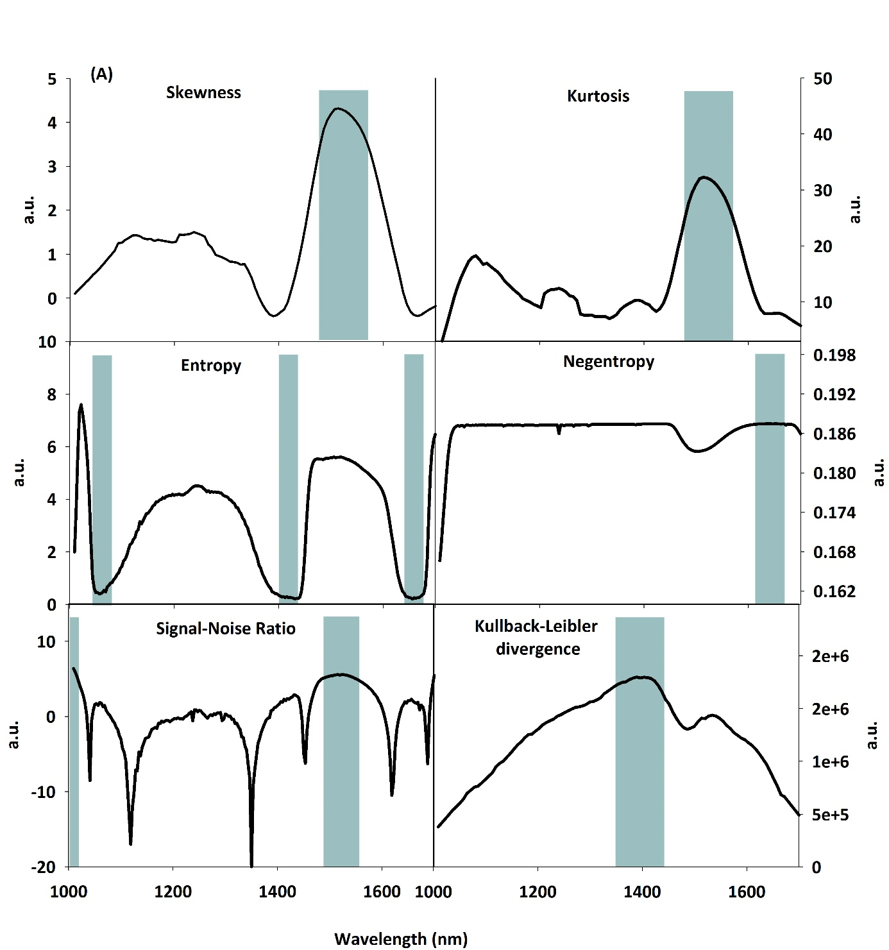
Additional File 2a Example of Non Gaussian measures indicating wavebands with high information content on the whole image (blue area show the bands in the upper 5 % quantile). a.u. arbitrary unit.
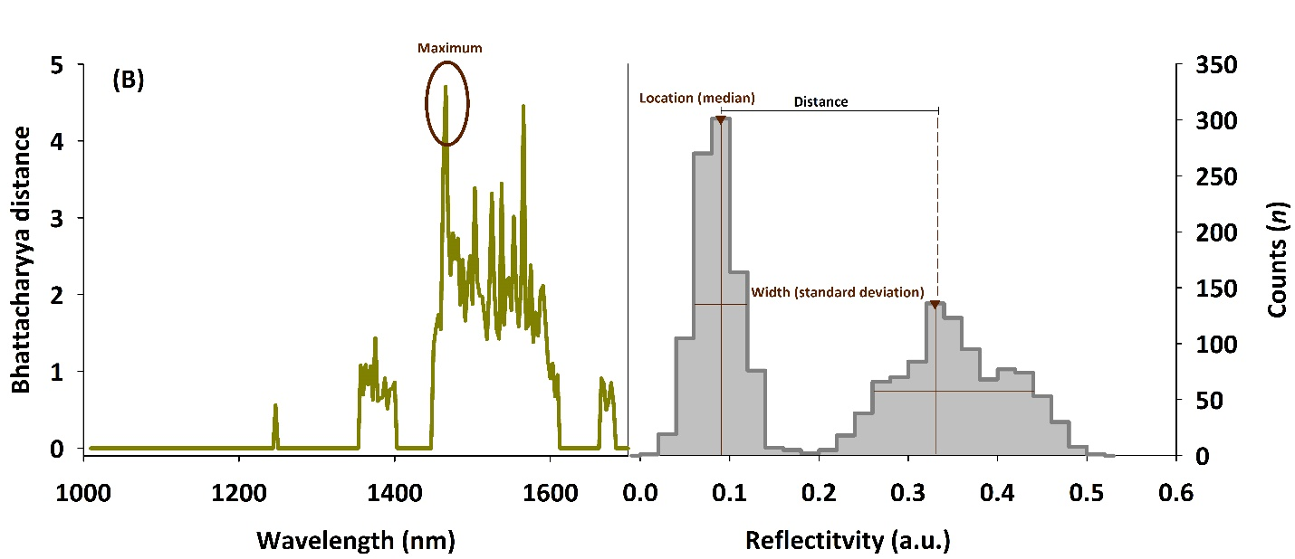
Additional File 2b Example of Bhattacharyya distance for single spectra (left) as an indicator of the spectral distinctness between root and soil pixel obtained via histogram evaluation (right).
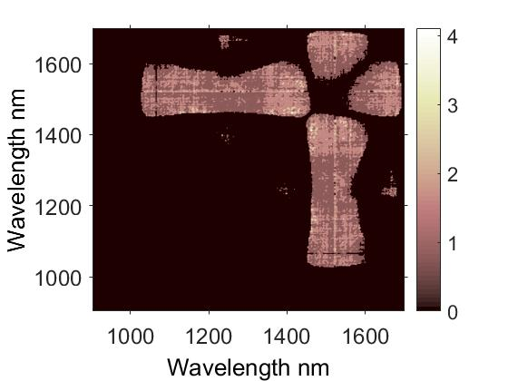

Additional File 2c Identification of wavelengths with maximum Bhattacharyya distance for difference spectra (λ_{m}- λ_{n} with m,n= 1…222).

