Additional File 4 Relation between segmented root length and image noise.
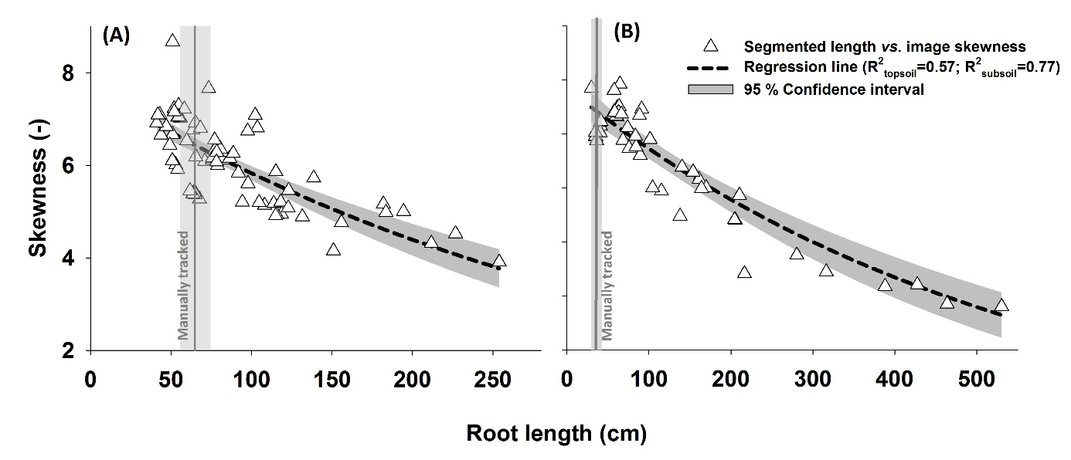
Additional File 4 Relation between segmented root length and image noise expressed via skewness for topsoil (A) and subsoil (B).

